2

Contents

Drive Mapping 1

Remove Labadmin User 2

Add FID to Administrators group 2

Copy remote To_Deploy to local PC 3

Disable User Account Control Settings 3

Installing Vehicle Spy 4

Running the Patch Script 5

Installing the Digibox 6

NIC Assignment 7

Configuring Multi-Port Serial Adapters 8

Editing COM Ports 9

Reassigning COM Ports (If COM2, 6, 7, or 8 is used by another device) 9

Installing and Running Test.Commander 10

Installing Synergy (Archival Information) 12

Installing VSCode 13

Using the Red Launcher Icons to Clone solution_common 14

Setting up SourceTree 14

SDF Onboarding (Warren Only) 17

General Troubleshooting 19

Python Wheel Installation 19

Python Errors at CMD 20

HASPlm.ini 20

## Drive Mapping

Map the Z: drive specific to the country the PC resides in  
US:

|  |  |
| --- | --- |
| **Z:** | **\\ice-batna-win.gm.com\Config** |
| S: | \\nam.corp.gm.com\tcws-dfs\dept\vehhyb |
| T: | \\nam.corp.gm.com\tcws-dfs\Project\HybBat |

China:

|  |  |
| --- | --- |
| **Z:** | **\\pdgipvfapa001.apa.corp.gm.com\GROUPS4\Config** |
| Q: | \\nam.corp.gm.com\tcws-dfs\dept\vehhyb |
| K: | \\nam.corp.gm.com\tcws-dfs\Project\HybBat |
| Y: | \\ice-batna-win.gm.com\Config |

After mapping the Z: drive, locate **drive_map.vbs** or **drive_map_China.vbs** file in Z:\ and double click it to automatically map the HybBat and Vehhyb drives

## Remove Labadmin User

If it exists, remove local admin user, labadmin

* 1. Right-click on This PC and select Manage or search **Computer Management**
  2. Expand **Local Users and Groups**
  3. Select **Users**
  4. Right-click on labadmin and select **Delete**  
     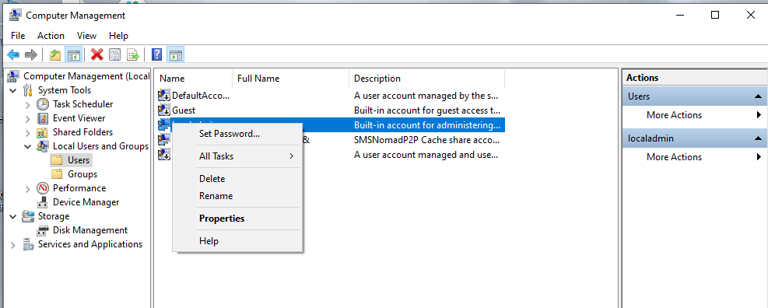
  5. Keep Computer Management open for the next step

## Add FID to Administrators group

Add Functional ID to admin group

1. Click **Groups**
2. Click **Administrators**, click **Add**
3. Change the From this location: to match your domain
   * 1. For the US – nam.corp.gm.com
     2. For China – apa.corp.gm.com
4. Enter the Functional ID (FID) of the device you are setting up, i.e. vehtestfidtc01A  
   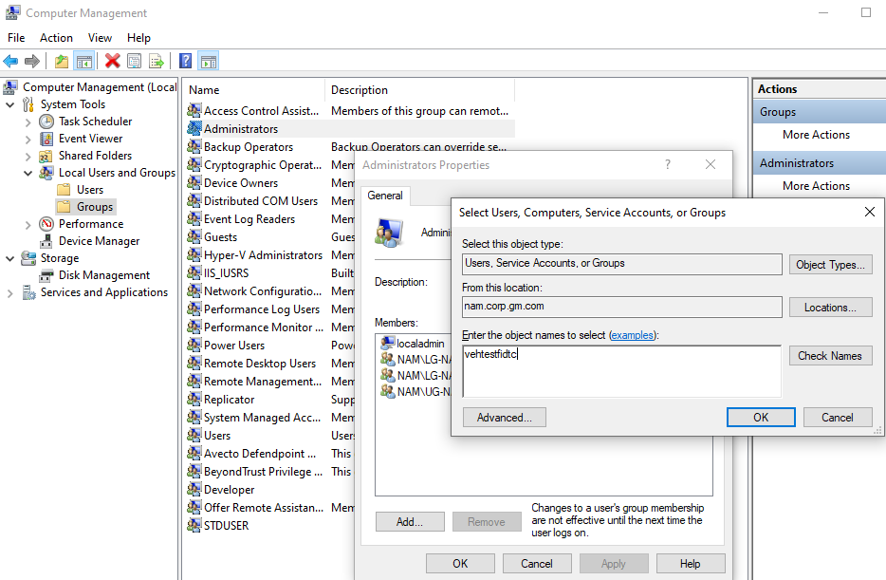
5. Click **Ok** on the Select Users, Computers, Service Accounts, or Groups page
6. Click **OK** on the Administration Properties window
7. Close Computer Management

## Copy remote To_Deploy to local PC

Copy Z:\Patches\To_Deploy to C:\Temp

If it says you need permission to move the iTest installer, just give it a minute and click retry until it works

## Disable User Account Control Settings

Disable UAC

1. Click **Start** and type **UAC**
2. Open **Change User Account Control Settings**
3. Move slider to the bottom and click **Ok** on the Windows Security prompt, then click **Ok**  
   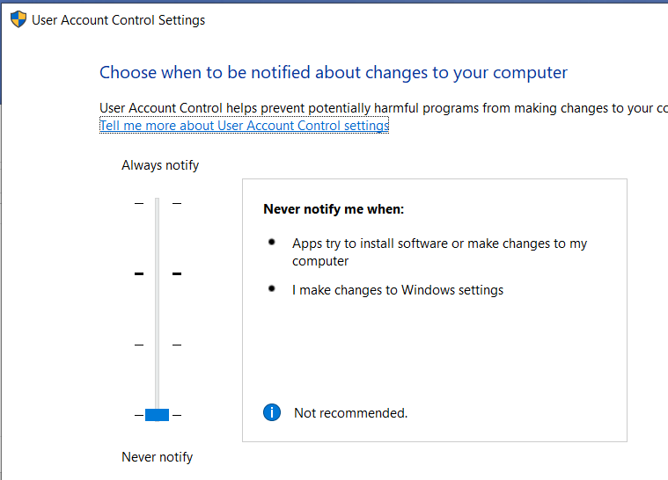

## Installing Vehicle Spy

Install Vehicle Spy manually, Z:\_Manual_Installs\vspy3_ProGM by selecting all default options (if prompted)

1. The Vehicle Spy installer has multiple drivers and applications that it installs, even after clicking Finish, more will appear  
   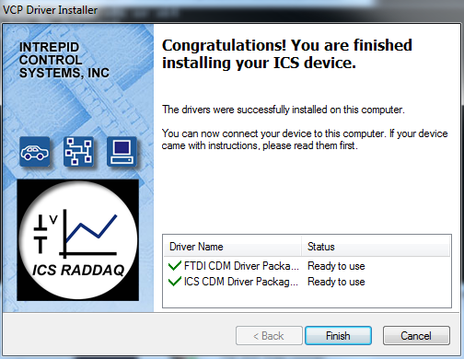  
   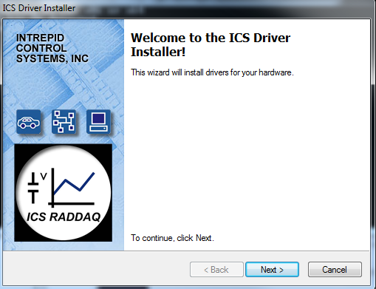
2. Keep an eye out for **Windows Security** prompts, if “Always trust software from “Intrepid Control Systems, Inc.” isn’t checked, check the box and click **Install**. You will logsee at least 3 security prompts on a brand new PC install.  
   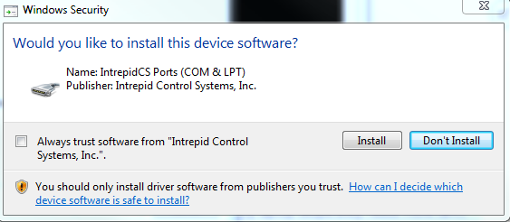

## Running the Patch Script

Run Z:\Patches\BatchGetAdmin by double clicking on the batch file

1. The first install will be the full install of all software and settings and requires a reboot before more work is completed.
2. PC will now reboot, if automatic reboot doesn’t occur, reboot manually.

Navigate to and run Z:\Patches\BatchGetAdmin a second time for the shortened version

This will get any settings that the initial install couldn’t complete due to missing software or permissions.

Finally run Z:\Patches\BatchGetAdmin and hold **F9** until a popup appears to trigger **Debug** **Mode**. Click **Yes**

1. Debug mode forces the patch script to run the full script outside of a release window, this is used for testing new scripts, debugging, and forcing all file copies from the Z: drive to copy again  
   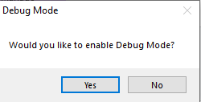
2. Click **Yes** to accept the current patch folder  
   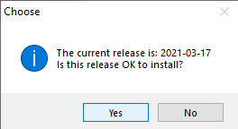
3. Click **Ok** to run the patch or let this window time out  
   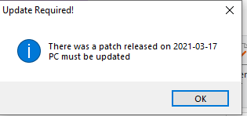
4. After this final run completes, it is wise to check the patchlog.log for any unresolved error messages.
5. Prior to the Q2 2024 release, patchlog is in C:\Apps\ADT\
6. After the Q2 2024 release the patch log is in C:\Logs\PatchLogs and Z:\PatchLogs

## Installing the Digibox

1. Open Z:\_Manual_Installs (\\ice-batna-win.gm.com\Config\_Manual_Installs)
2. Run the DigiBox **Setup64.exe** (don’t do this if the PC is on the Bench, only if it’s at stand and connected to the DigiBox)

### NIC Assignment

If 20.0.0.2 doesn’t show up:

1. Check NIC, they’re probably swapped or not configured  
   Set the IP Address/Subnet Mask for the “**DigiBox**” NIC to **20.0.0.1/255.255.255.0** and click **Ok** and **Ok**.
2. Set the IP Address/Subnet Mask for the “**IO Rack**” NIC to **192.168.1.99/255.255.255.0** and click **Ok** and **Ok**.
3. If they’re swapped
   1. Rename DigiBox to any random name or keyboard press
   2. Change IP to have 99 at the end to save time for later
   3. Rename IO Rack to DigiBox and change the IP to **20.0.0.1**
   4. Rename the other one to IO Rack and change IP to **192.168.1.99**
   5. Click Refresh on the Digi Setup

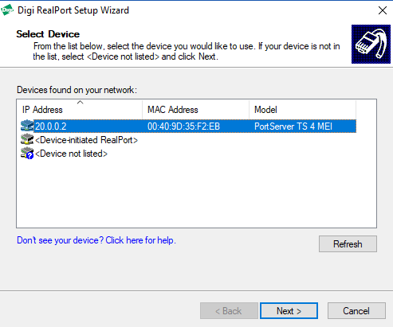If 20.0.0.2 shows up:

* 1. Click **Next**
  2. Use the defaults, click **Finish**  
     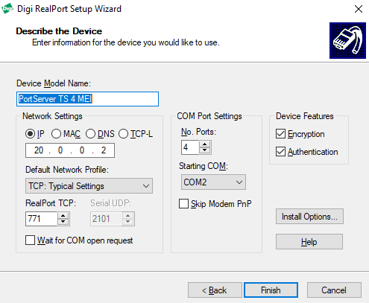

## Configuring Multi-Port Serial Adapters

Right click on This PC (My Computer), select Manage or open Computer Management

1. Expand the Multi-port Serial Adapters
2. Select **PortServer TS 4 MEI (20.0.0.2)**
3. Right-click and select **Properties**  
   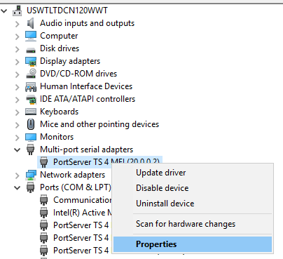
4. In the **Advanced** tab, click **Properties**  
   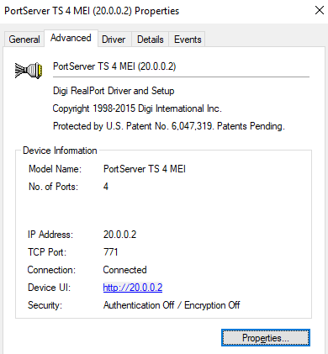
5. The ports need to be COM2, COM6, COM7, COM8

### Editing COM Ports

If ports need to be edited:  
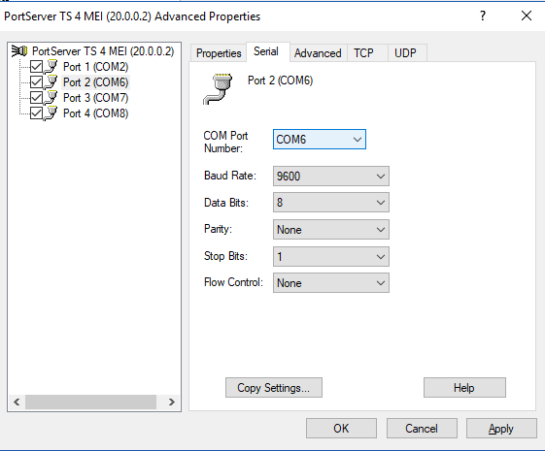

1. Start from the bottom and change them, if a port is already used you can’t reassign it
2. Click the last port and click the **Serial** tab
3. Change the port from the drop-down list
4. Click the next port up from the bottom and do the same action.
5. When all ports are correct, click **Apply** and **Ok**

### Reassigning COM Ports (If COM2, 6, 7, or 8 is used by another device)

If a port is missing because it’s being used by a USB or other device:

1. Expand the **Ports (COM & LPT)** menu
2. Right-click on the port that is using the COM you need
3. Select **Properties** > **Port Settings** > **Advanced**
4. Change the port in the drop-down at the bottom of the Properties window  
   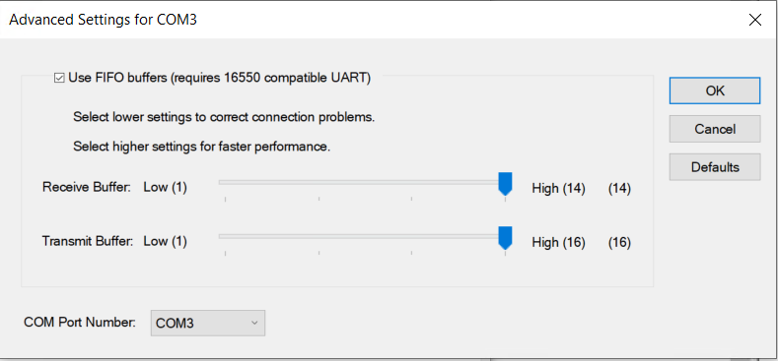
5. Click **OK**
6. Return to the steps above to continue correct port assignment

## Installing and Running Test.Commander

Run Test Commander Installer from the _Manual_Installs folder, select all defaults for the installer

1. **Don’t do this next part if the PC is on the Bench, only if it’s at stand**
   1. Open Test.Commander  
      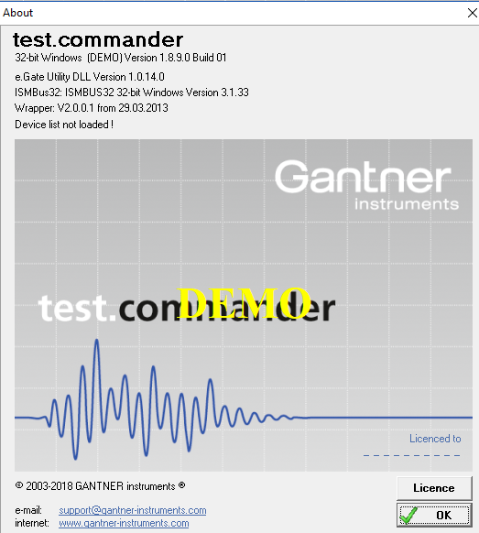
   2. Click **License** and enter:

|  |
| --- |
| A&D Technology, Inc. |
| A&D Technology, Inc. |
| 4379103090 |

* 1. Open **Wizard** to start from scratch…

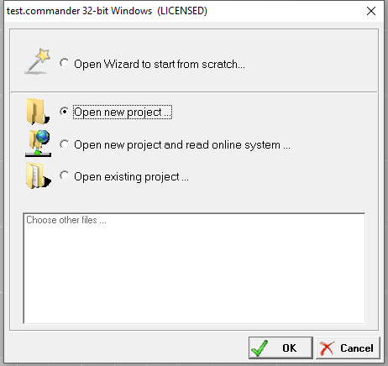

* 1. Click **Next**
  2. Name it anything, I name it Test, click **Next**
  3. In the network drop-down, select the **192.168.1.99 Static** option

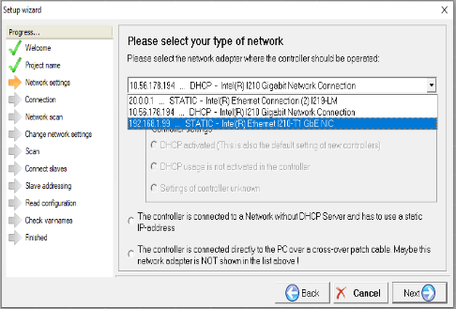

* 1. Select the second radio button to indicate that we are using a static IP-address, click **Next**
  2. Click **Next**, click **Next**
  3. Select the e.gate IP and click **Next**  
     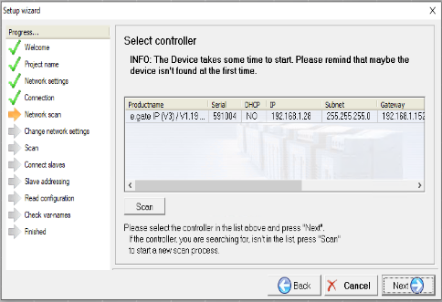
  4. Click **Next** on the Change network setting page and wait while it sets up the parameters
  5. Click **Next** on the connect Slaves page and wait for it to scan
  6. Click **Next** on the Reading controller configuration page and wait for it to connect
  7. Click **Next** on the Checking for unique variable names page and wait for it to connect
  8. Click **Next** on the Finished successfully page
  9. Click **OK** on the View values window and close test commander

## Configuring the Anderson EtherCat Port

1. 192.168.55.1

## Installing Synergy (Archival Information)

**This may be impossible with the SDF implementation and should only be kept for archival information**

Run Synergy (don’t do this if the PC is on the Bench, only if it’s at stand)

1. A is always the server, B is the client
2. Set Mode to disable
3. In Edit check the top two checkboxes
4. On A (the server), in Configure Server drag a new PC to the right of A and name it B’s hostname  
   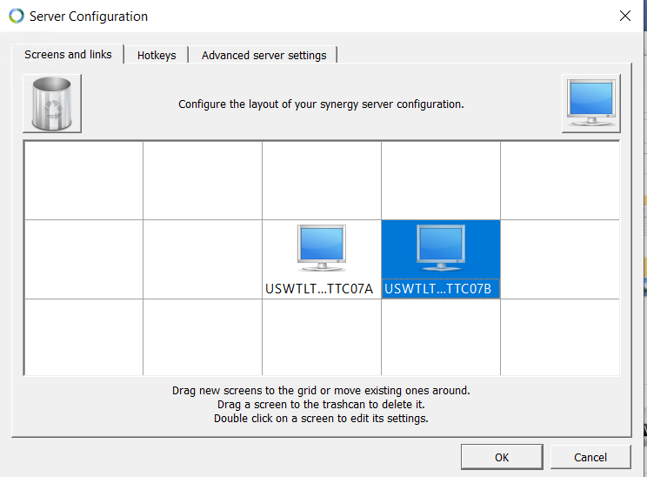
5. On B (the client) in the server field enter A’s IP address
6. On both A and B, click Edit menu, select Settings
7. Check all Startup options  
   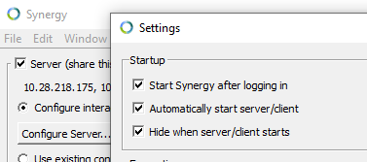
8. Click Start on A
9. Click Apply on B

## Installing VSCode

Run VSCode Setup

* 1. Use defaults for all except the follow options:  
     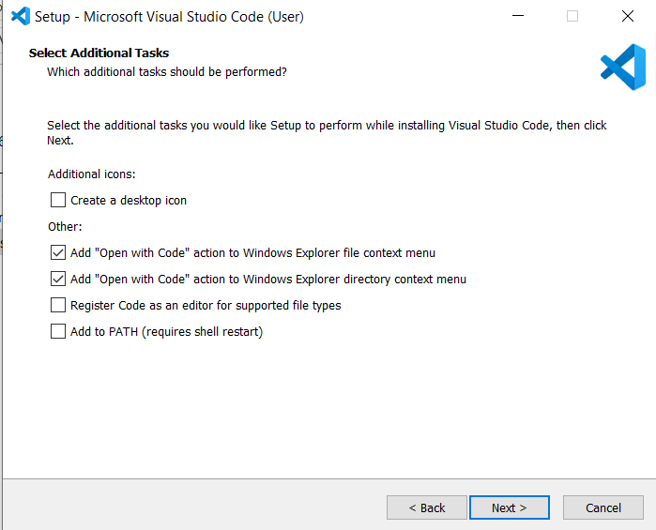
  2. Uncheck Launch Visual Studio Code and finish setup

## Using the Red Launcher Icons to Clone solution_common

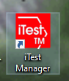Click the red launcher icon on the desktop for Test Manager

1. After the iTest Launcher script runs, click on **master** branch and click **Clone Selected Repo**  
   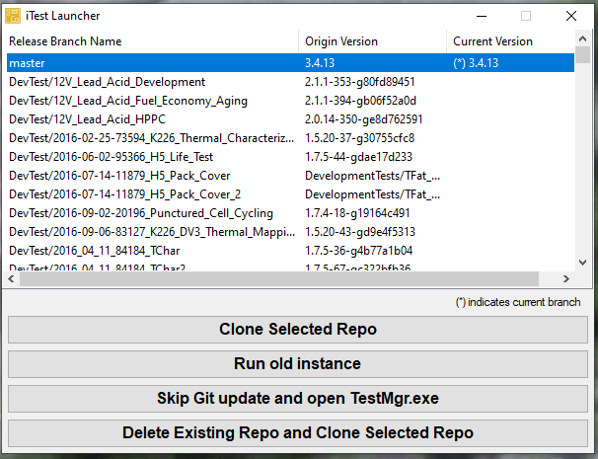
2. Close Test Manager

## Setting up SourceTree

Open Z:\_Manual_Installs\SourceTree\SourceTreeSetup

* 1. Click **Skip** for the Bitbucket account
  2. Click **“I don’t want to use Mercurial”**
  3. SSH Key info goes here
  4. Click **Add**
     1. Browse the file system to C:\Apps\ADT\solution_common
     2. Select folder  
        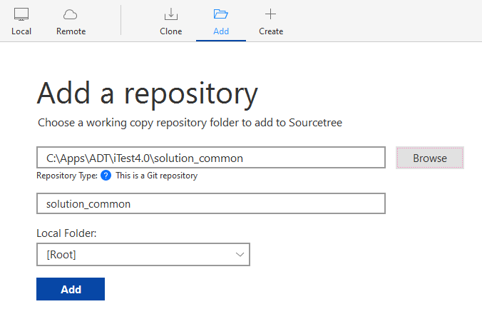
     3. **Add**
     4. After adding the repo you may see an error window from Bitbucket about dubious ownership, close the error

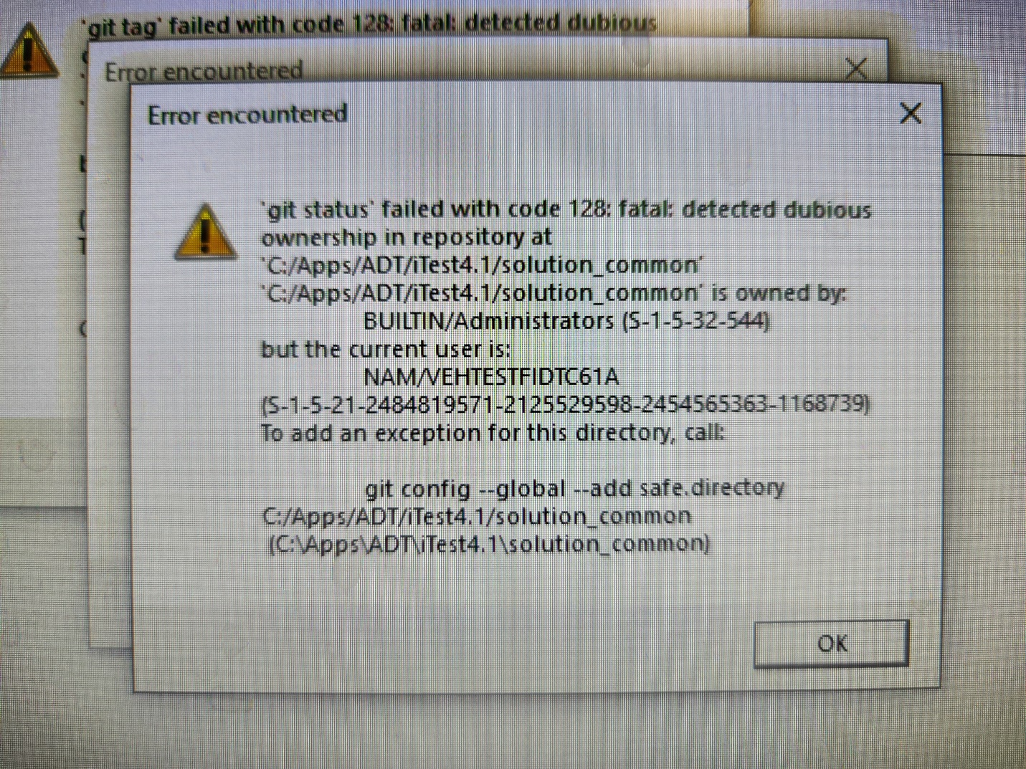

* + 1. Click Fetch so the error appears in the full output screen

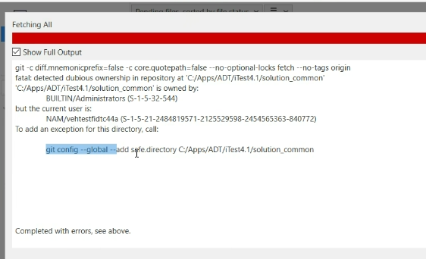

* + 1. Highlight and copy the command to send “git config –global –add safe.directory C:/Apps/ADT/iTest4.1/solution_common” from that full output window. It doesn’t like to be typed or copied some an external source
    2. Close the full output log
    3. Click Terminal in the upper right
    4. Paste the command and press enter

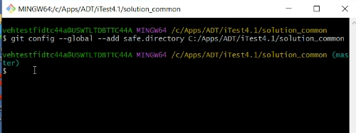

* + 1. Close Terminal and click Fetch again
  1. If the SSH key is still not working despite SourceTree showing its correct location, close Pageant from the task bar and allow SourceTree to open it.

## SDF Onboarding (Warren Only)

How to Onboard to the SDF if a PC IP address does not start with 10.210…

1. Make sure the PC is at the stand, if it is at the IT bench, this will not work and will likely be resolved by on-site IT prior to the PC being placed at the test stand.
2. Contact Marsha Holley and let her know the hostnames of the new TCWS machines. Enter the Technician Assistance ticket stating the PCs that need onboarding to the SDF, for the specific PC drop down, select “Searched but did not find”
3. In the Start Menu, search mmc and open the console
4. Click File and select Add/Remove Snap In to add to the modules you can modify  
   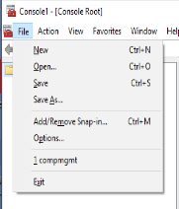
5. Double-click Certificates  
   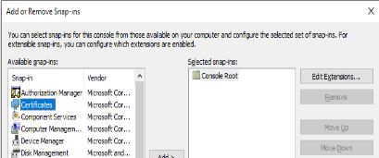
6. Select the Computer account radio button, click next  
   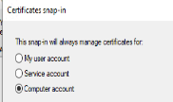
7. Click Finish, click Ok to close the add/remove window
8. Double-click Certificates (Local Computer)
9. Double-click Personal
10. Double-click Certificates
11. In the issued to column, select and delete any entry that starts with USWTLTD  
    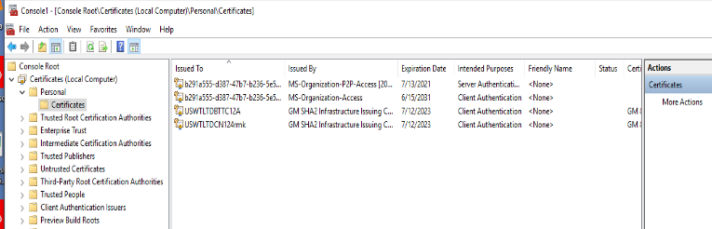
12. Right-click in the window and select All Tasks > Request New Certificate  
    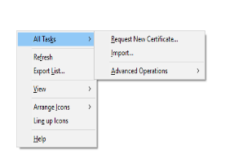
13. Click Next, click Next
14. Select the GM 802.1x Comp checkbox  
    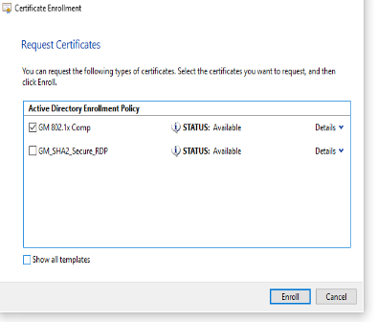
15. Click Enroll, click Finish
16. Close the Console window and do not save (this is to save the added snap-in and has nothing to do with the certificate)
17. **Only proceed when Marsha says the hostnames are enrolled in the SDF**
18. Open CMD
19. Enter gpupdate /force and hit enter
20. This takes some time, but if it is successful, the PC will disconnect from Remote Desktop as it is now behind the firewall
21. If the PC does not disconnect and the CMD says it completed updating group policy, press the up arrow key and enter to update group policy again

# General Troubleshooting

Each computer is slightly different, whether because of group policy hiccups, location, or Windows OS number. When in doubt, check PatchLog.log for information on what worked, errored out, or needs manual intervention

Below are some common steps that may need to be taken on a PC that behaves slightly differently than expected.

## Python Wheel Installation

Open a new command prompt window (type cmd into the start menu)

For Python 2 wheels:

In cmd send python -m pip list

For Python 3 wheels:

In cmd send py -3 -m pip list

For both of the cmd returns, you should see a long list of python wheels that have been loaded. If you only see 2 or 3 listed wheels, proceed to the solution immediately.

In the same cmd window,

For Python 2 wheels:

In cmd send C:\Python27\python.exe -m pip install -r C:\Temp\To_Deploy\wheelhouse\requirement.txt --no-index --find-links file:C:\Temp\To_Deploy\wheelhouse

For Python 3 wheels:

In cmd send py -3 -m pip install -r C:\Temp\To_Deploy\python3_wheels\requirement.txt --no-index --find-links file:C:\Temp\To_Deploy\python3_wheels

Once pip has completed loading wheels, press the Up Arrow key a few times to get back to the pip list commands.

Run both pip list commands for Python 2 and 3

## Python Errors at CMD

Beginning with Windows 10 on the EDWS laptops, some PCs have a setting where entering python in cmd results in the Windows Store opening. This has not yet been encountered on TCWS desktops but that doesn’t mean it won’t.

To disable this, search **Manage App Execution Aliases** in the start bar.

Disable the two python sliders:  
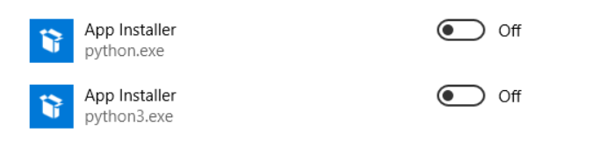

## HASPlm.ini

The HASP license manager file sometimes doesn’t copy from temp to the HASP folder, this will cause iTest to say that it is unlicensed

1. Go to **C:\Program Files (x86)\Common Files\Aladdin Shared\HASP**
2. If the **hasplm.ini** file is missing
   1. Go to **C:\Temp\To_Deploy\haspdinst_itest**
   2. Verify that **hasplm.ini** has the TCWS hostname in the [SERVER] name field
   3. Search **cmd** so you can right-click the program and **Run as Administrator**
   4. Send net stop hasplms
   5. After HASP stops, send xcopy C:\Temp\To_Deploy\haspdinst_itest\hasplm.ini “C:\Program Files (x86)\Common Files\Aladdin Shared\HASP\hasplm.ini”
   6. Send net start hasplms