This will guide you through all of the installs performed by the patch script, Updater.exe, with troubleshooting tips since every laptop behaves differently. Homework assignment at the end of the document; Don’t forget!

Installs include:  
iTest  
iView  
Python 2 and 3  
Vehicle Spy  
VSCode  
7Zip

1. Map Network Drives

|  |  |
| --- | --- |
| Z: | \\ice-batna-win.gm.com\Config |
| S: | \\nam.corp.gm.com\tcws-dfs\dept\vehhyb |
| T: | \\nam.corp.gm.com\tcws-dfs\Project\HybBat |

1. Copy **Z:\Patches\To_Deploy** to **C:\Temp** (this takes a while)
   1. If it says you need permission to move the 3.9 installer, just give it a minute (or more) and click retry until it works
2. Run **Z:\Patches\BatchGotAdmin** by double-clicking
   1. The first install will be the full install, you will need to help the VSpy Installer near the end
   2. Reboot your laptop manually, the reboot messages in the script will **not** restart your PC purposely.
3. Run **Z:\Patches\BatchGotAdmin** for the shortened version
4. Run **Z:\Patches\BatchGotAdmin** and hold **F9** after confirming the GM IT Security message to trigger **Debug Mode**, this will catch the python wheels and any installers that failed, laptop installs can be one-off and fail the installer
5. Open **Z:\_Manual Installs**
6. Run **VSCodeUserSetup**
   1. All default settings are fine, customize as you see fit, I check the first two options under Other

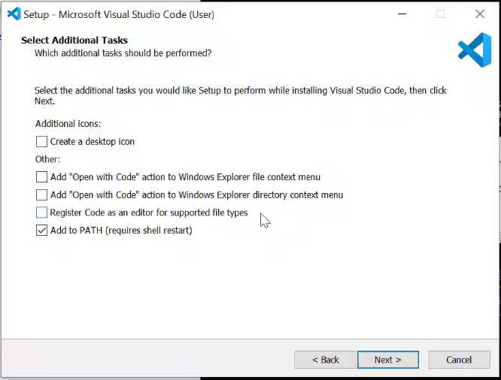

# Troubleshooting Common TCWS Laptop Issues

## Python Installers

Checking to see if Python 2 and 3 installed properly will also check to see if the python wheels installed properly.

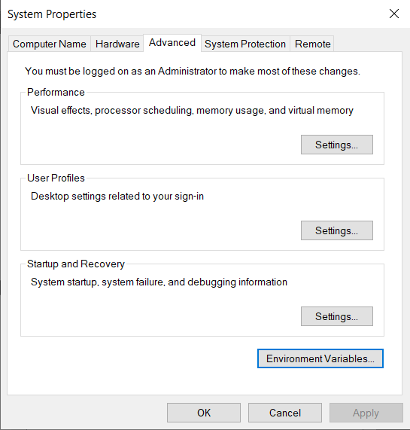

To begin, open the **Environment Variables**, typing Environment variables in the start menu will show the **System Properties**

Double click the **Path** variables field

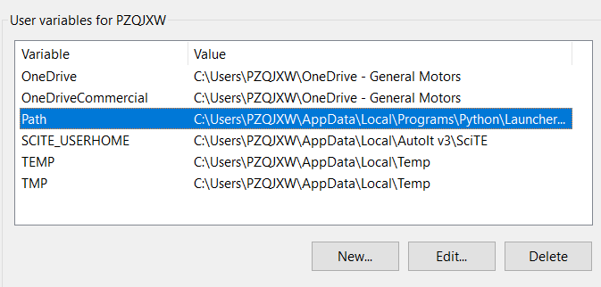

Verify that C:\Python27 and C:\Python27\Scripts are in the path.

If they aren’t in the User Environment Variables, add them

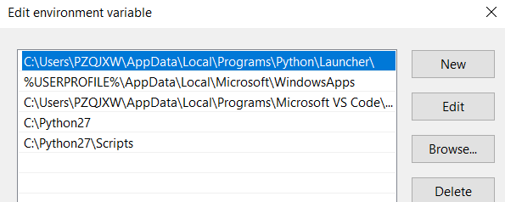

### Python 2

1. Open **cmd**
2. Send python -m pip list
   1. You should see a ton of wheels, ending around xlrd and xlwt
   2. Ignore the out of date error
3. If this returns an error that python 2 isn’t installed:
   1. Manually install python **C:\Temp\To_Deploy\python-2.7.14**
   2. Add python 2 to the path
   3. Jump to Python Wheels section below

### Python 3

1. Open or use the same **cmd** window
2. Send py -3 -m pip list
   1. You should see a ton of wheels, ending around xlrd and xlwt
3. If this returns an error that python 3 isn’t installed:
4. Manually install python **Z:\Patches\To_Deploy\python-3**
   1. **Do not** add python 3 to the path
   2. Jump to Python Wheels section below

## Sending Python CMD opens Microsoft Store

A new update to Windows 10 is now opening the Microsoft Store when the ‘python’ command is sent through cmd. To disable this, search Manage App Execution Aliases in the start bar.

Disable the two python sliders:

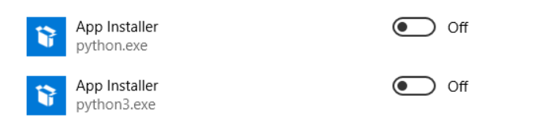

## System Environment Variable Error

You may see an error message stating that the environment variables were not set, use the following settings to add or edit the **System Environment Variables**:

|  |  |
| --- | --- |
| Variable | Value |
| iTestSystemDir | C:\Apps\ADT\iTest3.9\ |
| TC_ID | <your computer’s hostname> |

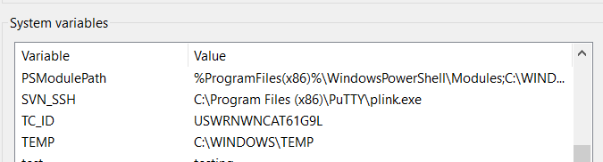

Your hostname

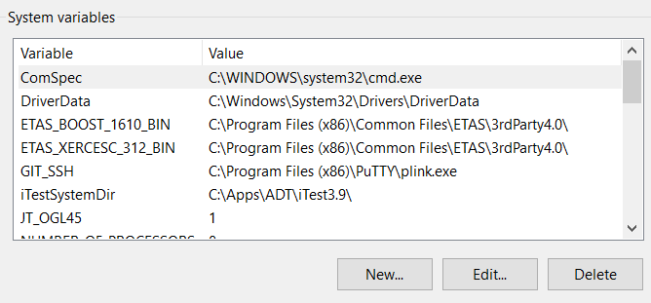

## HASPlm.ini

The HASP license manager file sometimes doesn’t copy from temp to the HASP folder, this will cause iTest to say that it is unlicensed

1. Go to **C:\Program Files (x86)\Common Files\Aladdin Shared\HASP**
2. If the **hasplm.ini** file is missing
   1. Go to **C:\Temp\To_Deploy\haspdinst_itest**
   2. Verify that **hasplm.ini** has your hostname in the [SERVER] name field
      1. Type hostname into cmd to get your hostname
   3. Search **cmd** so you can right-click the program and **Run as Administrator**
   4. xcopy C:\Temp\To_Deploy\haspdinst_itest\hasplm.ini “C:\Program Files (x86)\Common Files\Aladdin Shared\HASP\hasplm.ini”

## Python wheels

If in the previous step, python wheels were not installed, either run **Z:\Patches\BatchGetAdmin** in debug mode, holding **F9** or in **cmd** send:

python -m pip install -r C:\Temp\To_Deploy\wheelhouse\requirement.txt --no-index --find-links file:C:\Temp\To_Deploy\wheelhouse

py -3 -m pip install -r C:\Temp\To_Deploy\python3_wheels\requirement.txt --no-index --find-links file:C:\Temp\To_Deploy\python3_wheels

## How to Clone solution_common

After you have completed all installs, you need to clone the master branch of solution_common. See the Battery Lab Guide for how to do this:

<https://tslm-confluence.gm.com/display/BTSIKB/Starting+iTest#StartingiTest-iTestLauncher>

## How to Add solution_common to SourceTree

After cloning solution_common, open SourceTree.

You should see a blank page with the following buttons on a toolbar at the top:

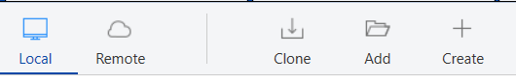

Because you have just cloned solution_common, you need to select **Add**

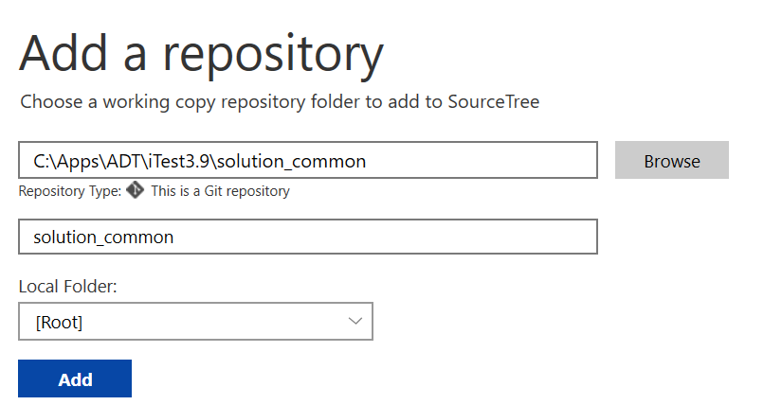Browse to your solution_common folder C:\Apps\ADT\iTest3.9\solution_common and double-click

Name it solution_common, if it doesn’t auto-populate.

Click **Add**

## I ran the Batch File/Updater and got a GM Security message

If you get a message like this:

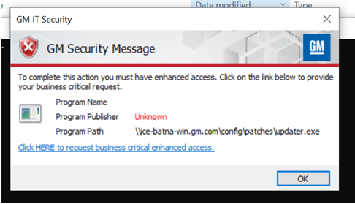

Submit the following IT Store ticket and the information you need to use to get developer access.

<https://itcatalog.gm.com/portal/shop/catalog/1ecf9f39-fa11-46f4-b452-44bd9ed713b8>

Here’s what you need to enter, the first few fields will prepopulate with your laptop:

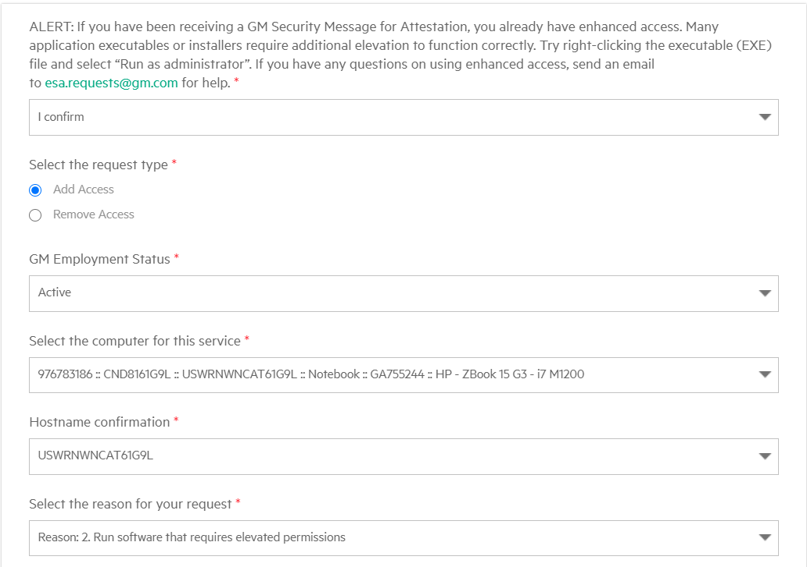

Your computer name here

Your hostname here

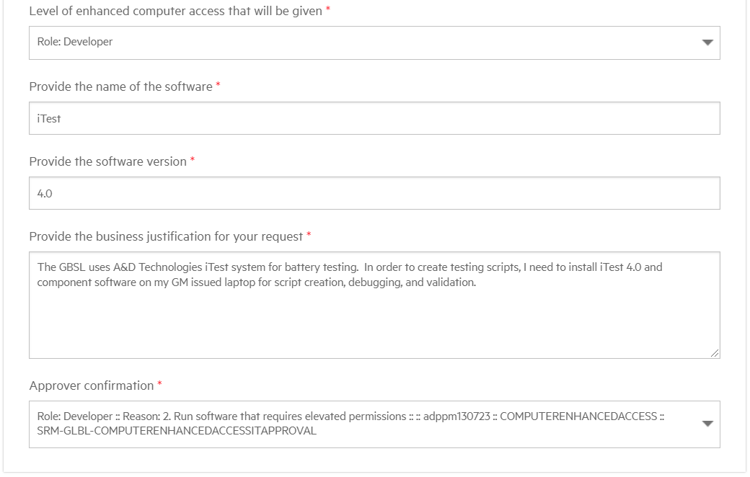

The business justification should be something like (feel free to copy):

The GBSL uses A&D Technologies iTest system for battery testing.  In order to create testing scripts, I need to install iTest 4.0 and its necessary component software on my GM issued laptop for script creation, debugging, and validation.  The scripts run by iTest require elevated permissions.

## Adding your Laptop to PCsList

In order to debug code on your laptop, you must provide your hostname to Chelsea to add to the PCsList.ini. Without doing so, iTest will fail init.

Send an email to [Chelsea.Flattery@gm.com](mailto:Chelsea.Flattery@gm.com) with your hostname

1. Type hostname into cmd to get your hostname
2. Highlight the hostname and hit enter, this will copy the value