

Assignment 6

Course Code: CSDD1007
Instructor Name: Abdul Khan
Group Members
Beant Kaur 500224635
Harshpreet Kaur 500224002
Rashpinder kaur 500225462
Harpreet kaur 500224264
Dennis Samuel Anumba 500222264

Task 1: - Setting Up Your Project
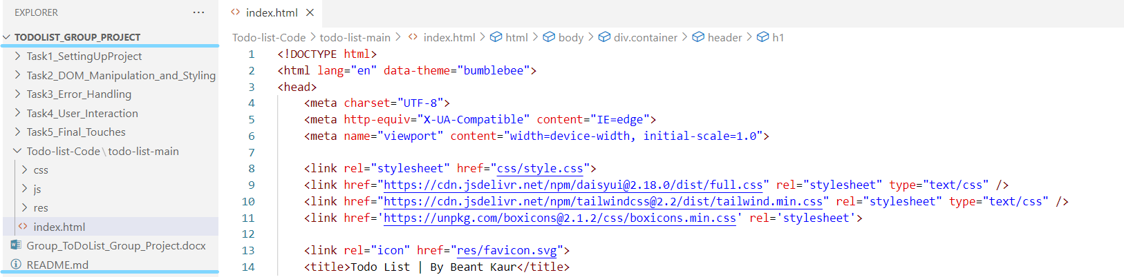
Task 2: DOM Manipulation and Styling:
- Using the Document Object Model, we are manipulating the html code with JavaScript to handle the list
- Here, we are using the list in the HTML to add the items and then we can delete the items on the UI.
- Here, we are used styles.css file to format the UI in the different forms.
- Manipulation is done by handling the code by validating logic of adding and deleting button in the ToDoList.

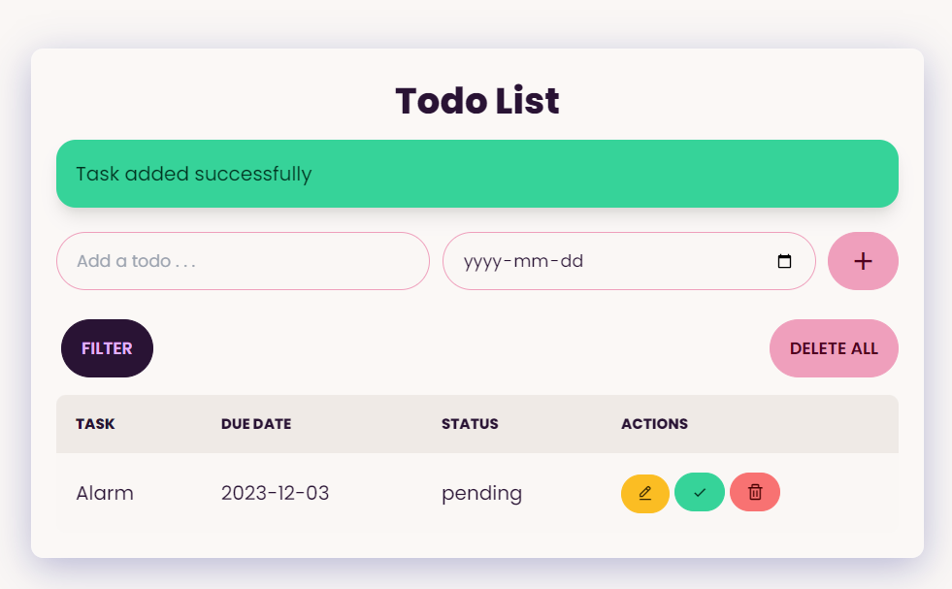

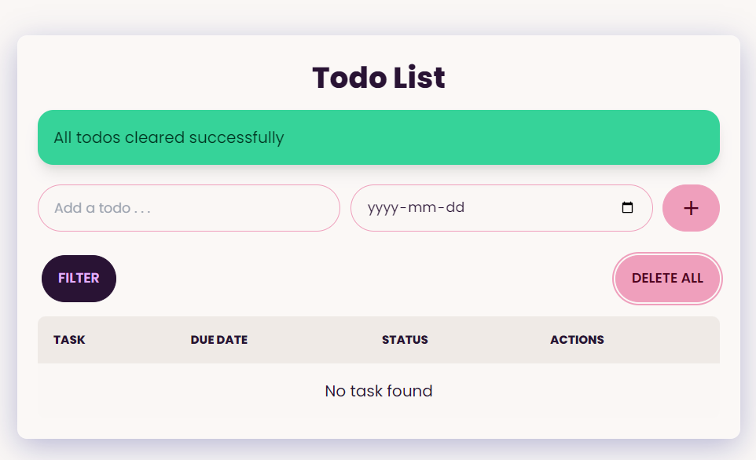

Task 3: Error Handling
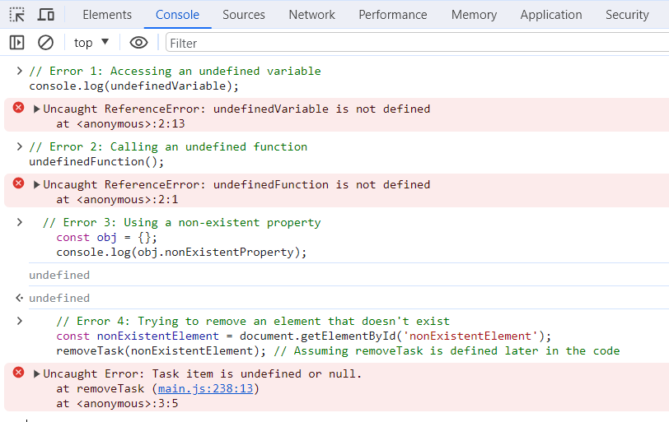
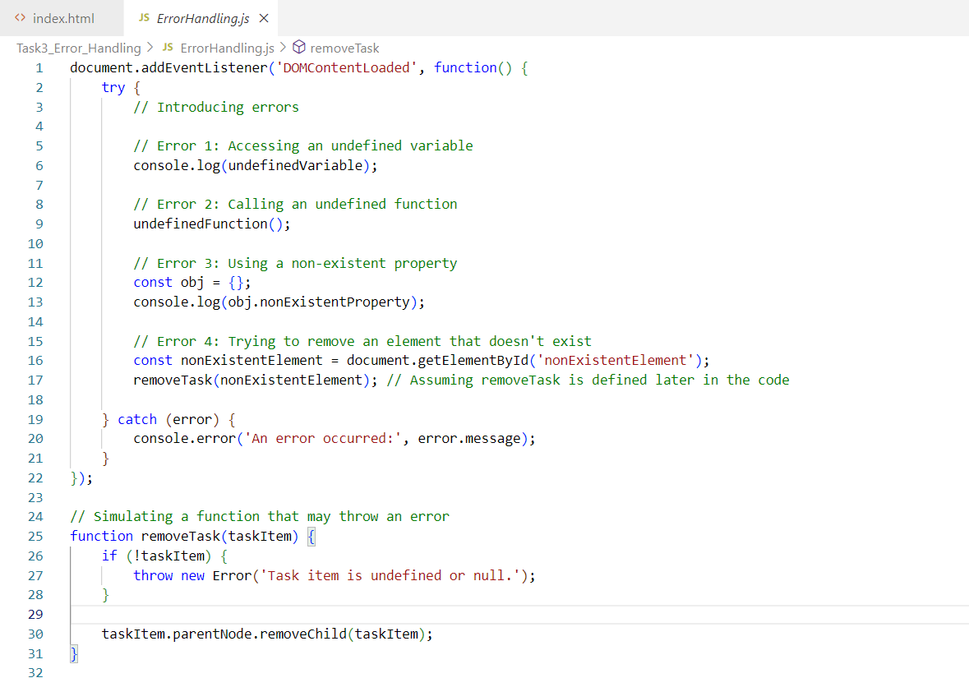
Task 4: User Interaction
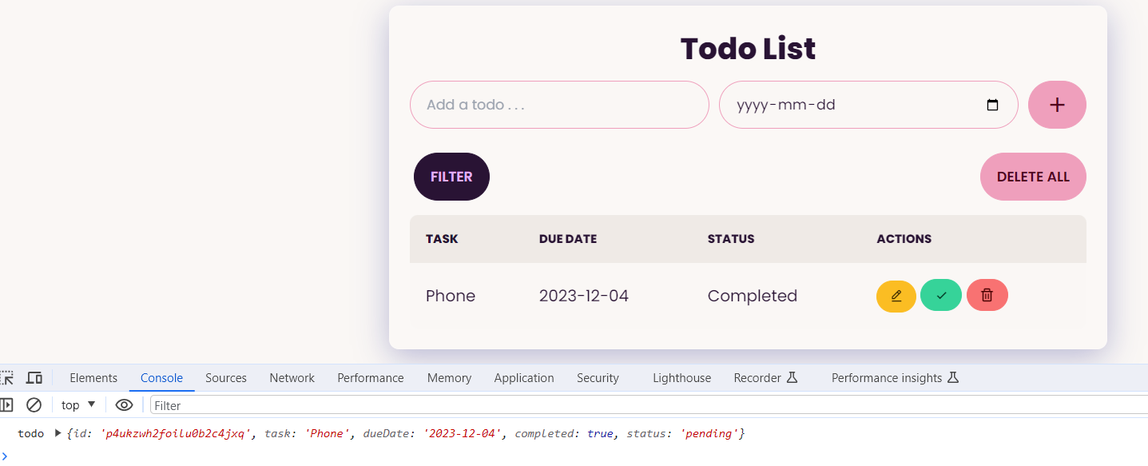

Task 5: Final Touches
