CSCI 4177/5709 | ASSIGNMENT 3
StudyFlow
Performance, Security, and Monitoring Report
FINAL SUBMISSION
Verified against the assignment instructions and rubric. Includes reproducible load tests, four measured optimizations, security remediation, and live monitoring evidence.
Prepared by
Arup Halder
Course and term
CSCI 4177/5709, Summer 2026
Repository
github.com/beaprogram/studyflow-assignment3
Report date: July 15, 2026
OUTCOME

1. Executive Summary
StudyFlow was profiled under light and moderate load, optimized on both the client and server, rescanned for security weaknesses, and instrumented for continuous operational visibility. All required implementation and evidence artifacts are in the linked repository.
Measured outcome
Overall average latency improved by 42.3% under light load and 47.0% under moderate load. p95 latency improved by 46.2% and 51.3%, respectively, while all 4,808 submitted JMeter samples completed with a 0.00% error rate.

Rubric coverage
Rubric area | Completed evidence | Status
Baseline testing | JMX plus light/moderate baseline CSVs and bottleneck analysis | Complete
Client optimization | Route code splitting and memoized course rendering | Complete
Server optimization | TTL response cache and compound MongoDB index | Complete
Performance comparison | Same plan rerun; avg, p95, RPS, errors, and percentages | Complete
Security | ZAP before/after reports and two remediations | Complete
Monitoring | Prometheus metrics and six-panel Grafana dashboard | Complete
Documentation | This report, repository instructions, and evidence inventory | Complete

Submission at a glance
- Repository: https://github.com/beaprogram/studyflow-assignment3
- Primary Brightspace file: StudyFlow_Assignment3_Report.pdf
- Editable backup: StudyFlow_Assignment3_Report.docx
JMETER

2. Baseline Test Method
The baseline and optimized measurements use the same parameterized JMeter sampler tree. A setup thread logs in once and extracts the bearer token. The load group then requests the authenticated course list, index page, JavaScript entry bundle, and CSS bundle with a 500 ms Constant Timer. This preserves an identical workload before and after.

Load scenarios
Scenario | Virtual users | Ramp-up | Loops/user | Samples/run
Light | 10 | 30 seconds | 10 | 401
Moderate | 50 | 60 seconds | 10 | 2,001

Metrics captured
- Average response time and p95 latency for each sampler and for the total run.
- Throughput in requests per second and request error rate.
- Raw timestamp, elapsed time, status, bytes, latency, connect time, URL, and thread counts in CSV.

Three baseline bottlenecks
Bottleneck | Baseline evidence | Why it mattered
POST Login | 324 ms light; 296 ms moderate | Slowest single request; includes authentication and database work.
GET Courses | 77.6/78.6 ms avg; 86/87 ms p95 | Repeated authenticated query dominated latency during the load group.
Main JS bundle | 578,126 bytes | Large initial payload contained charting code not needed on first render.

Interpretation note
Login runs once during setup, so it was identified as a bottleneck but was not the focus of the repeated read-path optimization. The course endpoint and first-load bundle offered the highest impact within the assignment scope.

REACT AND VITE

3. Client-Side Optimizations

3.1 Route-level code splitting
The Analytics page imports Recharts, the heaviest client dependency. It was changed from an eager import to React.lazy with a dynamic import and Suspense fallback. The browser now downloads chart code only when the user navigates to Analytics.
const Analytics = lazy(() => import('./pages/Analytics.jsx'))
Bundle metric | Baseline | Optimized | Improvement
Initial JavaScript entry | 578,126 bytes | 177,350 bytes | 69.3% smaller

The optimized build emits the Analytics/Recharts code as a separate deferred chunk. This reduces initial network transfer, parsing, and evaluation work for users who do not immediately open the analytics route.

3.2 Memoized course list and derived data
CourseRow now uses React.memo, summary calculations and the row collection use useMemo, and the loading callback uses useCallback. Stable course data no longer causes every row to render after unrelated parent-state changes.
const CourseRow = memo(function CourseRow({ course }) { ... })
Deterministic benchmark | Baseline | Optimized | Improvement
20 rows + 50 unrelated updates | 1,020 renders | 20 renders | 98.0% fewer

The benchmark is included at client/benchmarks/memoization-benchmark.mjs and runs with npm run benchmark:memo. It isolates render behavior, so the result is reproducible without relying on device-specific browser timing.
Client impact
The first optimization reduces bytes delivered on initial navigation; the second reduces repeated rendering after the page is loaded. Together they address network, JavaScript evaluation, and React reconciliation costs.

EXPRESS AND MONGODB

4. Server-Side Optimizations

4.1 Short-lived course-list cache
Read-heavy course-list payloads are cached in process memory for 30 seconds. Keys include the authenticated user, page, limit, and term. Course create, update, and delete operations immediately invalidate that user's list entries, limiting stale data risk.
const key = `courses:list:${userId}:${page}:${limit}:${term}`;
cache.set(key, payload, 30 * 1000);
GET Courses | Baseline avg | Optimized avg | Improvement | Errors
Light | 77.6 ms | 40.0 ms | 48.5% | 0.00%
Moderate | 78.6 ms | 38.3 ms | 51.3% | 0.00%

An X-Cache response header exposes HIT, MISS, or DISABLED, making the behavior easy to verify. CACHE_ENABLED=false preserves a controlled baseline path.

4.2 Compound query-and-sort index
The course-list query filters by owner and sorts by createdAt descending. The model now defines { owner: 1, createdAt: -1 }, allowing MongoDB to return records in index order instead of scanning and sorting the collection.
Explain metric | Collection scan | Compound index | Improvement
Plan | SORT <- COLLSCAN | LIMIT <- FETCH <- IXSCAN | No in-memory sort
Documents examined | 10,006 | 20 | 99.8% fewer
Execution time | 11 ms | 1 ms | 90.9% faster

Why both changes are needed
The index improves unavoidable database reads and cold-cache requests. The cache removes repeated database work during short bursts. Write-triggered invalidation keeps both performance and correctness in balance.

MEASURED RESULTS

5. Before-and-After Comparison
The optimized build was rerun with the same JMX plan, user counts, ramp times, loops, sampler tree, and think time. Percentage improvement for latency is calculated as (baseline - optimized) / baseline x 100.

Overall results
Scenario / metric | Baseline | Optimized | Change
Light average latency | 22.6 ms | 13.0 ms | 42.3% better
Light p95 latency | 80 ms | 43 ms | 46.2% better
Light throughput | 8.25 req/s | 8.32 req/s | +0.9%
Light error rate | 0.00% | 0.00% | No errors
Moderate average latency | 21.7 ms | 11.5 ms | 47.0% better
Moderate p95 latency | 78 ms | 38 ms | 51.3% better
Moderate throughput | 24.92 req/s | 25.03 req/s | +0.4%
Moderate error rate | 0.00% | 0.00% | No errors

Endpoint-level results
Scenario / endpoint | Avg before | Avg after | p95 before | p95 after | Avg gain
Light - GET Courses | 77.6 | 40.0 | 86 | 47 | 48.5%
Light - JS bundle | 4.2 | 3.3 | 6 | 5 | 21.9%
Moderate - GET Courses | 78.6 | 38.3 | 87 | 44 | 51.3%
Moderate - JS bundle | 3.6 | 2.7 | 5 | 4 | 25.9%

Units: All endpoint average and p95 values are milliseconds.
Result interpretation
Latency improved substantially while throughput rose slightly. Because each scenario uses fixed loops and a 500 ms timer, throughput is primarily workload-bound rather than an open-ended saturation measure. The unchanged 0.00% error rate confirms stability.

SECURITY

6. OWASP ZAP Security Validation
A headless ZAP baseline scan was captured before remediation and repeated against the optimized local production preview after the fixes. Both HTML and JSON reports are stored under zap/.

Baseline findings and fixes
Baseline alert | Risk / count | Remediation | Final result
CSP Header Not Set | Medium / 3 | Restrictive Content-Security-Policy across Vite, Netlify, and serve | Resolved
Missing Anti-clickjacking Header | Medium / 1 | frame-ancestors 'none' plus X-Frame-Options: DENY | Resolved

Remediation detail
default-src 'self'; script-src 'self'; style-src 'self'; img-src 'self' data:;
connect-src 'self'; object-src 'none'; base-uri 'self'; form-action 'self';
frame-ancestors 'none'
- Removed the only inline React style, so style-src does not require 'unsafe-inline'.
- Added X-Frame-Options: DENY and frame-ancestors 'none' for legacy and modern clickjacking protection.
- Added nosniff, no-referrer, Permissions-Policy, and cross-origin isolation headers as defense in depth.

Final scan
0 high-risk and 0 medium-risk findings
The July 15, 2026 after-scan crawled six URLs. Its only remaining alerts are informational: Modern Web Application and Storable but Non-Cacheable Content. The two required medium findings are absent from the final JSON and HTML reports.

Evidence files: zap/zap-report-before-web.html, zap/zap-report-before-web.json, zap/zap-report-after-web.html, zap/zap-report-after-web.json, and zap/remediation.md.
OBSERVABILITY

7. Prometheus and Grafana Monitoring
The API exposes Prometheus metrics at /metrics using prom-client. Docker Compose runs Prometheus and Grafana; provisioning files connect the data source and load the StudyFlow dashboard automatically. The dashboard was verified with live JMeter traffic.
Required signal | Implementation / panel
CPU | Node process user and system CPU rate
Memory | Resident memory and V8 heap used
Response time | p50, p95, and p99 from the HTTP duration histogram
Error rate | 4xx/5xx share derived from request counters
Additional | Throughput by route and requests in flight

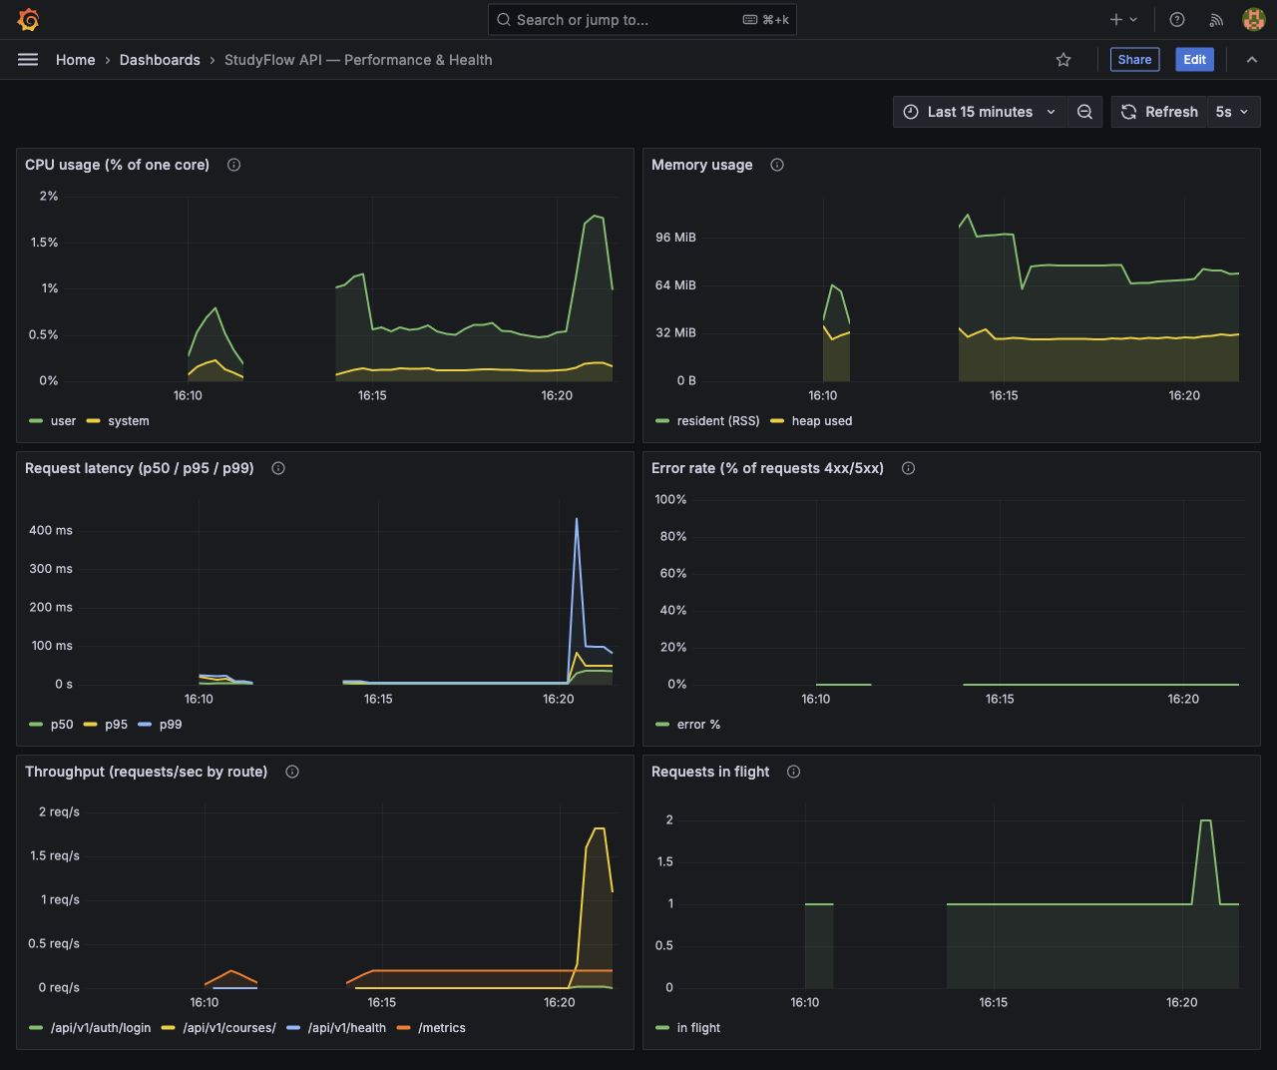
Figure 1. StudyFlow Grafana dashboard under live API load.
QUALITY ASSURANCE

8. Validation and Reproducibility

Final validation status
Check | Result | Evidence
API smoke tests | 6 of 6 passing | api/tests/smoke.test.js
Client production build | Passing | Vite optimized build
Production dependency audit | 0 vulnerabilities | npm audit --omit=dev
Memoization benchmark | 98.0% fewer row renders | client/benchmarks/
JMeter runs | 4,808 samples; 0.00% errors | Four CSV result files
MongoDB explain | IXSCAN; 20 docs vs 10,006 | api/seed/explain-courses.js
OWASP ZAP | 0 high; 0 medium | Final JSON/HTML reports
Monitoring | Prometheus up; six panels | Dashboard JSON and screenshot

Core reproduction commands
cd api && npm test
cd client && npm run build && npm run benchmark:memo
cd jmeter && python3 compare.py
cd monitoring && docker compose up -d

Repository deliverable inventory
- client/ - optimized React/Vite source, benchmark, and security-header configuration.
- api/ - optimized Express/MongoDB source, tests, index evidence, cache, and metrics.
- jmeter/ - local and deployment JMX plans plus baseline/optimized light/moderate CSVs.
- zap/ - before/after reports, scan configuration, and remediation evidence.
- monitoring/ - Compose, Prometheus, Grafana provisioning, dashboard, and screenshot.
- deliverables/ - this report in PDF and Word plus the Brightspace checklist.
SUBMISSION READINESS

9. Conclusion
StudyFlow now has a smaller initial client bundle, fewer unnecessary React renders, a faster indexed and cached read path, stronger browser security headers, and continuous operational monitoring. The same JMeter workload demonstrates meaningful latency gains without introducing errors.
Assignment status: complete
Every rubric area has implementation evidence, measured results, and a reproducible path in the repository. The final report is ready for Brightspace after the completed repository is pushed to the GitHub URL below.

Repository
GitHub repository - StudyFlow Assignment 3

Primary Brightspace deliverable
StudyFlow_Assignment3_Report.pdf
The Word file is retained as an editable backup. Source artifacts are submitted through the repository link in this report; secrets, node_modules, and generated build folders are excluded.

Evidence index
Question | Go to
How was load tested? | Section 2 and jmeter/
What changed on the client? | Section 3 and client/
What changed on the server? | Section 4 and api/
What improved? | Section 5 and PERFORMANCE_EVIDENCE.md
Were security findings fixed? | Section 6 and zap/
How is the system monitored? | Section 7 and monitoring/

