W9. China’s Urbanization in Comparative Perspective
SeoYoung Kim | Workshop in China and World Economy
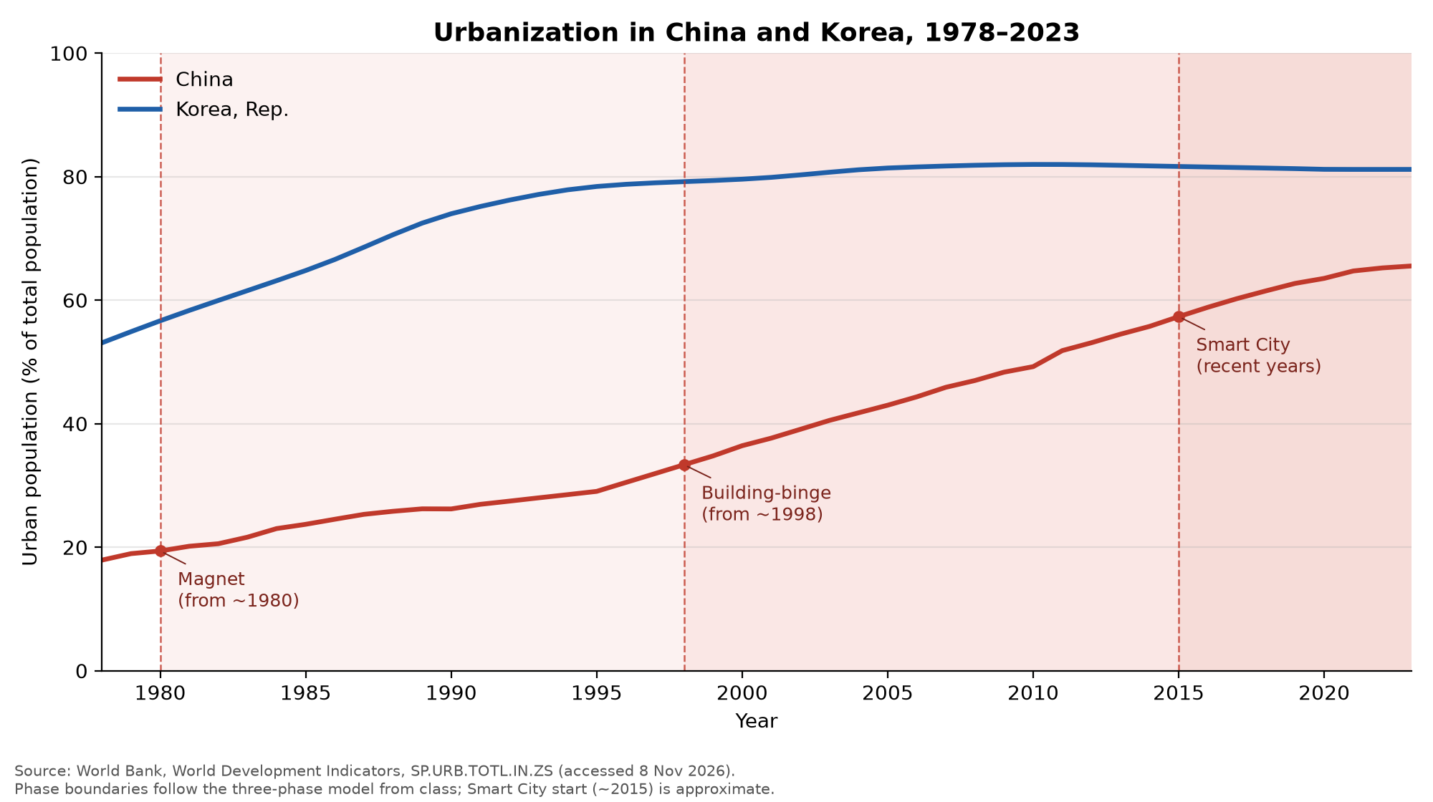
(a) Urbanization gains
China gained 47.6 points, from 17.9% in 1978 to 65.5% in 2023, or 10.6 points per decade. Korea gained 28.1 points, from 53.1% to 81.2%, or 6.2 points per decade (World Bank, 2026). Per-decade figures divide each gain by 4.5, the number of decades in 1978–2023.
(b) Explaining the difference
China gained more points over 1978–2023, mainly during the Building-binge phase. During the Magnet phase, its urban share rose by 7.9 points in 1978–1988 and 7.5 points in 1988–1998. Factory jobs drew rural workers to cities, but most left their families behind and lived in dormitories, and the hukou system reserved urban services for local residents (Kroeber 2020, 96, 101). China urbanized jobs faster than people (Kroeber 2020, 99). The pace nearly doubled after 1998, to 13.6 points in 1998–2008 and 14.5 points in 2008–2018. Kroeber links this to looser migration rules, the privatization of urban housing in the late 1990s, and state support for infrastructure, so construction itself became a source of growth (2020, 95–97). The pace then slowed to 4.0 points in 2018–2023, or 8.1 points per decade. Kroeber anticipated a construction plateau and a shift toward Smart City growth through specialization and innovation (2020, 97–98). Korea urbanized earlier, not more slowly. It was already 53.1% urban in 1978, gained 17.5 points in the next decade, and has stayed near 81–82% since 2003 (World Bank, 2026). The data show when the pace changed, not why. If other factors drove these shifts, policy could matter less than the timing suggests.
(c) Korea’s closest phase today
Korea most closely resembles the Smart City phase. With its urban share flat for two decades, it is past the building binge. Kroeber describes the next phase as one in which dense pools of skilled workers create specialization and productivity growth (2020, 96). Korea spent 4.94% of GDP on R&D in 2023, almost twice China's 2.58% (World Bank, 2026). R&D spending is a national figure, however. It does not show whether this activity is concentrated in specialized cities, which is what the phase requires.
References
Kroeber, Arthur R. 2020. China’s Economy: What Everyone Needs to Know. 2nd ed. Oxford University Press, ch. 6, pp. 95–101.
World Bank. 2026. World Development Indicators: SP.URB.TOTL.IN.ZS and GB.XPD.RSDV.GD.ZS, China and Korea, Rep. Accessed 8 November 2026. https://databank.worldbank.org/source/world-development-indicators

