Weekly Assignment: China’s Urbanization in Comparative Perspective
**** Seo Young Kim
1. Urban population (% of total population)
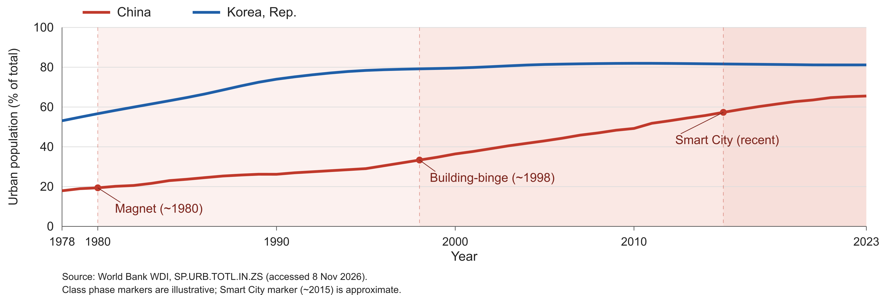
2. Answers
(a) How many percentage points did each country gain, and how many per decade?
China gained 47.6 points, from 17.9% in 1978 to 65.5% in 2023, or 10.6 points per decade. Korea gained 28.1 points, from 53.1% to 81.2%, or 6.2 points per decade (World Bank, 2026). Per-decade figures divide each gain by 4.5, the number of decades in 1978–2023.
(b) Why was China faster or slower?
China gained more points over 1978–2023, but I read the difference partly as one of timing. Korea was already 53.1% urban in 1978 and gained 17.5 points in the next decade (World Bank, 2026). The same starting year compares different stages of urbanization. During China's Magnet phase, factory jobs drew rural workers to cities, but most left their families behind and lived in dormitories, and the hukou system reserved urban services for local residents (Kroeber 2020, 96, 101). China urbanized jobs faster than people (Kroeber 2020, 99). The pace accelerated after 1998, to 13.6 points in 1998–2008 and 14.5 points in 2008–2018. Kroeber links this to looser migration rules, the privatization of urban housing in the late 1990s, and state support for infrastructure, so construction itself became a source of growth (2020, 95–97). The pace then slowed to 4.0 points in 2018–2023, or 8.1 points per decade. Kroeber anticipated a construction plateau and a shift toward Smart City growth through specialization and innovation (2020, 97–98). The data show when the pace changed, not why.
(c) Which phase does your comparison country most closely resemble today?
Korea most closely resembles the Smart City phase. With its urban share flat for two decades, it is past the building binge. Kroeber describes the next phase as one in which dense pools of skilled workers create specialization and productivity growth (2020, 96). Korea spent 4.94% of GDP on R&D in 2023, almost twice China's 2.58% (World Bank, 2026). I would judge the transition by productivity gains and access to better jobs. R&D spending is a national figure, however. It does not show whether this activity is concentrated in specialized cities, which is what the phase requires.
Source: World Bank (2026), World Development Indicators: SP.URB.TOTL.IN.ZS and GB.XPD.RSDV.GD.ZS (accessed 8 November 2026). https://databank.worldbank.org/source/world-development-indicators. Kroeber (2020), China’s Economy: What Everyone Needs to Know, 2nd ed., ch. 6, pp. 95–101.

