Trent Giever

Chapter 1

4/3/18

First Program Ch 1-1

Code: // This program calculates the user's pay.

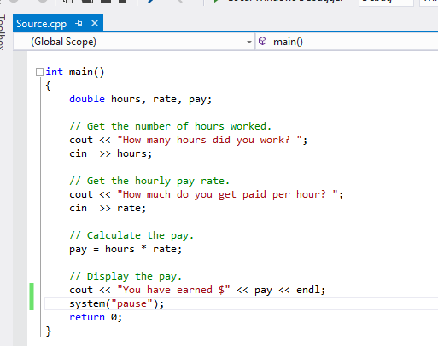

Output:

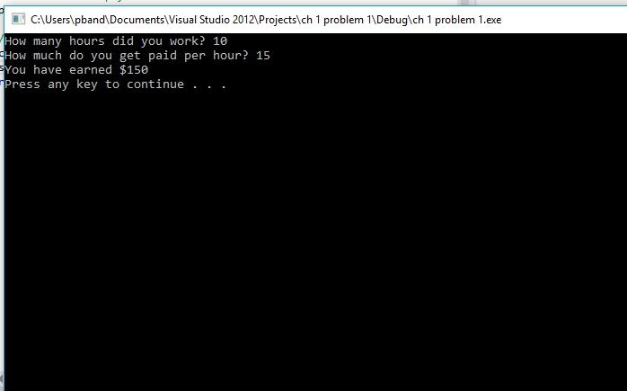

Second Program Ch1-2

Code:

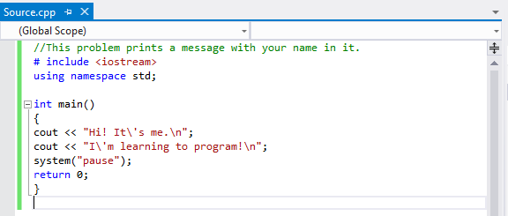Output:

