Trent Giever

Chapter 3

4/24/18

Programming Challenge # 3 Housing Costs

Code:

// Ch 3 problem 3 Housing Problem

// Program to determine yearly and monthly costs for bills

#include <iostream>

#include <iomanip>

using namespace std;

int main()

{

double monthRent, monthUtilities,monthPhone,monthCable, monthTotal;

double yearRent,yearUtilities,yearPhone,yearCable, yearTotal;

// input of values

cout << "Please enter your monthly rent: ";

cin >> monthRent;

cout << "Please enter your monthly Utilities: ";

cin >> monthUtilities;

cout << "Please enter your monthly Phone Bill: ";

cin >> monthPhone;

cout << "Please enter your monthly Cable Bill: ";

cin >> monthCable;

//calculation

monthTotal = monthRent + monthUtilities + monthPhone + monthCable;

yearRent=monthRent\*12;

yearUtilities=monthUtilities\*12;

yearPhone=monthPhone\*12;

yearCable=monthCable\*12;

yearTotal=monthTotal\*12;

//output

cout<< fixed << showpoint<< setprecision(2);

cout << "Total monthly and yearly bills"<<endl;

cout << endl;

cout << left << setw(12) << "Rent" << right << setw(10) << monthRent << setw(10)<< yearRent << endl;

cout << left << setw(12) << "Utilities" << right << setw(10) << monthUtilities << setw(10)<< yearUtilities << endl;

cout << left << setw(12) << "Phone Bill" << right << setw(10) << monthPhone << setw(10)<< yearPhone << endl;

cout << left << setw(12) << "Cable Bill" << right << setw(10) << monthCable << setw(10)<< yearCable << endl;

cout << left << setw(12) << "Total" << right << setw(10) << monthTotal << setw(10)<< yearTotal << endl;

system("pause");

return 0;

}

Output:

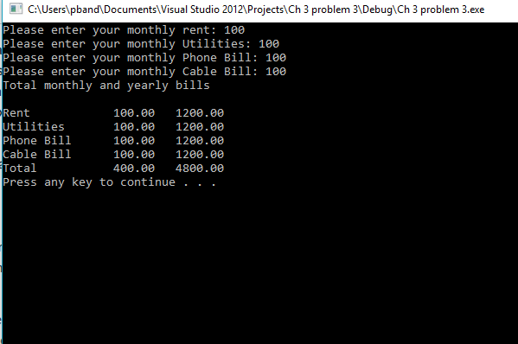

Programming Challenge # 16

Code:

//Ch 3 program 16 Math Tutor

// Program to be able to have random addition problems

#include <iostream>

#include <cstdlib>

#include <ctime>

using namespace std;

int main ()

{

int num1,num2,total, input;

// seed value

unsigned seed;

seed =time(0);

srand(seed);

// number generator

num1= rand() % 9 + 1;

num2= rand() % 9 + 1;

total = num1 + num2;

// output testing math skills

cout << "Math Addition program"<< endl;

cout << "Please enter the solution: " << num1 << " + " << num2<< << " =? " << endl;

cin >> input; // used to allow input

cout << "Your answer is; " << input << " The correct answer is: " << total<< endl;

system("pause");

return 0;

}Output:

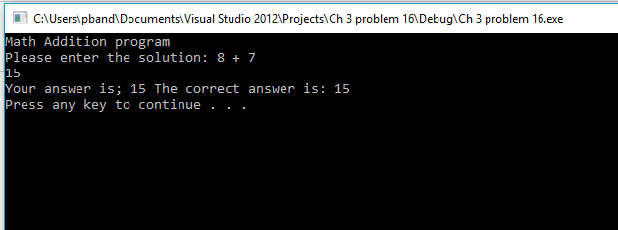

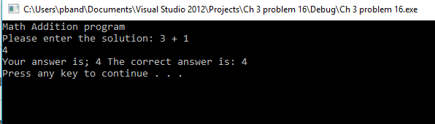

Program Challenge # 13

Code: //Ch 3 problem 13 Monthly Sales Tax

// Calculates the amount of taxes

#include <iostream>

#include <string>

#include <iomanip>

using namespace std;

int main()

{

string month;

int year;

double total, afterState,afterCounty,afterTax,taxTotal;

const double STATETAX = .04;

const double COUNTYTAX = .02;

const double HUNDREDPERCENT = 1.00;

//INPUT

cout << "Enter the month: " ;

getline(cin,month);

cout << "Enter the year: ";

cin >> year;

cout << "Enter the total amount collected: ";

cin >> total;

// calculation;

afterState = total \* STATETAX ;

afterCounty = total \* COUNTYTAX;

afterTax = total / (HUNDREDPERCENT + STATETAX + COUNTYTAX);

taxTotal=total-afterTax;

// total

cout << fixed << showpoint << setprecision(2);

cout << "Month: "<< month << " " << year << endl;

cout << "--------------------" << endl;

cout << left << setw(20) << "Total Colected:" << setw(3) << "$" << right << setw(10) << total << endl;

cout << left << setw(20) << "Sales:" << setw(3) << "$" << right << setw(10) << afterTax << endl;

cout << left << setw(20) << "County Sales Tax:" << setw(3) << "$" << right << setw(10) << afterCounty << endl;

cout << left << setw(20) << "State Sales Tax:" << setw(3) << "$" << right << setw(10) << afterState << endl;

cout << left << setw(20) << "Total Sales Tax:" << setw(3) << "$" << right << setw(10) << taxTotal << endl;

system("pause");

return 0;

}

Output:

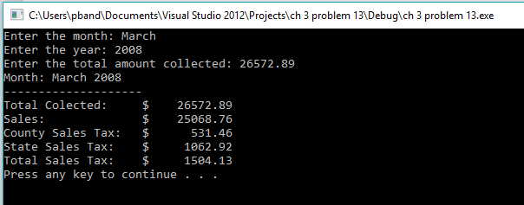

Program Challenge #22

Code:

//Ch 3 problem 22 Stock Transaction Program

//Determines the outcome from the initial to end selling of stocks profit or loss

#include <iostream>

#include <iomanip>

using namespace std;

int main()

{

double startValue,endValue,numOfShares,stockFee,startStockFee,endStockFee,totalStockFee, startTotal,endTotal, difference;

//input

cout << "How much did you pay for the intial purchase of a stock: ";

cin >> startValue;

cout << "How many stocks purchesed: ";

cin >> numOfShares;

cout << "What is the stock brokers percent fee: ";

cin >> stockFee;

stockFee/=100;

cout << "How much did the stocks sell for each: ";

cin >> endValue;

//calculations

startTotal =startValue \* numOfShares;

endTotal=endValue\*numOfShares;

startStockFee=stockFee\*startTotal;

endStockFee=stockFee\*endTotal;

totalStockFee=startStockFee+endStockFee;

difference=endTotal-(startTotal+startStockFee+endStockFee);

//output

cout << fixed << showpoint << setprecision(2);

cout << left << setw(38) << "Amount paid for buying the stock:" << right << setw(3) << "$" << setw(10) << startTotal << endl;

cout << left << setw(38) << "Broker fee for buying the stock:" << right << setw(3) << "$" <<setw(10) << startStockFee<< endl;

cout << left << setw(38) << "Amount earned for selling the stock:" << right<< setw(3) << "$" << setw(10) << endTotal << endl;

cout << left << setw(38) << "Broker fee for selling the stock:" << right << setw(3) << "$" << setw(10) << endStockFee << endl;

cout << left << setw(38) << "Total earned or lost at the end: " << right << setw(3) << "$" <<setw(10) << difference << endl;

system("pause");

return 0;

}

Output:

