Trent Giever

Chapter 4

5/2/18

Programming Challenge # 14

Code:

// Ch 4 program 14 Body Mass index

// Determines a persons BMI number

#include <iostream>

#include <iomanip>

using namespace std;

int main()

{

double bmi, weight,height;

bmi=0;

const int MINVALUE=0,//0 lb or height

MAXVALUEHEIGHT= 120;//10 feet

cout<<"BMI program" <<endl;

cout<<"Please enter your weight";

cin >> weight;

cout << "please enter your height in inches";

cin >> height;

//BMI Calc

if(weight > MINVALUE)

{

if(height > MINVALUE && height< MAXVALUEHEIGHT)

{

bmi= weight * 703 / (height*height);

}

else

cout<< "please enter a height that is possible that is less than 10 feet tall";

}

else

cout << "please enter a valid weight";

//output

if(bmi < 18.5)

cout << "The BMI value is " << bmi << ". The weight is unhealthy underweight, and need to gain some weight" << endl;

else if(bmi < 25)

cout << "The BMI value is " << bmi << ". The weight is ideal" << endl;

else

cout << "The BMI value is " << bmi << ". The weight is unhealthy overweight, and need to lose some weight" << endl;

system("pause");

return 0;

}

Output:

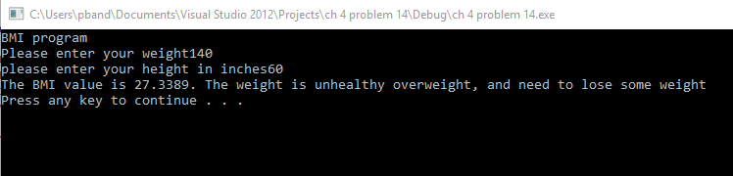

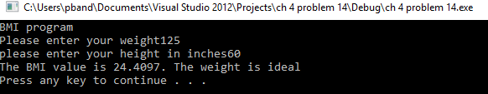

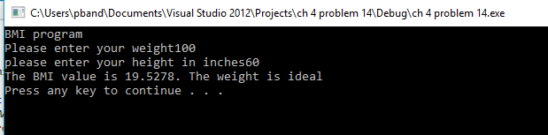

Programming Challenge # 16

Code:

//Ch 4 problem 16 The speed of sound

//Determines the speed it takes sound in either air, water, or steel to travel

# include <iostream>

# include <iomanip>

using namespace std;

int main ()

{

const int AIRSPEED=1100,

WATERSPEED =4900,

STEELSPEED=16400;

double time, distance;

int input;

// input

cout << "The Speed of Sound Calculator" << endl;

cout<< "Please enter 1 for Air, 2 for Water, or 3 for Steel: ";

cin >> input;

cout << "Please enter the distance in feet the sound wave is needing to go: ";

cin >> distance;

cout<< fixed << showpoint<< setprecision(4);

// calculation

switch (input)

{

case 1: time = distance/AIRSPEED;

cout << "The distance for " <<distance << " going through air takes " << time << " Seconds." << endl;

break;

case 2: time = distance/WATERSPEED;

cout << "The distance for " <<distance << " going through water takes " << time << " Seconds." << endl;

break;

case 3: time = distance/STEELSPEED;

cout << "The distance for " <<distance << " going through steel takes " << time << " Seconds." << endl;

break;

default : cout << "Please enter a number between 1 and 3";

}

system("pause");

return 0;

}

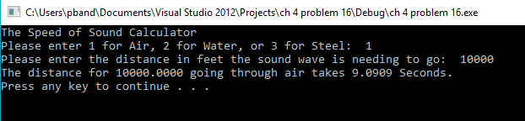Output:

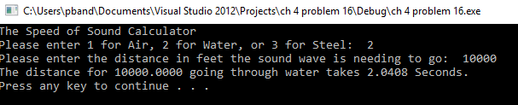

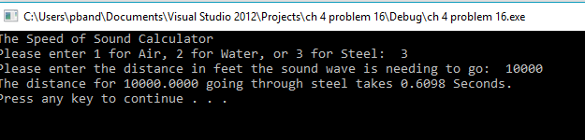 

Program Challenge #21

Code:

//Ch 4 problem 21 Internet Service Provider

// Calculates the bill

#include <iostream>

#include <iomanip>

#include <string>

using namespace std;

enum Plan{A=1, B=2, C=3};

int main ()

{

const double AMonth =9.95, AOver=.08, AMin= (5*60),

BMonth=14.95,BOver=.06, BMin = (10*60),

CMonth=19.95;

double total, hours, minutes;

string userName; //input name

int num;// for switch case user input

cout << "Phone Bill calculation System" << endl;

cout << " Please enter your name: ";

getline(cin,userName);

cout << "Please enter the phone plan the number 1 = A, 2 = B, or 3 = C? ";

cin >> num;

switch (num)

{

case A: cout << "Please enter the number of minutes used ";

cin >> minutes;

if(minutes >AMin)

total = AMonth + ((minutes-AMonth)*AOver);

else

total = AMonth;

cout<< fixed << showpoint<< setprecision(2);

cout << "The total bill for " << userName << " is S " << total << " Due for this month" << endl;

break;

case B: cout << "Please enter the number of minutes used ";

cin >> minutes;

if(minutes >BMin)

total = BMonth + ((minutes-BMonth)*BOver);

else

total = BMonth;

cout<< fixed << showpoint<< setprecision(2);

cout << "The total bill for " << userName << " is S " << total << " Due for this month" << endl;

break;

case C: total = CMonth;

cout<< fixed << showpoint<< setprecision(2);

cout << "The total bill for " << userName << " is S " << total << " Due for this month" << endl;

break;

default:

cout << "Please enter a vaild number, and not the letters";

}

system("pause");

return 0;

}

Output:

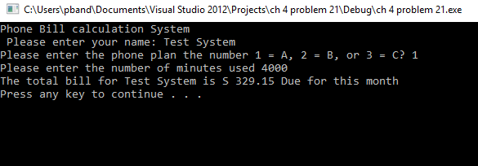

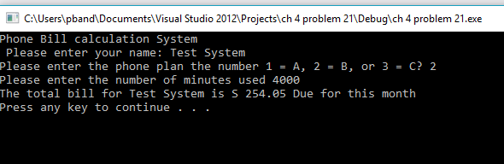

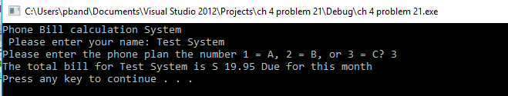

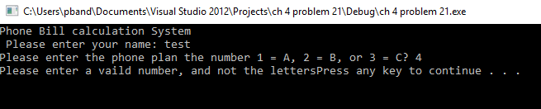

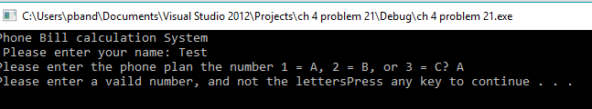

Program Challenge #22

//Ch 4 problem 22 Internet Service Provider part 2

// Calculates the bill

#include <iostream>

#include <iomanip>

#include <string>

using namespace std;

int main ()

{

const double AMonth =9.95, AOver=.08, AMin= (5*60),

BMonth=14.95,BOver=.06, BMin = (10*60),

CMonth=19.95;

double total, hours, minutes;

string userName; //input name

int num;// for switch case user input

cout << "Phone Bill calculation System" << endl;

cout << " Please enter your name: ";

getline(cin,userName);

cout << "Please enter the phone plan the number 1 = A, 2 = B, or 3 = C? ";

cin >> num;

switch (num)

{

case 1: cout << "Please enter the number of minutes used ";

cin >> minutes;

if(minutes >AMin)

total = AMonth + ((minutes-AMonth)*AOver);

else

total = AMonth;

cout<< fixed << showpoint<< setprecision(2);

cout << "The total bill for " << userName << " is S " << total << " Due for this month" << endl;

break;

case 2: cout << "Please enter the number of minutes used ";

cin >> minutes;

if(minutes >BMin)

total = BMonth + ((minutes-BMonth)*BOver);

else

total = BMonth;

cout<< fixed << showpoint<< setprecision(2);

cout << "The total bill for " << userName << " is S " << total << " Due for this month" << endl;

break;

case 3: total = CMonth;

cout<< fixed << showpoint<< setprecision(2);

cout << "The total bill for " << userName << " is S " << total << " Due for this month" << endl;

break;

default:

cout << "Please enter a vaild number, and not the letters";

}

if ( num == 1 || num == 2)

{

if(num == 1)

{

double tempTotal1 = BMonth + ((minutes-BMonth)*BOver);

double tempTotal2 = CMonth;

if(total > tempTotal1)

{

double temp3 = total -tempTotal1;

cout << "Can Save $" << temp3 << " By Switching to plan B with a total of per month $" << tempTotal1 << endl;

}

if(total > tempTotal2)

{

double temp4 = total -tempTotal2;

cout << "Can Save $" << temp4 << " By Switching to plan C with a total of per month $" << tempTotal2 << endl;

}

}

else if (num == 2)

{

double tempTotal = CMonth;

if(total > tempTotal)

{

double temp = total -tempTotal;

cout << "Can Save " << temp << " By Switching to plan C with a total of per month " << tempTotal << endl;

}

}

}

system("pause");

return 0;

} Code:

Output:

