Trent Giever

Chapter 5

5/17/18

Programming Challenge # 8

Code:

// Ch 5 problem 8 Calories Burned

// This program displays the number of calories burned by using a simple for loop

#include <iostream>

using namespace std;

int main()

{

const double calPerMin = 3.9;

for (int x =10; x < 35; x+=5)

{

int temp = x * calPerMin;

cout << "Calories burned at " << x << " minutes is: " << temp << endl;

}

system("pause");

return 0;

}

Output:

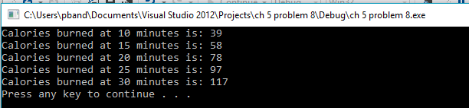

Programming Challenge # 12

Code:

//Ch 5 problem 12 The greatest and least of these

// Detemines the biggist and smallest value

#include <iostream>

using namespace std;

int main()

{

int Min; //smallest

int Maxs=0; //largest

int inputs; //user input

int count=0;

cout << "This program will find the biggest and smallest numbers in a array. To Stop enter -99"<<endl<<endl;

do

{

cout << "Please enter a number: ";

cin >> inputs;

if (count ==0)

{

Min = inputs;

Maxs = inputs;

}

if (inputs < Min && inputs !=-99)

Min = inputs;

else if (inputs > Maxs && inputs !=-99)

Maxs = inputs;

Count++:

}

while (inputs !=-99);

cout << "The smallest value is: " << Min << endl;

cout << "The largest value is: " << Maxs << endl;

system("pause");

return 0;

}

Output:

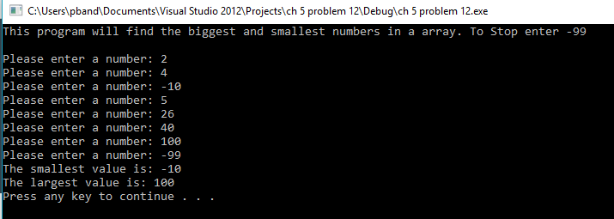

Program Challenge #14

Code:

// Ch 5 problem 14 Rate of Inflation

// Program that determines inflation data for people interested in the rate of change of buying power

# include <iostream>

# include <iomanip>

using namespace std;

int main()

{

double rate;

int userInput;

double value;

cout << "Program determines the amount of interest rate " << endl << endl;

cout << "Please enter the amount wanting to determine: $" ;

cin >> value;

cout << "At what rate do you want to calculate at between 1-15%: ";

cin >> rate;

if( rate > 0 && rate < 16)

{

cout<< fixed << showpoint<< setprecision(2);

for(int x = 1; x < 11; x++)

{

value = (1 / (1 + (rate/100))) * value ;

cout << "In " << x << " years the value is: $" << value << endl;

}

}

else

cout << "Please enter a valid percent number between 1 - 15";

system("pause");

return 0;

}

Output:

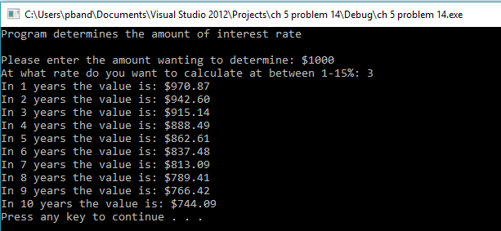

Program Challenge #16

Code:

// Ch 5 problem 16 Math Tutor V. 3

//Program repeats to allow multiple practices with addition, subtraction, or mutiplication

#include <iostream>

#include <cstdlib>

#include <ctime>

using namespace std;

int main()

{

int num1, num2, total,input, test;

unsigned seed;

cout << "Program to help with addition, subtraction, or multiplication"<<endl<<endl;

do

{

seed=time(0);

srand(seed);

num1= rand() % 51 + 10;

num2 = rand() % 51 + 10;

cout << "Please enter 1 for addition, 2 for subtraction, 3 for mutiplication, or 4 for exiting: " ;

cin >> input;

switch (input)

{

case 1: total = num1 + num2;

cout << "What is the solution to " << num1 << " + " << num2 << " =? ";

cin >> test;

if(test == total)

cout << "Correct";

else

cout << "Inccorect";

break;

case 2: total = num1 - num2;

cout << "What is the solution to " << num1 << " - " << num2 << " =? ";

cin >> test;

if(test == total)

cout << "Correct";

else

cout << "Inccorect";

break;

case 3: total = num1 * num2;

cout << "What is the solution to " << num1 << " * " << num2 << " =? ";

cin >> test;

if(test == total)

cout << "Correct";

else

cout << "Inccorect";

break;

case 4:

break;

default:

cout << "Invalid Number please enter again";

break;

}

cout << endl << endl;

}

while(input != 4);

system("pause");

return 0;

}

Output:

