Trent Giever

Chapter 6

5/21/18

Programming Challenge # 10

Code:

// ch 6 problem 10 Present Value

// Calculates the amount of money needing to have

// P = present value

// F = future value

// R = Percentage rate

// N = years

#include <iostream>

#include <iomanip>

using namespace std;

double calc(double, double, double);

double askPercent();

double askGoal();

double askYears();

int main()

{

bool stop = false, input;

double P,F,R,N;

cout << "This program calculates the amount needed to invest for the disired outcome"<<endl<<endl;

do

{

F = askGoal();

R = askPercent();

N = askYears();

P= calc(F,R,N);

cout << "With a goal of " << F << " And a pecentage of " << R << " With " << N << " years. The needed amount to invest is " << P << endl;

cout << "To sotp enter true, or false to continue";

cin >> input;

if(input == stop)

stop = true;

}

while (!stop);

system("pause");

return 0;

}

double calc( double f, double r, double n)

{

double p = f / (pow((1+r),n));

return p;

}

double askGoal()

{

double goal;

bool found = false;

do

{

cout << "How much money is desired in the account?: ";

cin >> goal;

if (goal >= 0)

{

found = true;

}

else

cout << "Please try again with an actual number";

}

while(!found);

return goal;

}

double askPercent()

{

double goal;

bool found = false;

do

{

cout << "How much percent back does the account have in decimal format: ";

cin >> goal;

if (goal >= 0 && goal <= 1)

{

found = true;

}

else

cout << "Please try again with an actual number";

}

while(!found);

return goal;

}

double askYears()

{

double goal;

bool found = false;

do

{

cout << "How many years desired in for the account?: ";

cin >> goal;

if (goal >= 0)

{

found = true;

}

else

cout << "Please try again with an actual number";

}

while(!found);

return goal;

}

Output:

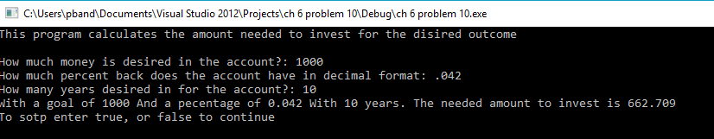

Programming Challenge # 11

Code:

//ch 6 problem 11 Stock Profit

// Calculates the value of stock

//NS number of shares

//SP sale price per share

//SC sales commision

//PP Perchase price per share

// PC purchase price commision paid

#include <iostream>

#include <iomanip>

using namespace std;

double calc(double, double, double, double, double);

double askNumberOfSharess(); //NS

double askSalePrice(); //SP

double askSaleCommission();//SC

double askPurchasePrice();//PP

double askPurchaseCommission();//PC

int main()

{

double NS, SP, SC, PP, PC, total;

cout << "Program determines price profit or loss"<<endl<< endl;

PP = askPurchasePrice();

NS = askNumberOfSharess();

PC= askPurchaseCommission();

SP= askSalePrice();

SC = askSaleCommission();

total = calc(NS,SP,SC,PP,PC);

cout << fixed << showpoint << setprecision(2);

cout << "The difference is: $" << total << endl;

system("pause");

return 0;

}

double calc (double NS, double SP, double SC, double PP, double PC)

{

double total = ((NS \*SP)-SC)-((NS\*PP)+PC);

return total;

}

double askNumberOfSharess()

{

double goal;

bool found = false;

do

{

cout << "How many shares for the stock?: ";

cin >> goal;

if (goal >= 0)

{

found = true;

}

else

cout << "Please try again with an actual number";

}

while(!found);

return goal;

}

double askSalePrice()

{

double goal;

bool found = false;

do

{

cout << "How much for the stock?: ";

cin >> goal;

if (goal >= 0)

{

found = true;

}

else

cout << "Please try again with an actual number";

}

while(!found);

return goal;

}

double askSaleCommission()

{

double goal;

bool found = false;

do

{

cout << "How much did the broker get at selling in a percentage ?: ";

cin >> goal;

if (goal >= 0 && goal <=1)

{

found = true;

}

else

cout << "Please try again with an actual number";

}

while(!found);

return goal;

}

double askPurchasePrice()

{

double goal;

bool found = false;

do

{

cout << "What was the original value of the stock?: ";

cin >> goal;

if (goal >= 0)

{

found = true;

}

else

cout << "Please try again with an actual number";

}

while(!found);

return goal;

}

double askPurchaseCommission()

{

double goal;

bool found = false;

do

{

cout << "How much did the broker gett at buying the stock in a percentage?: ";

cin >> goal;

if (goal >= 0 && goal <=1)

{

found = true;

}

else

cout << "Please try again with an actual number";

}

while(!found);

return goal;

}

Output:

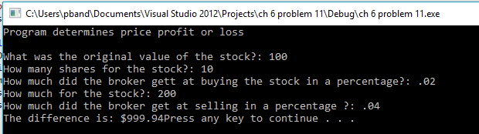

Program Challenge #12

Code:

//ch 6 problem 12 Multiple Stock Profit

// Calculates the value of stocks

//NS number of shares

//SP sale price per share

//SC sales commision

//PP Perchase price per share

// PC purchase price commision paid

#include <iostream>

#include <iomanip>

using namespace std;

double calc(double, double, double, double, double);

double askNumberOfSharess(); //NS

double askSalePrice(); //SP

double askSaleCommission();//SC

double askPurchasePrice();//PP

double askPurchaseCommission();//PC

int main()

{

double NS, SP, SC, PP, PC, total=0;

int counter;

cout << "Program determines price profit or loss"<<endl<< endl;

cout << "How many Stocks want to enter";

cin >> counter;

cout << fixed << showpoint << setprecision(2);

for(int x = 0; x < counter; x++)

{

PP = askPurchasePrice();

NS = askNumberOfSharess();

PC= askPurchaseCommission();

SP= askSalePrice();

SC = askSaleCommission();

double temp = calc(NS,SP,SC,PP,PC);

total +=temp;

cout << "The difference is for this stock is : $" << temp << endl << endl << endl;

}

cout << "The difference for all stocks is: $" << total << endl << endl;

system("pause");

return 0;

}

double calc (double NS, double SP, double SC, double PP, double PC)

{

double total = ((NS \*SP)-SC)-((NS\*PP)+PC);

return total;

}

double askNumberOfSharess()

{

double goal;

bool found = false;

do

{

cout << "How many shares for the stock?: ";

cin >> goal;

if (goal >= 0)

{

found = true;

}

else

cout << "Please try again with an actual number";

}

while(!found);

return goal;

}

double askSalePrice()

{

double goal;

bool found = false;

do

{

cout << "How much for the stock?: ";

cin >> goal;

if (goal >= 0)

{

found = true;

}

else

cout << "Please try again with an actual number";

}

while(!found);

return goal;

}

double askSaleCommission()

{

double goal;

bool found = false;

do

{

cout << "How much did the broker get at selling in a percentage ?: ";

cin >> goal;

if (goal >= 0 && goal <=1)

{

found = true;

}

else

cout << "Please try again with an actual number";

}

while(!found);

return goal;

}

double askPurchasePrice()

{

double goal;

bool found = false;

do

{

cout << "What was the original value of the stock?: ";

cin >> goal;

if (goal >= 0)

{

found = true;

}

else

cout << "Please try again with an actual number";

}

while(!found);

return goal;

}

double askPurchaseCommission()

{

double goal;

bool found = false;

do

{

cout << "How much did the broker gett at buying the stock in a percentage?: ";

cin >> goal;

if (goal >= 0 && goal <=1)

{

found = true;

}

else

cout << "Please try again with an actual number";

}

while(!found);

return goal;

}

Output:

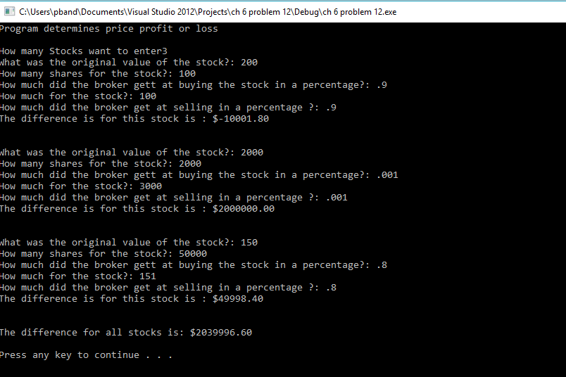

Program Challenge #15

Code:

//Ch 6 problem 15 Population

//Determines the popultion forcasts

// SP= start pop size

// BR = birth rate

// DR = death rate

// YR = years

// PR = previous rate

#include <iostream>

#include <iomanip>

using namespace std;

double calc(double, double, double);

double askPopulation();

double askBirthRate(double SP);

double askDeathRate(double SP);

double askNumYears();

int main()

{

double SP, BR, DR, PR;

int YR;

cout << "Program that calculates the popution forcasts"<<endl<<endl;

cout << "How many years are needed to calculate: ";

cin >> YR;

SP = askPopulation();

BR = askBirthRate(SP);

DR = askDeathRate(SP);

cout << fixed << showpoint << setprecision(0);

for(int x =0; x < YR; x++)

{ double temp = calc(SP,BR,DR);

cout << "At year " << (x+1) << " the population will be " <<temp << endl;

SP=temp;

}

system("pause");

return 0;

}

double calc(double SP, double BR, double DR)

{

double temp = SP \* (1+BR) \* (1-DR);

return temp;

}

double askPopulation()

{

double goal;

bool found = false;

do

{

cout << "What is the starting population size ?: ";

cin >> goal;

if (goal >= 2 )

{

found = true;

}

else

cout << "Please try again with an actual number";

}

while(!found);

return goal;

}

double askBirthRate(double SP)

{

double goal;

bool found = false;

do

{

cout << "What is the starting birth rate percentage or number ?: ";

cin >> goal;

if (goal >= 0 && goal < 1)

{

found = true;

}

else if (goal >= 1)

{

goal = goal/SP;

found = true;

}

else

cout << "Please try again with an actual number";

}

while(!found);

return goal;

}

double askDeathRate(double SP)

{

double goal;

bool found = false;

do

{

cout << "What is the starting death rate percentage or number ?: ";

cin >> goal;

if (goal >= 0 && goal < 1)

{

found = true;

}

else if (goal >= 1)

{

goal = goal/SP;

found = true;

}

else

cout << "Please try again with an actual number";

}

while(!found);

return goal;

}

double askNumYears()

{

double goal;

bool found = false;

do

{

cout << "What is the number of Years wanting to find ?: ";

cin >> goal;

if (goal > 0 )

{

found = true;

}

else

cout << "Please try again with an actual number";

}

while(!found);

return goal;

}

Output:

