Trent Giever

Chapter 7

5/27/18

Programming Challenge # 4

Code:

//Ch 7 problem 4 Car class

// Tests how a class works

#include <iostream>

//#include "Car.h";

using namespace std;

class Car

{

private:

int year;

string make;

int speed;

public:

Car(int Year, string Make)

{

year=Year;

make =Make;

speed =0;

cout << "Program that displays the current speed of a car"<<endl;

}

int getYear()

{

return year;

}

string getMake()

{

return make;

}

int getSpeed()

{

return speed;

}

void accelerate()

{

speed +=5;

}

void brake()

{

speed -=5;

}

};

int main()

{

Car sportscar (2018,"Expensive");

for(int x = 0; x < 5; x++)

{

sportscar. accelerate();

cout << "Current Speed " << sportscar.getSpeed() << endl;

}

for(int i = 0; i < 5; i++)

{

sportscar.brake();

cout << "Current Speed " << sportscar.getSpeed() << endl;

}

system("pause");

return 0;

}

Output:

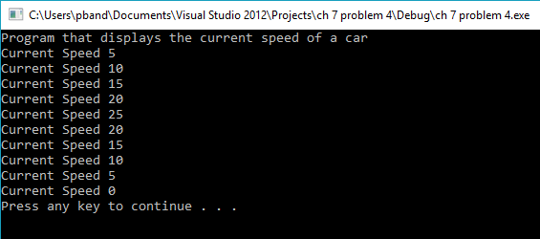

Programming Challenge # 7

Code:

//Ch 7 rroblem 7 Inventory Class

//Free resonsce output program to show how to use a class

#include <iostream>

#include <cstdlib>

#include <ctime>

using namespace std;

class Inventory

{

private:

int itemNumber;

int quantity;

double cost;

public:

Inventory()

{

itemNumber =0;

quantity =0;

cost= 0;;

}

Inventory(int item, int stock, double ask)

{

itemNumber= item;

quantity= stock;

cost = ask;

}

void setItemNumber(int x)

{

if(x > 0)

itemNumber =x;

}

void setQuantity(int i)

{

if(i > -1)

quantity =i;

}

void setCost(double c)

{

if(c >= 0)

cost =c;

}

int getItemNumber()

{

return itemNumber;

}

int getQuantity()

{

return quantity;

}

double getCost()

{

return cost;

}

double getTotalCost()

{

return quantity * cost;

}

};

int main()

{

Inventory one;

Inventory two(10,10,5.00);

unsigned seed;

cout << "Program will display an item from random numbers" << endl<<endl;

seed =time(0);

one.setCost(rand()%100 -20);

one.setItemNumber(rand()%100-20);

one.setQuantity(rand()%100-20);

one.setCost(rand()%100 -20);

one.setItemNumber(rand()%100-20);

one.setQuantity(rand()%100-20);

cout << "Results" <<endl << endl;

cout << "First Item" << endl;

cout << "Item number " << one.getItemNumber() << endl;

cout << "Quantity " << one.getQuantity()<< endl;

cout << "Cost $" << one.getCost() << endl;

cout << "Total $" << one.getTotalCost() << endl << endl;

cout << "Second Item" << endl;

cout << "Item number " << two.getItemNumber() << endl;

cout << "Quantity " << two.getQuantity() << endl;

cout << "Cost $" << two.getCost() << endl;

cout << "Total $" << two.getTotalCost() << endl;

system("pause");

return 0;

}

Output:

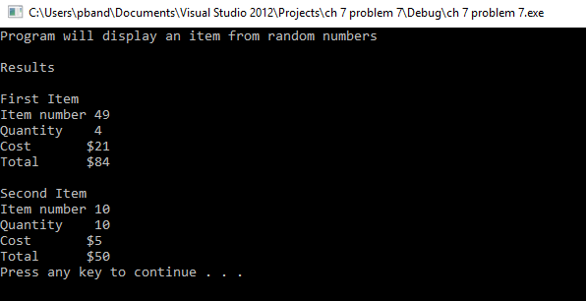

Program Challenge #8

Code:

Outpu //Ch 7 problem 8 Movie Data

//Gets and displays two movies

#include <iostream>

#include <iomanip>

#include <string>

using namespace std;

struct MovieData

{

string title;

string director;

int year;

double length;

MovieData()

{

cout << "Please enter the title of the movie: ";

getline(cin, Movie.title);

cout << "please enter the director: ";

getline(cin,Movie.director);

cout <<"Please enter the year: ";

cin >> Movie.year;

cout << "Please enter the length of the movie in minutes : ";

cin >> Movie.length;

cout << endl;

cin.ignore(numeric_limits<streamsize>::max(),'\n');

}

};

void displayMovieData(const MovieData &);

int main()

{

MovieData mov1;

MovieData mov2;

displayMovieData(mov1);

displayMovieData(mov2);

system("pause");

return 0;

}

void displayMovieData(const MovieData &Movie)

{

cout << fixed << showpoint << setprecision(2) << endl;

cout << "Title " << Movie.title << endl;

cout << "Director " << Movie.director << endl;

cout << "Year " << Movie.year << endl;

cout << "Length " << Movie.length << endl;

}t:

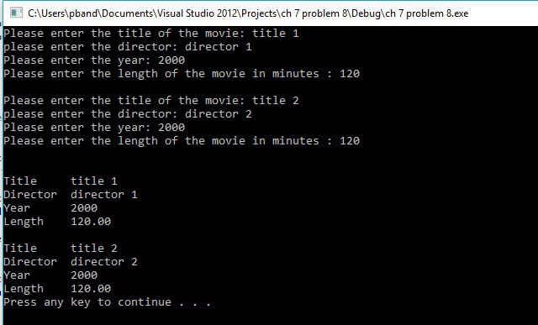

Program Challenge #10

Code:

//Ch 7 problem 10 Coorporate sales Data

//Calculates the different divsions

#include <iostream>

#include <iomanip>

#include <string>

using namespace std;

struct corpData

{

string division;

double firstQ, secondQ, thirdQ, fourthQ;

corpData()

{

cout << "Please enter the division name: ";

getline(cin,division);

cout << "please enter the first Quarter Sales: ";

cin >> firstQ;

cout << "please enter the second Quarter Sales: ";

cin >> secondQ;

cout << "please enter the third Quarter Sales: ";

cin >> thirdQ;

cout << "please enter the fourth Quarter Sales: ";

cin >> fourthQ;

cin.ignore(numeric_limits<streamsize>::max(),'\n');

}

};

void displayData(const corpData &);

int main()

{

corpData east;

corpData west;

corpData north;

corpData south;

displayData(east);

displayData(west);

displayData(north);

displayData(south);

system("pause");

return 0;

}

void displayData(const corpData &Data)

{

double total = Data.firstQ + Data.secondQ + Data.thirdQ +Data.fourthQ;

double avg = total/4;

cout << fixed << showpoint << setprecision(2) << endl;

cout << "Division " << Data.division << endl;

cout << "First Quarter " << Data.firstQ << endl;

cout << "Second Quarter " << Data.secondQ << endl;

cout << "Third quarter " << Data.thirdQ << endl;

cout << "Fourth Quarter " << Data.fourthQ << endl;

cout << "Total " << total << endl;

cout << "Average " << avg<<endl;

}

Output:

