Trent Giever

Chapter 8

6/6/18

Programming Challenge #3

Code:

//ch 8 problem 3 Chips and Salsa

//Program that has sales reports for salsa

#include <iostream>

#include <iomanip>

#include <string>

using namespace std;

int main()

{

const int NUM_SALSA =5;

string salsaNames[NUM_SALSA] = {"mild", "medium", "sweet", "hot", "zesty"};

string highestS, lowestS;//string

int highestI,lowestI;//int

int total=0;

int salsaSales[NUM_SALSA];

cout <<"This program determines the total number of salsas sold, please enter the amounts below"<<endl << endl;

for(int x = 0; x < NUM_SALSA; x++)

{

cout << "Please enter the amount of " << salsaNames[x] << " :";

cin >> salsaSales[x];

}

//total sales

for(int j =0; j < NUM_SALSA; j++)

total+=salsaSales[j];

//highest/lowest

highestS = lowestS= salsaNames[0];

highestI = lowestI =salsaSales[0];

for(int i =1; i < NUM_SALSA; i++)

{

if(salsaSales[i] > highestI)

{

highestI =salsaSales[i];

highestS=salsaNames[i];

}

else if(salsaSales[i] < lowestI)

{

lowestS=salsaNames[i];

lowestI=salsaSales[i];

}

}

// output

cout << "Total sales by salsa"<<endl;

for(int y =0; y < NUM_SALSA; y++)

cout << setw(10) << salsaNames[y] << " had " << setw(5) << salsaSales[y] << " jars sold" <<endl;

cout << "Total sales is " << total << " jars" << endl;

cout << "Most popular is " << highestS << endl;

cout << "least popular is " << lowestS << endl;

system("pause");

return 0;

}

Output:

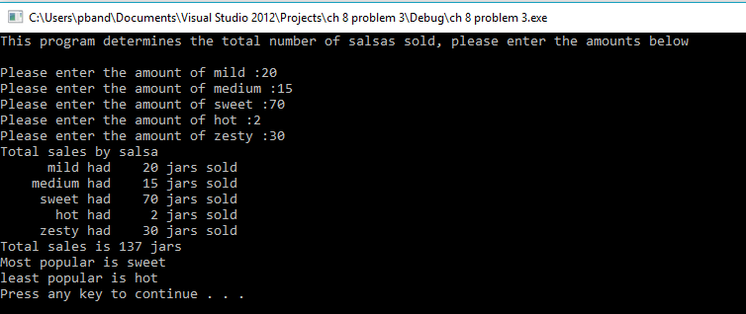

Programming Challenge # 4

Code:

//ch8 problem 4 Monkey business

// animal weight

#include <iostream>

#include <iomanip>

#include <string>

using namespace std;

int main()

{

const string DAYS_OF_WEEK[7]={"Sunday","Monday", "Tuesday","Wednesday","Thursday","Friday","Saturday"};

const int ROW =3;

const int COL =7;

double monkeys[ROW][COL];

//input loops

cout << "This program determines the amount of food the Moneys are eating" <<endl << endl;

for(int r =0; r < ROW; r++)

{

for(int c=0; c < COL; c++)

{

cout << "For monkey " << (r+1)<< " how much food was eaten on " << DAYS_OF_WEEK[c] << " :";

cin >> monkeys[r][c];

}

}

// loop that finds the average, least, and most amount of food

double avg =0;

int count =0;

double least, greatest;

least = greatest = monkeys[0][0];

for (int r=0; r < ROW;r++)

{

for(int c=0; c <COL; c++)

{

avg+=monkeys[r][c];

count++;

if(monkeys[r][c] > greatest)

greatest = monkeys[r][c];

else if(monkeys[r][c] < least)

least = monkeys[r][c];

}

}

avg = avg/count;

cout << endl << "The average amount eaten is " << avg << endl;

cout << "The greatest amount eaten is " << greatest << endl;

cout << "The least amount eaten is " << least << endl;

system("pause");

return 0;

}

Output:

