APCS-A Exposure Java | Exercises 8.2 | Date: 1/9/16
Name: Trent Giever |  | Period: 1

Questions 1 & 2 refer to the CardDeck Case Study tables in Section 8.5 of your book.

1. List an additional CardDeck method.
Initializing the deck
Shuffling the deck
Dealing from the deck
Counting leftover cards
Cutting player out

2. List an additional piece of CardDeck data.
Number of decks
Number of players
Number of cards dealt with each hand
Number of cards left on the deck
Number of rounds
3. Would methods be considered verbs or nouns?
Verbs

4. Would data be considered verbs or nouns?
Nouns

5. Print the shortest possible class, called Qwerty that can compile.
Class Qwerty
{
}

6. Look at program Java0812.java. This program does compile and execute. Even so, what is wrong with it?
The program is all in the main method, and should be in a separate module

7. What is the essence of encapsulation?
is to package the data and the methods that access the data in one container

8. Look at program Java0813.java. Why will this program not compile?
The program can’t access the cardDeck variables since the programmer made them private and can’t be accessed outside the program.

9. The constructor is automatically called by the __new____ operator and increases reliability by assigning correct __starting values___ to the data.

10. Should constructors be used to display data values?
Constructors are designed to initialize private data members. Constructors should not be in charge of displaying data values. Furthermore, even a very versatile constructor has built-in limitations. The constructor show starts and is over very rapidly. It is only during the instantiation of a new object that the constructor is called.

11. It is only during the __instantiation____ of a new object that the constructor is called.

12. Methods are usually declared public. What does this mean in terms of accessing these methods?
Public class variables can be accessed outside the class, and reduce the errors of the variables not being able to be accessed

13. Should helper methods be declared as public or private ?
Private

14. What is the purpose of helper methods?
Helper methods help inside the class and preform a non- important part, but does do a job, card deck you need a shuffle class

15. Can a class have multiple constructors?
Yes

16. How many parameters does a default constructor have?
None

17. Look at programs Java0820.java and Java0821.java. Why did the draw method need to be changed for the 2nd program?
The draw method needed to change to handle multiple cubes with size and location

Questions 18 and 19 refer to program Java0822.java and its output:

Cube cube = new Cube(g,50,50,50);
for (int x = 50; x < 750; x += 50)
cube.move(g,x,300);

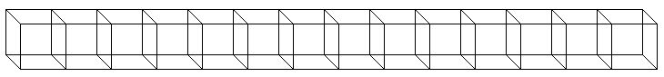

18. Refer to the bolded 50 in the for loop. Assume the number is changed to 100. Draw the new output below.
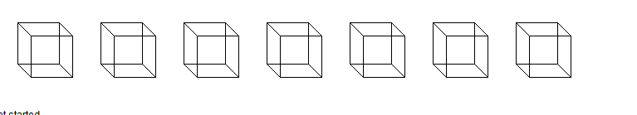

19. Refer to the previous question. Assume the number is changed to 25. Draw the new output below.



20. Look at program Java0823.java. Why does there seem to be no output in this program?
The program seems to have no output because the cube is moved so fast and erased it is impossible to even see

21. Look at program Java0824.java. How does this cure the problem of the previous program?
The program has a delay variable that delays the moving and erasing of the square

22. Explain how program Java0824.java creates the illusion of animation.
The program seems to have animation by having the square moved a few over to the right, and delete the previous spot fast

23. Assume you have an applet, which must have GUI output, that has println statements in it. You now want to see the text output of those println statements. What do you do?
They help find an error if the program does not work properly, and use the get method

24. Why would you want to have a GUI applet generate text output with println statements?
They help find an error if the program does not work properly

25. How does a class method get called?
A class method calls the class directly, not an object of the class.

26. Object methods are meant to be used in what situations?

Object methods are meant for those situations where multiple copies of a class must be constructed.

27. How are object methods called?
In contrast to the class methods, object methods are called by using the object identifier.

28. Private methods can only be accessed by ____methods of the same class_____.

29. What is the difference between a void methods
Void methods do not return a value and use the reserved word void to indicate that no value will be returned.d and a return method?

30-31. The term default constructor has 2 different meaning. What are they. (This counts as 2 questions)

- A constructor is a special method that is automatically called during the instantiation of a new object.
- If no visible constructor is provided Java will provide its own constructor, called a default constructor.
- call a no-parameter constructor a default constructor
- Constructors are always public and they are special methods that are neither void nor return methods.

32. What is the difference between a get method and a set method?
Methods that only access object data without altering the data are access methods or frequently called get methods. Altering methods are sometimes also called mutator methods or set methods.

