APCS-AB Exposure Java | Exercises 26.1 | Date:9/21/17
Name: Trent Giever |  | Period: 1

1. List 5 simple or primitive data types.
Int, float, char, double, and Boolean

2. What is a simple data type variable?
Single value

3. Any data type that can store more than one value is a _data structure_.

4. What was the first historical data structure?
Array or subscripted variable

5. What does FORTRAN stand for?
FORmula TRANslator

6. What is an array?
An array is a data structure with one, or more, elements
of the same type.

7. What is a vector?
A one-dimensional array

8. What is a matrix?
A two-dimensional array is frequently

9. Explain what parallel arrays are.
An array that worked alongside another array that held one part of the data with multiple arrays alongside eachother.

10. What does COBOL stand for?
Common Business Oriented Language

11. What data structure did COBOL introduce?
Record data structure

12. What is a record?
A record is a data structure with one, or more, elements, called fields, of the same or different data types.

13. What is a file?
A file is an internal data structure - with an unspecified number of elements of the same type - assigned to an external file name. The file data structure allows transfer of data between internal and external storage.

14. What is a stack?
A stack is a data structure with elements of the same type. Data elements of the stack data structure can only be accessed (stored or retrieved) at one end of the stack in a LIFO (Last In, First Out) manner.

15. What does LIFO stand for?
Last In, First Out

16. In a data structure, the storing and retrieval of the data elements is performed by _accessing methods__ that characterize the data structure.

17. What is the improved array definition?
An array is a data structure with a fixed number of elements of the same type. Every element of the array can be accessed directly.

18. What is the difference between the declaration of a variable and the definition of a variable?
Declaration of a variable presents an identifier
Definition is the number of bytes allocated to the variable
They have flipped with each other and is used at times flipped
19. What is meant by a contiguous block of memory?
Java will use a solid block in memory for an Array to have all the data values in memory be contiguous

20. Print the Java code necessary to declare a static array of 50 integers.
int list = new int[50];

21. Print the Java code necessary to declare a static array of 200 real numbers.
double numbers = new double[200];

22. Print the Java code necessary to declare a static array of 100 characters.
char characters = new char[100];

23. Print the Java code necessary to declare a static array of 10 boolean variables.
boolean values = new boolean[10];

24. What does static means in relation to Java built-in arrays?
Static means non-changing, and Java built-in arrays can’t change once the object is created

25. What is the default value assigned to the elements of an int array?
0

26. What is the default value assigned to the elements of a char array?
Blank space

27. What is the default value assigned to the elements of a String array?
null

28. Print the Java code necessary to declare an array of 5 integers that is initialized to 1, 2, 3, 4, 5.
int list[] = {1,2,3,4,5};

29. Print the Java code necessary to declare an array of 7 characters that is initialized to A, B, C, D, E, F, G.
char characters [] = {A,B,C,D,E,F,G};

30. Print the Java code necessary to declare an array of 4 strings that is initialized to John, Greg, Maria, Heidi.
String names[] ={“John”, “Greg”, “Maria”, Heidi”}

31. Accessing individual array elements is done with the __index[]_ operator.

32. If an array has 500 elements, what is the smallest and largest index?
Smallest: 0
Largest: 499

33. Is length a field or a method of built in Java arrays?
Field

34. Refer to the previous question. What is length used for?
Store the number of elements in the array

35. What operator is used to define the size of an array?
The length field

36. What control structure is used to traverse a one-dimensional array?
The static or built-in one-dimensional array

37. What control structure is used to traverse a two-dimensional array?
Matrix values are [rows][columns ]

38. Print the Java code necessary to declare a static 2-D array with 10 rows and 20 columns of integers.
Int Matrix = new int[10][20];

38. Print the Java code necessary to declare a static 2-D array with 20 rows and 10 columns of real numbers.
Int Matrix = new int[20][10];

39. How do you determine the number of rows with a Java static 2-D array?
Int Matrix = new int[10][20];
To find the rows, look at the first bracket to find the rows
40. How do you determine the number of columns with a Java static 2-D array?
Int Matrix = new int[10][20];
To find thecolumns, look at the second bracket to find the columns

41. What is a ragged array?
Java built-in two-dimensional arrays do not require that every row has the same number of columns.

It is allowed to declare an array with an unspecified number of columns in each row using something like new int[5][ ].

After that initial construction each row can then be individual constructed with a specified number of columns.

42. Print the Java code necessary to declare and initialize this ragged array example:

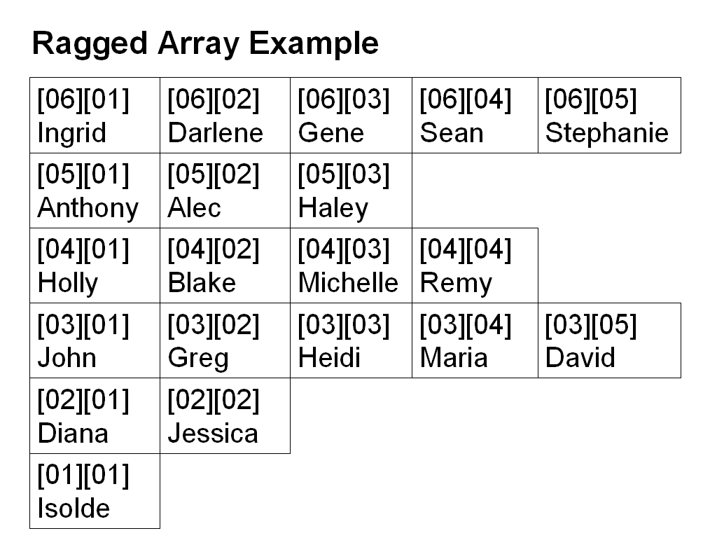
import java.text.DecimalFormat;

public class Java2642
{
public static void main(String args[])
{
System.out.println("\nJava2607.java\n");
int x[][] = new int[6][];
x[0] = new int[1];
x[1] = new int[2];
x[2] = new int[5];
x[3] = new int[4];
x[4] = new int[3];
x[5]= new int[5];

for (int r = 0; r < x.length; r++)
{
for (int c = 0; c < x[r].length; c++)
System.out.print(x[r][c] + " ");
System.out.println();
}
System.out.println();
}
}

