AP Computer Science I | Java Keyword Lab Assignment # 04
The AWT Graphics Program | 80, 90, 100 & 110 Point Versions
Assignment Purpose:

The purpose of this program is to demonstrate knowledge of calling methods, using
correct parameter passing with some of the common methods found in the Graphics class of the java.awt package.

Write a program, which displays three geometric designs using the Graphics class. You will be provided with a skeleton program. Your job is to use the proper methods along with the correct parameter values to match the output shown on this assignment. The syntax of the three methods necessary for this assignment is shown below.

Methods of the Graphics class used for Lab04

drawLine Method Class: Graphics
drawLine(int x1, int y1, int x2, int y2)

Draws a line from coordinate (x1,y1) to coordinate (x2,y2)

drawRect and fillRect Methods Class: Graphics
drawRect(int x, int y, int width, int height)

Draws a rectangle with top-left corner at coordinate (x,y) using width and height dimensions.

fillRect uses identical parameters, but fills in the rectangle.

drawOval and fillOval Methods Class: Graphics
drawOval(int x, int y, int width, int height)

Draws an oval that is circumscribed by the rectangle with
top-left corner at coordinate (x,y) using width and height dimensions.

fillOval uses identical parameters, but fills in the oval.

Lab04 Student Version | Do not copy this file, which is provided.
// Lab04st.java
// Student starting version of the Lab04 assignment.
// Resave this program as Lab048 for the 80-point version.
// Repeat this process as you progress to the 90 and 100 point versions.

import java.awt.*;
import java.applet.*;

public class Lab04st extends Applet
{

public void paint(Graphics g)
{
// DRAW CUBE

// DRAW SPHERE

// DRAW TRIANGLE
}

}

80-Point Version Specifics

The 80-point lab assignment displays a cube in the top-left corner of the screen. The sides of the cube are 300 pixels in length. It is not necessary that your cube is exactly the same appearance as the sample execution. However, it does need to look like a cube with neatly connecting lines.

90-Point Version Specifics

The 90-point lab assignment displays a cube in the top-left corner of the screen, as described earlier. Additionally, you need to display a sphere in the top-right corner. The sphere fits inside a 300 X 300 square. The appearance of the sphere is simulated with three horizontal ovals and three vertical ovals.

100-Point Version Specifics

The 100-point lab assignment displays a cube in the top-left corner of the screen and a sphere in the top-right corner of the screen, as described earlier. Additionally, you need to display a triangle in the bottom center. The triangle has a base of 600 pixels and a height of 300 pixels. Inside the triangle you need to draw three lines from each vertex to the midpoint of the opposite side.
80 Point Version Ouput

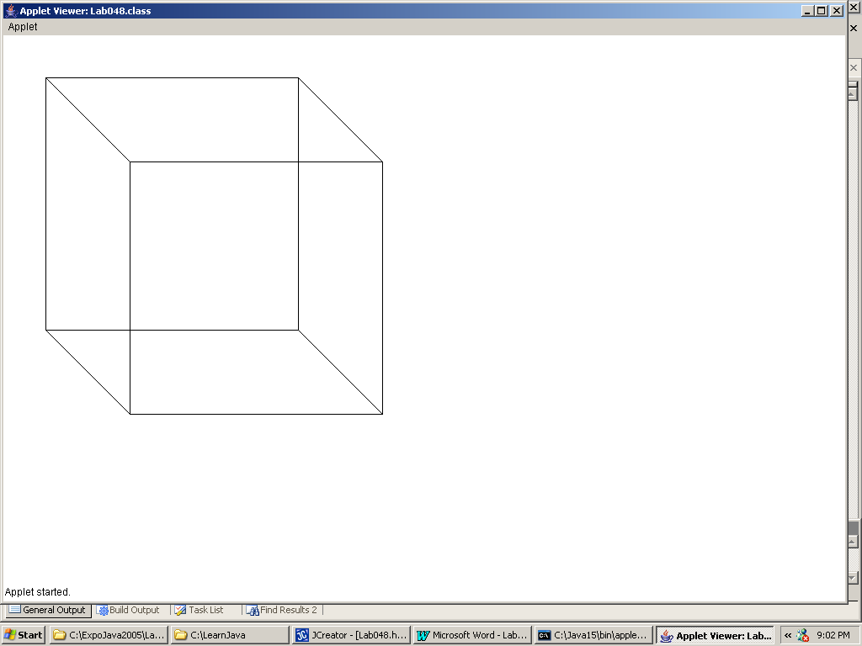

90 Point Version Ouput

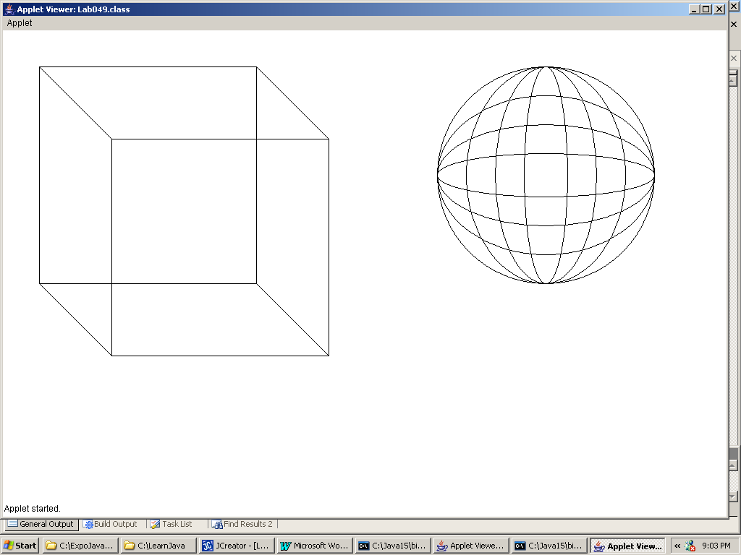

100 Point Version Ouput

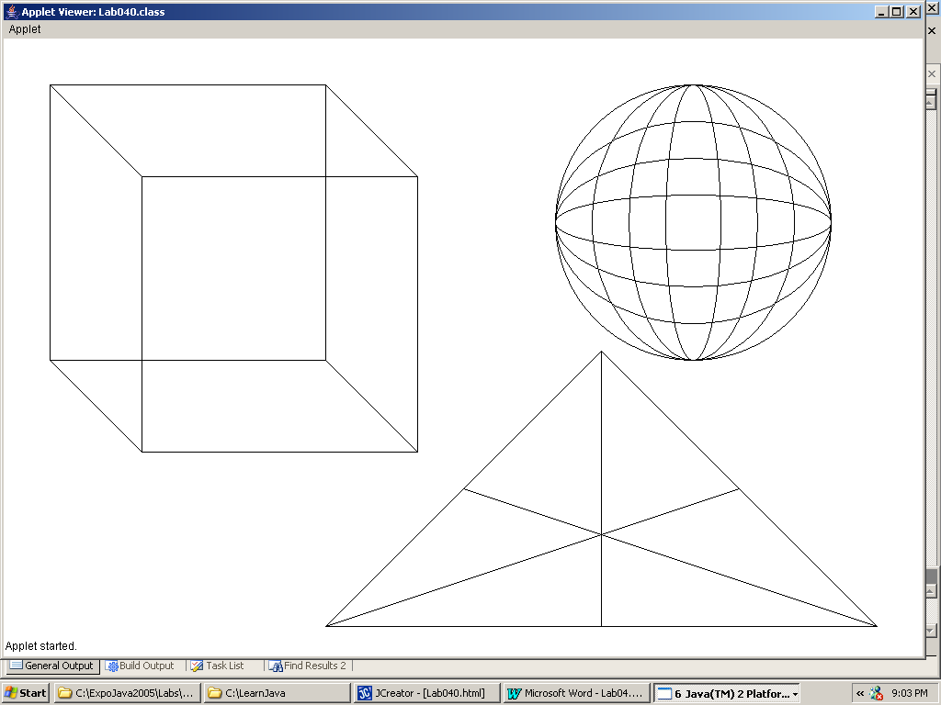
NOTE: In the triangle figure, the 3 interior lines connect a corner to the MIDPOINT of the opposite side. The Midpoint Formula that you learned in Geometry can be used here.

110 Point Version Specifics

Lab 04 is the first lab assignment with an extra credit, 110-point version. Not every lab assignment will have an extra credit version, but when they appear, you can earn some extra points by doing a very challenging version of the lab assignment. The trick for this 110 point program is to place the sphere inside the cube so that it is tangent to all six sides. Are you up to the challenge?

110 Point Version Ouput

