AP Computer Science I | Java Keyword Lab Assignment # 04
The AWT Graphics Program | 80, 90, 100 & 110 Point  Graded Lab Assignment Versions
Assignment Purpose:

The purpose of this program is to demonstrate knowledge of calling methods, using
correct parameter passing with some of the common methods found in the Graphics class of the java.awt package.

Write a program, which displays three geometric designs using the Graphics class. You will be provided with a skeleton program. Your job is to use the proper methods along with the correct parameter values to match the output shown on this assignment. The syntax of the four methods necessary for this assignment is shown below.

Methods of the Graphics class used for Lab04

drawLine Method Class: Graphics
drawLine(int x1, int y1, int x2, int y2)

Draws a line from coordinate (x1,y1) to coordinate (x2,y2)

drawRect and fillRect Methods Class: Graphics
drawRect(int x, int y, int width, int height)

Draws a rectangle with top-left corner at coordinate (x,y) using width and height dimensions.

fillRect uses identical parameters, but fills in the rectangle.

drawOval and fillOval Methods Class: Graphics
drawOval(int x, int y, int width, int height)

Draws an oval that is circumscribed by the rectangle with
top-left corner at coordinate (x,y) using width and height dimensions.

fillOval uses identical parameters, but fills in the oval.

setColor Method Class: Graphics
Color.constant Class: Color
setColor(Color.constant)

Sets the graphics display color of the following graphics output to the specified constant of the Color class. The following constants are defined for the Color class:

red green blue orange cyan
magenta yellow gray lightGray darkGray
pink black white

Lab04G Student Version | Do not copy this file, which is provided.
// Lab04Gst.java
// Student starting version of the Lab04 assignment.
// Resave this program as Lab04G8 for the 80 point version.
// Repeat this process as you progress to the 90 and 100 point versions.

import java.awt.*;
import java.applet.*;

public class Lab04Gst extends Applet
{

public void paint(Graphics g)
{

}

}

80 Point Version Specifics

The 80-point lab assignment displays a pyramid in the top-left corner of the screen. The pyramid needs to be approximately the same size as the pyramid in the later sample execution. Exact precision is not required, but all point must meet neatly and two sides of the pyramid need to be visible on the display.

90 Point Version Specifics

The 90-point lab assignment displays a pyramid the top-left corner of the screen, as described earlier. Additionally, you need to display an archery target on the right side. The colors of the target are black, white, blue, red and yellow from outer ring to inner circle. The 90-point version does not require that the circles are concentric. However, the circles may not overlap. The sample execution is quite bad. Make no effort to make such a bad target.

100 Point Version Specifics

The 100-point lab assignment displays a pyramid in the top-left corner of the screen and a perfect archery target on the right side. Every circle in the archery target is a concentric circle and every circle has the same width.

110 Point Version Specifics

Lab 04 is the first lab assignment with an extra credit, 110-point version. Not every lab assignment will have an extra credit version, but when they appear, you can earn some extra points by doing a very challenging version of the lab assignment. The trick for this 110 point program is to draw an arrow hitting the bullseye into the target.

80 Point Version Output

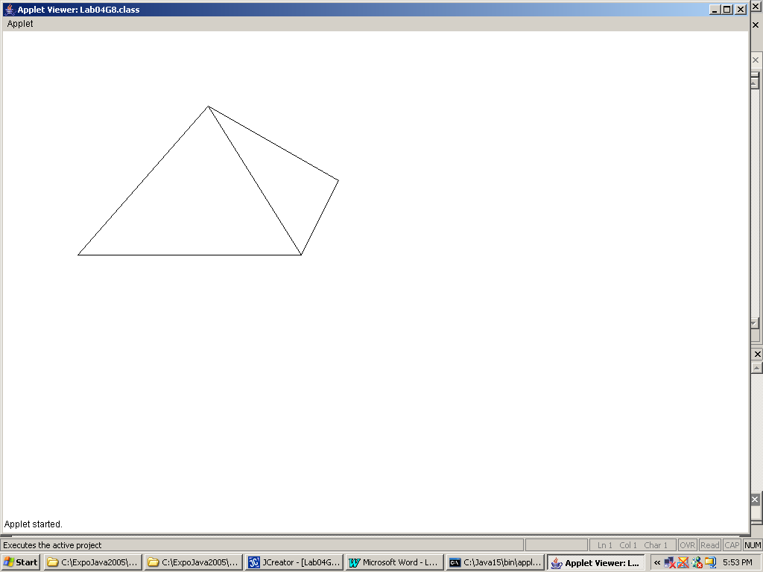

90 Point Version Output

Keep in mind that the archery target is a particularly bad example of poorly positioned circles that still satisfy the requirement that there are no overlapping circles. The requirement is that each circle is completely on top of the previous circle.

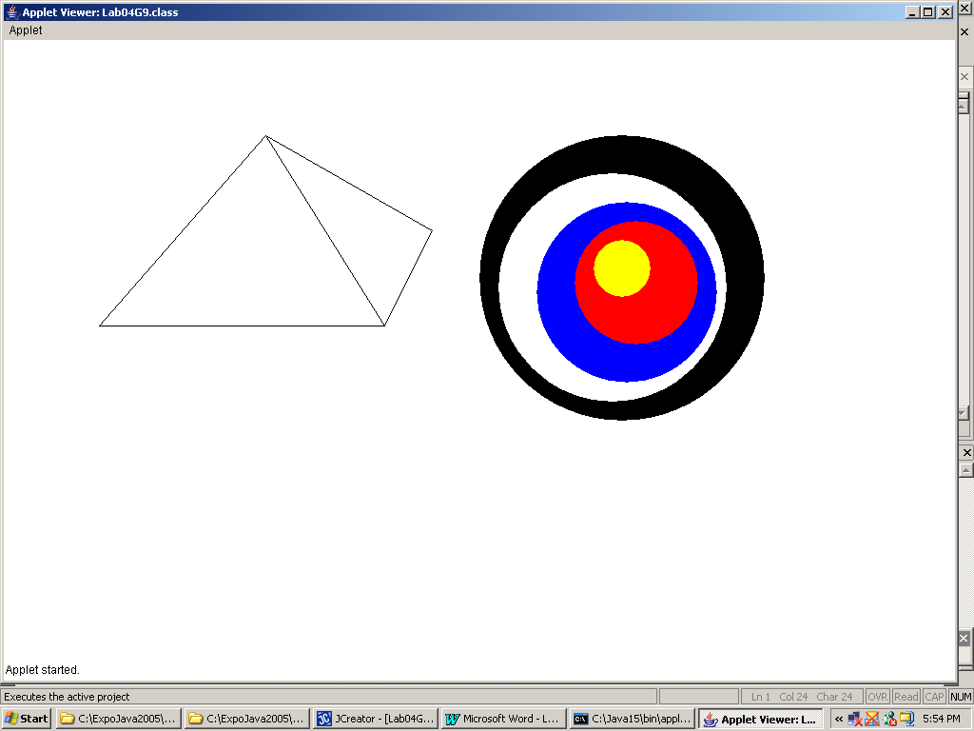

100 Point Version Output

Note that the 100-point version has every circle on top of the previous circle, like the 90-point version. Additionally, all the circles are concentric and every circle has the same width. Your 100-point version does not need to display the precise same archery target, but it does need to satisfy the requirements for the archery target.

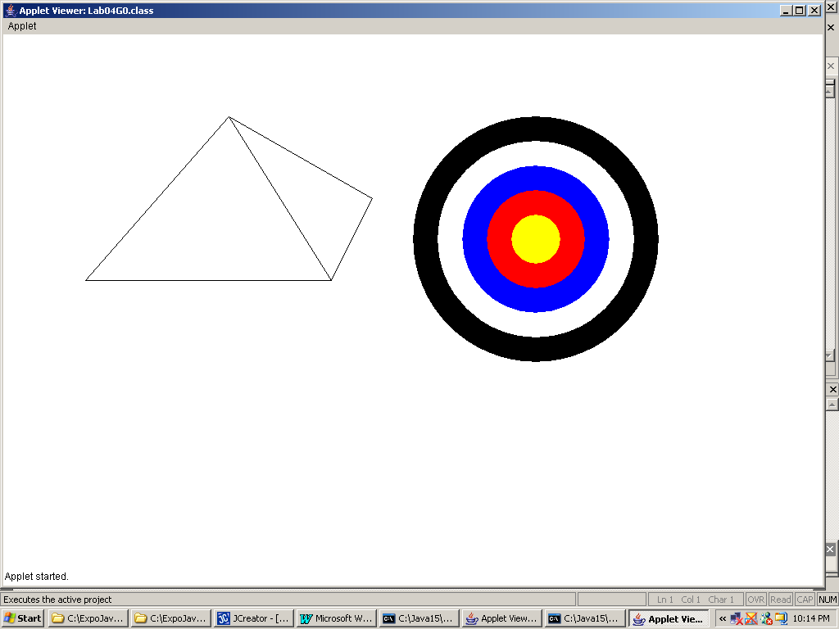

110 Point Version Output

