AP Computer Science I | Java Keyword Lab Assignment # 05
The Graded Control Structures  Graphics Program | 80, 90 & 100 Point Versions
Assignment Purpose:

The purpose of this program is to demonstrate knowledge of loop control structures combined with Graphics methods.

Write a program, which displays straight lines inside a rectangle from one corner to the opposite vertical. The lines must be drawn equidistant along the vertical sides. The size of the rectangle is 800 pixels width by 600 pixels height with the top-left corner at coordinate (10,10);

Lab05G Student Version | Do not copy this file, which is provided.
// Lab05Gst.java
// The student version of the Lab05G assignment.

import java.awt.*;
import java.applet.*;

public class Lab05Gst extends Applet
{
public void paint(Graphics g)
{
int width = 800;
int height = 600;
g.drawRect(10,10,width,height);

}
}

80 Point Version Specifics

The 80-point lab assignment displays lines from the top-left rectangle corner to the right, vertical side only. All the lines start at one corner but are drawn to the opposite side spaced in an equidistant manner. You will need to draw twenty lines from the corner. The sides of the rectangle are not included in the twenty count.

90 Point Version Specifics

The 90-point lab assignment displays lines from the top-left rectangle corner to the right, vertical side. It also draws lines from the top-right rectangle corner to the left, vertical side. This is an example where you can benefit from a functional 80-point version. Block-copy the code segment that draws from the top-left corner and then alter the values in such a way that the top-right corner is drawn.

100 Point Version Specifics

The 100-point lab assignment displays lines from all four of the rectangle corners. Once again block copying can save time due to the similarity of the code. There is one warning about block copying. It is a timesaving tool, but it is also an error duplicator. If the source code is not tested properly, you will be block-copying many errors.

80 Point Version Output

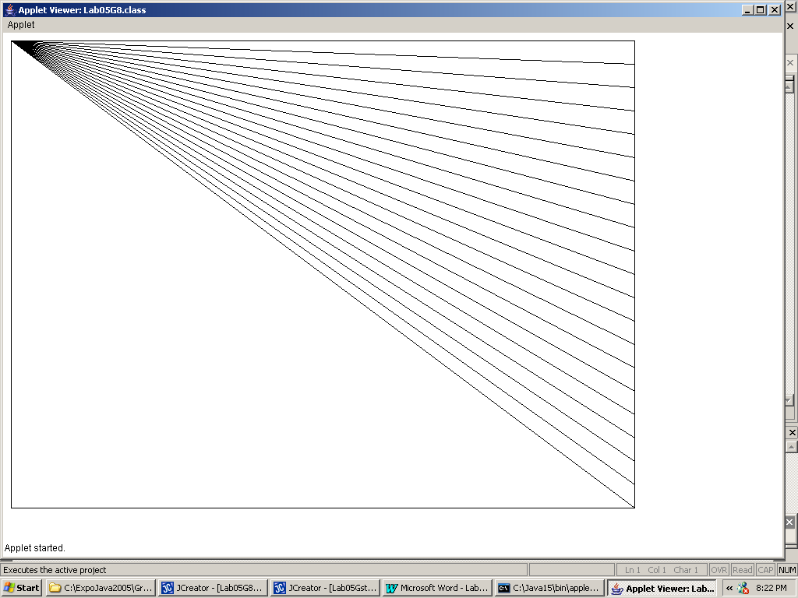
90 Point Version Output

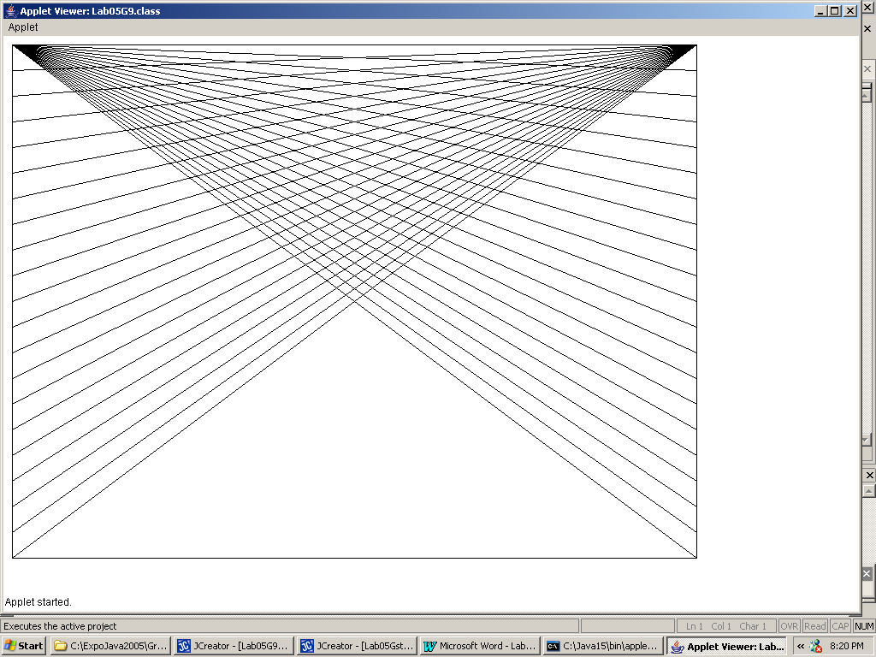

100 Point Version Output

