AP Computer Science I | Java Keyword Lab Assignment # 06
The Random Graphics Program | 80, 90, 100 & 110 Point  Graded Lab Assignment Versions
Assignment Purpose:

The purpose of this program is to demonstrate knowledge of using constructing objects with the new operator and use object methods.

For this lab assignment you are provided with a grid of two rows by two columns. Each cell in the grid needs some graphics object to be drawn. It will be necessary to construct objects of the Random, Color and Polygon class to complete this assignment. The use of the grid is intentional. For three cells you will need to display random graphics objects that must stay within the boundaries of the cell. This becomes a test of your knowledge about generating random values in the proper range. You will not get credit if the objects are drawn outside the cell boundaries.

Lab06st.java Student Version | Do not copy this file, which is provided.
// Lab06st.java
// Student Version

import java.awt.*;
import java.applet.*;
import java.util.*;

public class Lab06st extends Applet
{
public void paint(Graphics g)
{
// Draw Grid
g.drawRect(10,10,780,580);
g.drawLine(400,10,400,590);
g.drawLine(10,300,790,300);

Random rnd = new Random(1234);

// Draw Random Lines

// Draw Random Squares

// Draw Random Circles

// Draw 3-D Box

}
}
Current Output of Lab06st.java

At the beginning, the output is a simple 2 by 2 grid.

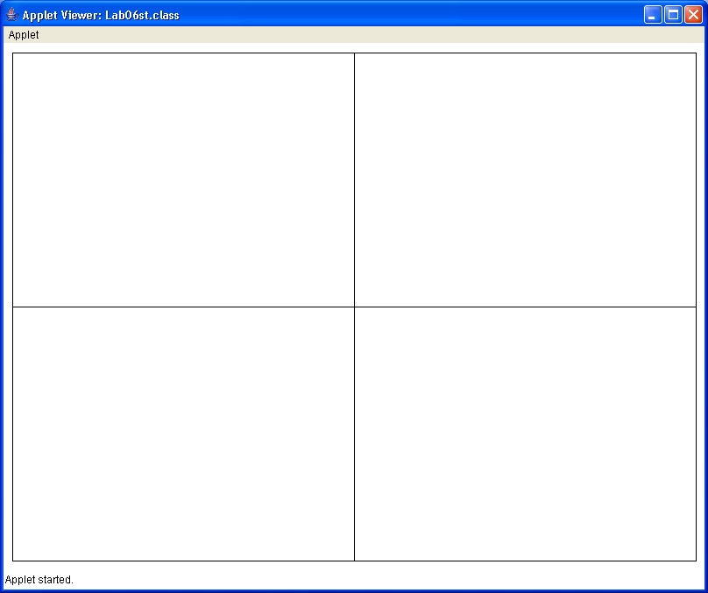

80, 90, 100 & 110-Point Versions

The 80-point version displays one of the cells on the next page. The 90-point version displays two.
The 100-point version displays three, and the 110-point version displays all four.

The cell with lines displays 100 random lines.
Both ends of the line have random x and y coordinate locations.
The lines are also drawn in random colors.

The cell with squares displays 100 random squares.
The squares need to be drawn at random locations within the cell, and be entirely in the cell.
The squares have a height and width of 50 pixels.
The squares are also drawn in random colors.

The cell with circles displays 100 random circles.
The circles need to be drawn at random locations within the cell, and be entirely in the cell.
The circles have a random diameter which ranges from 0 to 200 pixels.
The circles are also drawn in random colors.

The random colors used for the first 3 cells are created by having 3 random values from 0 to 255 which represent the red, green, and blue values for the random color.

The cell with the box uses nothing random.
It uses Polygons and the built in colors of red, green, yellow and blue.

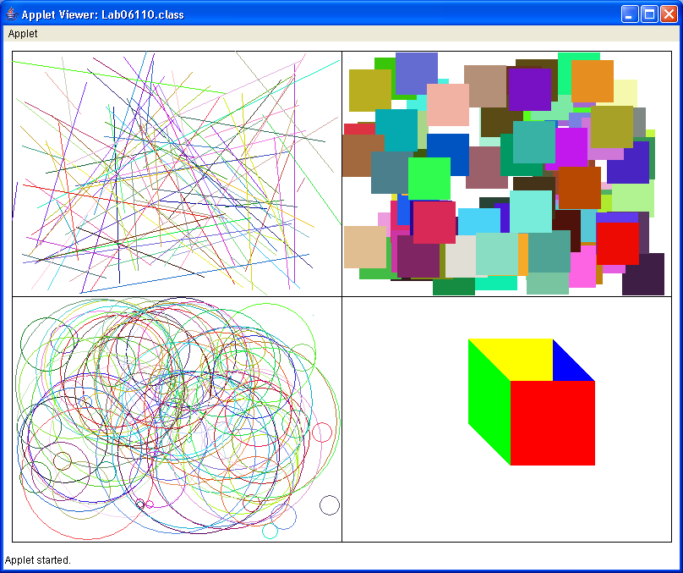
Note: Don’t give up!

If you cannot get random colors, or your square/circles cross the grid lines, you can still get partial credit!

