AP Computer Science II | Java Lab Assignment # 28A & B
Encryption File Writing Program &  Decryption File Reading Program | 90 and 100  Point Versions
Assignment Purpose:

The purpose of this assignment is to practice writing to and reading from text files, and to gain understanding of file encryption/decrption.

What will be a bit different in this assignment is that you are expected to write 2 programs.

First, write a program that will take 4 provided lines of text; encrypt them based on a “key” that is entered by the user; display the encrypted text on the screen; and then write the encrypted text to a text file called “code.dat”.

Second, write a program that will read in the 4 lines of encrypted text from “code.dat”; display the encrypted text on the screen; decrypt the text based again on a “key” that is entered by the user (which must be the same as the other key in order to work); and then display the decrypted text on the screen.

The provided student files for Lab28ast.java AND Lab28bst.java are shown here.

Lab28ast.java Provided Student File
// Lab28ast
// The Encryption File Writing Program
// Student Version
// NOTE: 3 files are used for this assignment: Lab28ast.java, Lab28bst.java, and code.dat

import java.io.*;

import java.util.Scanner;

public class Lab28ast
{
public static void main (String args[]) throws IOException
{
String line1 = "How much wood would a wood chuck chuck";
String line2 = "if a wood chuck would chuck wood?";
String line3 = "He would chuck what a wood chuck COULD";
String line4 = "if a wood chuck would chuck wood.";

Encode topSecret = new Encode(line1, line2, line3, line4);
topSecret.displayOriginalText();
topSecret.enterKey();
topSecret.encodeText();
topSecret.displayEncodedText();
topSecret.writeToFile();
}
}

class Encode
{
private String line1, line2, line3, line4;
private String codeLine1, codeLine2, codeLine3, codeLine4;
private String key;

public Encode(String ln1, String ln2, String ln3, String ln4)
{
codeLine1 = line1 = ln1;
codeLine2 = line2 = ln2;
codeLine3 = line3 = ln3;
codeLine4 = line4 = ln4;
}

public void displayOriginalText()
{
System.out.println("The original uncoded message is:\n");
System.out.println(line1);
System.out.println(line2);
System.out.println(line3);
System.out.println(line4);
System.out.println();
}

public void enterKey()
{
Scanner input = new Scanner(System.in);
System.out.print("Enter key --> ");
// For the 90-point version the "key" is a single letter.
// For the 100-point version, the "key" is a word.
key = input.nextLine();
}

public String encodeLine(String line)
{

}

public void encodeText()
{
System.out.println("\nEncoding the Text\n");

}

public void displayEncodedText()
{
System.out.println("The ENCODED message is:\n");

}

public void writeToFile() throws IOException
{
BufferedWriter outStream = new BufferedWriter(new FileWriter("code.dat"));
System.out.println("Saving coded message\n");

}
}

Lab28bst.java Provided Student File
// Lab28bst
// The Decryption File Reading Program
// Student Version
// NOTE: 3 files are used for this assignment: Lab28ast.java, Lab28bst.java, and code.dat

import java.io.*;

import java.util.Scanner;

public class Lab28bst
{
public static void main (String args[]) throws IOException
{
Decode topSecret = new Decode();
topSecret.readFromFile();
topSecret.displayEncodedText();
topSecret.enterKey();
topSecret.decodeText();
topSecret.displayOriginalText();
}
}

class Decode
{
private String line1, line2, line3, line4;
private String codeLine1, codeLine2, codeLine3, codeLine4;
private String key;

public Decode()
{
codeLine1 = line1 = codeLine2 = line2 = codeLine3 = line3 = codeLine4 = line4 = "";
}

public void displayOriginalText()
{
System.out.println("The original uncoded message is:\n");
System.out.println(line1);
System.out.println(line2);
System.out.println(line3);
System.out.println(line4);
System.out.println();
}

public void enterKey()
{
Scanner input = new Scanner(System.in);
System.out.print("Enter key --> ");
// For the 90-point version the "key" is a single letter.
// For the 100-point version, the "key" is a word.
key = input.nextLine();
}

public String decodeLine(String encodeLine)
{

}

public void decodeText()
{
System.out.println("\nEncoding the Text\n");

}

public void displayEncodedText()
{
System.out.println("The ENCODED message is:\n");
System.out.println(codeLine1);
System.out.println(codeLine2);
System.out.println(codeLine3);
System.out.println(codeLine4);
System.out.println();
}

public void readFromFile() throws IOException
{
BufferedReader inStream = new BufferedReader(new FileReader("code.dat"));
System.out.println("Loading coded message\n");

}
}

You will notice that both the Encode class of Lab28A and the Decode class of Lab28B have several methods in common. Those are the one already written for you. You need to concentrate on the file handling methods, and the encryption/decryption process.

90 Point Version Specifics

The 90-point version uses a simple 1-letter key to create a simplistic form of encryption. This will resemble the decoder rings that your parents (and grandparents) played with as they listened to radio shows several decades ago.

Here is how it works. For the encrypting process, the user enters a single letter. Let us say he enters a J. This means that all As in the text need to be changed to Js. It also means all Bs in the text need to be changed to Ks. All Cs are changed to Ls. All Ds are changed to Ms and so forth.

You could say the following chart is then being used for the conversion:

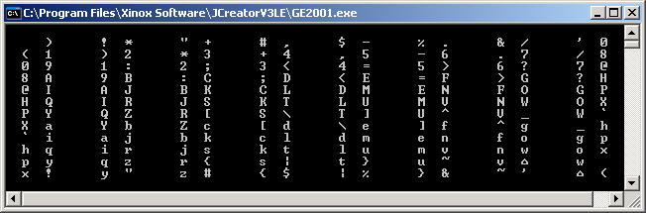

In terms of ASCII we are strictly working with codes from 32 to 127. If you look at the chart on the previous page, you will see that lowercase u becomes the tilde (~) and lowercase v becomes something that looks like a little house (⌂). The ASCII code for the tilde is 126 and the ASCII code for the house thing is 127.

After 127, ASCII characters are not standardized and, in most cases, not even printable. Codes 0-31 are also a bit of a pain. Notice what the chart shows for lowercase w. It becomes a space, which has an ASCII value of 32. In other words, your programs need to wrap around when doing the encrypting/decrypting.

As for the decrypting process in Lab28B, the user the encrypted file is read in and the user must enter a key. When ever key the user enters, the decrypting process – which is the exact opposite of the encrypting process – will occur. However, if the user does not enter the same key that was entered when the file was encrypted, the decrypted file will still look like nonsense.
90 Point Version Outputs

1 Execution required for Lab28A

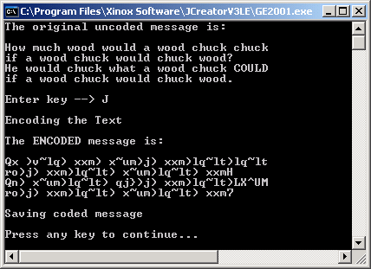

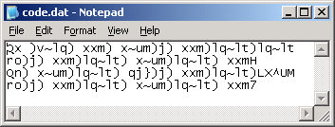

2 Executions required for Lab28B
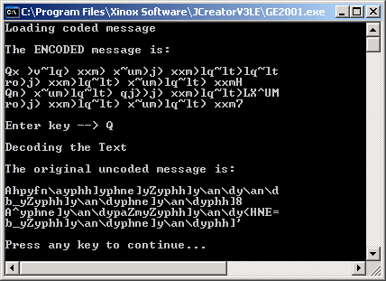

The first execution shows the result of entering an incorrect key.
The second execution shows the desired result when the proper key is entered.

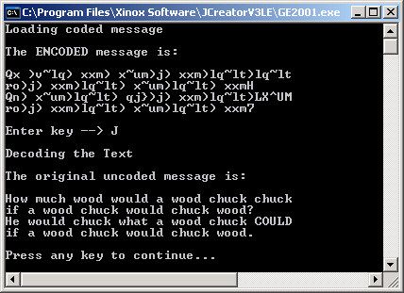

100 Point Version Specifics

The 90-point version does perform a simple encrypting/decrypting process, but the code is not very advanced. Most hackers would notice by looking at the encrypted file that the close parenthesis ) seems to be showing up many times. They might surmise this could be the letter E or a space. Once they figure out that a space – with ASCII code 32 – translates to close parenthesis ) – with ASCII code 41, it will not take long to figure out the entire encryption is nothing more than a shifting of 9 ASCII values.

For the 100-point version, the user needs to enter a longer key. Instead of a single letter, a word – or better yet – a phrase will make the encryption MUCH more secure.

Here is an example of what happens when the user enters PYRAMID for the key:

Encrypting:

How much wood would a wood chuck chuck
↓↓↓↓↓↓↓↓↓↓↓↓↓↓↓↓↓↓↓↓↓↓↓↓↓↓↓↓↓↓↓↓↓↓↓↓↓↓
PYRAMIDPYRAMIDPYRAMIDPYRAMIDPYRAMIDPYR
↓↓↓↓↓↓↓↓↓↓↓↓↓↓↓↓↓↓↓↓↓↓↓↓↓↓↓↓↓↓↓↓↓↓↓↓↓↓
W'( y}fw8(o{l#&'&lp(d// op(fw-tk,kk${|

Decrypting:

W'( y}fw8(o{l#&'&lp(d// op(fw-tk,kk${|
↓↓↓↓↓↓↓↓↓↓↓↓↓↓↓↓↓↓↓↓↓↓↓↓↓↓↓↓↓↓↓↓↓↓↓↓↓↓
PYRAMIDPYRAMIDPYRAMIDPYRAMIDPYRAMIDPYR
↓↓↓↓↓↓↓↓↓↓↓↓↓↓↓↓↓↓↓↓↓↓↓↓↓↓↓↓↓↓↓↓↓↓↓↓↓↓
How much wood would a wood chuck chuck

This is now a much more secure form of encryption. Any hackers trying to look at the encrypted file, cannot tell anything by looking for repetition of characters. It then becomes almost impossible to break this without knowing the key. Keep in mind that the text file itself will not tell you what the key is or even how long it is. There is no limit as to how long the key can be – and the longer the key, the more secure the data.

100 Point Version Outputs

1 Execution required for Lab28A

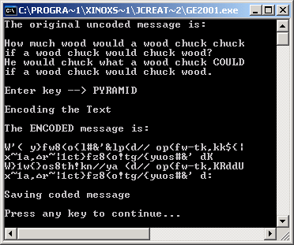

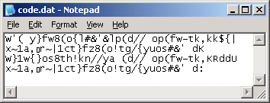
2 Executions required for Lab28B

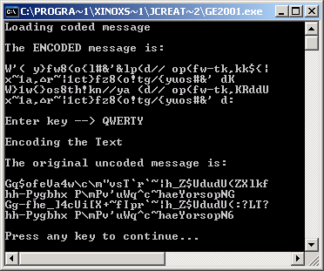

The first execution shows the result of entering an incorrect key.
The second execution shows the desired result when the proper key is entered.

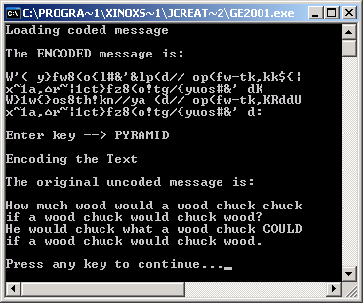

AP Computer Science II | Java Lab Assignment # 28C
Graphics Background File Program | 100 and 110 Point Versions
Assignment Purpose:

The purpose of this assignment is to combine text files with Graphics.

You need to write a program that will take a text file, and convert it into a graphics background. The best explanation would really be to see an example. In addition to the Lab28cst.java file (shown later), you are also provided with the blank.dat file (shown below).

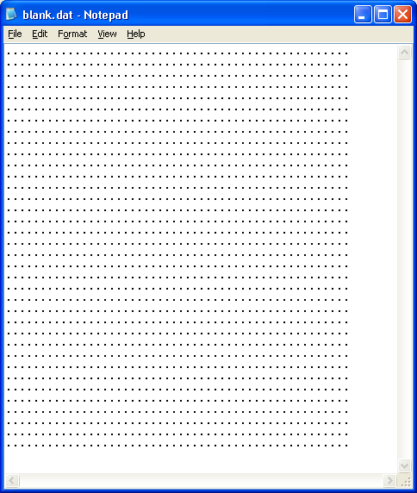
The blank.dat file contains
36 rows of
50 periods.

Use this file to
design your
Graphics
Background.

An example is shown on the next page.

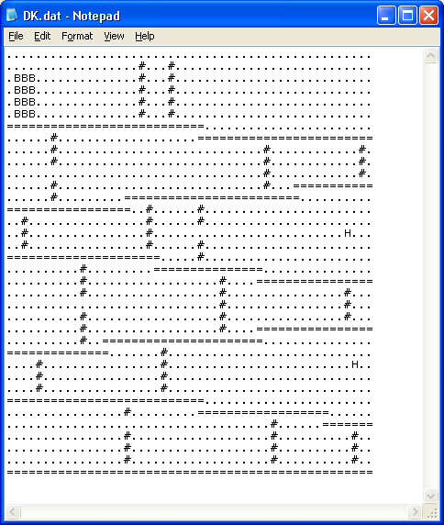
Different text symbols are used to represent different objects in the Graphics Background.

Try to pick symbols that have some logical meaning.

For example,
I am using a pound sign (#) for a ladder, an
H for a Hammer, and a B for a Barrel.

Using the provided student file, you need to write a program that will ask the user for a file name, read in that text file, and then display the Graphics Background like the example on the next page.

Lab28cst.java Provided Student File
// Lab28cst
// Graphics Background File Program
// Student Version

import java.io.*;
import java.awt.*;
import java.awt.event.*;
import javax.swing.JOptionPane;

public class Lab28c0
{
public static void main(String args[]) throws IOException
{
GfxApp gfx = new GfxApp();
gfx.setSize(1024,768);
gfx.addWindowListener(new WindowAdapter() {public void
windowClosing(WindowEvent e) {System.exit(0);}});

gfx.readFile();

gfx.show();
}
}

class GfxApp extends Frame
{
int numRows = 36; // 35 Rows are displayed. The top row
// (row 0) is hidden behind the title bar.
int numCols = 50;
String background[];
String fileName;

public void paint(Graphics g)
{
for (int r = 0; r < numRows; r++)
for (int c = 0; c < numCols; c++)
switch(background[r].charAt(c))
{
case '.' : drawSpace(g,r,c); break;

// YOU SHOULD HAVE SEVERAL MORE CASES HERE.

default : drawUnknown(g,r,c);
}
}
}

100 and 110 Point Versions
The difference between the 100 and 110 point version is that the 100 point version requires basic shapes, like most of those shown on the next page.

The 110-point version requires more advanced shapes. For instance, the barrels on the next page have shading added to give them a more 3-D effect.

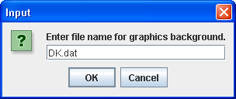
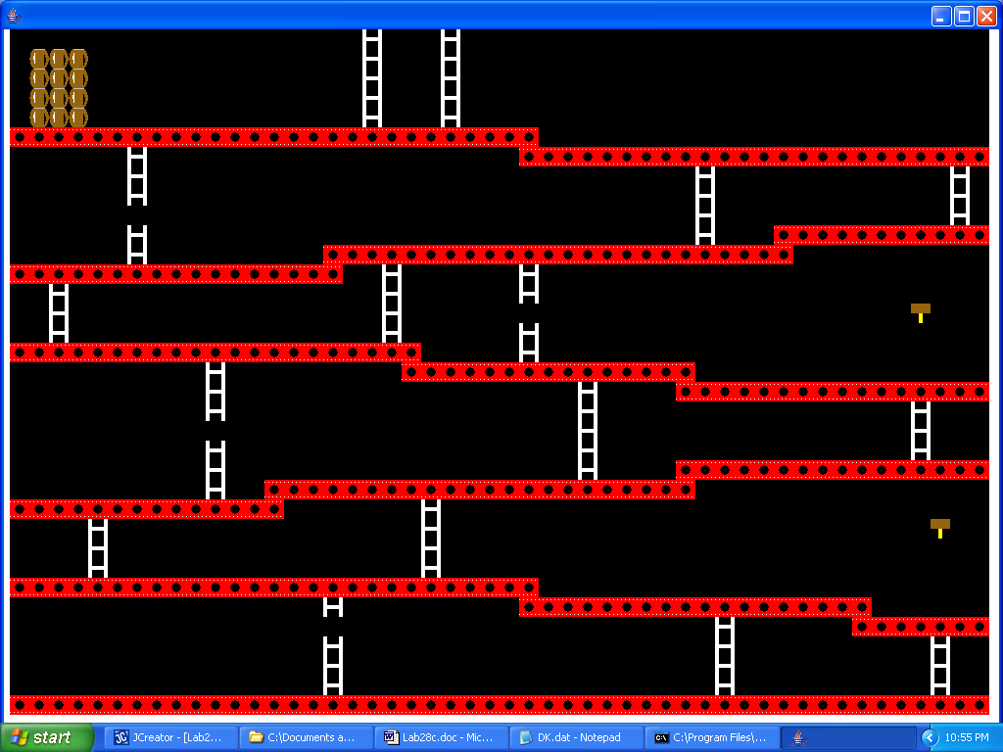

Each text symbol represents a 20 x 20 pixel square on the graphics screen. Your display needs to have 35 rows and 50 columns. NOTE: The file will have 36 rows. The first row (row 0) will not be visible since the title bar of the graphics window covers it up. You will also need to adjust the output 10 pixels down and 10 pixels over to make the image display properly. This means that the upper-left hand corner of the very first square displayed (row 0, column 0) will be at (10,10). However, since row 0 will not be visible, the upper-left hand corner of the very first visible square (row 1, column 0) will be at (10,30). The next square is at (30,30). The next is at (50,30) and so forth.

The period "." in the text file indicates empty space. The drawSpace method simply requires a 20 x 20 pixel square to be drawn in the desired background color. You need to come up with at least 4 other characters and corresponding images. You also need a drawUnknown method which will draw something (like a ?) to indicate the user has a character in the file that is not one from your list.

This is a multi-day lab assignment. In addition to writing the program, you need create a text file with your own symbols and to plan a background of your choosing (KEEP IT SCHOOL APPROPRIATE) that your program will draw.

