AP Computer Science II | Java Unit Lab Assignment # 31a
The "Polymorphic List" Program |  | 80, 90 & 100 Point Versions
Assignment Purpose:

Demonstrate understanding of abstract interfaces, abstract classes, implementation classes and using methods polymorphically.

This is not a very practical program. Java has some perfectly working classes for you like ArrayList, LinkedList, HashSet and TreeSet. Now you are going to write a program that will simulate most of these classes using Java static arrays. Just keep in mind that the goal of this program is not the capabilities of the classes that you create. The goal is to demonstrate that you understand the logic and syntax of polymorphism.

You are provided with a MyList interface. This interface somewhat resembles the Collection interface. You will note in the MyList declaration below that there are four abstract methods that will need to be implemented. You mission is to write classes MyStack, MyQueue, MySet and MyOrdList. Each one of these classes will implement the four methods below.

All four classes implement isEmpty and getSize the same way. Method isEmpty returns true if the object is empty and false otherwise. Method getSize returns the number of elements stored in the specified object.

abstract interface MyList
{
public abstract void add(int x);

public abstract int remove();

public abstract boolean isEmpty();

public abstract int getSize();
}

Methods add and remove are explained in the matrix below. Some implementations are identical and others are quite different.

Method | MyStack | MyQueue | MySet | MyOrdList
add | Adds new elements to the front of the list by pushing existing elements to the next location. | Adds new elements to the end of the list. | Adds new elements to the end of the list, provided the element is not already stored in the object. | Adds new elements in the list location, such that the list is always in ascending order.
remove | The net result is that elements are removed from the front of the list. Do not be concerned whether this is practical or not. The MyStack class and the MyQueue class behave as expected. The other classes can be debated but that is not an issue for this program.

Look at the main method below. Everything needed for the 80-point version main method is provided. You will note calls to methods addData and removeData. Each one of these is a static method of the Lab31 class. These are precisely the methods that demonstrate polymorphism, especially the addData method. There will only be one method for adding data and removing data. Yet four different objects will call these methods. If you handle the parameters correctly, the proper personal method for each object will be used where needed. You will also need to write the showData method, which is not polymorphic.

Lab31 80 Point Version | Student Version
import java.util.Random;

public class Lab31st
{
public static void main(String args[])
{
System.out.println("\nLab31 80 Point Version\n");
MyList list1 = new MyStack(100);
MyList list2 = new MyQueue(100);
Random rnd = new Random(12345);
for (int k = 1; k <= 20; k++)
{
int rndInt = rnd.nextInt(20) + 10;
addData(list1,rndInt);
addData(list2,rndInt);
}
showData(list1,list2);
System.out.println();

for (int k = 1; k <= 5; k++)
{
removeData(list1);
removeData(list2);
}
showData(list1,list2);
System.out.println();
}

}

abstract interface MyList
{
public abstract void add(int x);

public abstract int remove();

public abstract boolean isEmpty();

public abstract int getSize();
}

80 Point Version

The 80-point version is limited to implementing the MyStack and MyQueue classes. For every class declaration you need to implement the methods of the MyList interface. However, that is not sufficient. You will also need to store the integer elements in an int array, which needs to be constructed for 100-element capacity. You will use a size field that keeps track of the number of elements that are stored in the array. Do not confuse size with capacity.

Each class needs a constructor, which will construct an integer array with a capacity of 100 elements and sets size to 0.

Each class also needs to redefine the toString method in such a manner that objects are displayed in the manner that is shown in the sample execution.

80 Point Version Execution

Lab31 80 Point Version | One Required Output
Lab31 80 Point Version

[25,22,13,17,14,22,16,20,12,27,19,11,12,25,14,25,18,11,10,21]

[21,10,11,18,25,14,25,12,11,19,27,12,20,16,22,14,17,13,22,25]

[22,16,20,12,27,19,11,12,25,14,25,18,11,10,21]

[14,25,12,11,19,27,12,20,16,22,14,17,13,22,25]

Press any key to continue...

90 Point Version

The 90-point version implements the MyStack, MyQueue and MySet classes. You will need to do more than add a third class to a functional 80-point version. You will also need to alter the provided main method to test the third class and alter the other static methods as well.

90 Point Version Execution

Lab31 90 Point Version | One Required Output
Lab31 90 Point Version

[25,22,13,17,14,22,16,20,12,27,19,11,12,25,14,25,18,11,10,21]

[21,10,11,18,25,14,25,12,11,19,27,12,20,16,22,14,17,13,22,25]

[21,10,11,18,25,14,12,19,27,20,16,22,17,13]

[22,16,20,12,27,19,11,12,25,14,25,18,11,10,21]

[14,25,12,11,19,27,12,20,16,22,14,17,13,22,25]

[14,12,19,27,20,16,22,17,13]

Press any key to continue...

100 Point Version

The 100-point version adds the MyOrdList class. This is the only one of the four classes that will store the integers in an ascending order. Once again you will need to upgrade the main method along with necessary changes to addData, removeData and showData.

100 Point Version Execution

Lab31 100 Point Version | One Required Output
Lab31 100 Point Version

[25,22,13,17,14,22,16,20,12,27,19,11,12,25,14,25,18,11,10,21]

[21,10,11,18,25,14,25,12,11,19,27,12,20,16,22,14,17,13,22,25]

[21,10,11,18,25,14,12,19,27,20,16,22,17,13]

[10,11,11,12,12,13,14,14,16,17,18,19,20,21,22,22,25,25,25,27]

[22,16,20,12,27,19,11,12,25,14,25,18,11,10,21]

[14,25,12,11,19,27,12,20,16,22,14,17,13,22,25]

[14,12,19,27,20,16,22,17,13]

[13,14,14,16,17,18,19,20,21,22,22,25,25,25,27]

Press any key to continue...

AP Computer Science II | Java Lab Assignment # 31B
The Multiple Traffic Signs Program | 80, 100 & 110 Point Versions
Assignment Purpose:

Demonstrate knowledge of the Interfaces, Abstract Classes, and Polymorphism.

This program will look similar to Lab25A – The Stop Sign Program, but it is only similar in initial appearance. You need to write a program that will display 4 different traffic signs. One of the signs happens to be a Stop Sign, but there is also an Old Yield Sign, a No Parking Sign and a Rail Road Crossing Sign.

This program is not a mere graphics assignment. Important Chapter 31 topics need to be used in the assignment. You are required to have an interface, an abstract class, and polymorphism.

The student file provides you with the interface:

abstract interface Sign
{
abstract public void drawShape(); // draws shape of the sign
abstract public void drawPole(); // draws the pole the sign rests on
abstract public void drawText(); // draws the text on the sign
}

This interface is implemented by an abstract class called TrafficSign. TrafficSign provides a few attributes, a constructor to initialize those attributes, and the implementation of the drawPole method. All signs use the same pole. The other methods are still abstract at this level since the shape and text are different on each traffic sign.

The StopSign class inherits from the TrafficSign class and implements the rest of the methods. You are provided with the majority of the StopSign class. The only method in this class that you need to write for yourself is drawText. Pay particular attention to the drawShape method as it demonstrates the use of the provided RegPolygon class.

NOTE: No explanation of the RegPolygon class will be provided.

Experimenting with the parameters is a good way to figure out what they do and how to use them.

You need to write the OldYieldSign, NoParkingSign and the RRCrossingSign classes completely on your own.

Polymorphism is accomplished with the drawTrafficSign method which you also need to write.

Lab31bst.java Provided Student File
// Lab31bst
// The Multiple Traffic Signs Program
// Student Version

import java.awt.*;
import java.applet.*;

public class Lab31bst extends Applet
{

public void paint(Graphics g)
{
StopSign stop1 = new StopSign(g,100,100,100,300);
StopSign stop2 = new StopSign(g,100,225,400,300);
OldYieldSign yield1 = new OldYieldSign(g,125,350, 75,325);
OldYieldSign yield2 = new OldYieldSign(g,125,475,475,275);
// NoParkingSign noPark1 = new NoParkingSign(g,100,600,100,300); // 100 & 110 Point Version Only
// NoParkingSign noPark2 = new NoParkingSign(g,100,725,400,300); // 100 & 110 Point Version Only
// RRCrossingSign rrx1 = new RRCrossingSign(g,100,850,100,300); // 110 Point Version Only
// RRCrossingSign rrx2 = new RRCrossingSign(g,100,900,550,200); // 110 Point Version Only

drawTrafficSign(stop1);
drawTrafficSign(stop2);
drawTrafficSign(yield1);
drawTrafficSign(yield2);
// drawTrafficSign(noPark1); // 100 & 110 Point Version Only
// drawTrafficSign(noPark2); // 100 & 110 Point Version Only
// drawTrafficSign(rrx1); // 110 Point Version Only
// drawTrafficSign(rrx2); // 110 Point Version Only
}

public void drawTrafficSign( )
{

}
}

class RegPolygon
{
public RegPolygon(Graphics g, int radius, int centerX, int centerY, int sides, Color fillColor, double offset)
{
double twoPI = 2 * Math.PI;
int xCoord[] = new int[sides];
int yCoord[] = new int[sides];

g.setColor(fillColor);
for (int k = 0; k < sides; k++)
{
xCoord[k] = (int) Math.round(Math.cos(twoPI * k/sides - offset) * radius) + centerX;
yCoord[k] = (int) Math.round(Math.sin(twoPI * k/sides - offset) * radius) + centerY;
}
g.fillPolygon(xCoord,yCoord,sides);
}
}

abstract interface Sign
{
abstract public void drawShape();

abstract public void drawPole();

abstract public void drawText();
}

abstract class TrafficSign implements Sign
{
protected Graphics g;
protected int centerX, centerY;
protected int height;

public TrafficSign(Graphics g1, int x, int y, int h)
{
g = g1;
centerX = x;
centerY = y;
height = h;
}

public void drawPole()
{
g.setColor(Color.black);
g.fillRect(centerX-7,centerY,15,height);
}

abstract public void drawShape();

abstract public void drawText();
}

class StopSign extends TrafficSign
{
protected Graphics g;
protected int centerX, centerY;
protected int radius;

public StopSign(Graphics g1, int r, int x, int y, int height)
{
super(g1, x, y, height);
g = g1;
centerX = x;
centerY = y;
radius = r;
}

public void drawShape()
{
RegPolygon rp = new RegPolygon(g,radius,centerX,centerY, 8, Color.red, Math.PI/8);
}

public void drawText()
{

}
}

80-Point Version Specifics

In the 80-point version, you need to complete the StopSign class and also write the OldYieldSign class from scratch. The reason the class is called OldYieldSign is that you are not drawing the modern red and white yield sign. Many years ago -- decades actually -- yield signs were yellow.
It is the old yellow yield sign that you are creating.

You also need to complete the drawTrafficSign method. This method is supposed to draw the pole, shape, and text of the sign polymorphicly.

80-Point Version Output

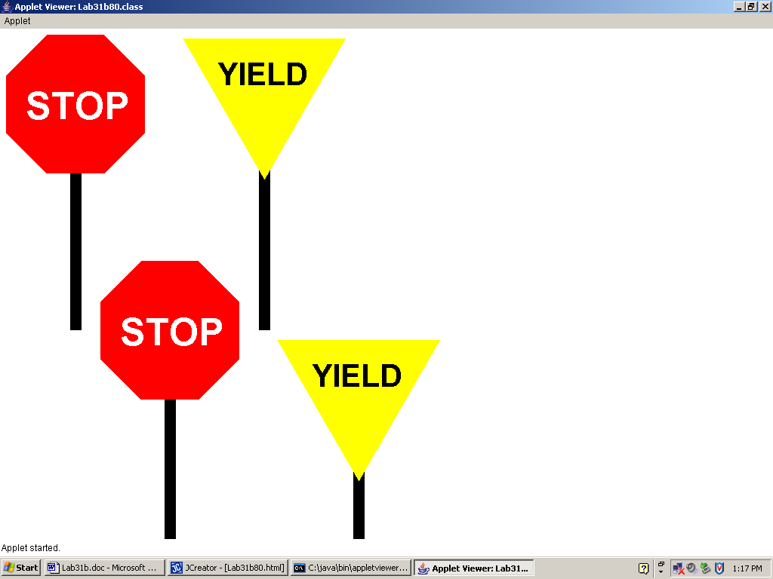

100-Point Version Specifics

In the 100-point version, you need to do everything specified in the 80-Point Version and then also write the NoParkingSign class from scratch. In the NoParkingSign class you are allowed to make the diagonal line (the one that goes on top of the P) part of the drawText method.

100-Point Version Output

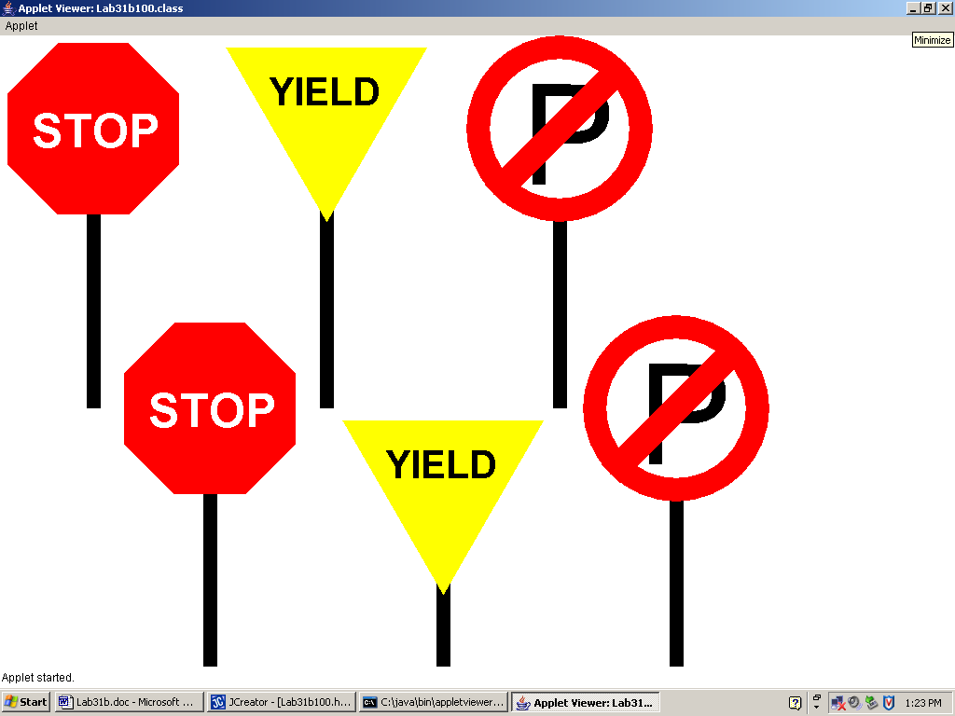

110-Point Version Specifics

In the 110-point version, you need to do everything specified in the 100-Point Version and then also write the RRCrossingSign class from scratch.

NOTE: The pole is NOT supposed to show behind the RRCrossingSign.

110-Point Version Output

