AP Computer Science II | Java Unit Lab Assignment # 32a
The "Disappearing Squares" Program |  | 80 & 100 Point Versions
Assignment Purpose:

The purpose of this program is to use recursion to draw a set of squares,
which become smaller as they reach the other side of the screen.

Write a program which start by drawing a 200 X 200 square at the top-left corner of the monitor. Continue drawing squares that become steadily smaller as they are displayed to right side of each preceding square. The bottom of the square stays at the same level. Each square is 25 percent smaller than the previously drawn square. Start with the student version, shown below.

Provided Student Program for Lab32a

// Lab32ast.java
// The student version of the Lab32a assignment.

import java.awt.*;
import java.awt.event.*;

public class Lab32ast
{
public static void main(String args[])
{
Windows win = new Windows();
win.setSize(1000,750);
win.addWindowListener(new WindowAdapter() {public void
windowClosing(WindowEvent e) {System.exit(0);}});
win.show();
}
}

class Windows extends Frame
{

}

In the student version you are provided with a completed main method. This method is designed to execute graphics application, which done by completing the Windows class. Make no changes to the main method.

Inside the Windows class, you will need to use a paint method that controls the graphics output with an object of the Graphics class. You will also need to create a method, called drawSquare, which actually draws the squares and calls itself recursively until the base case is reached.

The recursive process exits when it is true that either the square size becomes smaller than four pixels or the border of the monitor is reached. You must be aware that only full-sized squares must be displayed. Keep this in mind as you determine if you are reaching the border of the monitor.

This program may seem very familiar. It is a repeat of Lab Assignment 19b, which you may have done during the first-year course. This assignment is a good practice in preparation for the next assignment, which is quite a bit more challenging.

80 Point Version

The 80 point version draws one set of squares from left to right, starting with a 200X200 square
that is drawn with a top-left corner at coordinate (0,100). Each square is drawn with a 10 pixel space between the squares.

100 Point Version

The 100 point version draws a second set of squares in the same manner as the 80 point version, but this time the large square start on the right side and successive squares are drawn moving to the left side of the screen.

80 Point Execution

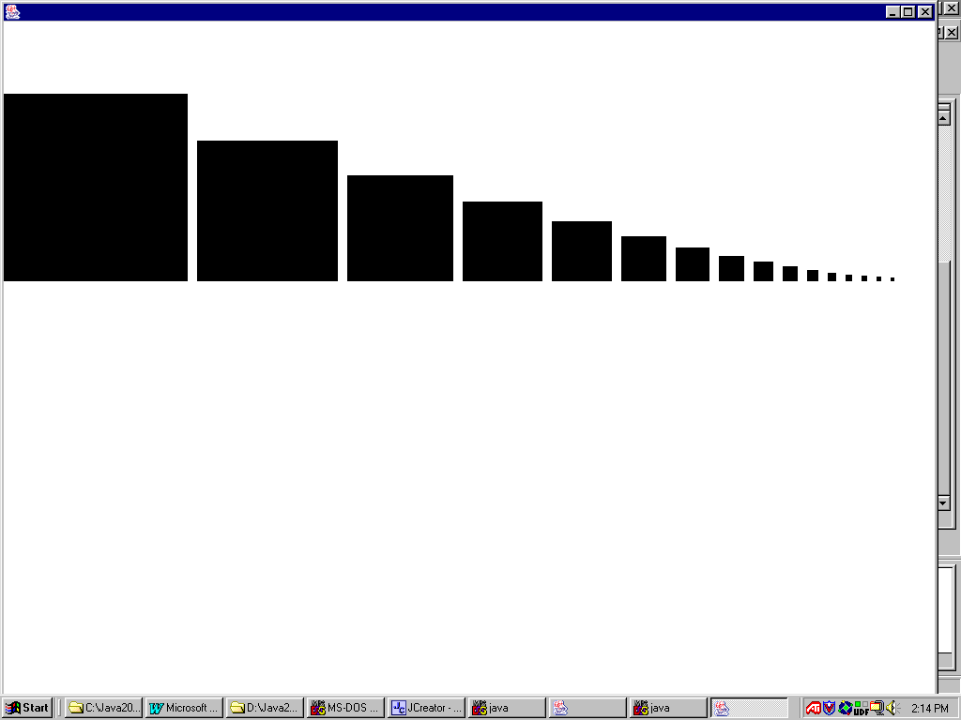

100 Point Execution

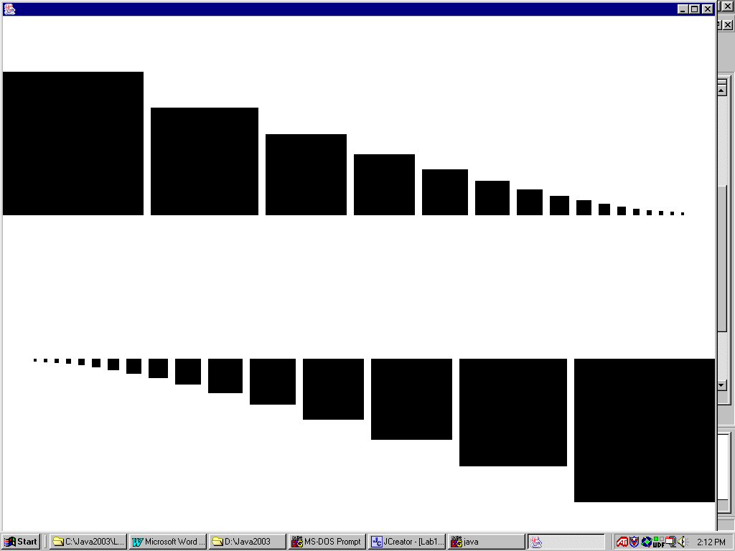

AP Computer Science I | Java Unit Lab Assignment # 32b
The "Square Fractal" program |  | 80 & 100 Point Versions
Assignment Purpose:

The purpose of this program is to display a sophisticated knowledge of recursion by writing a program that uses a variety of recursive features.

Write a program that draws a square fractal. Fractals are images that keep repeating their own image in ever-smaller versions. There exists numerous fractals and some fractals rely on computation of advanced mathematics. All fractals have a recursive quality and provide an ideal platform for practicing recursive concepts. This lab assignment is easiest to explain by first looking at the result of the 100-point execution below. You will note that from the four corners of the center rectangle, smaller rectangles are drawn and each rectangle in turn continues to draw three smaller rectangles until the rectangle is the size of one pixel.

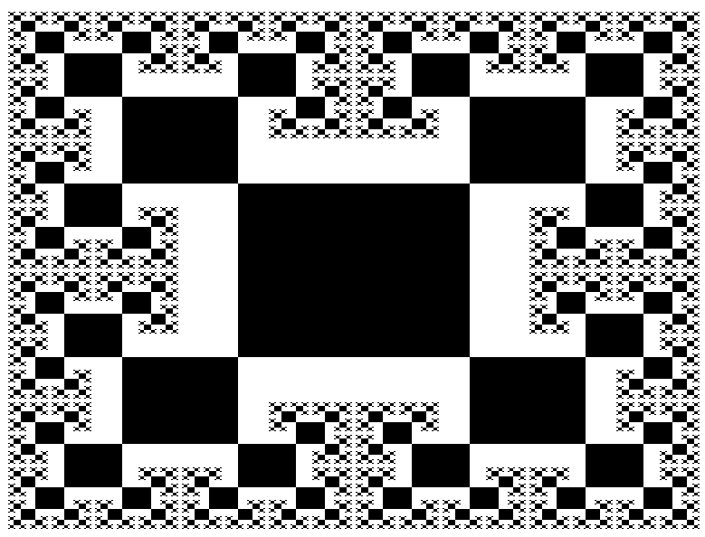

The student version of the program, shown below, demonstrates that the paint method only makes a single method call. This is a call to method drawSquare1, which is the very first square to be drawn, in the center of the monitor. The parameters, 1024 and 768 represent the monitor resolution. Your program needs to be written in such a manner that the graphics display adjust itself to the initial resolution parameters that are provided. This way you only need to alter one small set of parameters.

// Lab32bst.java
// The student version of the Lab32b assignment.

import java.awt.*;
import java.awt.event.*;

public class Lab32bst
{
public static void main(String args[])
{
GfxApp gfx = new GfxApp();
gfx.setSize(1000,750);
gfx.addWindowListener(new WindowAdapter() {public void
windowClosing(WindowEvent e) {System.exit(0);}});
gfx.show();
}
}

class GfxApp extends Frame
{

public void paint (Graphics g)
{
drawSquare1(g,1024,768);
}

public void drawSquare1(Graphics g, int maxX, int maxY)
{

}

private void delay(double n)
{
for (double k = 1; k < n; k+=0.001);
}

}

Method drawSquare1 gets the ball rolling and draws a solid rectangle in the center of the screen. The initial rectangle needs to be 1/4 the size of the monitor. This explains why it is important to know the screen resolution and why this information is passed by parameter. Method drawSquare1 needs to make four method calls to draw each one of the four rectangles attached to the initial rectangle. Each one of the succeeding rectangles is half the width and height or the preceding rectangle. The delay method is provided so that you can observe the recursive sequence as the fractal picture is drawn. You need to experiment with the delay value, which depends on the speed of your computer.

80-Point Version

The 80-point version of the fractal assignment draws four rectangles at each corner of every rectangle. This does happen from the initial rectangle, but in the earlier "Square Fractal" display you observed that later rectangle are only attached at three corners. Attaching three rectangles is more complicated. For the 80-point version you can happily and recursive keep on calling rectangle methods until the size of the size of the rectangle reaches one pixel. The result is that later, smaller rectangles will cover over earlier, larger rectangles.

80-Point Execution

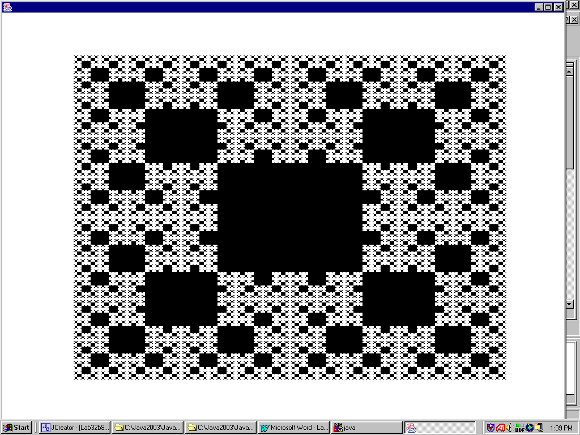

100-Point Version

The 100-point version of the fractal assignment draws only three rectangles at each corner of every rectangle, except for the initial rectangle. This provides you with a unique challenge. How do you prevent drawing over existing rectangles? There are a variety of solutions for this problem, but no hints are provided in this lab assignment.

100-Point Execution

