AP Computer Science II | Java Lab Assignment # 34
The Student Records  Doubly Linked List Program | 80, 90 & 100 Point Versions
Assignment Purpose:

This program requires knowledge of manipulating doubly linked lists.

Write a program that reads in a text file called "students2.dat". (This is the same file you used in Lab 18 last year.) The program will need to store all of the data (Name, ID#, Age, and GPA) into a doubly linked list of Student nodes.

The focus this assignment is Manipulating Doubly Linked Lists and not File Handling. A file is used to make entering all of the information more efficient. The method to read in this file is provided to you; however, this method will only read in the data and create a new Student node. It then calls the insert method which needs to insert the node into its proper location so the doubly linked list is always sorted by GPA in descending order. You need to write the insert method.

Lab34st.java Provided Student File
// Lab34st.java
// The Student Records Doubly Linked List Program
// Student Version

import java.io.*;
import java.util.*;

public class Lab34st
{
public static void main(String args[]) throws IOException
{
DoubleList studentList = new DoubleList();
studentList.getList();
studentList.displayAll();
studentList.pause();

studentList.displayHonorRoll();
studentList.pause();

studentList.displayAcademicProbation();
studentList.pause();

// int studentID = getID();
// Student2Node nodeRef = studentList.search(studentID);
//
// if (nodeRef == null)
// System.out.println("There is no student with an ID# of "+studentID+".\n");
// else
// {
// studentList.displayStudent(nodeRef); // displays the information for the found student
// studentList.pause();
// studentList.delete(nodeRef); // remove the same student from the List
// studentList.displayAll();
// studentList.pause();
// }
}

public static int getID()
{
Scanner input = new Scanner(System.in);
System.out.print("\nEnter the 6-digit ID of the student. { 100000 - 999999 } --> ");
return input.nextInt();
}
}

class Student2Node
{
private String name;
private int id;
private int age;
private double gpa;
private Student2Node forward;
private Student2Node back;

public Student2Node (String n, int ID, int a, double g, Student2Node f, Student2Node b)
{
name = n;
id = ID;
age = a;
gpa = g;
forward = f;
back = b;
}

public String getName () { return name; }
public int getID () { return id; }
public int getAge () { return age; }
public double getGPA () { return gpa; }
public Student2Node getForward () { return forward; }
public Student2Node getBack () { return back; }

public void setName (String n) { name = n; }
public void setID (int ID) { id = ID; }
public void setAgee (int a) { age = a; }
public void setGOA (double g) { gpa = g; }
public void setForward (Student2Node f) { forward = f; }
public void setBack (Student2Node b) { back = b; }
}

class DoubleList
{
Student2Node front, back;

public DoubleList()
{
front = back = null;
}

public void getList() throws IOException
{
FileReader inFile = new FileReader("students2.dat");
BufferedReader inStream = new BufferedReader(inFile);
String s1,s2,s3,s4;
int age, id;
double gpa;
while( ((s1 = inStream.readLine()) != null) &&
((s2 = inStream.readLine()) != null) &&
((s3 = inStream.readLine()) != null) &&
((s4 = inStream.readLine()) != null) )
{
String name = s1;
id = Integer.parseInt(s2);
age = Integer.parseInt(s3);
gpa = Double.parseDouble(s4);

Student2Node newStudent = new Student2Node(name,id,age,gpa,null,null);
insert(newStudent);
}
inStream.close();

}

private void insert(Student2Node newStudent)
{

}

public void displayAll()
{
System.out.println("\nDISPLAYING ALL STUDENTS");
System.out.println("\nStudent ID# Student Name Age GPA");
System.out.println("============================================================");

}

public void displayHonorRoll()
{
System.out.println("\nDISPLAYING HONOR ROLL");
System.out.println("\nStudent ID# Student Name Age GPA");
System.out.println("============================================================");

}

public void displayAcademicProbation()
{
System.out.println("\nDISPLAYING ACADEMIC PROBATION");
System.out.println("\nStudent ID# Student Name Age GPA");
System.out.println("============================================================");

}

public void pause()
{
Scanner input = new Scanner(System.in);
String dummy;
System.out.println("\nPress <Enter> to continue.");
dummy = input.nextLine();
}

public void displayStudent(Student2Node p)
{

}

// public Student2Node search(int studentID)
// {
// returns a reference to the proper Student2Node if a student with the matching ID is found
// returns null otherwise

// }

public void delete(Student2Node p)
{

}
}

80-Point Version Specifics

The 80-point version displays 3 lists of student data, all of which are sorted by GPA :
First, a display of all of the student records in descending order.
Second, a display of the Honor Roll students -- whose GPA >= 3.5 – in descending order.
Thirds, a display all of the students on Academic Probation – whose GPA < 2.0 – in ascending order.

80-Point Version Output

This program has a very long output. You will be shown separate screens which show individual stages of the output. Even though these are shown in separate windows, these are all part of the same output.

NOTE:
The output for the 80-point version is the same as the initial output of the 90 and 100-point versions.
To save paper, the windows below, and on the next page, will not be repeated for the other versions of this assignment.

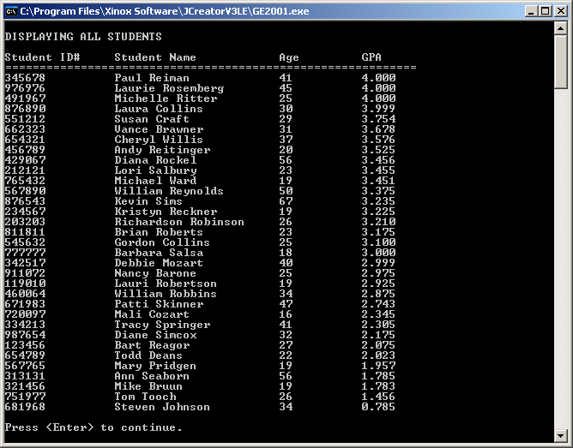
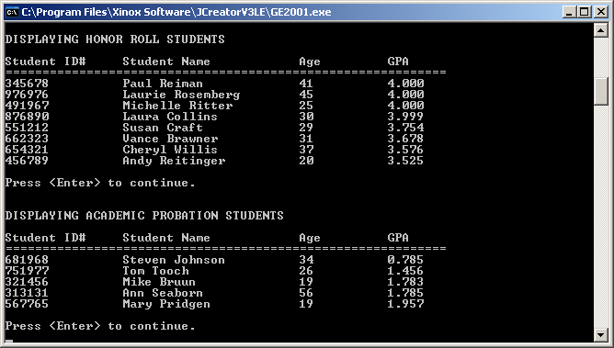

90-Point Version Specifics

The 90-point version requires everything from the 80-point version but adds a linear search. The user needs to be prompted for an ID# (use the provided getID method) and then the search method needs to find and return the reference of the student with that ID#.

Another method that needs to be written is displayStudent. This method uses the reference you obtained as its parameter and then displays all of the information about the student at that particular reference.

90-Point Version Output

The output will include everything you saw in the 80-point version output, plus what is below:

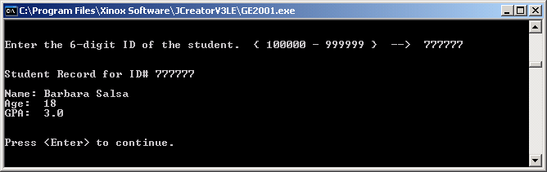
100-Point Version Specifics

The 100-point version requires everything from the 90-point version but adds a delete method to delete the student whose information you displayed at the end of the 90-point version.

100-Point Version Output

The output will include everything you saw in the 80-Point Version Output, plus what is below:

