AP Computer Science II | Java Lab Assignment # 35A
The "Graphical Binary Tree" Program | 80 & 100 Point Versions
Assignment Purpose:

The purpose of this program is to demonstrate logical understanding of Binary Trees and Tree Traversal.

Write a program that draws a graphical binary search tree. You will be drawing a full binary tree with 15 nodes. The tree must be drawn in the actual sequence that it would be formed when the following characters are inserted in this order:

M G D S P A F Q J H K W T N Z

Remember, this is a binary search tree. M will be the root. All characters that alphabetically go before M will be in M’s left subtree. All characters that alphabetically after M will be in M’s right subtree.

You will be provided with a special GfxTreeNode class, which is similar to the GfxNode class that you used in Lab 33A. As before, it is not important that you understand the implementation of the methods in the GfxTreeNode class. Your mission is to know how to use the methods properly.

The GfxTreeNode class is shown below, but only the public method headers and comments are provided. Understanding the implementation of the GfxTreeNode class is not necessary for completing this assignment.

GfxTreeNode Methods Headers and Comments

///////////////////////////////////////////////////////////////////
// GfxTreeNode.java
// Written by Leon Schram 05-27-03
// Updated by John Schram 3/9/2006
// This class allows creating graphical linked lists to simulate various
// linked list configurations
/////////////////////////////////////////////////////////////////////

import java.awt.*;

public class GfxTreeNode
{
private int x; // x coordinate of node
private int y; // y coordinate of node
private final int width; // width of the gfx node
private final int height; // heigth of the gfx node
private final int time; // delay time between displays
char letter;

// GfxNode constructor instantiates an object and stores its Top-Left coordinate (tlx,tly) information, as
// well as the length and width of the node object. A node object with two fields is drawn at the specified coordinate.
public GfxTreeNode(Graphics g, int tlx, int tly, int clr, int dt)

// Method drawNode is a private helper method to draw linked list nodes.
// This method draws a node with two fields at a location of the Top-Left coordinate information in the current object.
private void drawNode(Graphics g, int clr)

// Method getColor a private helper method to make it easier to use colors in a graphics program.
private Color getColor(int clr)
{
Color temp = Color.white;
switch (clr)
{
case 0: temp = Color.black; break;
case 1: temp = Color.red; break;
case 2: temp = Color.green; break;
case 3: temp = Color.blue; break;
case 4: temp = Color.orange; break;
case 5: temp = Color.cyan; break;
case 6: temp = Color.magenta; break;
case 7: temp = Color.yellow; break;
case 8: temp = Color.pink; break;
case 9: temp = Color.white; break;
}
return temp;
}

// Method getX returns the top-left X-coordinate of a linked list node.
public int getx()

// Method getY returns the top-left Y-coordinate of a linked list node.
public int gety()

// Method drawPointer draws a vertical pointer down to an existing node. The first pointer to a node uses OffSet value 1 and the second
// pointer to the same node uses OffSet value 2. The result is that the second pointer is moved farther to the right.
public void drawRootPointer(Graphics g, int clr)

// Method drawPointer draws the reference that is being used to traverse the Tree Node
public void drawPointer(Graphics g, char ltr, int clr)

// Method enterData draws a letter in the Data field of the Tree Node.
public void enterData(Graphics g, char ltr, int clr)

// Method getLetter return the letter stored in the Tree Node
public char getLetter()

// Method drawLeftLink draws a link from the parent to the left child.
public void drawLeftLink(Graphics g, GfxTreeNode endNode, int clr)

// Method drawRightLink draws a link from the parent to the right child.
public void drawRightLink(Graphics g, GfxTreeNode endNode, int clr)

// Method drawLeftNull draws a diagonal g.drawLine in the Left field of a tree node, to indicate a NULL value.
public void drawLeftNull(Graphics g, int clr)

// Method drawRightNull draws a diagonal g.drawLine in the Right field of a tree node, to indicate a NULL value.
public void drawRightNull(Graphics g, int clr)

// Method drawLetter upper-case Letter characters. The characters are drawn in a 9x9 pixel box.
// The (x,y) parameters indicate the coordinate of the top-left corner of the box. Only capital letters and numbers are drawn.
public void drawLetter(Graphics g, char ltr, int x, int y)

// Method delay allows viewing the sequence in which the linked lists are drawn
private void delay(double n)
}

80 Point Version Specifics

The 80 point version draws the tree below in the proper sequence. Keep in mind that whenever any tree node is drawn, its 2 linking nodes, should initially show diagonal lines indicating null values. Later, when a child is created, the null is erased and the link is drawn.

80 Point Version Output

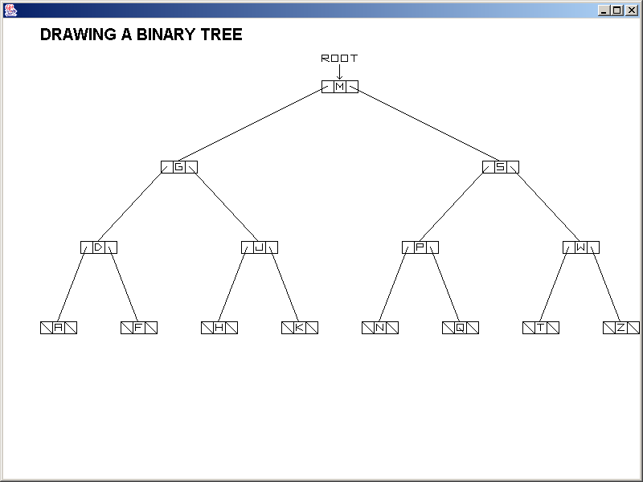

More Details
You will not need to create any new methods for this lab. All of the commands will be entered directly in the paint method. For the 80-point version that is all that is necessary. For the 100-point version, you will need to make use of the addition methods shown on the next page.

Provided Student Program for Lab35A

// Lab35ast.java
// The Graphical Tree Program
// Student Version

import java.awt.*;
import java.awt.event.*;

public class Lab35ast
{
public static void main(String args[])
{
GfxApp gfx = new GfxApp();
gfx.setSize(800,600);
gfx.addWindowListener(new WindowAdapter() {public void
windowClosing(WindowEvent e) {System.exit(0);}});
gfx.show();
}
}

class GfxApp extends Frame
{

private int td = 500; // time delay to slow down graphics display
String title = "";
String oldTitle = "";
String process = "";
String oldProcess = "";
String output = "";

public void paint (Graphics g)
{
g.setFont(new Font("ARIAL",Font.BOLD,20));
displayTitle(g,"DRAWING A BINARY TREE");

}

public void displayTitle(Graphics g, String t)
{
oldTitle = title;
title = t;
g.setColor(Color.white);
g.drawString(oldTitle,50,50);
g.setColor(Color.black);
g.drawString(title,50,50);
}

public void displayProcess(Graphics g, String p)
{
oldProcess = process;
process = p;
g.setColor(Color.white);
g.drawString(oldProcess,100,500);
g.setColor(Color.black);
g.drawString(process,100,500);
}

public void displayOutput(Graphics g, String output)
{
g.setColor(Color.black);
g.drawString(output,100,570);
for (double k = 1; k < td; k+=0.00001);
// The for loop is needed here because no node is accessed here, which means no time delay.

}

public void movePointer(Graphics g, GfxTreeNode oldTreeNode, GfxTreeNode newTreeNode)
{
oldTreeNode.drawPointer(g,'P',9);
newTreeNode.drawPointer(g,'P',0);
}
}

100 Point Version Specifics

The 100-point version displays the same tree as the 80-point version. When finished, a pointer (reference) variable P needs to do an IN-ORDER TRAVERSAL of the tree. As P traverses from node to node a description of what is happening at that node needs to be displayed. This description, as well as the “output”, need to be refreshed at each new node.

There are 6 different descriptions which are shown below:

• STARTING AT THE ROOT
• TRAVERSING TO THE LEFT
• TRAVERSING TO THE RIGHT
• BACK UP TO THE PARENT
• DISPLAY DATA
• FINISHED!

Methods displayTitle, displayProcess, displayOutput, and movePointer are provided to make the process less tedious. These methods make use of the 5 String fields of the GfxApp class.

100 Point Version Output

The output will be displayed in stages. Several of the beginning stages and enduing stages are shown. Keep in mind that several stages have also been left out. Your instructor will demonstrate the output of this lab so you can truly see what it is suppose to do.

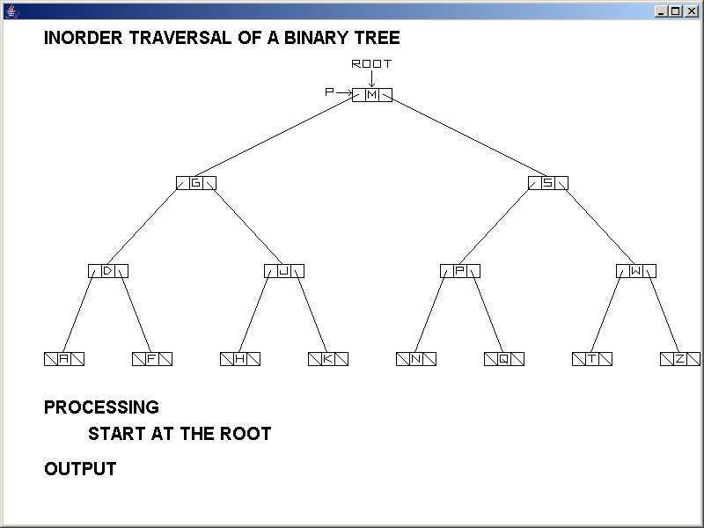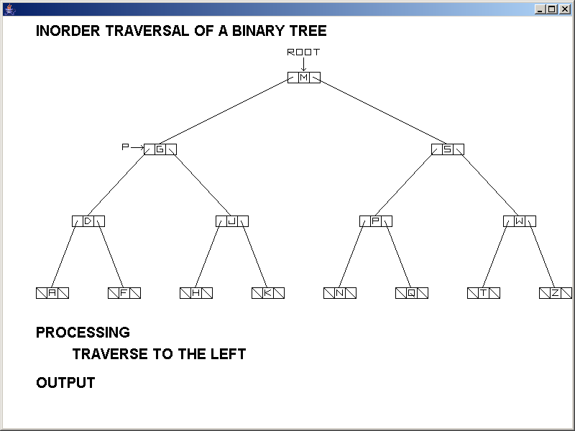

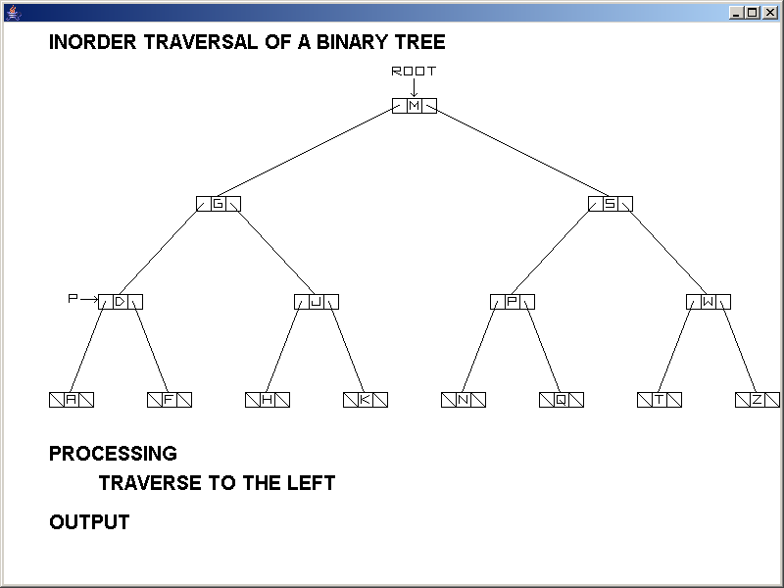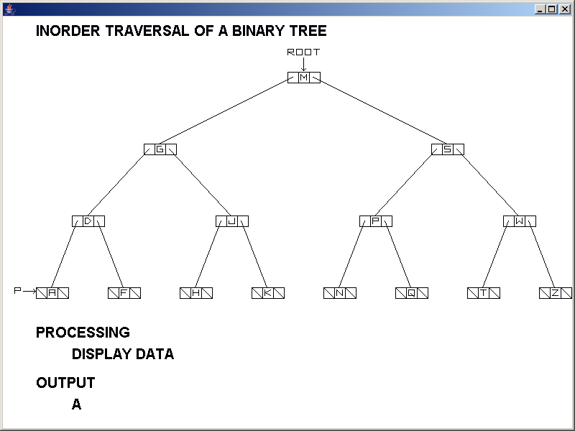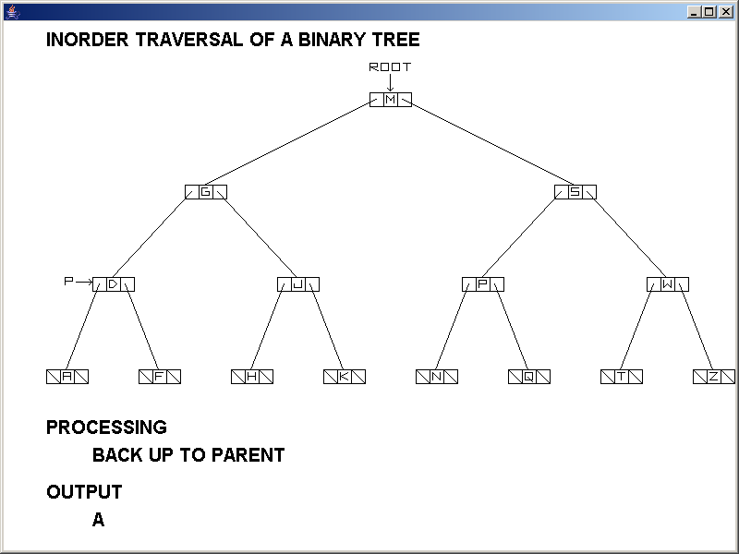
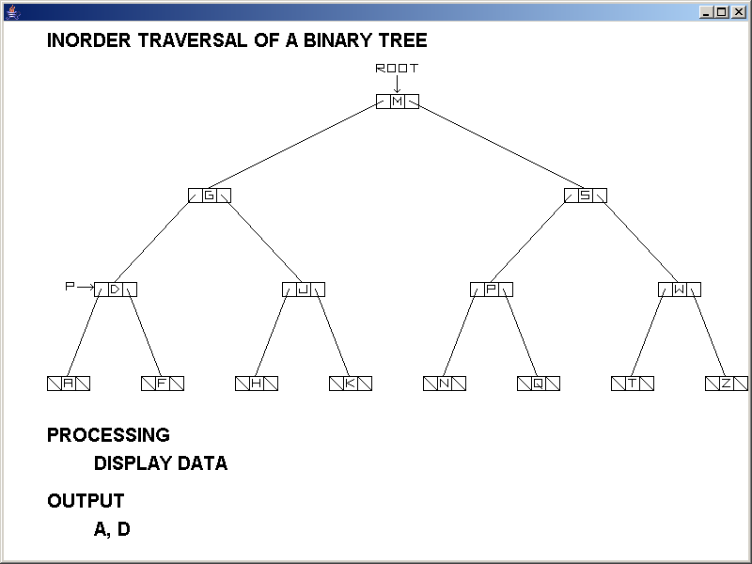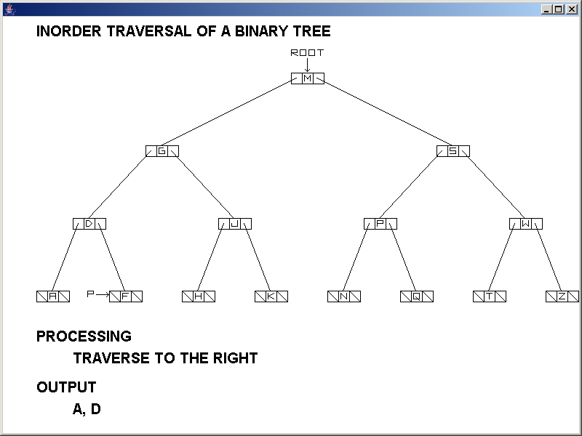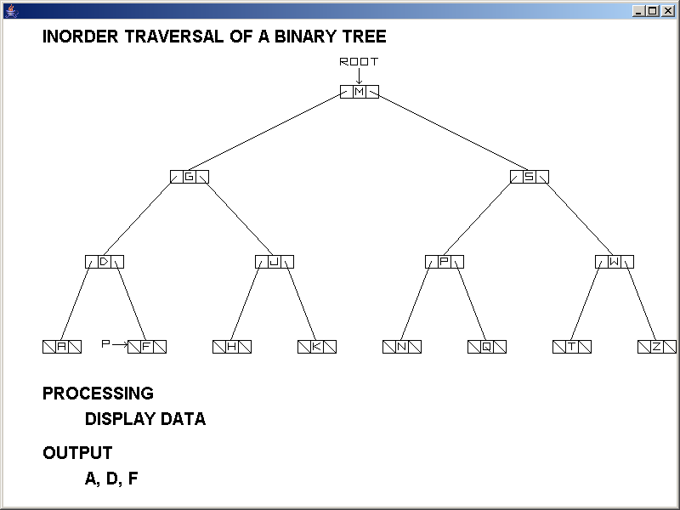

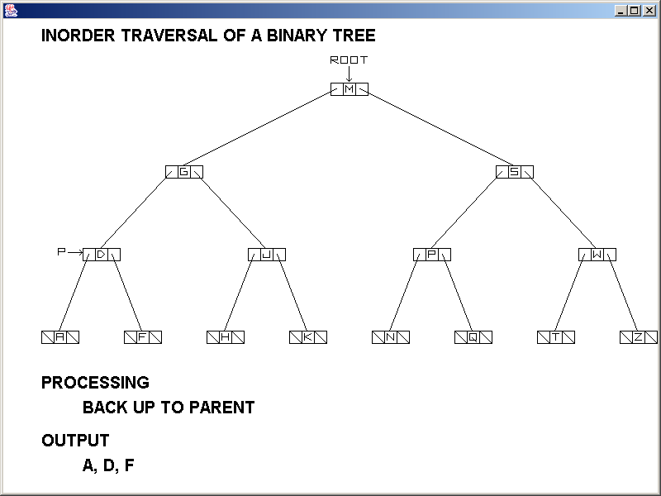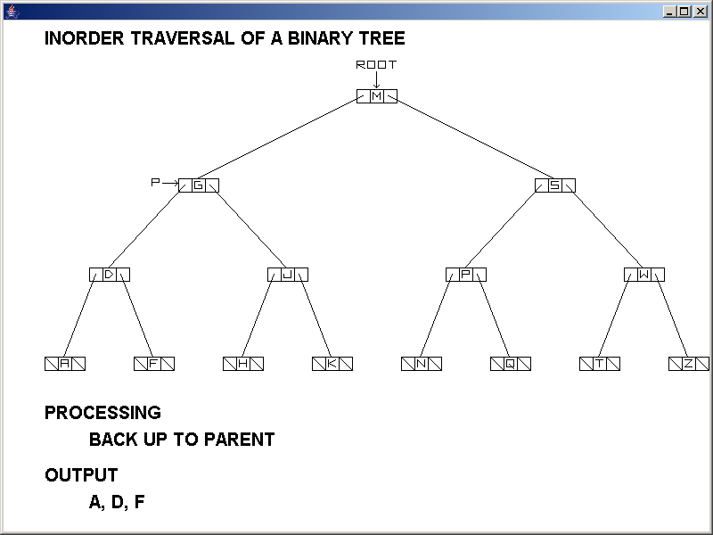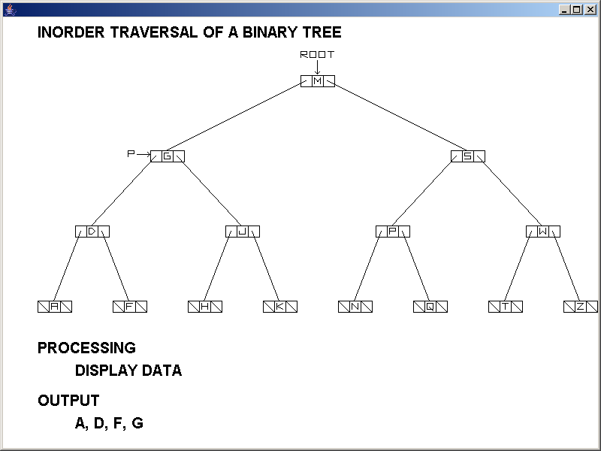

Skipping to the end…

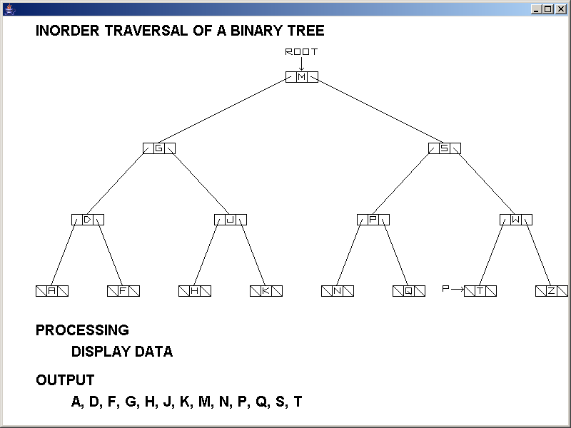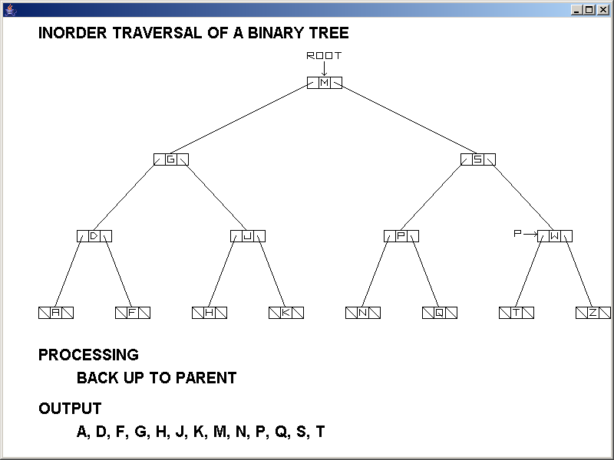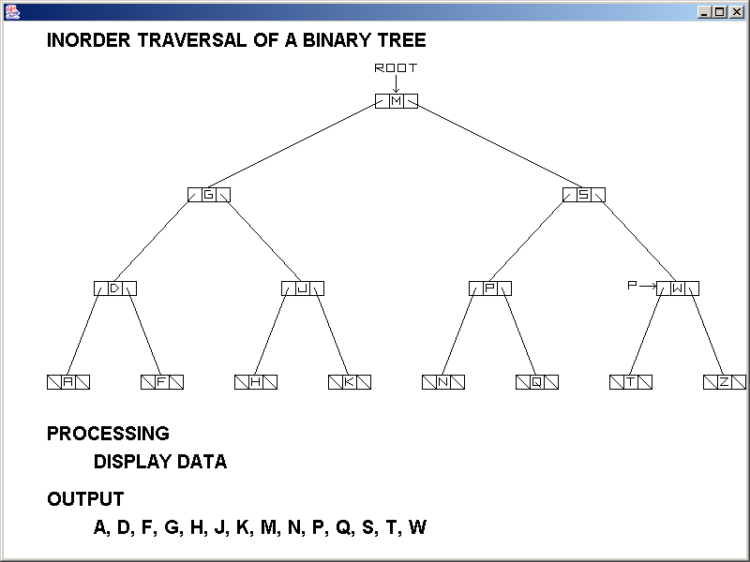

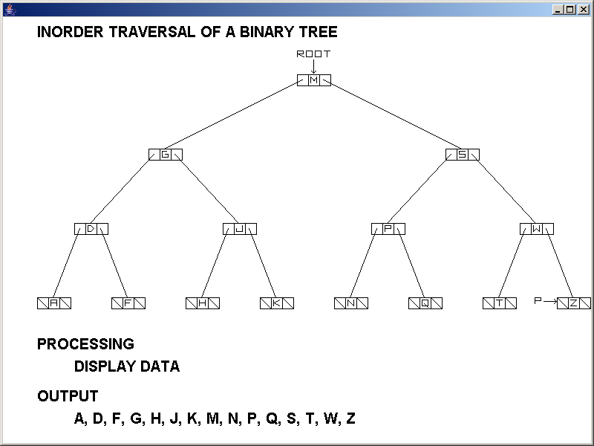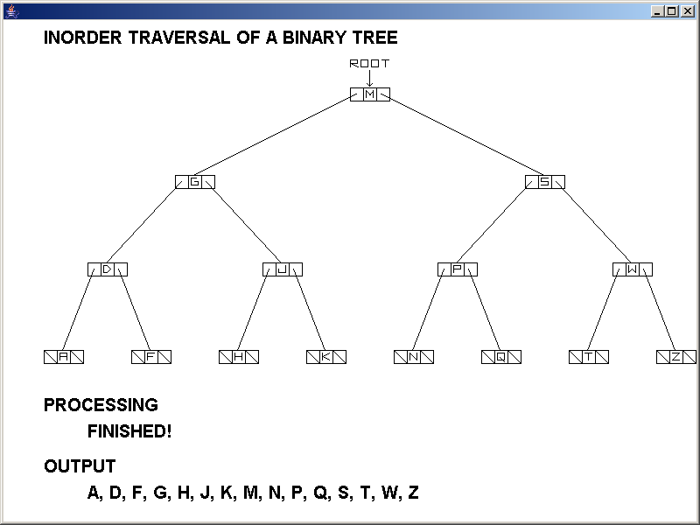

AP Computer Science II | Java Lab Assignment # 35B
The Binary Expression Tree Evaluation Program | 80, 90 & 100 Point Versions
Assignment Purpose:

The purpose of this program is to demonstrate logical understanding of Binary Trees and Tree Traversal.

Write a program that will traverse and evaluate the following binary expression tree:

*
+
7
/
^
5
-
Root
12
3
2
4

You are not concerned with the creation of the binary expression tree. That part is done for you.

Provided Student Program for Lab35B

// Lab35bst.java
// The Binary Expression Tree Evaluation Program
// Student Version

import java.io.*;
import java.util.*;
import java.text.DecimalFormat;

public class Lab35bst
{
public static void main(String args[]) throws IOException
{
ExpressionNode root = ExpressionTree.createTree();

System.out.println("Original Tree");
System.out.println("=============");
System.out.print("\nIn-Fix Notation: ");
ExpressionTree.inOrderTraverse(root);
System.out.print("\n\nPre-Fix Notation: ");
ExpressionTree.preOrderTraverse(root);
System.out.print("\n\nPost-Fix Notation: ");
ExpressionTree.postOrderTraverse(root);
System.out.println("\n");

System.out.println("This tree has "+
ExpressionTree.operatorCount(root)+" operators and "+
ExpressionTree.numberCount(root)+" numbers, and evaluates to "+
ExpressionTree.evaluate(root)+"\n\n");

// ExpressionNode mirrorRoot = ExpressionTree.mirror(root);
//
// System.out.println("\nMirror Tree");
// System.out.println("===========");
// System.out.print("\nIn-Fix Notation: ");
// ExpressionTree.inOrderTraverse(mirrorRoot);
// System.out.print("\n\nPre-Fix Notation: ");
// ExpressionTree.preOrderTraverse(mirrorRoot);
// System.out.print("\n\nPost-Fix Notation: ");
// ExpressionTree.postOrderTraverse(mirrorRoot);
// System.out.println("\n");

// System.out.println("This tree has "+
// ExpressionTree.operatorCount(mirrorRoot)+" operators and "+
// ExpressionTree.numberCount(mirrorRoot)+" numbers, and evaluates to "+
// ExpressionTree.evaluate(mirrorRoot)+"\n");
}
}

class ExpressionNode
{
public ExpressionNode(double initNum, char initOpr, ExpressionNode initLeft, ExpressionNode initRight)
{
num = initNum;
opr = initOpr;
left = initLeft;
right = initRight;
}

public double getNum() { return num; }
public char getOpr() { return opr; }
public ExpressionNode getLeft() { return left; }
public ExpressionNode getRight() { return right; }
public void setNum(int theNewNum) { num = theNewNum; }
public void setOpr(char theNewOpr) { opr = theNewOpr; }
public void setLeft(ExpressionNode theNewLeft) { left = theNewLeft; }
public void setRight(ExpressionNode theNewRight) { right = theNewRight; }

private double num;
private char opr;
private ExpressionNode left;
private ExpressionNode right;
}

class ExpressionTree
{
public static ExpressionNode createTree()
{
ExpressionNode n12 = new ExpressionNode(12,' ',null,null);
ExpressionNode n6 = new ExpressionNode( 6,' ',null,null);
ExpressionNode ndiv = new ExpressionNode( 0,'/',n12,n6);
ExpressionNode n7 = new ExpressionNode( 7,' ',null,null);
ExpressionNode nadd = new ExpressionNode( 0,'+',n7,ndiv);
ExpressionNode n2 = new ExpressionNode( 2,' ',null,null);
ExpressionNode n4 = new ExpressionNode( 4,' ',null,null);
ExpressionNode ncar = new ExpressionNode( 0,'^',n2,n4);
ExpressionNode n5 = new ExpressionNode( 5,' ',null,null);
ExpressionNode nsub = new ExpressionNode( 0,'-',ncar,n5);
ExpressionNode root = new ExpressionNode( 0,'*',nadd,nsub);
return root;
}

public static void inOrderTraverse (ExpressionNode p)
{

}

public static void preOrderTraverse (ExpressionNode p)
{

}

public static void postOrderTraverse (ExpressionNode p)
{

}

public static int numberCount (ExpressionNode p)
{

}

public static int operatorCount (ExpressionNode p)
{

}

public static double evaluate (ExpressionNode p)
{

}

// public static ExpressionNode mirror(ExpressionNode p)
// {

// }
}

80 Point Version Specifics

The 80-point version requires the completion of the 3 traversal methods, 2 counting methods, and the evaluate method. NOTE: The in-order traversal is does not show any parentheses.

80 Point Version Output

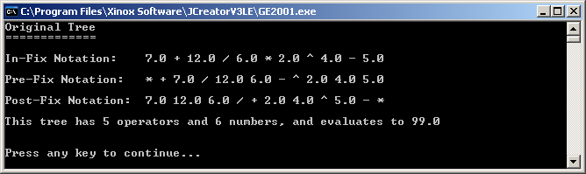

90 Point Version Specifics

The 90-point version is almost identical to the 80-point version. If you look at the In-Fix Notation output in the 80 point version, and used order of operations (PEMDAS) to solve it, you would get an answer of 34 and not 99. The problem is that the parentheses are missing. The 90-point version requires that the inOrderTraverse method is improved to show properly placed parentheses.

90 Point Version Output

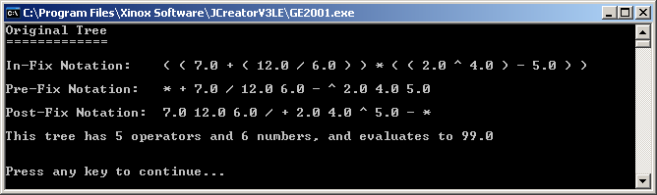

100 Point Version Specifics

The 100-point version adds the mirror method which will create a mirror image of the original binary expression tree. Then this tree is traversed, counted, and evaluated just like the original.

100 Point Version Output

