AP Computer Science II | Java Lab Assignment # 37
The Hexidecimal/Binary Translator | 80 & 100 Point Versions
Assignment Purpose:

This program requires knowledge of manipulating Sets and Maps.

Write a program that will convert an entered Hexadecimal (base16) number into a Binary (base 2) number. The process to do this was actually discussed way back in Chapter 1. Chances are, a review is necessary.
Base 16 | Base 2
0 | 0000
1 | 0001
2 | 0010
3 | 0011
4 | 0100
5 | 0101
6 | 0110
7 | 0111
8 | 1000
9 | 1001
A | 1010
B | 1011
C | 1100
D | 1101
E | 1110
F | 1111

Usually, converting from one base to another -- when neither base is Decimal (base 10) requires a two-step process.

First, convert the given number from the start base to base 10.

Second, convert the base 10 number into the desired base.

However, when converting between bases 2 and 16, the two-step process is not necessary. There exists a special relationship between bases 2 and 16 that allows conversion in one step.

The key is that you do not need to convert the entire number at once. The number can be converted one digit at a time.

The example below should help to make this more clear:

Problem: Convert the hexadecimal number 1023AB5C to binary.

Solution: When we deal with one hex digit at a time, and use this
chart, we see that 1 maps to 0001, 0 maps to 0000,
2 maps to 0010, 3 maps to 0011, etc.

Answer: The hex number converts to 0001 0000 0010 0011 1010 1011 0101 1100 in binary.

You program needs to enter a base 16 number, convert it to base 2 using a Map object, and then display the result.

80 and 100-Point Version Specifics
The difference between the 80 and 100-point versions is that in the 80-point version, you are allowed to assume the user will enter a valid base 16 number. If you look at the validB16 method right now it contains one statement -- return true; For the 80-point version this is fine. For the 100-point version you need to use a keySet to properly determine is a valid base 16 number is entered.

Lab37st.java Provided Student File
// Lab37st.java
// The Hexidecimal/Binary Translator
// Student Version

import java.util.*;

public class Lab37st
{
public static void main (String args[])
{

String[] hex = {"0","1","2","3","4","5","6","7","8","9","A","B","C","D","E","F"};
String[] bin = {"0000","0001","0010","0011","0100","0101","0110","0111",
"1000","1001","1010","1011","1100","1101","1110","1111"};

NumberSystems converter = new NumberSystems(hex,bin);

Scanner input = new Scanner(System.in);

boolean finished = false;
do
{
System.out.print("Enter a base 16 number or \"end\". --> ");
String base16num = input.nextLine();
if (base16num.equals("end"))
finished = true;
else if (converter.validB16(base16num))
{
String base2num = converter.getBinary(base16num);
System.out.println("\n" + base16num + " in hexadecimal converts to " + base2num + " in binary.\n");
}
else
{
System.out.println("\nError, you did not enter a valid hexadecimal number.");
System.out.println("Valid hexadecimal numbers can only containt digits from 0-9 or letters from A-F.");
}
}
while (!finished);
}

}

class NumberSystems
{

private TreeMap base;

public NumberSystems(String[] key, String[] val)
{

}

public String getBinary(String base16num)
{

}

public boolean validB16(String base16num)
{
return true;
}
}

80-Point Version Output

No input protection is necessary. If you enter an invalid character, null will be displayed.

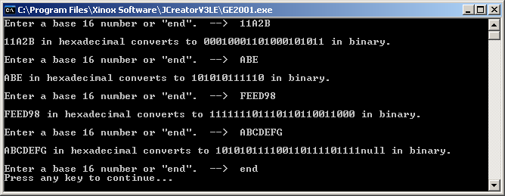

100-Point Version Output

Input protection required.

