AP Computer Science II | Java Unit Lab Assignment # 40A
The "Marbles" Program |  | 70, 80, 100 & 110 Point Versions
Assignment Purpose:

The purpose of this assignment is to demonstrate knowledge of the graphics animation techniques of "double buffering" and multithreading.

Write a Java Applet that displays moving marbles in a window, which bounce in random angles of the window boundaries. The degree of animation of the marbles depends on the point version. Make sure to review multithreading program examples before starting this assignment.

This lab assignment has been greatly motivated by some of the program examples provided by Johannes WallRoth. Johannes Wallroth lives in Berlin and maintains an excellent web site for programmers at www.programming.de.

At this site he shows numerous program examples in multiple program languages along with some very nice tutorials. Check out his site, you will like his examples.

Student Provided Version

The Lab40ast.java program is a good starting point to start to comprehend the lab assignment for Chapter 40. The student version is a partially functional program, which does not execute in a very satisfactory manner. You will see a continuous stream of red marbles drawing on the screen like a fat paintbrush. The paintbrush starts to paint and runs off the screen. It does not bounce off the walls at all. Poor as this starting program might be, it does contain some important principles and components that you will need to use for your assignment. At the same time your considered teacher does not wish to deprive you of important cerebral development.

Start by loading the Lab40ast.java file and create the bytecode file. Remember that this is an applet. You will need to use the Lab40ast.html file to execute the program with appletviewer or some Java enabled web browser.

// Java40ast.java.java
// The Student-provided version of the Lab40a assignment
// This version draws continuous red marbles without erasing any previous marbles.

import java.util.*;
import java.awt.*;
import java.applet.*;

public class Lab40ast extends Applet
{

Marble m; // object of the Marble class
int appletWidth; // width of the Applet window
int appletHeight; // height of the Applet window

public void init()
{
appletWidth = size().width;
appletHeight = size().height;
int initialX = 50;
int initialY = 20;
int initialIncX = 5;
int initialIncY = 5;
m = new Marble(appletWidth,appletHeight,initialX,initialY,initialIncX,initialIncY,Color.red);
}

public void update(Graphics g)
{
paint(g);
}

public void paint(Graphics g)
{
g.setColor(Color.cyan);
g.fillRect(0,0,size().width,size().height);
g.setColor(Color.lightGray);
for (int x = 0; x < appletWidth; x +=50)
g.drawLine(x,0,x,appletHeight);
for(int y = 0; y < appletHeight; y +=50)
g.drawLine(0,y,appletWidth,y);

for (int k = 1; k <= 1000; k++)
{
m.moveMarble();
m.showMarble(g);
}
}

}

class Marble
{
int width, height; // dimensions of the applet boundaries
int size; // diameter of the marble
int xCoord, yCoord; // coordinates of the marble
int incX, incY; // X and Y increment values for the next marble position
Color clr; // marble color

public Marble(int w, int h, int x, int y, int adjustX, int adjustY, Color c)
{
width = w;
height = h;
size = 30;
xCoord = x;
yCoord = y;
incX = adjustX;
incY = adjustY;
clr = c;
}

public void moveMarble()
{
xCoord += incX;
yCoord += incY;

// This is the only method that needs to be completed for the 70-point version.
}

private void delay(long n)
{
for (long k = 1; k < n; k++);
}

public void showMarble(Graphics g)
{
g.setColor(clr);
g.fillOval(xCoord,yCoord,size,size);
delay(1000000);
}

}

Student Provided Version Output
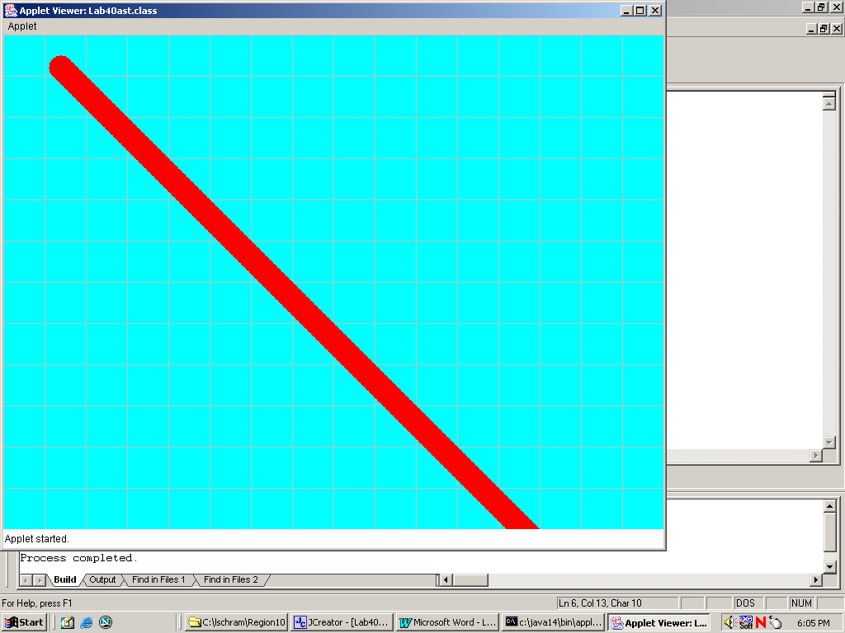
70 Point Version

The 70-point version completes the moveMarble method so that the "paintbrush" marbles bounce off the Applet window boundaries. The student version increases the xCoord and the yCoord values by a fixed amount. Nothing is done to see if the window boundary is reached. Your first job is to make the program behave like the sample execution below.

70 Point Version Required Output

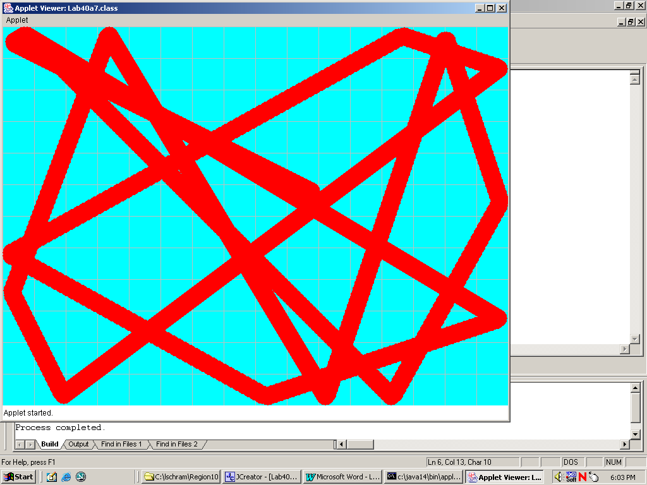

80 Point Version

The 80-point version starts to look like a "marble" program. A single marble moves happily along the Applet window, bouncing randomly off the boundaries. You will need to make some considerable changes to reach this stage.

The 70-point version made no attempt to erase any previous marbles, which resulted in the fat paintbrush. You could actually try to create some type of eraseMarble method and that might work. It will flicker a lot and there will be problems when you move up to higher point versions.

It is time to use double buffering techniques with virtual memory. This means that you need to draw a virtual image of the screen each time that the marble moves. This image is drawn very rapidly in memory and flipped into the display screen fully finished. This technique eliminates the need to erase any previous drawings.

There is a secondary issue, which is threading. Java is one of the few program languages, which supports multi threading. Now it may not be that big a deal to be concerned with threading as you draw a single marble, but the 100-point version expects you to move six marbles at the same time in six different random patterns. This is exactly what multi-threading is all about. It is wise to go ahead and use this technique already for the 80-point version.

The data fields of the 80-point version are provided below. Keep in mind that you have sample programs in the animation chapter that explain both double buffering with virtual memory and multithreading techniques.

public class Lab40a8 extends Applet implements Runnable
{
Thread execution; // control animation execution sequence
Marble m; // object of the Marble class
int appletWidth; // width of the Applet window
int appletHeight; // height of the Applet window
Image virtualMem; // stores the virtual graphics image
Graphics gBuffer; // graphics object used to draw into the virtual memory

80 Point Version Required Output

The sample output, shown below, does not tell the story of this version. This comes as no big shock since this is a lab assignment for animation, and animation is difficult to print on your average laser printer. We could print multiple sample outputs, with each output showing the next stage of the marble, but that would be tedious and waste paper.

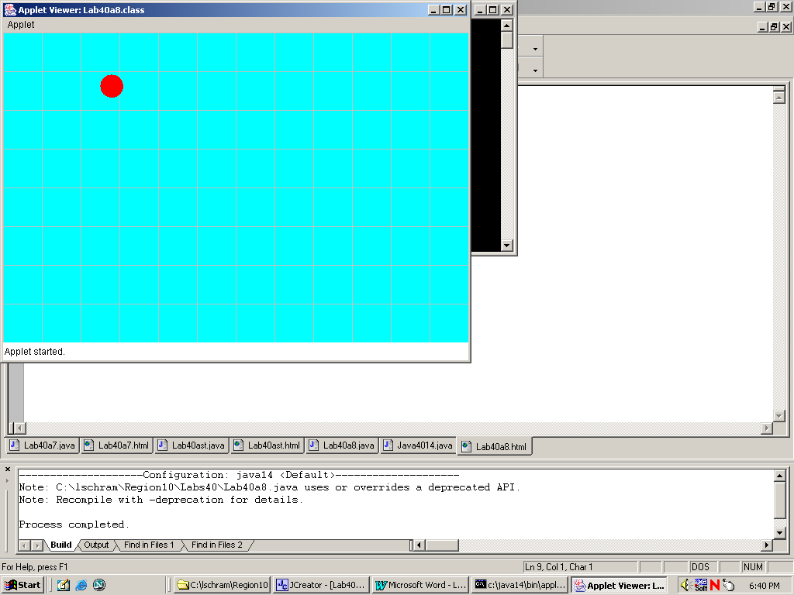

100 Point Version

The 100-point version is the first version that really looks interesting. You will need to write the program so that six marbles move simultaneously along the Applet window. The program is actually quite similar to the 80-point version with some clever multi-threading techniques applied. It will also be very practical to create an array of Marble objects. Once again, the flavor of the execution cannot be depicted by the printed display. At the start of the execution, position the six marbles so that they follow each other in one neat diagonal line. After each marbles bounces off the wall, it will then start its own random journey through its universe.

100 Point Version Required Output at the Start

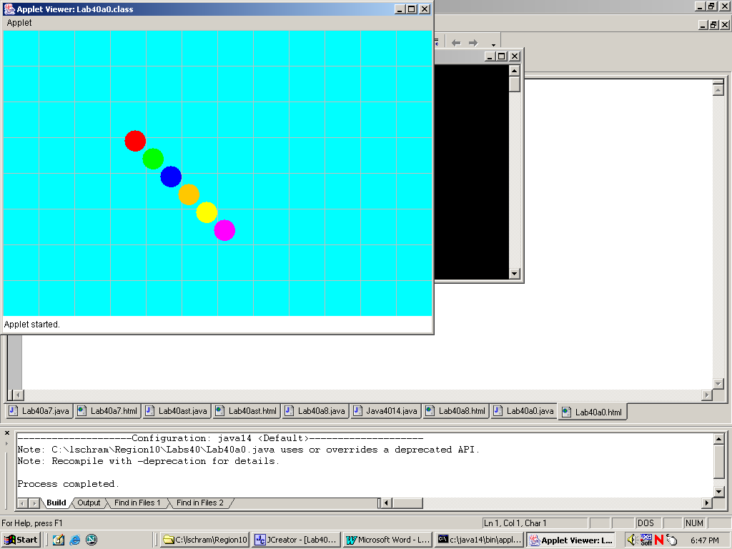

100 Point Version Sample Output Later During Execution

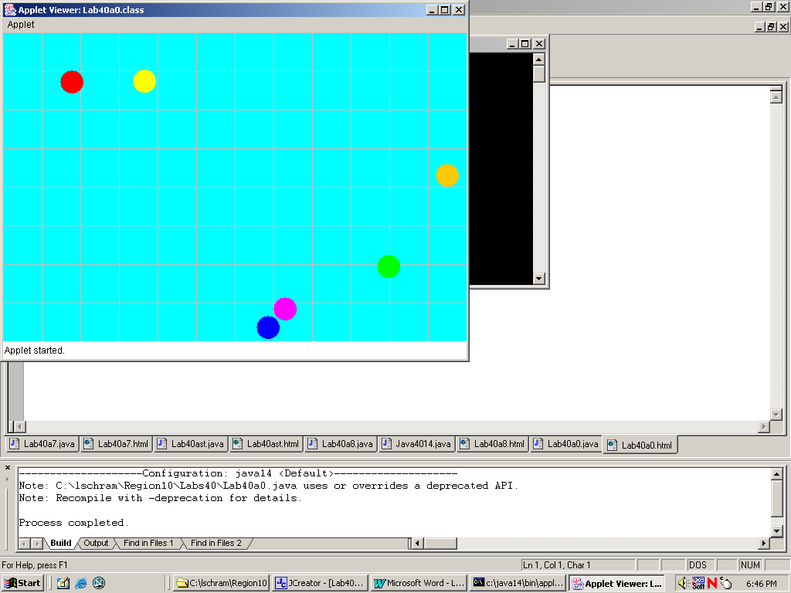

110 Point Version

The 110-point, extra credit version, adds an interesting touch of sophistication. Once again six marbles take off, ready to bounce randomly off the walls. But now there is a twist. Anytime a marble collides into another marble, both marbles bounce off each other and move in the opposite direction. It is not necessary to compute any exotic physics formulas. This is not a pool table. Just send the marbles back in the opposite direction.

110 Point Version Sample Output

