TBMI26 – Computer Assignment Reports  
Boosting

Deadline – February 26 2018

Author/-s:

Villiam Rydfalk

Jonathan Sjölund

In order to pass the assignment you will need to answer the following questions and upload the document to LISAM. If you meet the deadline we correct the report within one week after the deadline. Otherwise we give no guarantees when we have time.

1. **Plot how the classification accuracy on training data and test data depend on the number of weak classifier (in the same plot). Be sure to include the number of training data (non-faces + faces) and the number of Haar-Features.**

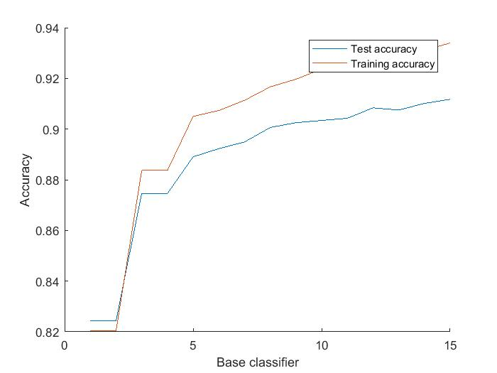

***Figure 1:*** *Training and test accuracy*

Number of training samples: 1500

Number of Haar-Features: 200

1. **How many weak classifiers did you chose before testing the data?**

Number of weak classifiers: 15

1. **How many weak classifiers did you use for final strong classifier? Why?**

Number of weak classifiers: 15. We choose the same number of weak classifiers for testing and training just to see better how much the accuracy changes between the two.

1. **What is the accuracy on the test data after applying the optimized strong classifier?**

Accuracy: 0.9117 = 91.17 %

1. **Plot some of the misclassified faces and non-faces that seem hard to classify correctly.**

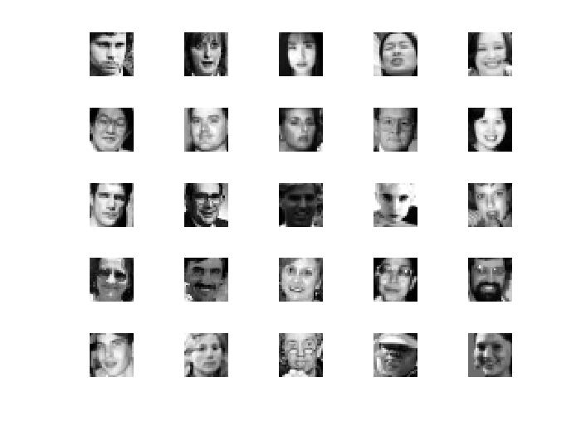

***Figure 2:*** *Misclassified faces*

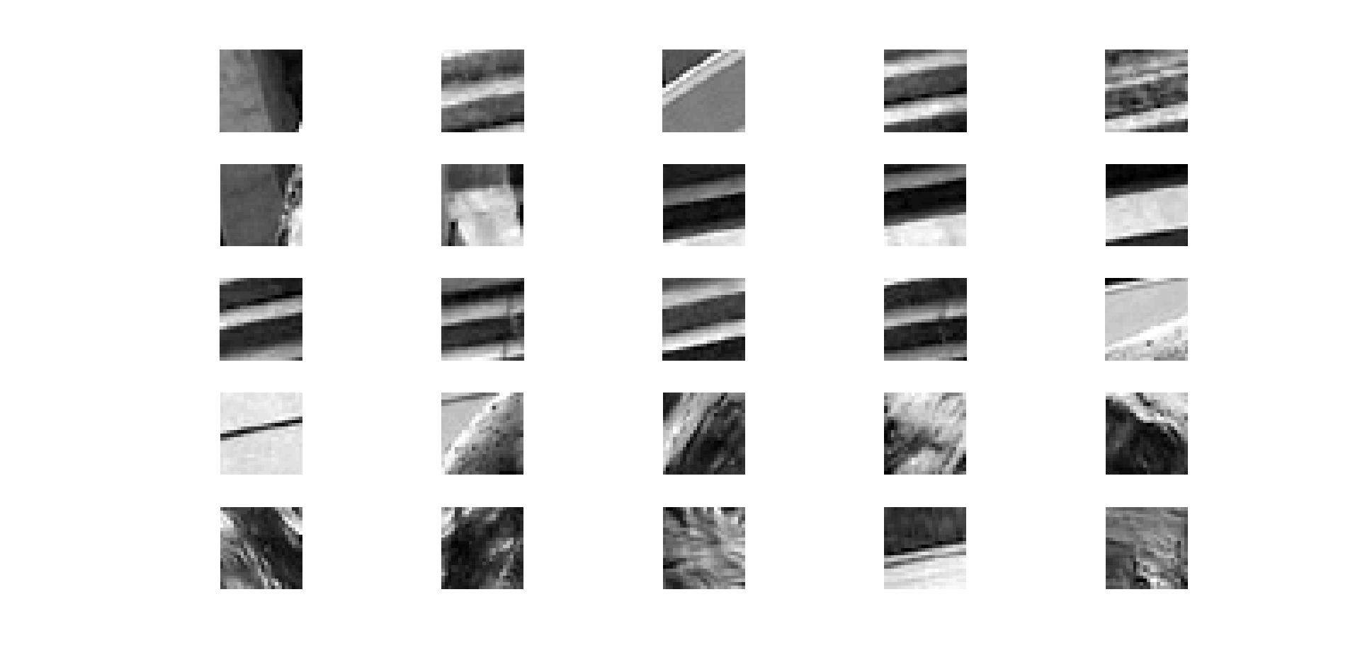

***Figure 3:*** *Misclassified non-faces*

1. **Defend your results. Are they reasonable?**

Yes, test accuracy is lower than training accuracy in the end which is reasonable. The misclassified faces seem reasonable hard since some faces has glasses, some faces have shadow over the eyes and some have even closed eyes and since the eyes are an extremely good for recognizing faces it makes it harder to classify.

For non-faces the system may find parts of the figure that has similar characteristics as details in faces. For example, a ridge that could be interpreted as a nose ridge, two dark slits that could be interpreted as two closed eyes.

1. **Can we expect perfect results?**

If we use enough Haar features, it may be possible, but it will be extremely computationally heavy. In practice we cannot expect it!