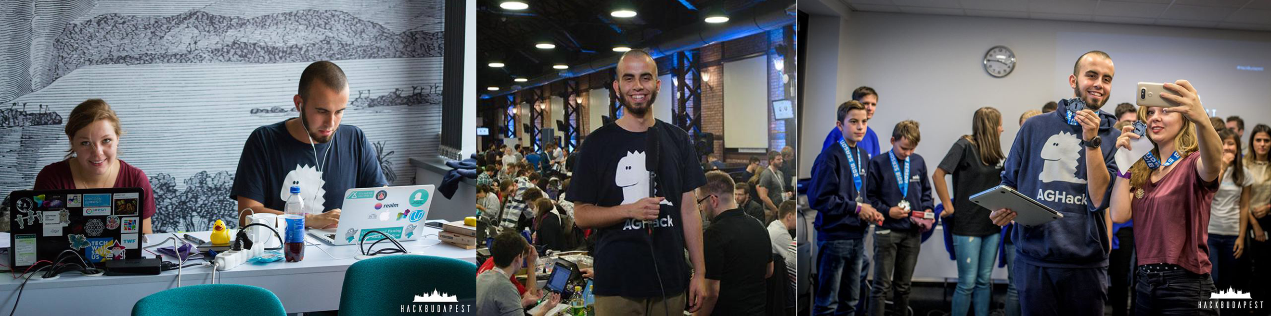

Hey there!

I’m Konrad and I’ve spent my whole career in developer ecosystem. I used to work as an iOS software engineer, developer advocate and developer community engineer but also used to do management and leadership pretty regularly. I really enjoy writing software in Swift, JavaScript and Python and using the last one for data analytics and automation. Being super passionate about anything developer ecosystems, product engineering and research, I’m always willing to engage in projects bringing added value!

When it comes to my educational background, I have a Master’s degree from AGH University of Science and Technology where I studied Computer Science and Econometrics. My Bachelor’s degree thesis was about: Data Science using Python, while in my Master’s thesis I focused on implementing an application for pattern recognition in medical data using iOS.

I’m super passionate about innovation and bringing my leadership and management skills in order to create more valuable and useful products. Always doing my best to spark creative and critical thinking in others in order to empower my team and company I work for as much as I can. There isn’t a single company in the world that have perfect processes and structures. We’re here to make those as effective as possible bringing added value for everyone!

Hope to collaborate with you soon!



