

**A**

**Mini Project Report On**

# Local Services Provider Management System

**Submitted By**

KARAN (4328)

PAYAL (4336)

R SANKALP SHUKLA (4340)

RIYA SHERON (4341)

Under the guidance of

**Prof. Y N Gholap**

Department of Information Technology

**ARMY INSTITUTE OF TECHNOLOGY, PUNE**

**SAVITRIBAI PHULE PUNE UNIVERSITY**

**2020-2021**

**CERTIFICATE**

This is to certify that,

KARAN (4328)

PAYAL (4336)

R SANKALP SHUKLA (4340)

RIYA SHERON (4341)

of class T.E IT; have successfully completed their mini project work on “Local Service Provider Management System’’ at Army Institute of Technology in the partial fulfillment of the Graduate Degree course in T.E at the department of **Information Technology**, in the academic Year 2020-2021 Semester – I as prescribed by the Savitribai Phule Pune University.

Prof. Y N Gholap Dr. (Mrs.) Sangeeta Jadhav

Guide Head of the Department

(Department of Information Technology)

**ACKNOWLEDGEMENT**

I take this opportunity to express my sincere gratitude to **Prof. Y N Gholap** for his immense support and guidance. Without the help and vision provided by him, this project report would not have achieved its present form. I am indebted to **Prof. (Dr.) Sangeeta Jadhav** (Head of Department, Information Technology) for providing me with all the facilities required for the seminar work.

I would like to thank other staff members of the information technology department who have helped me at various stages in the preparation of this seminar, for which I am thankful to them. Last but not the least I would like to extend my thanks to all my friends for their help, which led to the completion of the report.

R SANKALP SHUKLA

Roll No : 4340

**INDEX**

**Sr. No Content Page no.**

1. Introduction 4
2. Feasibility Study 5
3. Proposed System 6
4. Design 8
5. Snapshots 9
6. Coding 10
7. References 11

**Acronyms**

ART Adaptive Resonance Theory

AVHRR Advanced High Resolution Radiometer

CEOS Committee on Earth Observation Satellites

cp ‘change’ pixels

CSA Canadian Space Agency

DCT Discrete Cosine Transform

DEM Digital Elevation Model

DInSAR Differential Interferometric SAR

DN Digital Number

**Abstract**

This Local Service Provider Management System is in PHP, JavaScript, and CSS. Talking about the features of this system, it contains the admin section and the user (customer or service provider) section. All the editing, updating, managing bookings, and service providers are from the admin section while customers can only go through the site and make bookings if want. The design of this system is simple so that the user won’t get any difficulties while working on it.

The user can be either **a customer** who needs home services or a **service provider** who performs home services. In order to register as a service provider, the user has to fill up the registration form. Whereas, to book the service provider as a customer, the user can first search for the available service provider and then book them. This project makes a convenient way for customers to book service providers, without having to go to the required service center.

**Chapter 1**

**Introduction**

This web Application provides facility to find services worldwide. It saves time as it allows user of application to find the service provider at any time with in its reach of the Internet result as they provide all info of service provider , so no need to find in streets and running. It is automatically generated by the server. Administrator has a privilege to insert, update and delete. Users can register with the unique ID number provided to them by the institution and can see the person as well. Application can be used in any big companies and even in small house and save lot of time and resources.

The various front end software used in the project are HTML, JAVASCRIPT and SQLITE, PHP is used as the backend tool.

LSPMS is a web-based application which helps the user to find a service provider in a local area such as maid, tuition teacher, plumber, doctor etc. In this project, there are two modules i.e. admin and user.

**Chapter 2**

**Feasibility Study**

Feasibility Study In feasibility study phase we had undergone through various steps which are described as under:

1. Problem analysis of services
2. Literature review
3. Conceptualization of problem
4. Initiation and scope definition

1. Usability study
2. Conceptualization of proposed solution

Working of Present Manual System The staffs of institution are involved in the following process:

1. Available services
2. Regularly update the services
3. Distribution of services to the users

**Drawbacks of present systems:**

Some of the problems being faced in the manual system are as follows:

1. Fast sevice providing is not possible.
2. No central database can be maintained to store all the service providers.

**Chapter 3**

**Proposed System**

**Admin:**

1. **Admin Setting:**  In this section, admin can update his/her profile, Change password and logout.
2. **Dashboard:**  In this section, admin can briefly view the total number of categories and the total number of person.
3. Service Category: In this section, admin can manage category (Add/Update).
4. Person List: In this section, admin can manage a person (Add/Update).
5. Pages: In this section, admin can manage about us and contact us pages.

Admin can update his profile, change the password and recover the password.

**User**

1. **Home Page:**Users can visit the home page and view category wise serviceman details.
2. **Categories:** Users can view category wise serviceman details.
3. **About Us**: The user views the details of the website.
4. **Contact Us**: Users can contact the website administrator.

**Justification and need for the System**

LSPS is a web-based application which helps to user to find a service provider in a local area such as maid, tuition teacher, plumber etc. In this project, there are two modules i.e. admin and user.

**Chapter 4**

**Design**

**Collections/Tables:**

1. **Users**

It has Fields

1. Local Service Category
2. Location wise search
3. About LSPMS
4. Individual details

-Name,

-Contact

-Photo

1. **Admin**

It has Fields

1. Login
2. Dashboard
3. Admin Setting

-Profile update

- Change password

- Logout

1. Service Category

-Add Category

- Manage Category

1. Person List

-Add person

-Manage person

**E-R Diagram**

Logout

Profile update

Dashboard

**ADMIN**

Change Password

Searching & Processing

Add Person

**USER**

**Info**

Service Provider

Manage Prsn.

Location

**Name**

**Photo**

**Chapter 5**

**Implementation**

// Important Codes

**1-SQL Query Handling and Manipulating**

$sql="SELECT Category, count(ID) as total from tblperson group by Category";

$query = $dbh -> prepare($sql);

$query->execute();

$results=$query->fetchAll(PDO::FETCH_OBJ);

$cnt=1;

if($query->rowCount() > 0)

{

foreach($results as $row)

}

**2-Connection forming and Credential forming**

define('DB_HOST','localhost');

define('DB_USER','root');

define('DB_PASS','');

define('DB_NAME','lssemsdb');

// Establish database connection.

try

{

$dbh = new PDO("mysql:host=".DB_HOST.";dbname=".DB_NAME,DB_USER, DB_PASS,array(PDO::MYSQL_ATTR_INIT_COMMAND => "SET NAMES 'utf8'"));

}

catch (PDOException $e)

{

exit("Error: " . $e->getMessage());

}

**Chapter 6**

**Snapshots**

**Snapshots**

1. **Admin login Page**

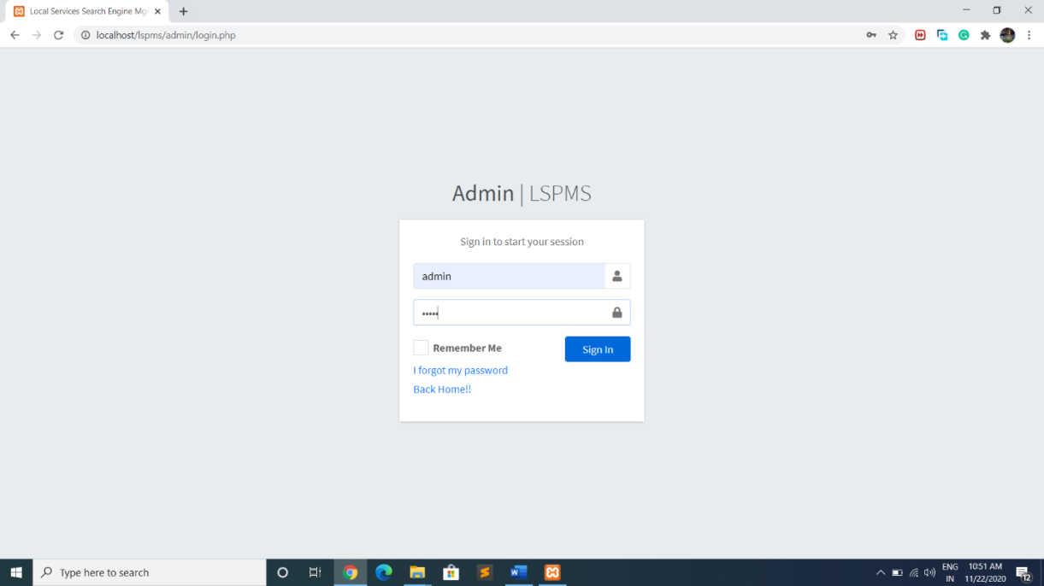

1. **Admin Home Page**

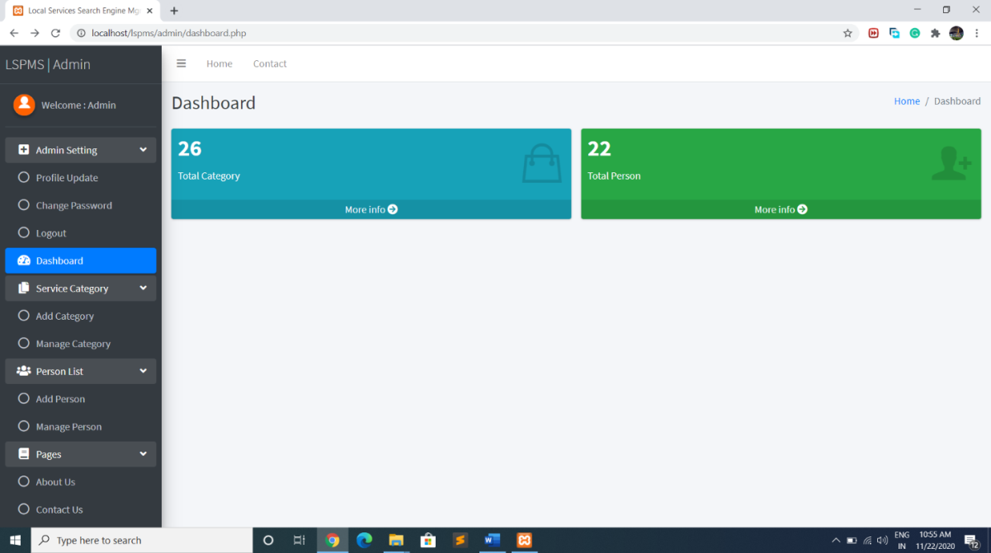

1. **User Home Page**

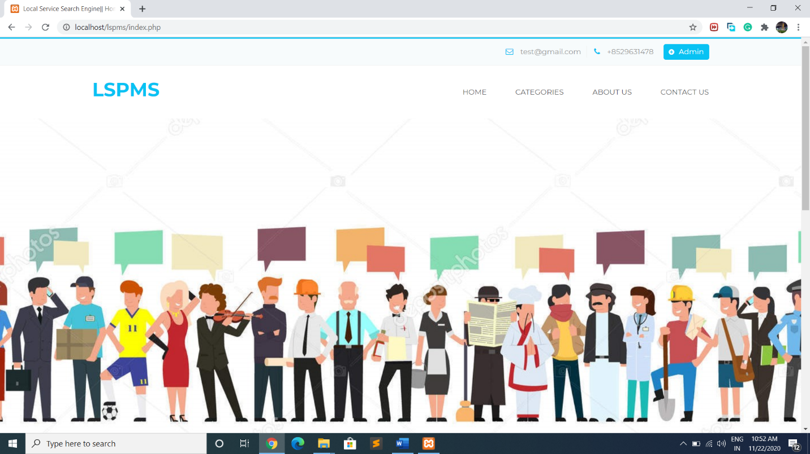

1. **Data Base**

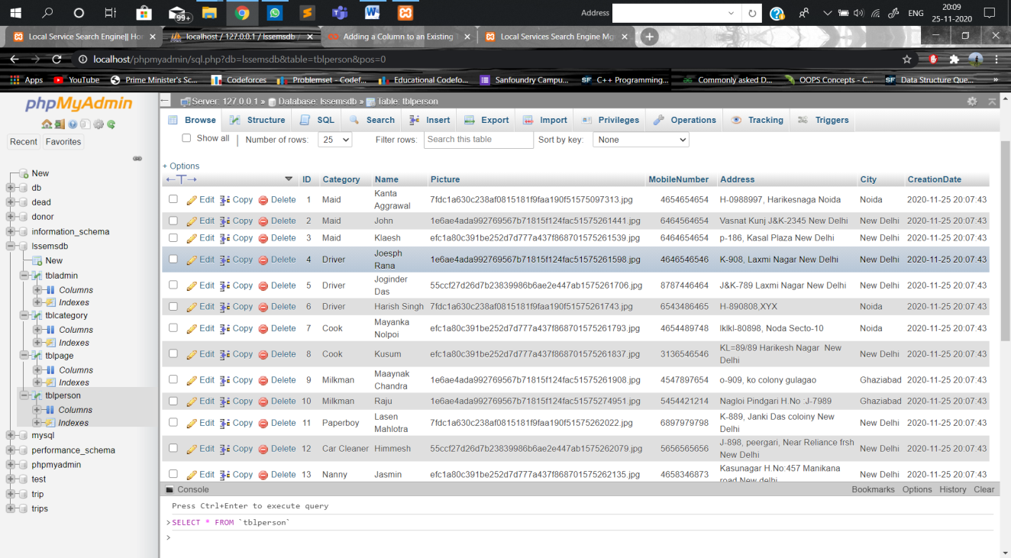

**Chapter 7**

**Conclusion**

To conclude the description about the project: The project, Local Service Provider Management System is based on the requirement specification of the user and the analysis of the existing system, with flexibility for future enhancement.

We have successfully implemented various functionalities of MySQL and Php and created the fully functional database management system for providing local services to individuals.

This particular project deals with the problems of finding the local serviceman and avoids the problems which occur when carried manually.

**References**

1. [https://www.mysql.com/](https://www.mysql.com/%20%20)  Tutorial of MySQL
2. <http://php.net/manual/en/tutorial.php> : Tutorial of php language.
3. <http://www.w3schools.com/php/> : Functions of php explained with their proper examples.
4. <https://en.wikipedia.org/wiki/Database> : Concepts of Database Management System
5. <https://en.wikipedia.org/wiki/XAMPP> : Functionality of Xampp