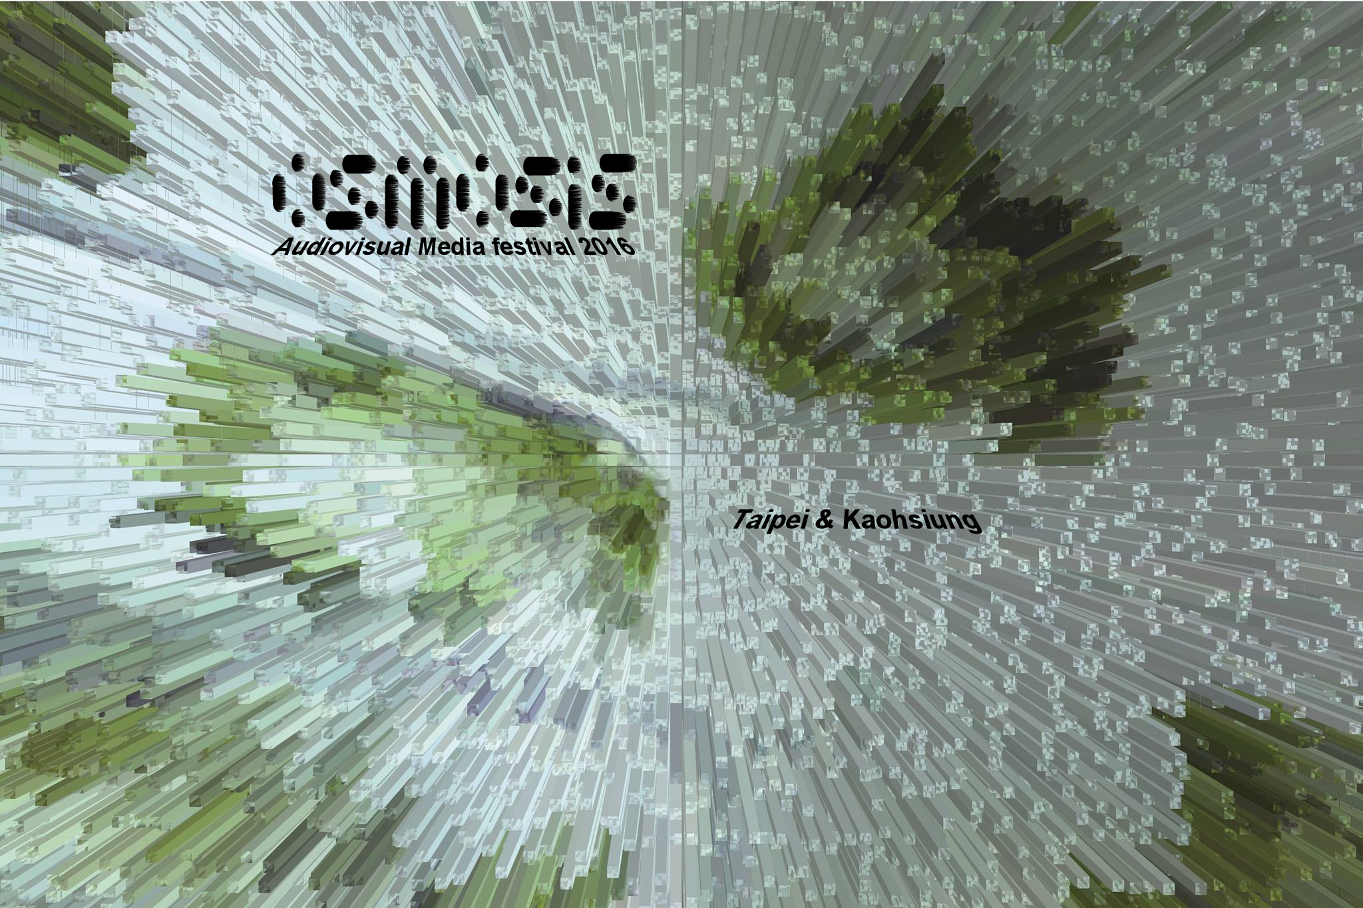》OSMOSIS - Audiovisual Media festival 2016  
[http://ascjoin.wix.com/ascool](http://ascjoin.wix.com/ascool?fbclid=IwAR1L-PknBqD5-C0K5LFvwRHHy1v5fu9lSiQ5iLExhrKEyPy9rDwQ60hV22U)

2017/08/18 – 2017/08/28

Taipei and KaohsiungTAIWAN

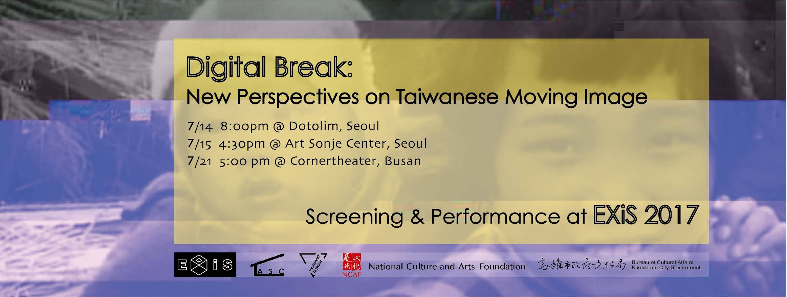

》DIGITAL BREAK : EXiS 2017

2017/07/14 – 201707/21

Seoul and Busan KOREA

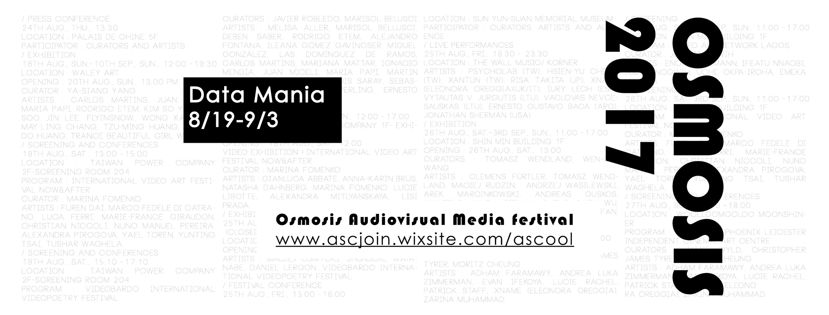

》OSMOSIS - Audiovisual Media festival 2017  
[http://ascjoin.wix.com/ascool](http://ascjoin.wix.com/ascool?fbclid=IwAR1L-PknBqD5-C0K5LFvwRHHy1v5fu9lSiQ5iLExhrKEyPy9rDwQ60hV22U)

2017/08/19 – 2017/09/03

TaipeiTAIWAN

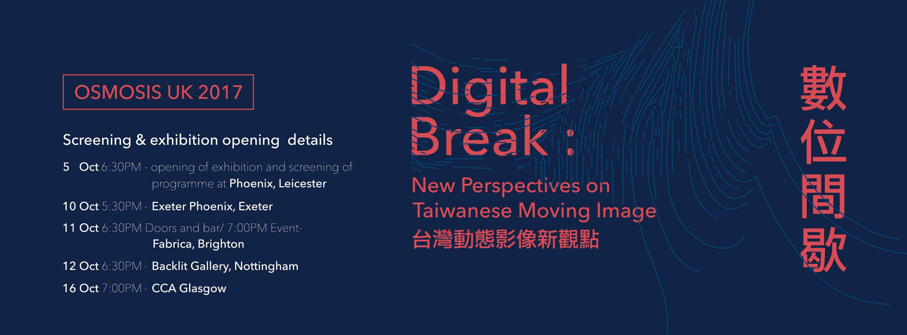

》DIGITAL BREAK : OSMOSIS UK Tour

2017/10/05 – 2017/10/16

Brighton, Nottingham and Glasgow UK

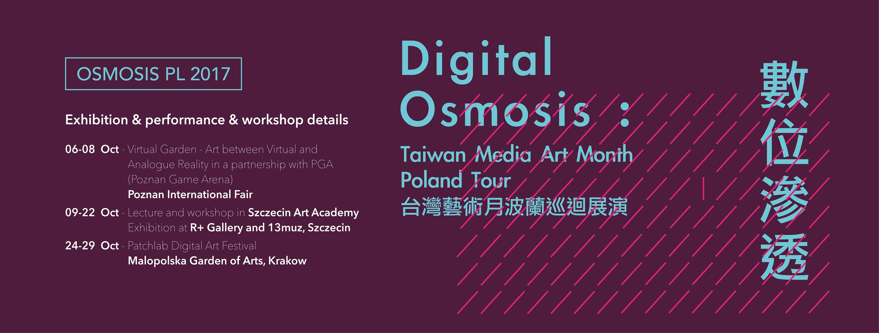

》DIGITAL OSMOSIS : OSMOSIS Poland Tour

2017/10/06 – 2017/10/29

Poznan, Szczecin and Krakow POLAND

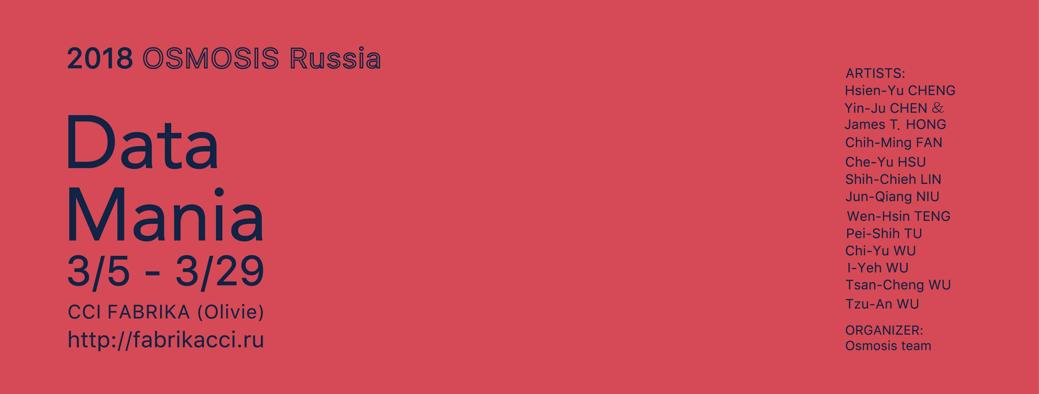

》DATA MANIA

2018/03/05－2018/03/29  
俄羅斯文化產業藝術中心 CCI Fabrika Moscow

Moscow RUSSIA

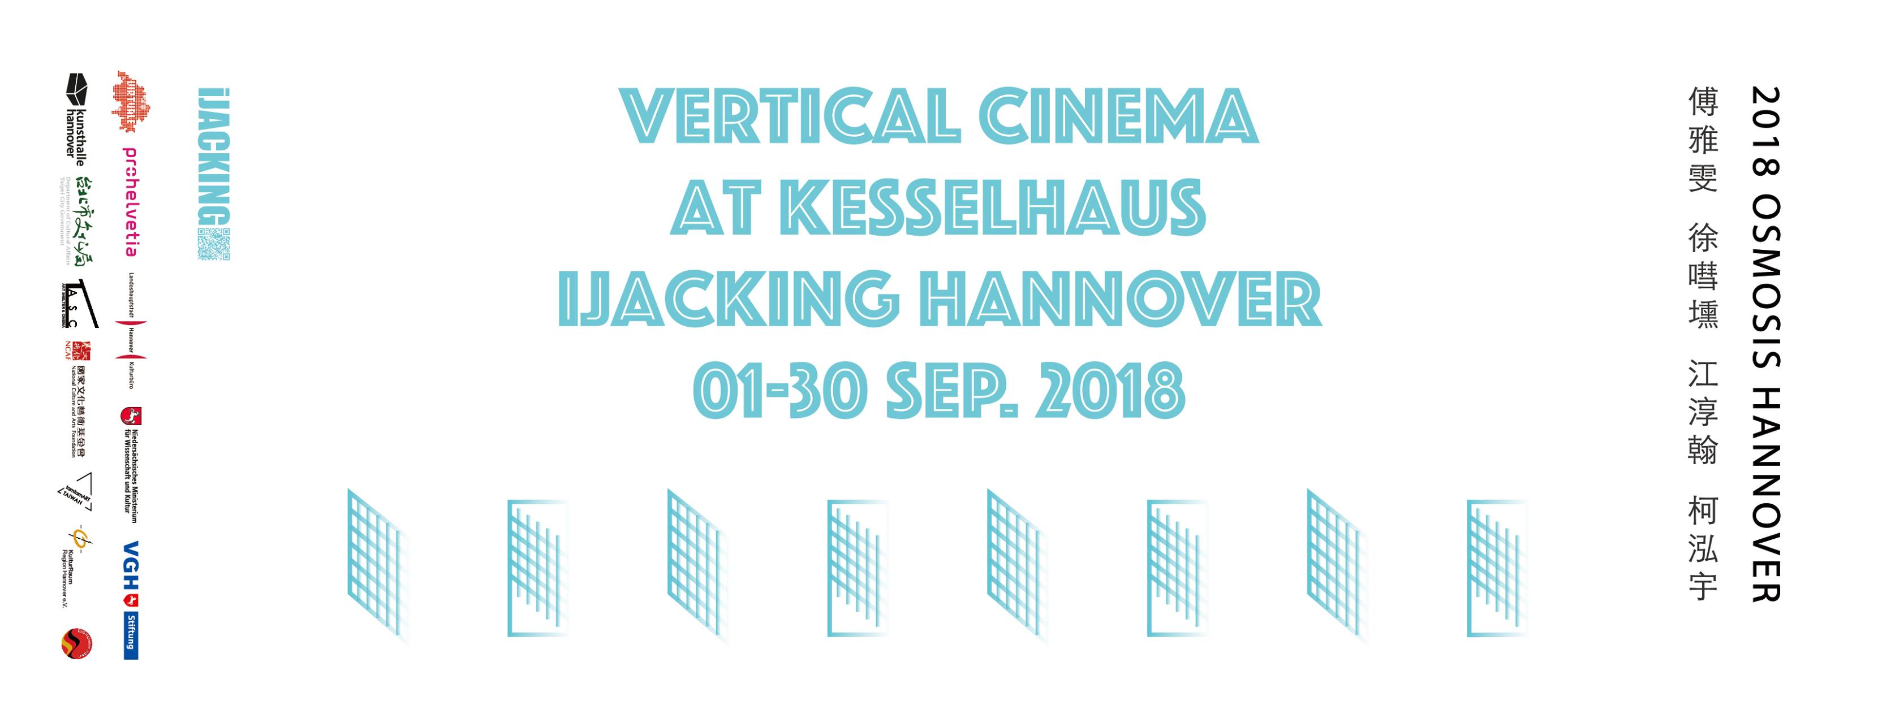

》VERTICAL CINEMA -IJACKING

2018/09/01 – 2018/09/30

Kasselhaus

Hannover GERMANY

# 45664032_2096585590386520_4736283414821339136_o.jpg

# 》回聲像—動態影像論壇

# 2018/10/28 Vol. 1 什麼是動態影像？

# 2018/12/01 Vol. 2「現場電影」—反映「時代－當下」的所有精神事件

# 2018/12/22 Vol. 3:「柏拉圖的洞穴」—動態影像的感官探索與未來

2019/01/26 表演＋放映:「Back to the Cave」未來寓言  
臺灣當代文化實驗場C-LAB Workshop  
Taipei TAIWAN

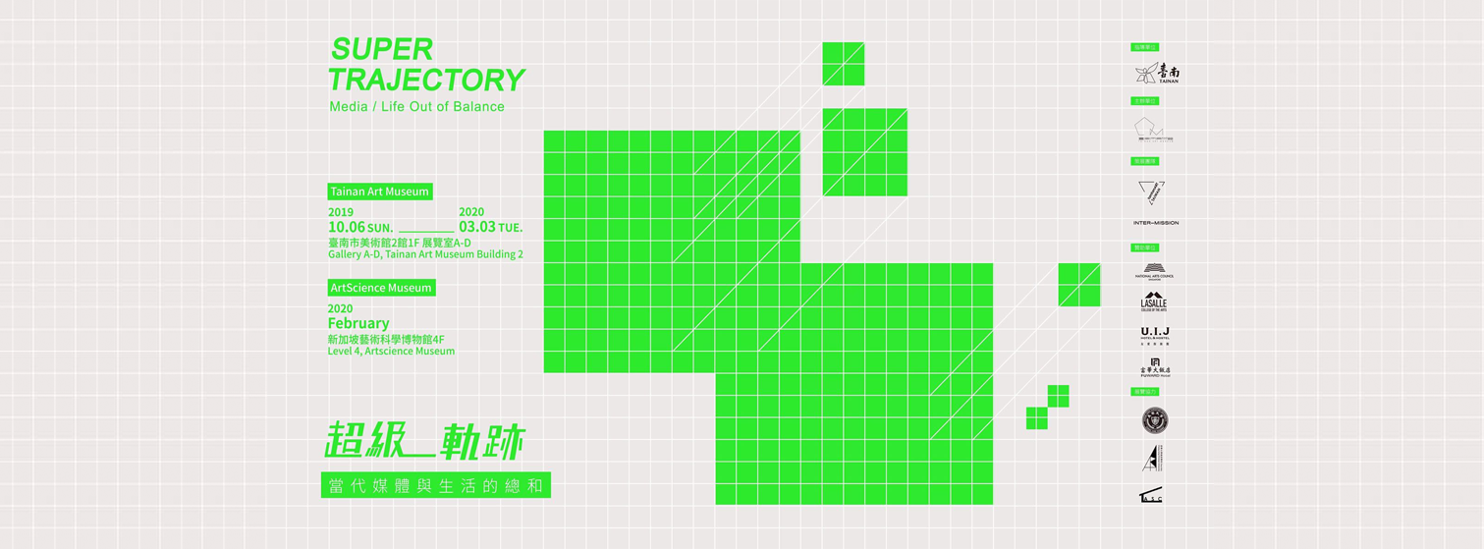

》「超級－軌跡」—— 當代媒體與生活的總和  
SUPER – TRAJECTORY Media / Lift Out of Balance

2019/10/06－2020/03/03  
臺南美術館2館 Tainan Art Museum Building 2

Tainan TAIWAN

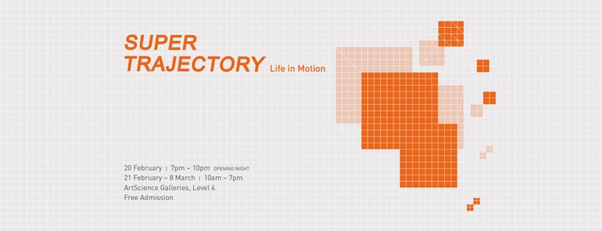

》SUPER–TRAJECTORY: Life in Motion   
2020/02/20－2020/03/08  
ArtScience Galleries, Level 4  
SINGAPORE