Barret Jackson
66122573
October 2, 2020
COSC 328 Lab 2

1) SSL (and TSL) operates at the application layer. In order to implement it, a developer invokes an SSL (or TSL) library in both the client and server codebases. The client side will take clear text arguments, a password for example, and pass it to the SSL socket. The SSL socket will encrypt the data, send it to the server, then the server will use SSL code to decrypt the message.

2) The TCP requires a socket on the server side to handle the handshake from the client, then all the data received from the client is routed to the connection socket. UDP does not require a handshake between client and server, so the data is sent directly to the server socket from the client socket. For a TCP server with n simultaneous connections, the server will require one handshake or welcome socket plus n connection sockets, so n+1 sockets in total.

3) a) The average time to send an object over the access link is given by
Δ = L/R = 850,000bits/15,000,000 bps = 0.0567 s
This means the average access delay is given by
Δ/(1-Δβ) = 0.0567s/(1-0.0567s * 16 requests/s) = 0.607 s/request
The average time from the router on the internet side of the access link to a given server is 3 s, so the total access delay is given by
0.607 s + 3 s = 3.607 s

b) If 60% of the requests are satisfied by the cache, this means overal traffic intensity is reduced by 60% as well. The average access delay will decrease as such:
Δ/(1-0.4Δβ) + 3 s = 0.0567s/(1-0.4*0.0567s * 16 requests/s) + 3 s = 3.889 s/request
Cached responses happen near instantaneously, at a frequency of 60%. The requests that actually access the internet occur 40% of the time, so the total response time is given by
0.6 * 0 s + 0.4 * 3.889 s = 1.236 s
a significant improvement over the 3.607 uncached response time.

4)
Distribution | F | u_{s} | d_{i} | u | N | D
Client-server | 15 Gbits | 30 Mbps | 2 Mbps | 300 Kbps | 10 | 7680s
Client-server | 15 Gbits | 30 Mbps | 2 Mbps | 300 Kbps | 1000 | 512,000s
Client-server | 15 Gbits | 30 Mbps | 2 Mbps | 2 Mbps | 10 | 7680s
Client-server | 15 Gbits | 30 Mbps | 2 Mbps | 2 Mbps | 1000 | 512,000s
P2P | 15 Gbits | 30 Mbps | 2 Mbps | 300 Kbps | 10 | 7680s
P2P | 15 Gbits | 30 Mbps | 2 Mbps | 300 Kbps | 1000 | 47558.78s
P2P | 15 Gbits | 30 Mbps | 2 Mbps | 2 Mbps | 10 | 7680s
P2P | 15 Gbits | 30 Mbps | 2 Mbps | 2 Mbps | 1000 | 7680s

For client-server distribution, the time to distribute a file of size F to N clients is given by
D_{c-s} >= max{NF/u_{s}, F/d_{min}}
So the upload rate of peers u is irrelevant, and as an example, the total time to download for 10 clients is given by
D_{c-s} >= max{NF/u_{s}, F/d_{min}} = max{10*15Gbit/30Mbps, 15Gbit/2Mbps}
= max{10*15*1024 Mbit/30Mbps, 15 * 1024 Gbit / 2 Mbps} = max{5120s, 7680s}
= 7680s = 2 hr 8 min
and similarly for the other three rows.
max{512,000s, 7680s}

For peer-to-peer distribution, the time is given by
D_{P2P} >= max{F/u_{s}, F/d_{min}, NF/(u_{s} + Σu)}
As an example, the first row in the P2P table is calculated as:
D_{P2P} >= max{F/u_{s}, F/d_{min}, NF/(u_{s} + Σu)}
= max{15Gbit/30Mbps, 15Gbit/2Mbps, 10*15Gbit/(30Mbps + 10*300Kbps)}
= max{15*1024Mbit/30Mbps, 15*1024Mbit/2Mbps, 10*15*1024Mbit/(30Mbps + 10*300/1024Mbps)}
= max{512s, 7680s, 4664.48s} = 7680 s = 2 hr 8 min
and similarly for the other three rows.
max{512s, 7680s, 47,558.78s} max{512s, 7680s, 3072s} max{512s, 7680s, 7566.50}

5) a) TCP b) UDP c) UDP d) UDP e) TCP f) UDP

6) a) localhost/index.html
b) The browser is requesting a persistent connection; the Connection field of the request header indicates Keep-Alive, meaning keep the connection open until it times out.

7) a) Using non-persistent connections, the order of connections is as such:
i) Client initiates TCP connection
ii) Server acknowledges connection
iii) Client requests HTML document
iv) Server acknowledges requests and begins sending HTML document
v) Client receives HTML document
vi) Server closes connection
vii) Client unpacks HTML document, sees reference to four image files
viii) Client repeats above for all four images
This means each object will involve two TCP connections and the file transfer time, so the total time is given by:
t_{tot} = 0.1 s * 2 * 5 + 10,000bit / 10 * 1024² bps + 4 * 50,000bit / 10 * 1024² bps = 1.02 s

b) If the browser is able to open any number of parallel connections, the first step to obtain the HTML remains the same, but then all four images can be obtained concurrently. Hence
t_{tot} = 0.1 s * 2 * 2 + 10,000bit / 10 * 1024² bps + 50,000bit / 10 * 1024² bps = 0.406 s

c) In a persistent connection with no pipelining and parallel connections, the client will require two RTT to initiate the TCP handshake with server 1, then transfer the HTML document, see the references to the images, begin the transfer of the three images from server 1 while concurrently setting up a TCP handshake with server 2 and transferring the image file from there. In other words, four RTT times will be necessary plus the HTML file transfer and one image transfer time, or
t_{tot} = 0.1 s * 2 * 2 + 10,000bit / 10 * 1024² bps + 50,000bit / 10 * 1024² bps = 0.406 s
This is effectively the same result as a non-persistent connection with concurrency. However, with pipelining, the client will request the images as it encounters a reference to them in the HTML document. Unless the image on server 2 is at the very end of the HTML document, this means the TCP handshake will occur some time during the HTML document transfer. Assuming the image on server 2 is referenced at the very beginning of the HTML file, it will effectively negate the transfer time of the html file, or
t_{tot} = 0.1 s * 2 * 2 + 50,000bit / 10 * 1024² bps = 0.405 s
which is the fastest of the four options (although only by one ms).

8) a)
Time (ms) | Request type | Details
0 | HTTP GET | m1.a.com performs a HTTP GET for the file at www.b.com. Message sent to local HTTP cache (based on question assumptions, no time taken)
~0 | DNS REQUEST | m1.a.com performs a DNS REQUEST to obtain the IP for www.b.com from its local DNS server, since the local cache did not have the address. No time based on assumptions.
~0 | DNS REQUEST | Local DNS server does not have the entry cached, requests from root-level DNS
50 | DNS RESPONSE | DNS REQUEST arrives at root-level server, sends back DNS RESPONSE with top level domain (TLD)
100 | DNS REQUEST | Local DNS receives the root-level DNS response, sends a DNS REQUEST to the TLD DNS
150 | DNS RESPONSE | TLD DNS receives the request and send a response containing the authoritative DNS
200 | DNS REQUEST | The local DNS receives the reply with the authoritative DNS, sends DNS REQUEST to authoritative DNS (25 ms to get to www.b.com servers)
225 | DNS RESPONSE | Authoritative DNS in www.b.com domain receives the request and sends a DNS RESPONSE with the A record for www.b.com
250 | DNS RESPONSE | DNS RESPONSE received by local DNS and forwarded to HTTP cache
~250 | HTTP GET (TCP handshake init) | Local HTTP cache initiates TCP handshake with www.b.com for the file, requiring one RTT before the request can be sent
300 | HTTP GET (SENT) | Local HTTP performs HTTP GET to www.b.com for the file
350 | HTTP RESPONSE | www.b.com responds with the document, begins transmitting.  t = 10 ms (b LAN) + 1000 ms (on 1 Mbps link) + 100 ms (a LAN) = 1110 ms
1460 | HTTP RESPONSE | Local HTTP cache sends HTTP RESPONSE to m1.a.com, taking 100 ms to transmit
1560 | None | File has arrived in full to m1.a.com

b)

Time (ms) | Request type | Details
0 | HTTP GET | m2.a.com performs a HTTP GET for the file at www.b.com. Message sent to local HTTP cache (based on question assumptions, no time taken)
~0 | HTTP GET | Local HTTP cache has a copy of the file and the IP address for www.b.com  Sends HTTP conditional GET to www.b.com
75 | HTTP RESPONSE | www.b.com receives the request and responds that the file is unchanged, and that it will not be transmitted.
100 | HTTP RESPONSE | Local cache receives the message that the file from www.b.com is unchanged, sends HTTP RESPONSE with the file to m2.a.com  t = 100 ms
200 | None | File has arrived in full to m2.a.com

WIRESHARK LAB!!!!!

1.
nslookup en.whu.edu.cn
Server: 137.82.1.2
Address: 137.82.1.2#53

Non-authoritative answer:
Name: en.WHU.edu.cn
Address: 202.114.64.200
Name: en.WHU.edu.cn
Address: 2001:250:4001:1::1001

2.
nslookup -type=NS home.cern
Server: 137.82.1.2
Address: 137.82.1.2#53

Non-authoritative answer:
home.cern nameserver = ext-dns-1.cern.ch.
home.cern nameserver = ext-dns-2.cern.ch.

Authoritative answers can be found from:
ext-dns-2.cern.ch internet address = 192.91.245.85
ext-dns-2.cern.ch has AAAA address 2001:1458:1:2::100:85

3. Using the CERN DNS server gave no response

nslookup mail.yahoo.com ext-dns-1.cern.ch
Server: ext-dns-1.cern.ch
Address: 192.65.187.5#53

** server can't find mail.yahoo.com: REFUSED

I tried again with DNS server 1.1.1.1 and got a response

nslookup mail.yahoo.com 1.1.1.1
Server: 1.1.1.1
Address: 1.1.1.1#53

Non-authoritative answer:
mail.yahoo.com canonical name = edge.gycpi.b.yahoodns.net.
Name: edge.gycpi.b.yahoodns.net
Address: 69.147.80.15
Name: edge.gycpi.b.yahoodns.net
Address: 69.147.80.12
Name: edge.gycpi.b.yahoodns.net
Address: 2001:4998:64:800::6000
Name: edge.gycpi.b.yahoodns.net
Address: 2001:4998:64:800::6001

4. Wireshark setup: I’m running Wireshark on Arch Linux, and as far as I can tell, Linux does not cache DNS queries (see https://wiki.archlinux.org/index.php/Domain_name_resolution for further details). I therefore skipped the DNS flush operation.

Here are the captured DNS queries

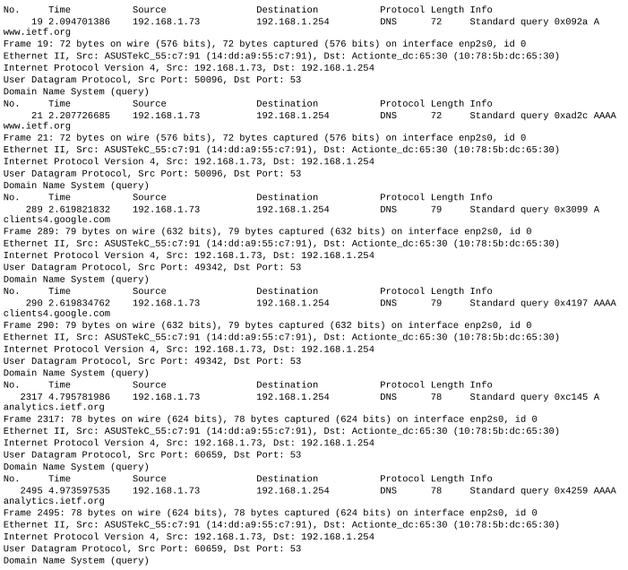

And here are the captured DNS responses:
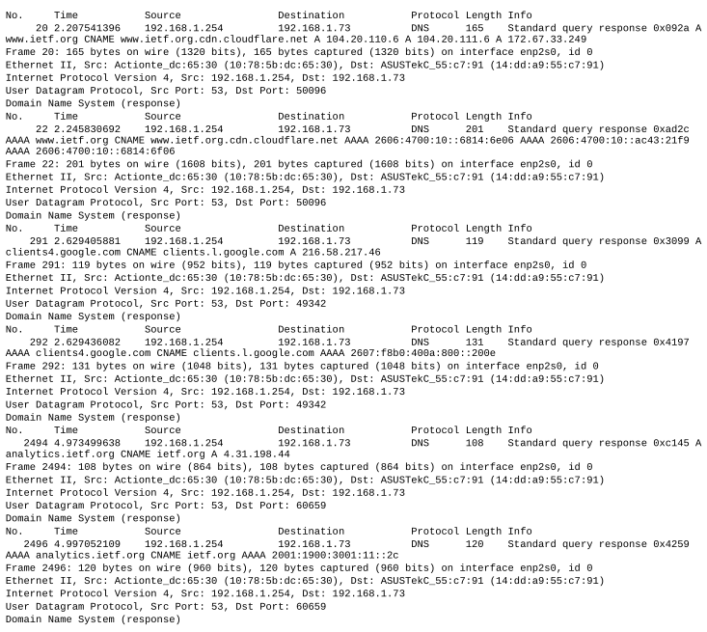
All DNS queries and responses are sent over UDP.

5. The destination port for the DNS queries is the same as the source port for the DNS responses, port 53.

6. The DNS queries are all sent to 192.168.1.254. When running (again, on Linux) cat /etc/resolv.conf, the first nameserver shown is also 192.168.1.254, which is a DNS hosted by Telus (I should really change that…).

7. I will look at the first DNS query since the others all appear to be advertisers, trackers, etc. This is a standard query, and other than the requested URL, the source information and destination information, the message doesn’t really contain any useful information or answers.

8. The DNS response, on the other hand, contains four answers:
i) The canonical name for www.ietf.org is www.ietf.org.cdn.cloudflare.net
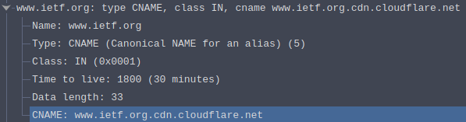
ii-iv) The next three answers give three separate IP addresses, 104.20.110.6, 104.20.111.6, and 172.67.33.249
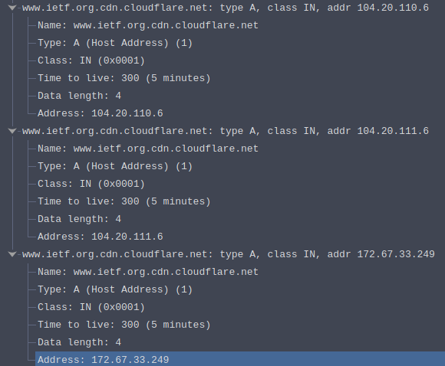

A subsequent DNS response also gives the canonical name for the site, and returns three different IP addresses in IPV6 format.
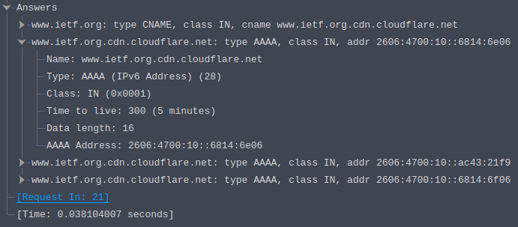

9. The SYN request decided to communicate using IPV6 protocols. Here’s a look at it:
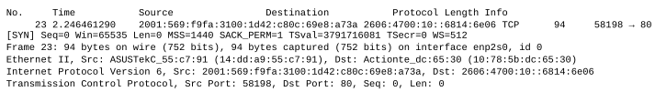
The destination IP address matches the first IP address given by the second DNS lookup (the one that returned IPV6 addresses).

10. Since most of the site seems to be encrypted via TLS, I only see one HTTP request from my machine. It occurs after the DNS responses and TCP handshake, so no, another DNS request is not made prior to requesting the image.

11. Once again, the destination port for the query and the source port for the response is port 53
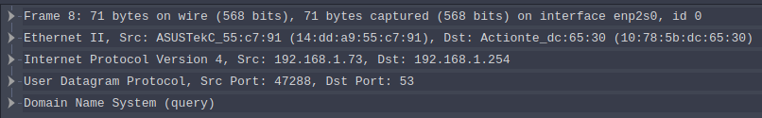
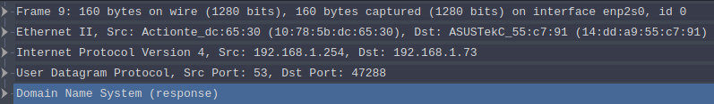
12. The query is once again sent to my default local DNS server 192.168.1.254

13. Once again, the query is a standard query and contains no answers.

14. The response contains three answers: the canonical hostname (www.mit.edu.edgekey.net), the canonical hostname for that canonical hostname (e9566.dscb.akamaiedge.net), and lastly the ip address for that last url, 104.65.167.154.
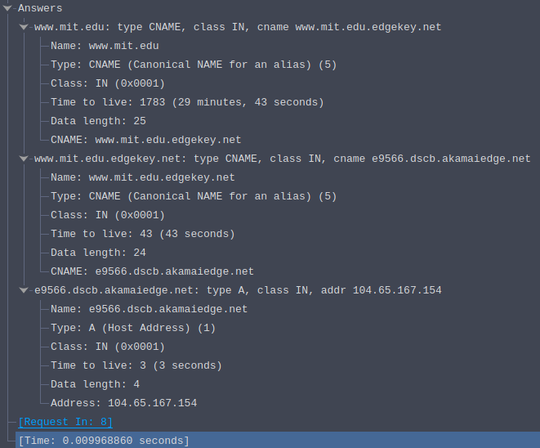
15. A screenshot of what? Here’s one:

