Barret Jackson
66122573
November 27, 2020
COSC 328 Lab 7

Part 1: ICMP and Ping
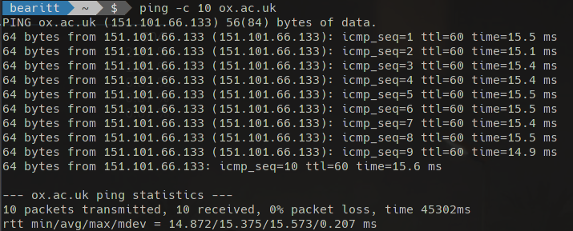

Note: The URL “www.ust.hk” resulted in only dropped packets (not sure why since I was able to access it in my browser), so I used the Oxford University’s homepage instead

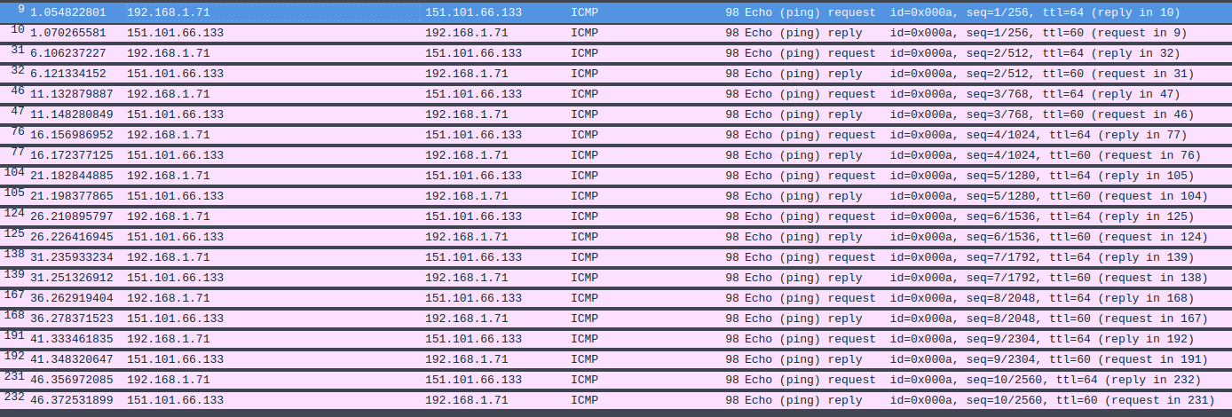
1) The IP address of my host is 192.168.1.71 (although this a a private address, so this is clearly behind a NAT). The IP address of the destination host is 151.101.66.133.

2) ICMP is primarily (but not exclusively) used for error messages; all ICMP messages are handled directly by the operating system of the source and destination hosts. Since port numbers are used by the operating system to forward datagrams to a specific process, ICMP does not require port numbers for either the source or destination because the data will not be forwarded to any processes in the OS. More specifically, TCP/IP usually implements the ping server directly in the operating system (Kurose and Ross 7th Edition, pg. 472).
3) Packet information from first packet sent from my host to destination:

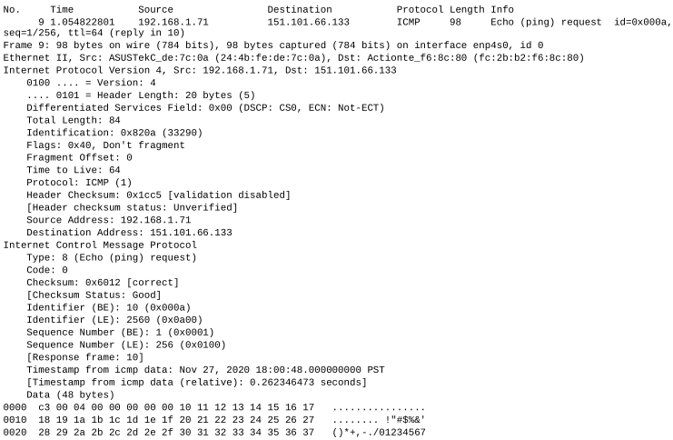
The ICMP is of type 8 and code 0, which is a “echo request” packet. The packet also has a checksum, identifiers (BE and LE), a timestamp, and lastly, the data being sent (randomized data 56 bytes long, https://linux.die.net/man/8/ping). The checksum, sequence number, and identifier fields are all identified by a four digit hex number, meaning they are (4 bits per hex digit) * (4 hex digits) = 16 bits = 2 bytes long each.

4) The ICMP packet is of type 0 and code 0, also known as an “echo reply” packet. This packet also has a checksum, an identifier, a sequence number, timestamp, and the data from the request packet. As in the request packet, the checksum, identifier, and sequence number fields are all 2 bytes long. (see next page for screenshot).
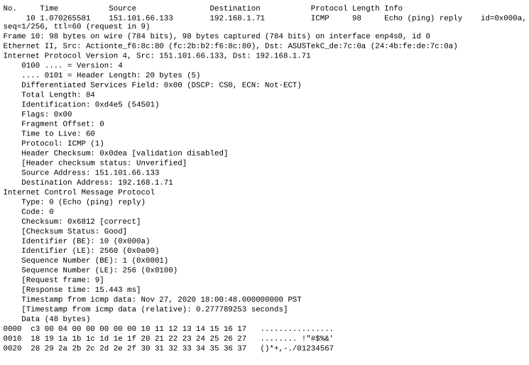
Part 1 question 4) screenshot

Part 2: ICMP and Traceroute

(note that I use Linux, however from the man page for traceroute, the -I flag forces traceroute to use ICMP ECHO for probes. Therefore, this is what I used)

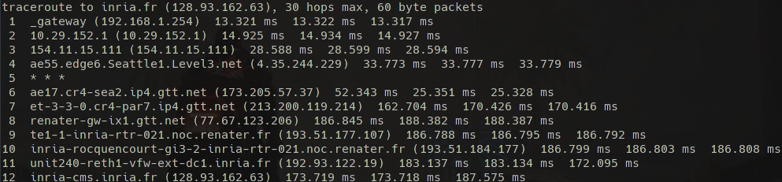
5) As in Part 1, the IP for my source host remains 192.168.1.71 (hidden behind a NAT. However, the IP 192.168.1.254 is frequently seen, as in hop 1 from traceroute. This is the internal IP address for my router, confirmed in the browser as it navigates to the settings page for my router). The destination host’s IP is 128.93.162.63.

6) No, if ICMP sent UDP packets instead, the IP protocol would be 17 since this is the protocol number for UDP (Kurose and Ross 7th Edition, pg. 377. Verified by running traceroute without -I flag)
7)

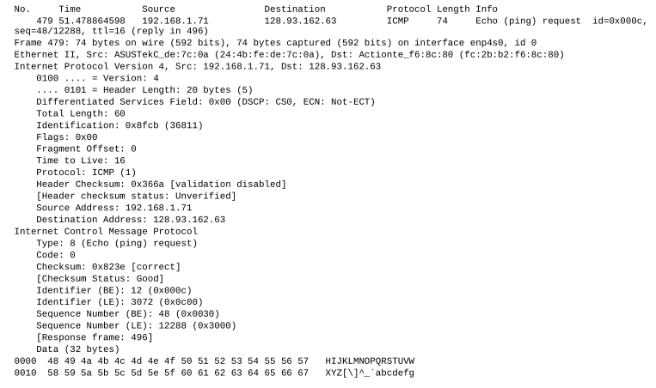

This packet appears to be the same format as the one from part 1. The packet is a type 8, code 0 packet (echo request) and it has a 2 byte checksum, identifier, and sequence number (albeit the values are different than the packet from part 1). One noticeable difference is that the length of the payload is only 32 bytes, compared to 48 bytes in the ping packet, and rather than being randomized, the payload is part of the alphabet in upper case, which starts again in lower case after what I’m assuming would be a carriage return or maybe line feed character (looking at the hex values, it’s merely increasing by 1 at each character).
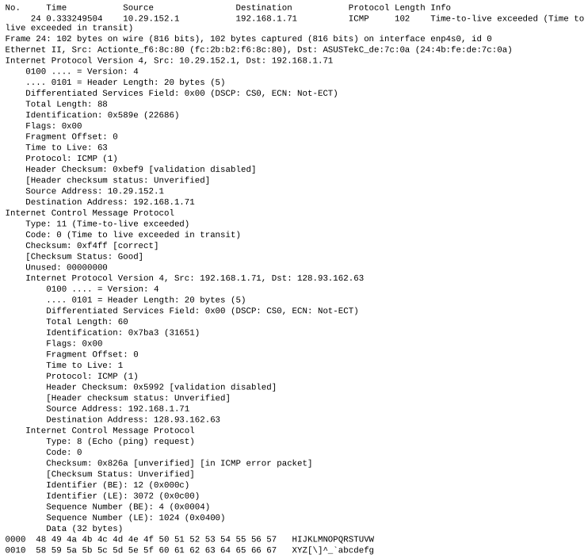
8)
In the ICMP header, we have a type 11 code 0 packet, indicating the TTL was exceeded (exactly the behaviour we’re looking for). We also have a checksum (2 bytes), an unused part of the header, then what looks like the header from the packet that was rejected. Distinctly missing here are the identifier and sequence number header fields.

9) (screenshots on following pages, answer to question 9 after)

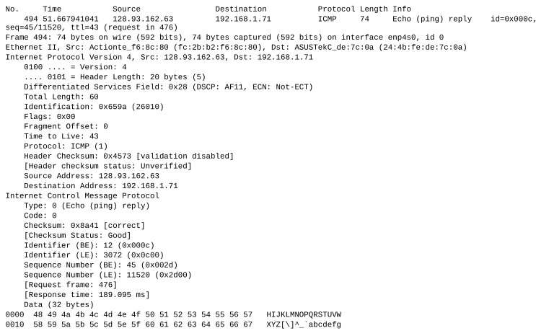
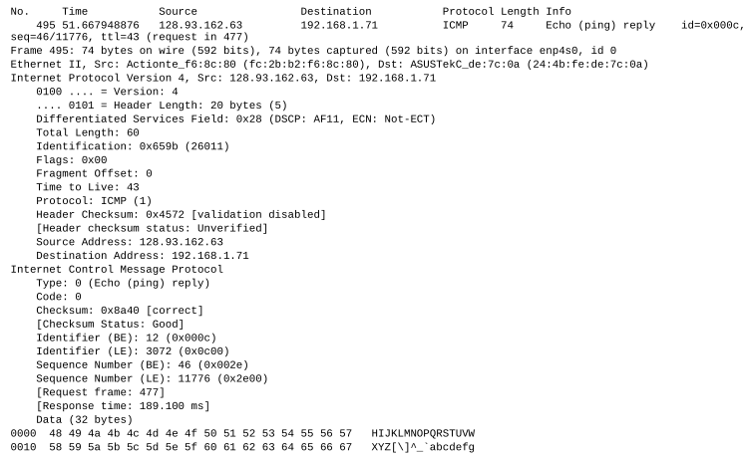

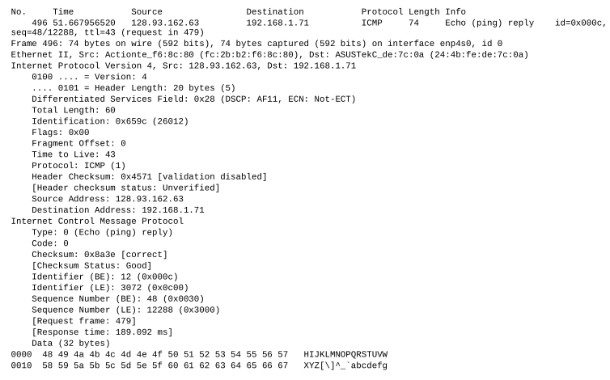
These packets are all type 0 code 0 (echo reply) ICMP packets. They each have a checksum, an identifier, and a sequence number, but are lacking a timestamp like in part 1. They are different than the other ICMP error packets because once the destination has been reached, the source host sends three ICMP echo request packets and waits to receive ICMP echo reply packets in order to obtain an average RTT from the source host to the destination host.

10) On my screenshot, the link between routers 6 and 7 seems to incur the longest delay, and on the screenshot in figure 4 of the assignment, the link between routers 9 and 10 seems to incur the longest delay. My screenshot is a little less obvious on the router names, although looking at router 4 with the name ‘Seattle’ in it and router 6 with sea2, we can guess that the packets depart from Seattle at router 6. The next router isn’t very obvious at all, with cr4-par7.gtt.net at the end. GTT is a multinational ISP, so not a lot to go on there. Router 8 though contains renater which looks like a French name, so we can assume the link between routers 6 and 7 crosses the Atlantic Ocean.
Figure 4 on the assignment is a lot more obvious: router 9 contains ‘nyc’ (New York City), and router 10 contains ‘Pastourelle’, which I would bet $1000 is located in France. So clearly, link 9-10 crosses the Atlantic.

Note: sure enough, using iplocation.net/ip-lookup, router 6 on my example is located in Seattle and router 7 is located in France. How a packet can travel directly from Seattle to France without any intermediate links is beyond me though (some sort of satellite transmission?). By the same method, routers 9 and 10 in the assignment are located in the US (although somehow in California?) and Paris, France respectively.

