Barret Jackson
66122573
December 4, 2020
COSC 328 Lab 8

1) This question can be answered by looking at one node in isolation, call it node 0. At t=0, node 0 begins transmitting its packet, length L. The time this node will take to finish transmitting this packet is L/R. Since d_{prop} < L/R, this means the packet from the other node, call it node 1, will begin to arrive before node 0 is finished transmitting its packet, resulting in a collision (the same will be true from the point of view of node 1).

2) Since a token ring relies on a single token which is only given up once a given node has finished transmitting its current packet, as the number of nodes in the LAN increases, the probability that a given node will receive the token and be given the chance to begin transmitting decreases. This means that with a very large LAN with many connected nodes, any given node may have to wait for quite a long time before it is able to begin transmitting. A token ring protocol also carries the overhead of transferring the token from one node to another, which could incur a significant delay in a ring with a large number of nodes.

3) G = 10011 D = 1010101010 need to find R
From class notes, D * 2r XOR R = nG, or R = remainder( D * 2r / G )
The G generator pattern is r+1 bits long, so r=4
Shifting D 4 bits to the left, we get 10101010100000, then dividing:

1000111000
10011 | 10101010100000
10011
000100101
10011
100100
10011
100010
10011
1111 ← R
The remainder from integer division is R = 1111

4) a) Any single bit error in sending/receiving the data D would result in a different remainder R. This means that the value for R calculated by the receiver would not match the value for R transmitted by the sender, signalling to the sender that there is at least one flipped bit.
b) In CRC, any number of flipped bits E < r+1 will be detected by performing the division as in question 3. For even numbers of errors E greater than r, there is a possibility p = 1-0.5r of being detected. Even assuming all even number of errors E > r go undetected, this means we can assume flipped bits pair up and cancel each other out, so we obtain E` = E-2^{x}. Eventually, enough pairs will cancel out such that E` < r+1, which has a 100% chance of being detected by CRC. QED, any odd number of errors will be detected by CRC.

5) See the figure on the following page. To view my work, refer to the included ‘q5aloha.py’ script.
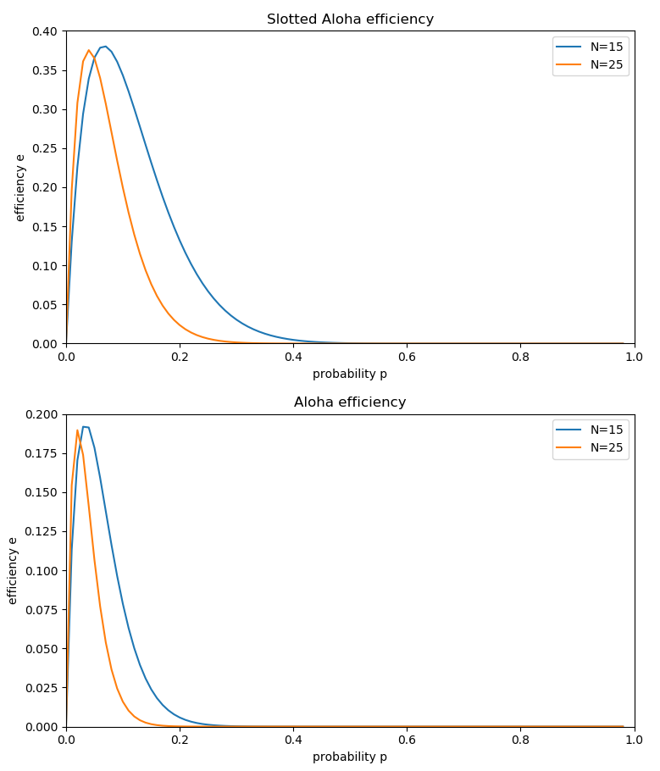

6)

