Approximate Counting

Gil Lopes Teixeira

*Resumo* – Este relatório apresenta dois métodos não determinísticos de contagem de caracteres em texto e compara-os com um Contador deterministico. O primeiro método apresentado apenas efetua uma contagem com probabilidade, fixa, de 25%. O segundo é um Contador com probabilidade descrescente com um fator:

Sendo k o total de contagens já efetuadas.

*Abstract* – This report presents two non deterministic methods to count characters in text and compares them to a deterministic counter. The first method is a fixed probability counter that counts every character with the same probability of 25%. The second method is a decreasing probability counter with a lesser factor of:

k being the total amount of times it already counted.

# I. Introduction

The maximum independent set of a graph is the largest set of non adjacent vertexs from the graph. In the following chapters we will elaborate on the algorithms built!

A lot of times there are multiple sets that are maximum independent sets. The exhaustive algorithm must search through every combination but the freedy finds a valid optimal solution with less complex steps.

# II. exhaustive Algorithm

Calculating the maximum independent set of a Graph G with n Vertexs:

vertexs_half = int((graph.total_vertexs + 1) / 2) #No need to check past half of the number of vertexes.

res = []

for i in range(vertexs_half):

non_adjacent_vertexs = findNonAdjecentVertexes(graph, graph.vertexs[i])

#this list includesgraph.vertexs[i]

if len(non_adjacent_vertexs) > len(res):

res = non_adjacent_vertexs

return res

Auxiliary functions:

:

Best case:

All vertexes are connected to the ith vertex!

Worst Case:

**findAdjacentVertexs(k):**

This depends on the number of edges! For a given graph with n vertexs the maximum amount of edges is:

Lets respresent this amount as !

The minimum amount of edges would be 0!

**Conclusion**

0 edges case:

Undirected Graph G with V vertexs but 0 edges:

Best case!

Most edges case:

Undirected Graph G with n vertexs but edges:

Worst Case!

Complexity:

Test results:

|  |  |  |
| --- | --- | --- |
| n | Exhaustive | n^3 |
|  |  |  |
| 1 | 2 | 1 |
| 2 | 4 | 8 |
| 3 | 18 | 27 |
| 4 | 27 | 64 |
| 5 | 64 | 125 |
| 6 | 94 | 216 |
| 7 | 250 | 343 |
| 8 | 809 | 512 |
| 9 | 1062 | 729 |
| 10 | 1648 | 1000 |
| 11 | 1217 | 1331 |
| 12 | 1789 | 1728 |
| 13 | 4585 | 2197 |
| 14 | 11154 | 2744 |
| 15 | 4676 | 3375 |

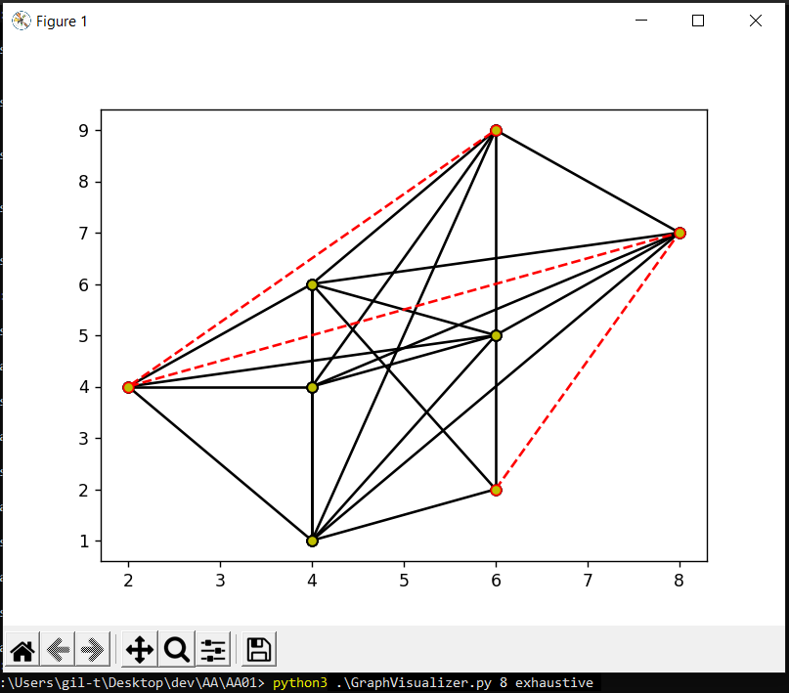

Figure 1 – Exhaustive Search for a 8 vertexs Graph

# III. Greedy Algorithm

Calculating the maximum independent set of a Graph G with n vertexs:

current_vertex = getMinEdgesVertex(graph, graph.vertexs)

res = []

vertexs_to_explore = (findNonAdjecentVertexes(graph, [current_vertex]))

res.append(current_vertex)

while True:

if not vertexs_to_explore:

break

current_vertex = getMinEdgesVertex(graph, vertexs_to_explore)

res.append(current_vertex)

vertexs_to_explore = findNonAdjecentVertexes(graph, res)

return res

This algorithm always chooses, in the next step, the valid* vertex with minimum adjacent vertexs.

*A valid vertex is a vertex that is not adjacente to the vertexs already choosen.

Let’s represente the length of the vertexs chosen list as v_len

getMinEdgesVertex():

FindNonAdjacentVertexs(graph g, vertexs_list v_list):

Returns a subset of g containing vertexs that are not adjacente to any of the vertexs in v_list.

Com v1 = len(v_list)

findAdjacentVertexs(graph g, vertex v):

Worst Case:

Graph G with n vertexs and edges:

**Conclusion**

Calculating the maximum independent set:

Graph G with n vertexs and edges:

findAdjacentVertexs with 0 edges represents 0.

findNonAdjacentVertexs(x):

,

x being the size of the set of

vertexs already selected!

So:

For a graph G with edges:

Auxiliary functions:

getMinEdges(i) =

findAdjacentVertexs(i) = n*(n-1)´

findNonAdjacentVertexs(i) = v_len *findAdjacentVertexs() + 2 * n

Result:

=

Complexity:

Test Results:

|  |  |  |
| --- | --- | --- |
| n | Greedy | n^2 |
|  |  |  |
| 1 | 2 | 1 |
| 2 | 8 | 4 |
| 3 | 29 | 9 |
| 4 | 38 | 16 |
| 5 | 62 | 25 |
| 6 | 92 | 36 |
| 7 | 217 | 49 |
| 8 | 451 | 64 |
| 9 | 595 | 81 |
| 10 | 1052 | 100 |
| 11 | 940 | 121 |
| 12 | 1564 | 144 |
| 13 | 1862 | 169 |
| 14 | 3849 | 196 |
| 15 | 2650 | 225 |

# IV. Conclusion

The implementation of the exhaustive algorithm seems to be a fairly good one and the results of the number of comparisons obtained are very close to the estimated ones within the formal analysis presented. The greedy algorithm, though it did amount to about half the complexity of the exhaustive algorithm, doesn’t match with the expected results probably due to a sloppy implementation.

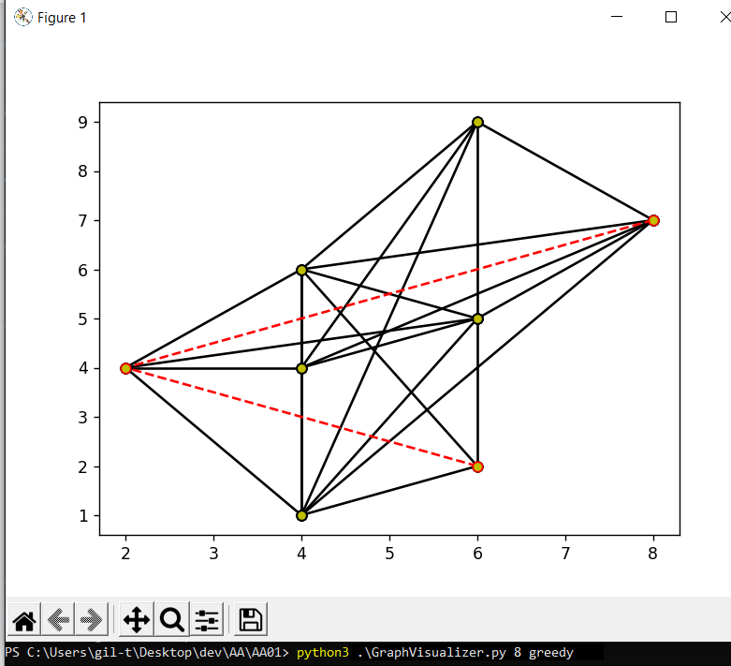

Figure 1 – Greedy Search for a 8 vertexs Graph

For this same exemple the exhaustive algorithm managed to find a maximum independent set of size 4 wich confirms that the greedy algorithm does not always find the optimal solution! Included in the readme.md file is a refence on how to generate this same graphs that were used. As long as the seed is the same so will be the graphs.