Technical Ceramics Manufacturing

Author (Gil Teixeira, 88194)

Information Visualization, 2021 (MEI, University of Aveiro)

Abstract

The manufacturing process of Technical Ceramics has many variables that affect the end product’s rentability. In this report we will try to compare said variables inn graphical ways so that any user can manipulate the visualizations and take conclusions.

# Motivation and objectives

The project was suggested by Paulo Dias and presented by Sónia Gouveia in the context of a master theses in Mathematics and Applications. The goal was to find what are the variables that most influence the success of the end product and in what ways to combine them. With this goal in mind a website was created to help visualizing the combinations between a pair of variables in multiple ways.

# Users and the Questions

The website is to be of use to both people of this field and everyday people. It allows for user interaction controlling the parameters for both visualizations at the same time.

## What are technical ceramics?

Examples of technical ceramics are car catalysts and thermic/electrical insulators.

# Dataset

The dataset was provided by Sónia Gouveia and contains a list of entries. Each entry corresponds to a product, and it contains information for most of the selectable parameters. Only 150 entries exist in the live example though the website could handle many more with ease.

# Visualization Solution

Two solutions were implemented. An Alluvial Plot that shows the flow between two given parameters and RD (%), the yield, and a Scatter Plot in which the x-axis represents the yield and there are 2 y-axis each for each variable. The selection of the two variables is made through two selectors that immediately change the output of both plots.

In the following images the parameters selected were:



## Image 1 – Selected Parameters

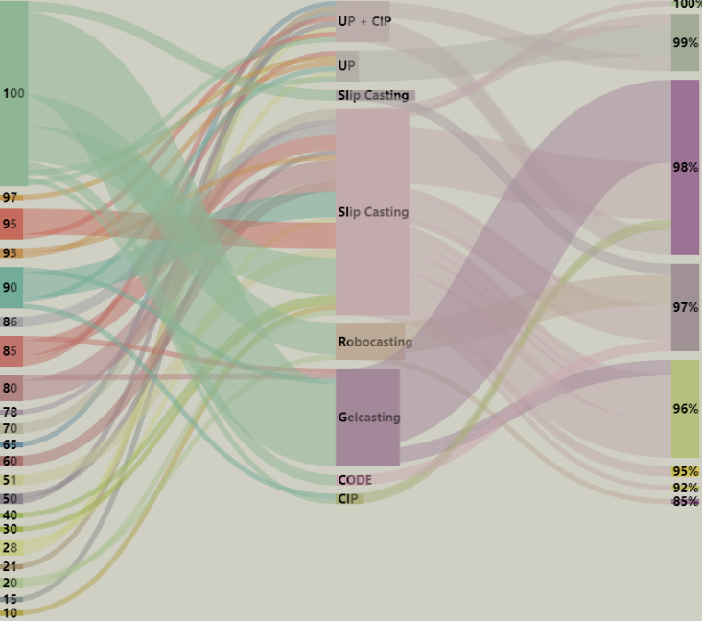

## Image 2 – Alluvial plot

This plot is very interesting as it allows one to follow the links and establish relationships between the parameters leading directly to a yield value. The visualization also includes a feature that when the user passes the mouse over a link the number of entries, the source and target are displayed.

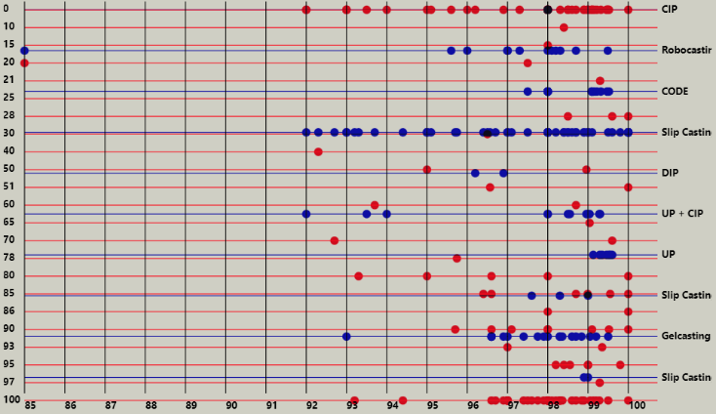

## Image 3 –Scatter plot

## In this visualization each parameter has its own y-axis and scale. The dots are placed on the corresponding scale and coloured the colour of the parameter, unless when they overlap and mix colours.

## Implementation challenges

The Alluvial Plot was the hardest to implement. A function was created that outputs a list of nodes and a list of links. The list of nodes have their own colours and the links must have the source node colour and the amount of entries that respect the relationship between parameter 1 and 2. Implementing the mouseover label had it’s own challenges since the graph is just an SVG generated by the d3.js library with absolute values for positioning which prevented the use of outer containers.

The Scatter Plot’s challenge was getting both Y-axis set up with separate scales.

## Evaluation and changes in the prototype

There were multiple emails traded and a meeting was held before the presentation of this project with both Paulo Dias and Sónia Gouveia where we discussed the initial implementation and where they made their opinions clearly heard.

Some of the changes made include:

* The Scatter Plot now supports 2 parameters
* Both plots now use the same parameters
* Aesthetic improvements for the Alluvial Plot

# Conclusion and Future Work

The proposal for the master theses was for a statistics analysis of the data and then to use the visualization solutions to further testify the found results. As to future work it would be important to:

1. Get more data! For a valuable analysis a lot of data is required.
2. Perform the statistical analysis.
3. Improve, if need be, the visualizations to help assert the results obtained.

Finally, the visualizations provided help to visualize only the relationship between one or two parameters and RD(%). It is important to state that some parameters, when selected, automatically rule out some parameter values and so some 2-way visualizations might still have the same effect as n>2-way visualization.