Aula 2

Authors (Gil Teixeira, 88194)

Information Visualization, 2021 (MEI…, University of Aveiro)

Abstract

This report will contain information and comments about the second lab guide! This is an introduction to ortographic cameras, shading, lighting, and transformations.

# Motivation and objectives

The objective is to be able to build a website with some geometries and animations. The first objective consisted of using an ortographic camera to observe a cube with wireframe. The second of creating some spheres with diferent materials to apply shading and transparency and to learn about ambient and directed lighting, Finally the last two exemples use all the concepts of prior exemples plus the combination of geometries in Object3D objects and animations with translation and rotation.

# Users and the Questions

This website hosts some exemples built with the Three.js library. Since the source code is open source this website might be of use for someone looking for simple exemples to start building their own solution.

# Visualization Solution

The solutions presented are the following:

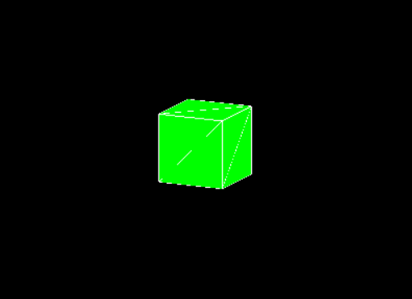

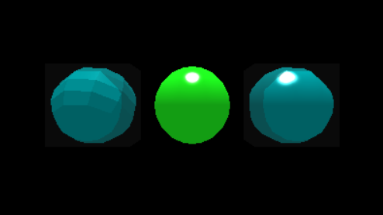Image 1 – Ortographic Camera Cube

Image 2 – Shading Spheres and lighting

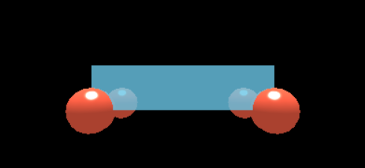

Image 3 – Transformations

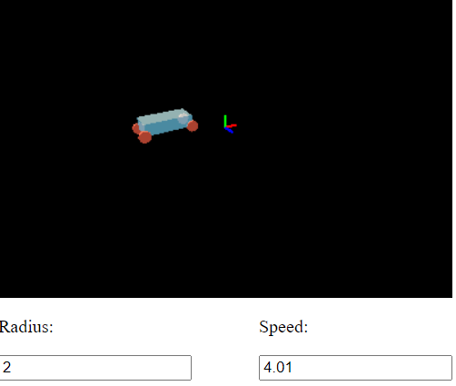

Image 4 – Transformations and Animation

In the last exemple the car runs on a square shaped trail. The radius is the square side length!

## Implementation challenges

The first exercise was hard has even after understanding the concepts it took a while to get it working. I also added orbit controlls to all exemples except the second. The las exemple took a lot of tweaking around but ended up doing exactly what I entended it to.

# Conclusion and Future Work

The library seems to abstract a lot of the work done “under the hood” for graphics rendering. The work developed was done with a certain degree of ease.