Aula 1

Authors (Gil Teixeira, 88194)

Information Visualization, 2019 (MSc…, University of Aveiro)

Abstract

This report will contain information and comments about the first lab guide! This is an introduction to Three.js.

# Motivation and objectives

The objective is to be able to build a website with some geometries and animations. The first objective consisted of producing a rotating green cube and the second one was to create multiple triangles, one of them with a color gradiant.

# Users and the Questions

This website hosts some exemples built with the Three.js library. Since the source code is open source this website might be of use for someone looking for simple exemples to start building their own solution.

# Visualization Solution

The solutions presented are the following:

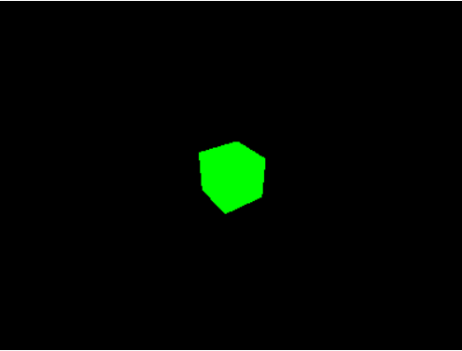

Image 1 – Spinning Cube

## 

Image 2 – Colorful Triangles

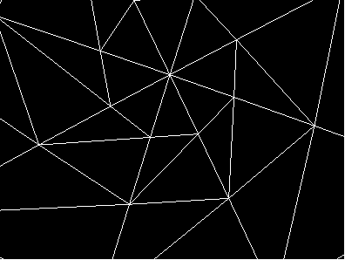

Image 3 –Inside a Sphere

## Implementation challenges

The second exercise was the hardest. At first only one of the triangles was being rendered since it didn’t know what colors to give to the others. After understanding that each geometry triangle’s color should be represented by 3 RGB values each. Since one of them has a gradiant.

# Conclusion and Future Work

The library seems to abstract a lot of the work done “under the hood” for graphics rendering. The work developed was done with a certain degree of ease.