NUS-ISS · Graduate Certificate in Architecting AI Systems (SWE5008) · Practice Module

Group Project Report
MOSAIC
A Multi-Agent System for Hyper-Personalised Email Marketing
Team | Team 13
Members | Ong Qing Quan (OQQ) — engineering lead: Orchestrator, Segmentation & Insight, Email Composer & Assembly, Campaign Console, CI and versioning  Agustinus Benyamin Prasetyo (ABP) — domain and assurance lead: Creative Direction, Compliance & Brand Guardian, Responsible AI instrumentation, AI security test corpus
Project sponsor | None — self-initiated project. All customer data is synthetic and generated by the team.
Repository | github.com/bearly-profitable/MOSAIC
Submitted | October 2026

Contents
1. Executive Summary 4
1.1 Objective and scope 4
1.2 Key highlights 4
1.3 Constraints and assumptions 4
2. System Overview 6
2.1 The business problem 6
2.2 Why a multi-agent architecture 6
2.3 Stakeholders 7
2.4 How the agents work together 7
2.5 How the benefits are demonstrated 8
3. System Architecture 9
3.1 Logical architecture 9
3.2 Physical architecture 10
3.3 Deployment strategy 11
3.4 Agent communication protocols 11
3.5 Data architecture 13
3.6 Justification of architectural styles and technology choices 14
3.7 Scalability 14
4. Agent Roles and Design 16
4.1 Orchestrator 16
4.2 Segmentation & Insight Agent 16
4.3 Creative Direction Agent 17
4.4 Email Composer & Assembly Agent 18
4.5 Compliance & Brand Guardian Agent 19
4.6 Evaluator (sidecar) 20
4.7 Shared prompt-engineering patterns and fallbacks 20
5. Explainable and Responsible AI Practices 22
5.1 Alignment across the development and deployment lifecycle 22
5.2 Fairness and bias mitigation 22
5.3 Explainability 23
5.4 Accountability and human oversight 24
5.5 Manipulation guardrail and ethical exclusions 24
5.6 Governance framework alignment 25
5.7 Data minimisation 25
6. AI Security Risk Register 26
6.1 Threat model 26
6.2 AI security testing 27
7. MLSecOps / LLMSecOps Pipeline 28
7.1 Pipeline overview 28
7.2 Automated testing, including AI security tests 28
7.3 Versioning and tracking 29
7.4 Deployment strategy 29
7.5 Monitoring and alerting 29
7.6 Logging and auditability 30
8. Testing and Evaluation Summary 31
8.1 Types of tests performed 31
8.2 Results 31
8.3 Key findings 32
9. Reflection 33
9.1 What went well 33
9.2 What changed from the proposal, and why 33
9.3 Challenges 33
9.4 Limitations and future work 34
9.5 Team contributions 34
Appendix A. API Surface 35
Appendix B. Repository Structure 35
Appendix C. Console Screenshots 36

1. Executive Summary

1.1 Objective and scope
Most retailers run an email campaign as three or four creative variants — new, lapsed, high-value and everyone else — because every extra variant needs its own brief, design pass, copy pass, render test and QA sign-off. Two customers with opposite motivations end up in the same bucket, and “personalisation” usually means inserting a first name into a fixed sentence.
MOSAIC treats campaign production as a generation-and-assurance problem. Four specialised agents, coordinated by an Orchestrator over a shared, typed blackboard, discover micro-segments in the operator’s own customer list, write a distinct creative direction and email for each segment, and adjudicate every message against ten pre-flight checks. Then the system stops: a person reviews the result and is the only actor who can send. The agents are Segmentation & Insight, Creative Direction, Email Composer & Assembly and the Compliance & Brand Guardian; a sidecar Evaluator grades their saved output.
The project is a working demonstrator rather than a production system. It runs end to end on a bundled 1,000-contact synthetic customer list, is deployed as two services on Railway with Supabase as the data store, and dispatches approved emails for real through Resend to an address the operator confirms.

1.2 Key highlights
- Works on any customer CSV. The feature schema is inferred per run; protected and consent columns are detected by name and handled specially. Nothing is hardcoded to one dataset.
- Segments that explain themselves. HDBSCAN clusters engineered features plus text embeddings; each segment carries its z-scored feature contributions, and the language model is only allowed to name what the numbers already found.
- Fairness by construction and by test. Protected attributes never enter the feature matrix; a proxy test then checks whether a segment correlates with them anyway. On the demo data it flagged one of six segments (age, 37% deviation).
- Grounded generation. Every model call uses a strict, length-capped JSON schema; code assembles the email layout; offer citations that are not real catalogue rows are dropped.
- A deterministic Guardian with a veto. Ten checks across compliance, content and deliverability produce PASS, REVISE or BLOCK. BLOCK is refused server-side, and the checks re-run after every edit. Demo workspace: 5 PASS, 1 REVISE, 0 BLOCK.
- Traceable by default. An append-only Decision Ledger records prompt version, model version and artifact lineage for every agent transition; an activity log records every operator action.
- MLSecOps / LLMSecOps. GitHub Actions runs a secrets check, an adversarial Guardian corpus and contract pins on every push — 14 of 14 tests pass, and a deliberate negative test proves the gate fails when it should. The eval-v1 sidecar scores the agents at 88.2 overall.

1.3 Constraints and assumptions
Table 1. Constraints and assumptions
Area | Constraint or assumption
Team and effort | Two members, guideline effort of 15 person-days each (30 in total), August to October 2026.
Data | All customer data is synthetic and generated by the team (backend/data/mosaic_customers.csv, produced by synthetic_data.py). The brand and offer catalogue are fictional; the demo workspace is configured as a fictional retailer, “FatCatPillow”.
Models | All model access goes through OpenRouter: openai/gpt-5.6-luna for text and judging, openai/text-embedding-3-small for embeddings. An image model exists but is never called by a pipeline stage — only when an operator reviews a prompt and presses Generate.
Dispatch | Real, via Resend, but deliberately narrow: each send delivers one rendered email to an operator-confirmed address, with merge tags filled from a real contact in that segment. Bulk delivery to a whole segment is out of scope.
Hardening | Demonstrator, not production-hardened: the API has no authentication or rate limiting, and the backend runs as a single replica because job progress is held in memory (Sections 3.7 and 6).

2. System Overview

2.1 The business problem
A retailer with around 200,000 contacts typically splits a campaign into a handful of variants. The constraint is cost rather than preference: the fifth variant costs about as much to produce as the first, so teams stop at four. A customer who consistently buys on durability and one who hunts discounts both sit inside “high value”, and the campaign speaks to neither. MOSAIC removes that ceiling by generating one creative treatment per discovered micro-segment while moving compliance from after-the-fact sampling to a check on every message.

2.2 Why a multi-agent architecture
We considered two simpler alternatives before choosing a modular, agentic design. Table 2 compares them on the properties the brief asks us to demonstrate.
Table 2. Alternatives considered
Criterion | One large prompt | Rules-based platform | MOSAIC (four agents)
New creative per segment | Yes | No — routes copy a human already wrote | Yes
Auditability | Low — one opaque call | High | High — typed artifact and ledger row per stage
Who checks compliance | The generator itself | Rules, on human-written copy | A separate Guardian that can veto any generator
Failure containment | Re-run everything | n/a | Re-run one stage or one email
Cost profile | Model call per recipient — O(n) | Low | Model work per segment — O(k); per-recipient work is deterministic
Right tool per task | One model for everything | No ML | Clustering, schema-bound copywriting and rule-based adjudication each use their own method

The decisive argument is the cost split. Expensive, high-variance work — segment discovery, creative direction and long copy — runs once per segment, O(k). Cheap deterministic work — filling a first name, choosing the cited offer — runs per recipient, O(n). Because n is far larger than k, that split is what makes per-segment creative affordable. The second argument is separation of duties: the agent that vetoes is not the agent that generates, and it is owned by the team member who did not build the generators.
The design has costs we accept. Model spend is real and is metered per stage. Review effort moves rather than disappears, so the console is built to make review fast. And a single off-brand or non-compliant message sent under a client’s name is serious, which is why the Guardian holds a veto and only a person can send.

2.3 Stakeholders
Table 3. Stakeholders
Stakeholder | Interest | How MOSAIC serves it
Campaign marketer (primary user) | Ship relevant campaigns quickly without compliance mistakes | Five-tab console; every artifact reviewable and editable; Send is theirs alone
Brand lead | Tone, palette and assets stay on-brand | Brand palette and assets stored once and applied by code; accent colour validated; judge scores brand fit
Data protection officer | Consent and withdrawal under PDPA | Consent column detected at upload; consent re-checked whenever the Guardian runs; synthetic data only
Legal | Claims are substantiated; unsubscribe route present | Offer grounding against the catalogue; unsubscribe check is BLOCK severity
Platform engineering | Cost, reliability, deployability | Cost meter per stage; health-checked containers; CI gate; prompt/model versions in the ledger
Customers (recipients) | Not manipulated, profiled unfairly or exposed | Protected attributes held out and proxy-tested; manipulation guardrails; PII leakage check

2.4 How the agents work together
The console has five tabs, each owning one stage, and each tab is locked until the previous stage has produced a reviewable artifact. The console’s route guard and the API enforce the same order independently, so a pasted URL cannot skip a step. Figure 1 shows the flow.
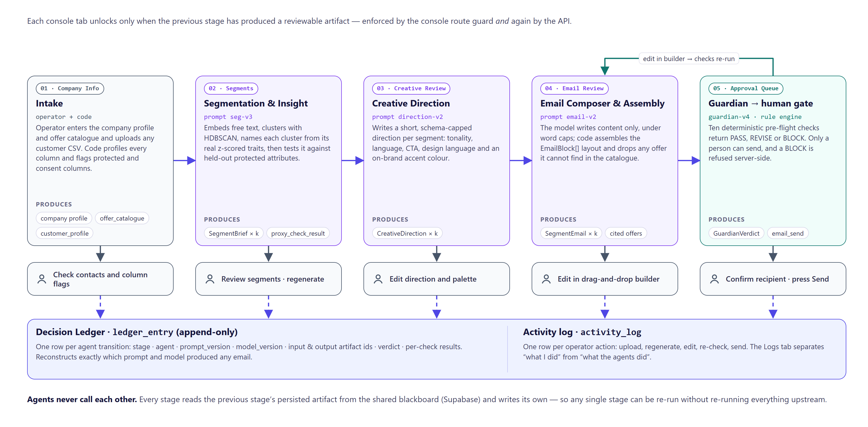
Figure 1. High-level workflow: five stages, four agents, one human gate, with the Decision Ledger and activity log underneath.
- Company Info (intake). The operator enters the company profile and offer catalogue and uploads any customer CSV. csv_ingest.py profiles every column as numeric, categorical, text, identifier or constant, and flags protected and consent columns.
- Segmentation & Insight. Clusters the audience, names each cluster from its real traits and runs the protected-attribute proxy test.
- Creative Direction. Writes a short, schema-capped direction for each segment.
- Email Composer & Assembly. Writes copy under word caps and assembles a builder-compatible email; the Guardian runs automatically on every composed email.
- Approval Queue. Shows each email exactly as it will render, with its Guardian verdict broken down by check. The operator can edit in the builder — the checks re-run — and finally confirms a recipient and presses Send.
Agents never call each other. Each stage reads the previous stage’s persisted artifact from the shared blackboard and writes its own, and every transition is appended to the Decision Ledger (Section 3.4).

2.5 How the benefits are demonstrated
Table 4. Demonstrating the claimed benefits
Benefit claimed | Where it shows in the demo
Agent autonomy | Segmentation chooses features, cluster count and which contacts stay as noise from an arbitrary CSV; the composer chooses which real offers to cite.
Responsible handling | The age-proxy flag on “Loyal Full-Price Buyers” appears on the Segments tab and as a REVISE in the Approval Queue.
Appropriate escalation | Planting a phone number, an unsubscribe-less footer or an unresolved merge tag in the builder turns the verdict to BLOCK and disables Send; the API refuses it with HTTP 409.
Traceability | The Logs tab separates “what I did” from “what the agents did”; each agent row shows its prompt and model version.
Scalability argument | Model calls per run depend on segment count, not contact count (Section 3.7).

3. System Architecture

3.1 Logical architecture
MOSAIC is organised in five layers (Figure 2). Dependencies point downward only: the console never talks to the database for pipeline state, and agents never talk to each other.
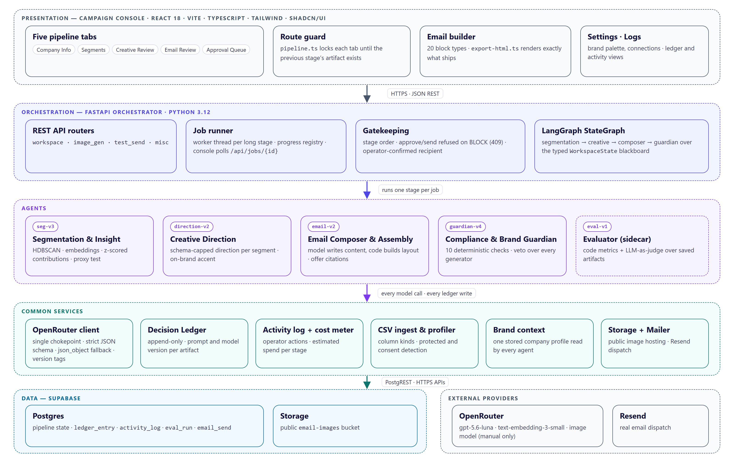
Figure 2. Logical architecture.
Table 5. Logical layers
Layer | Responsibility | Key components
Presentation | Operator workflow, review and editing | React 18 + Vite + TypeScript console; five pipeline tabs plus Settings and Logs; pipeline.ts route guard; drag-and-drop email builder with 20 block types and the export-html.ts renderer
Orchestration | Sequencing, job execution, gatekeeping | FastAPI app; routers workspace, image_gen, test_send, misc; job runner with progress registry; LangGraph StateGraph over WorkspaceState
Agents | The four decision-making agents plus the evaluator | segmentation.py, creative_direction.py, email_composer.py, guardian.py; app/eval/ sidecar
Common services | Shared capabilities every agent uses | openrouter_client.py (single model chokepoint), ledger.py, activity.py, cost_meter.py, csv_ingest.py, brand.py, storage.py, mailer.py, persistence.py
Data and external | State and third-party capabilities | Supabase Postgres and Storage; OpenRouter; Resend

3.2 Physical architecture
Physically, MOSAIC is two deployable services built from one repository plus three managed services it does not host (Figure 3).
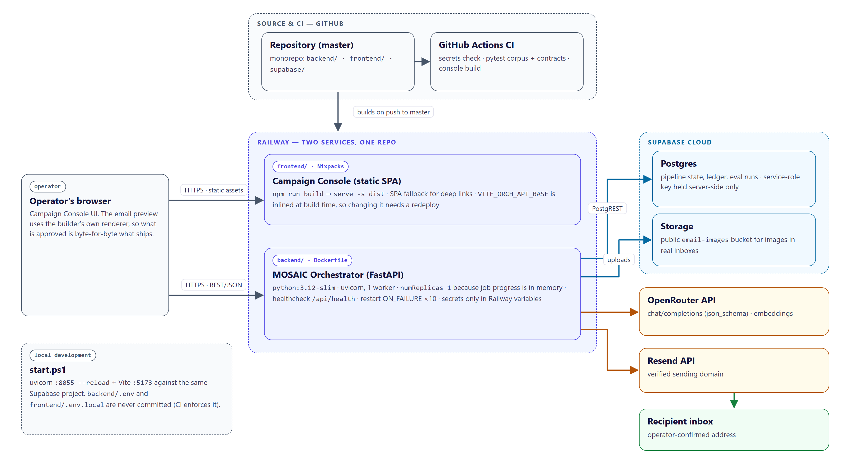
Figure 3. Physical architecture and infrastructure.
Table 6. Infrastructure components
Component | Technology | Hosting | Notes
Campaign Console | React 18, Vite, TypeScript, Tailwind, shadcn/ui | Railway service (Nixpacks), serve -s dist | Static SPA. VITE_* variables are inlined at build time, so changing the API base needs a redeploy.
MOSAIC Orchestrator | Python 3.12, FastAPI, uvicorn, LangGraph, scikit-learn, HDBSCAN | Railway service (Dockerfile, python:3.12-slim) | One worker, one replica; healthcheck /api/health; restart ON_FAILURE up to 10 times.
Database | Supabase Postgres | Supabase cloud | Schema in supabase/migrations/0001–0008; the backend writes with the service-role key.
Object storage | Supabase Storage, public email-images bucket | Supabase cloud | Hosts images so they render in real inboxes.
Models | OpenRouter (chat/completions, embeddings) | External API | Text, embeddings and judge model configured per role in .env.
Email dispatch | Resend | External API | Sends from a verified domain to an operator-confirmed address.
Local development | start.ps1 | Developer machine | uvicorn on :8055 with reload, Vite on :5173, same Supabase project.

3.3 Deployment strategy
- Containerisation. The orchestrator ships as a Docker image based on python:3.12-slim. Every dependency has a manylinux wheel, so no compiler is needed; dependency installation is a separate layer so code-only changes rebuild quickly.
- Two services, one repository. Railway builds each service from its own root directory (backend/ with its Dockerfile, frontend/ with Nixpacks). The backend deploys first because the console needs its public URL at build time.
- Health-gated releases. Railway waits for /api/health to answer before routing traffic; a deployment that never becomes healthy is not promoted, and a crashed container restarts up to ten times.
- Configuration and secrets. All secrets (OpenRouter, Supabase service-role, Resend) live only in Railway variables or an untracked backend/.env. Nothing VITE_-prefixed may hold a secret, because it ships to the browser. CI fails if a .env file is ever tracked.
- Single replica, deliberately. Job progress is kept in process memory (progress.py), so a second replica would answer half of the console’s polls with “job not found”. numReplicas: 1 encodes that; scaling out first needs a shared job store (Section 3.7).
- Schema migrations. Numbered SQL migrations are applied in order; the API turns a missing-table error into an actionable message naming the migration to run.

3.4 Agent communication protocols
MOSAIC uses a blackboard architecture rather than message passing. The Orchestrator threads a typed WorkspaceState through a LangGraph StateGraph (segmentation → creative direction → email composer → guardian). Each agent reads upstream artifacts and writes its own, and every artifact is persisted to Supabase, so each console tab can re-run its own stage from the latest persisted upstream output without re-running anything else (Figure 4).
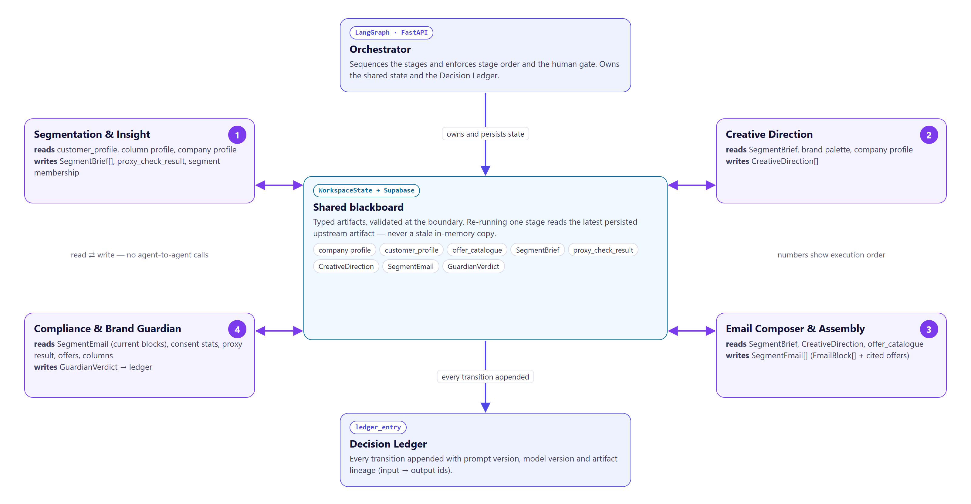
Figure 4. Inter-agent communication through the shared blackboard.
Table 7. Typed artifacts on the blackboard
Artifact | Producer | Consumers | Contract | Stored in
Company profile, column profile, offers | Operator + csv_ingest.py | All agents | Profile fields; column kinds and protected/consent flags | app_setting, offer_catalogue, customer_profile
SegmentBrief | Segmentation | Creative, Composer, Guardian, Evaluator | name, motivation, tone_guidance, size, confidence, feature_contributions | segment_brief
Proxy result | Segmentation | Guardian, console | protected_attribute, correlation, flagged | proxy_check_result
CreativeDirection | Creative Direction | Composer, Evaluator | tonality, language_style, cta_style, design_style, palette, logo/hero URLs, rationale | creative_direction
SegmentEmail | Composer (then operator edits) | Guardian, console, Evaluator | subject, preheader, EmailBlock[], cited offer ids | segment_email
GuardianVerdict | Guardian | Approval Queue, send endpoint, Evaluator | verdict, per-check name/category/passed/detail/severity | ledger_entry (checks column)

Three further protocols complete the picture:
- Model I/O protocol. Every model call goes through generate_text(), which requests OpenAI-style response_format: json_schema in strict mode. Schemas are rewritten into the strict subset automatically; if a provider rejects strict mode, the call is retried once in json_object mode with the schema restated in the prompt. Outputs are therefore typed at the boundary, and a malformed or injected payload fails there instead of spreading.
- Job protocol. Long stages return a job id immediately; the work runs on a worker thread that reports named steps through an on_step() callback, and the console polls GET /api/jobs/{id} (Figure 5). No HTTP request is held open, so no gateway timeout can cut a run short.
- Ledger protocol. Every agent transition appends a LedgerEntry with stage, agent, prompt version, model version, input and output artifact ids and, for the Guardian, the verdict and full check results. Rows are never updated; the workspace reset is the only code path permitted to delete them.
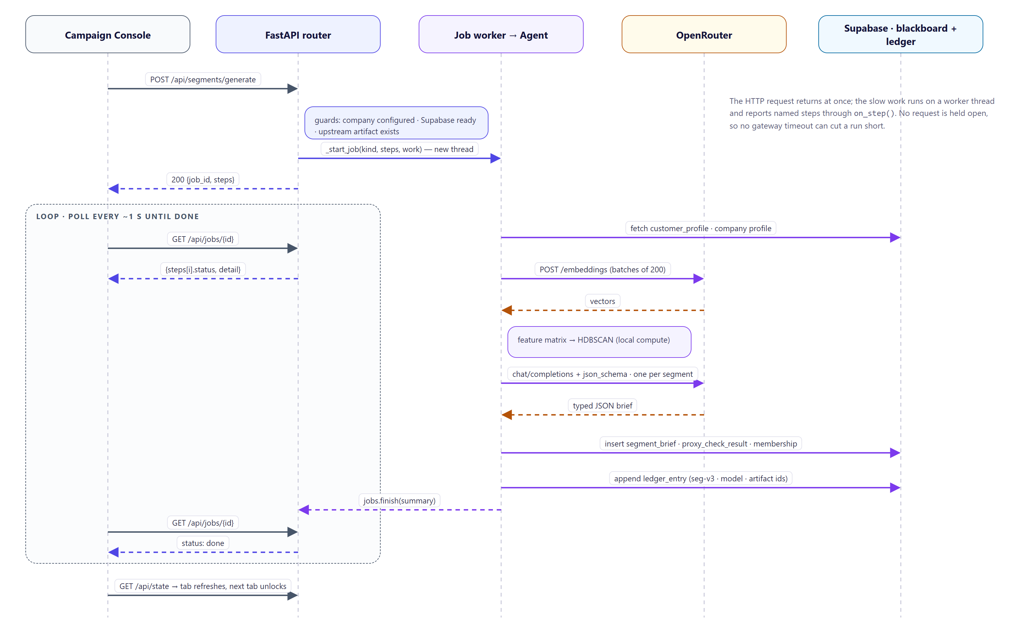
Figure 5. Sequence of one stage run (segmentation), showing the asynchronous job protocol.

3.5 Data architecture
Supabase Postgres is the single store for pipeline state, audit and evaluation (Figure 6). Customer attributes are stored as three JSONB groups — structured, behavioural and psychographic — so that any uploaded CSV fits without schema changes; free text and consent state get their own columns because they are treated specially.
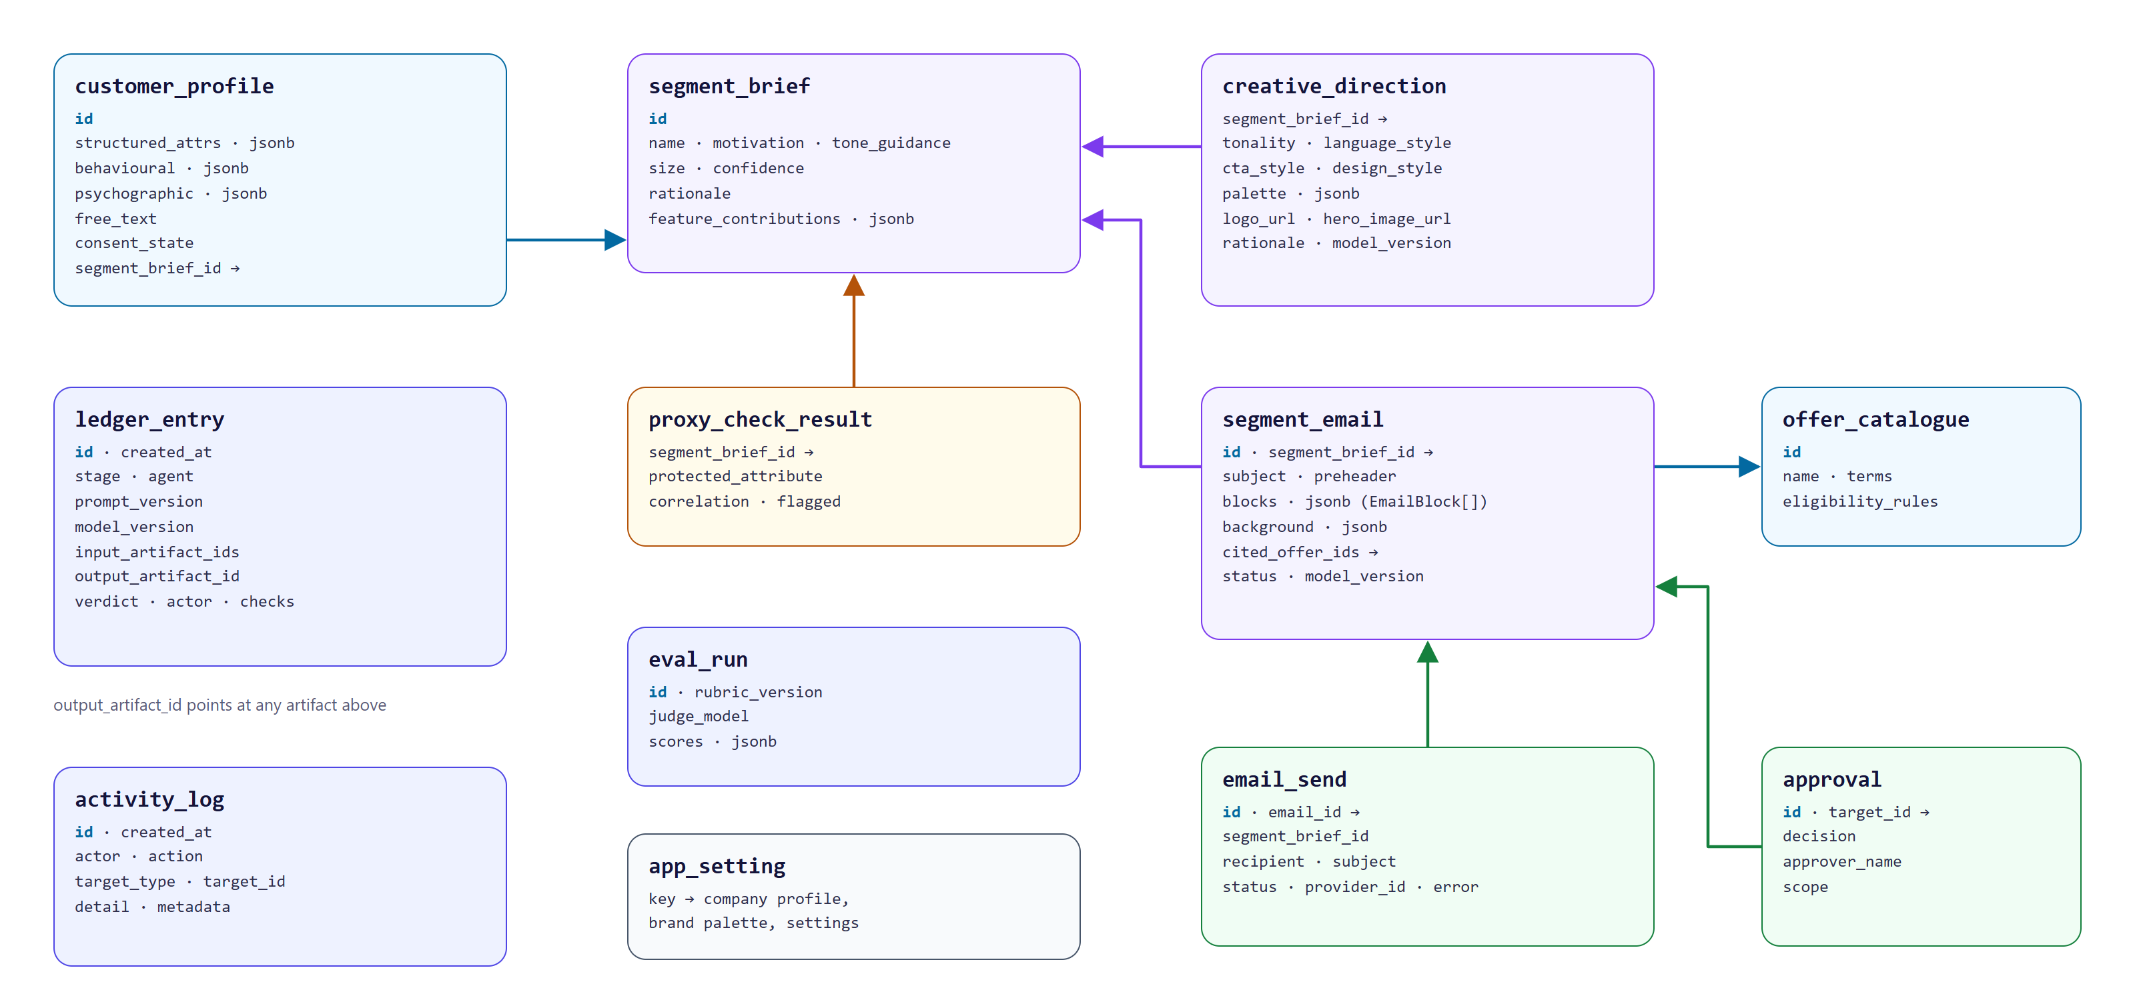
Figure 6. Core data model (pipeline, audit and evaluation tables).

3.6 Justification of architectural styles and technology choices
Table 8. Architectural decisions
Decision | Choice | Alternatives considered | Rationale
Coordination style | Blackboard with typed artifacts | Direct agent-to-agent messaging; one monolithic chain | Each stage is reviewable and re-runnable alone; no agent can influence another except through a validated artifact; lineage is natural to record.
Orchestration runtime | LangGraph StateGraph + FastAPI job runner | Hand-written pipeline; Celery | Explicit, inspectable graph over a typed state; stages also callable one at a time from the console. Celery would add a broker for a single-process demonstrator.
Graph shape | Strictly sequential | Parallel creative ∥ copy fan-out (proposal) | Creative direction became the composer’s input, and each tab reviews the previous output before the next runs.
Clustering | HDBSCAN (leaf selection) | k-means; Gaussian mixtures | No need to fix k in advance; contacts may remain noise instead of being forced into a segment; membership probabilities give a confidence score.
Guardian implementation | Deterministic rule engine | LLM-as-judge in the veto path | Cheap, fast, testable in CI without network access, and explainable check by check. The LLM judge is used only for offline evaluation.
Model access | OpenRouter behind one client | Direct provider SDKs | One key, one chokepoint for schema enforcement, cost metering and version tagging; models swappable by configuration.
Layout generation | Code assembles typed EmailBlock[] | Model generates HTML/MJML | A bad model response can shorten copy but never produce an unrenderable or off-brand template; output drops straight into the builder.
Data store | Supabase Postgres + Storage | SQLite; separate object store | Managed Postgres with JSONB, row-level security and a public bucket for email images in one service.
Frontend | React + Vite + shadcn/ui | Streamlit | A drag-and-drop email builder and per-check review UI needed a real component framework.

3.7 Scalability
We justify scalability from the architecture rather than quoting a throughput figure we have not measured. Table 9 counts external model calls per full pipeline run directly from the code, for n contacts and k segments.
Table 9. Model calls per run
Stage | LLM (chat) calls | Embedding calls | Per-recipient work
Segmentation & Insight | k | ⌈n / 200⌉ (only if the CSV has free text) | —
Creative Direction | k | — | —
Email Composer & Assembly | k | — | —
Guardian | 0 (rule engine) | — | —
Dispatch | 0 | — | Merge-tag fill from the contact record
Total | 3k — 18 at the default cap of k = 6 | 5 at n = 1,000; 1,000 at n = 200,000 | Deterministic

Chat-model work — the expensive, high-variance part — is therefore independent of list size: a 200,000-contact list costs the same 18 LLM calls as a 1,000-contact list at k = 6. Only the batched embedding calls grow with n. The demonstrator itself has been run end to end at 1,000 contacts; we have not load-tested it. Current limits are explicit:
- one backend replica, because job progress is held in memory;
- a 20,000-row ceiling per upload (MAX_ROWS) and a 25 MB request limit;
- HDBSCAN runs in-process on one machine; very large lists would need clustering on a sample with the remaining contacts assigned to the nearest cluster.
The path to horizontal scale is a shared job store (for example Redis or a Postgres jobs table), which removes the single-replica constraint, followed by moving long stages to a worker pool.

4. Agent Roles and Design
All four agents follow the same pattern: gather context from the blackboard, make one bounded decision, emit a schema-typed artifact, append a ledger entry. We deliberately chose bounded autonomy. Agents make real, data-driven decisions, but none of them runs an open-ended tool-calling loop, and the human operator is the outer loop: review, edit, regenerate, re-check. Section 9 discusses the bounded Guardian-to-Composer revise loop we would add next.

4.1 Orchestrator
Aspect | Design
Purpose | Sequence the stages, own the shared state and the Decision Ledger, and enforce stage order and the human gate.
Owner | OQQ
Implementation | orchestrator/graph.py (LangGraph StateGraph over WorkspaceState), routers/workspace.py (job runner, guards), ledger.py, progress.py.
Autonomy | The least autonomous component by design: it plans over a fixed action space and never chooses content.
Memory | WorkspaceState (typed in-run state) plus persisted artifacts in Supabase; the ledger is the audit memory.
Safeguards | Refuses a stage when its prerequisites are missing (no company profile, no Supabase, no upstream artifact); refuses approve or send for a BLOCK verdict (HTTP 409); an edit revokes any prior approval and triggers re-adjudication.

4.2 Segmentation & Insight Agent
Aspect | Design
Purpose | Discover micro-segments in the operator’s own customer list and explain each one in business terms.
Owner | OQQ · prompt version seg-v3
Models | HDBSCAN (scikit-learn ecosystem) for clustering; openai/text-embedding-3-small for free text; openai/gpt-5.6-luna to name and describe each cluster.
Tools | Column profiler, feature-schema inference, StandardScaler, PCA, z-scored feature contributions, protected-attribute proxy test, Supabase profile queries.
Memory | Reads the stored column profile and company profile; writes segment_brief, proxy_check_result and each contact’s segment membership.
Autonomy | Decides from the data which columns are features, how many clusters exist, and which contacts stay as noise. Keeps at most MAX_SEGMENTS (default 6) largest clusters.

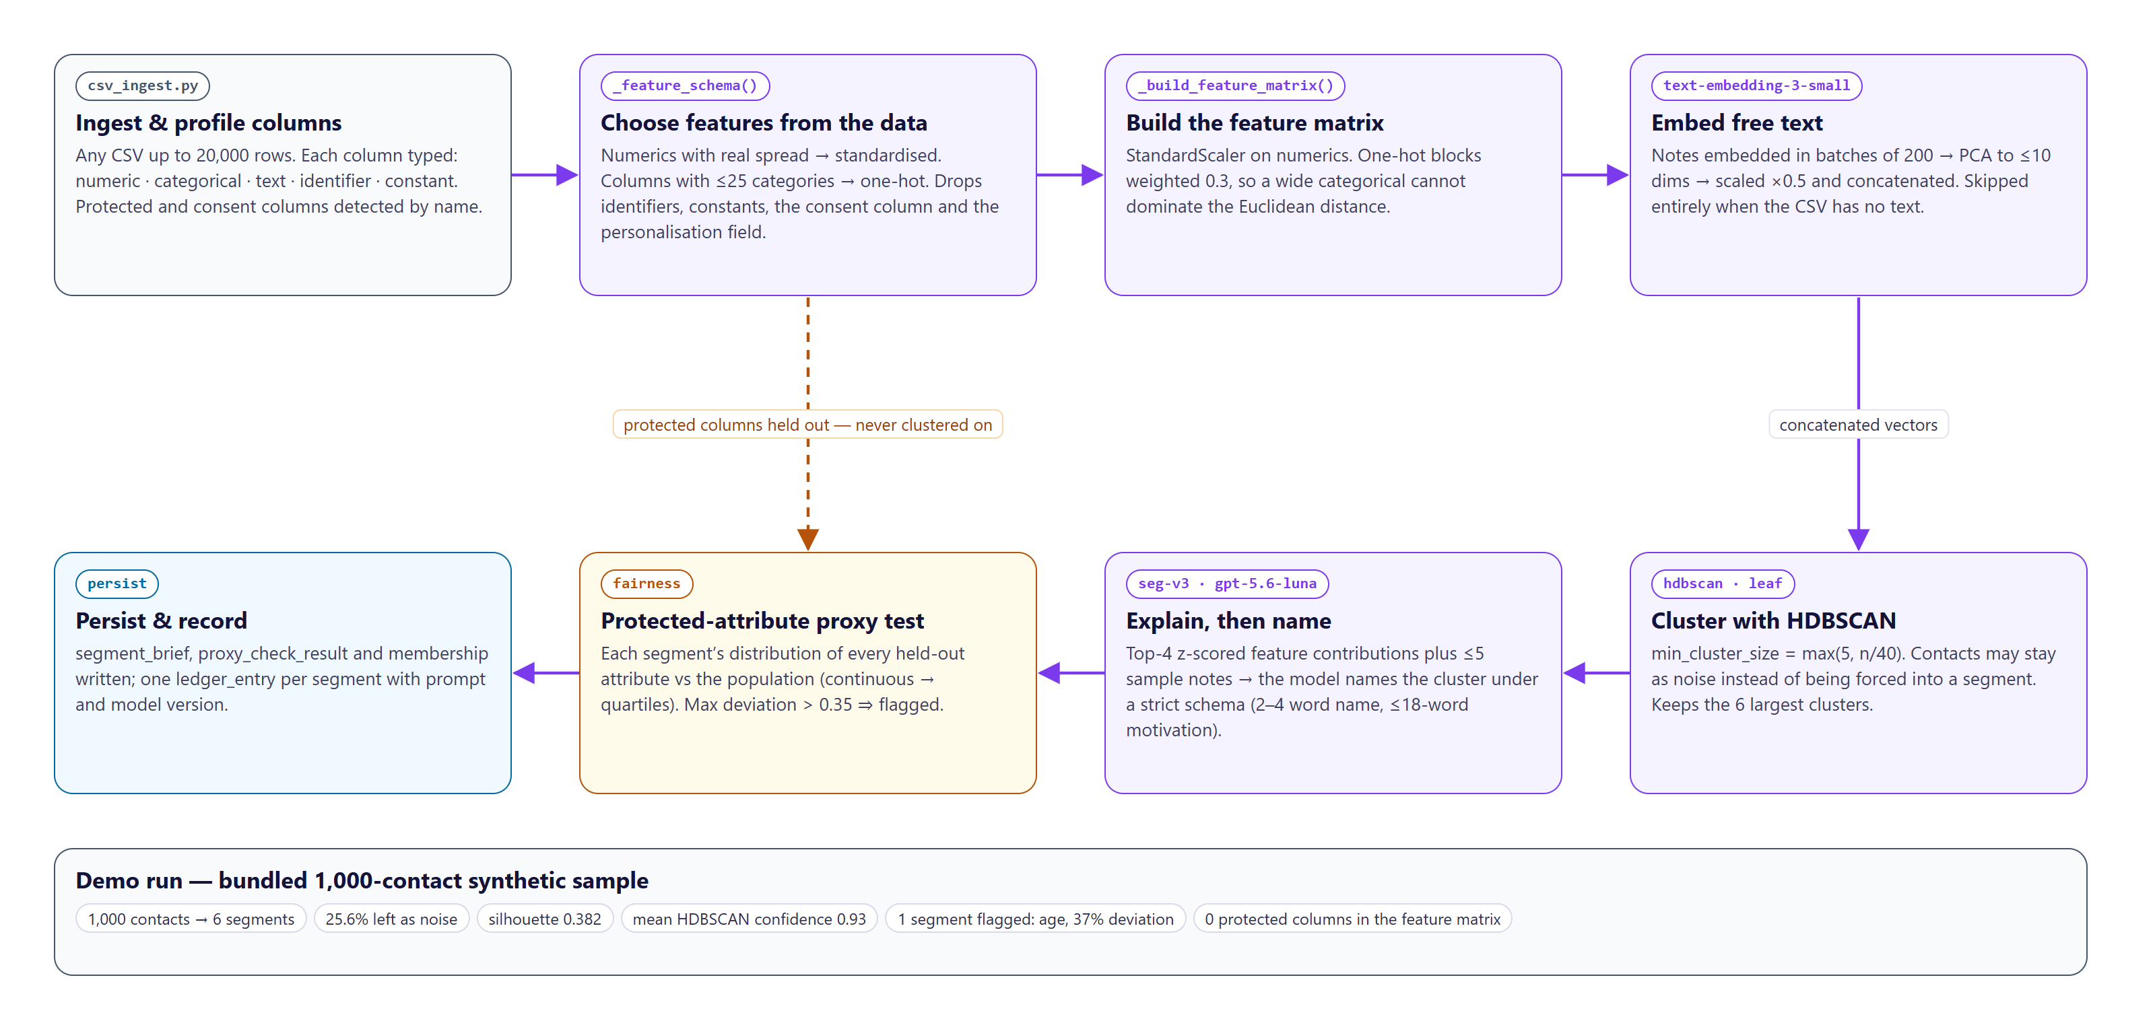
Figure 7. Segmentation & Insight agent: internal pipeline.
Reasoning pattern — explain, then name. The agent separates discovery from description. Discovery is numerical: numeric columns with real spread are standardised, categorical columns with at most 25 values are one-hot encoded at weight 0.3 (so a wide categorical block cannot dominate Euclidean distance), and text embeddings are reduced by PCA to at most 10 dimensions and scaled by 0.5. HDBSCAN runs with min_cluster_size = max(5, n/40) and leaf selection, which on the original base kept behavioural archetypes separate where the default merged them. Only then is the model asked to describe each cluster, and it is given the cluster’s top-four z-scored feature contributions and up to five sample notes — not the raw rows.
Prompt pattern. Company context, then the distinguishing traits as JSON, then the sample notes, then a terse instruction. The schema caps the output to a 2–4 word name, one motivation sentence of at most 18 words, one tone phrase of at most 10 words and one rationale sentence of at most 22 words.
Fallbacks. No contacts or no clusterable columns raises an actionable error. If the CSV has no free text, embeddings are skipped rather than paying for empty strings. If HDBSCAN finds no dense cluster, the agent says so and suggests a larger or more varied list. If the naming call fails, the cluster is still saved, named “Segment n” with the error recorded, so a model outage never discards the clustering.
Demo results. On the 1,000-contact sample the agent produced six segments covering 744 contacts (25.6% left as noise), with mean membership confidence 0.93 and silhouette 0.382.

4.3 Creative Direction Agent
Aspect | Design
Purpose | Turn each segment into a short written creative direction that the composer must follow.
Owner | ABP · prompt version direction-v2
Model | openai/gpt-5.6-luna under a strict JSON schema.
Tools | Company context (brand.py), stored brand palette, hex validator, per-segment asset overrides.
Memory | Reads SegmentBrief and the brand palette; preserves operator overrides of logo and hero across regenerations (existing_assets); writes creative_direction.
Autonomy | Chooses tonality, language style, CTA style, design language and an accent colour for each segment.

Prompt pattern. A role statement (“creative director … no imagery is being produced”), the company context, the segment’s name, motivation and tone guidance, and the brand palette, followed by explicit constraints: each style field is a phrase of at most eight words; never suggest urgency, scarcity or loss framing; never reference age, gender or any protected attribute.
Fallbacks. The strict-schema subset cannot express a regex, so the accent colour is validated in code and falls back to the brand palette’s accent if it is not a valid hex value. If the call fails, the direction is saved with empty fields and the error in its rationale, visible on the Creative Review tab.
Change from the proposal. The proposal’s Creative Director generated images and critiqued them in a loop. We replaced that with a written direction because per-segment image generation was expensive, slow to review and hard to evaluate. Image generation still exists, but only as an operator-triggered tool.

4.4 Email Composer & Assembly Agent
Aspect | Design
Purpose | Write each segment’s email and assemble it into the builder’s block format.
Owner | OQQ · prompt version email-v2
Model | openai/gpt-5.6-luna under a word-capped strict JSON schema.
Tools | Offer catalogue, block assembler (_build_blocks), merge-tag layer (brand.merge_tag), company social and footer links.
Memory | Reads SegmentBrief, CreativeDirection and the offer catalogue; writes segment_email with its blocks, background and cited offer ids.
Autonomy | Chooses the copy and which real catalogue offers to cite; code owns the layout.

Split of responsibility. The model writes only content: subject (≤8 words), preheader (≤12), headline (≤7), intro (≤34), exactly three highlight cards, a 2–3 word CTA, two FAQs and a closing line. Code assembles the layout — centred logo, hero, headline, intro, three benefit columns, an offer coupon, FAQ accordion, CTA, closing, social links and footer — and applies the segment’s palette and corner radius derived from its design language. A bad model response can shorten the copy but cannot produce an unrenderable or off-brand template.
Grounding enforced, not trusted. Cited offer ids that are not real catalogue rows are dropped before saving. The coupon block appears only when an offer is genuinely cited. The personalised greeting is inserted by code as a real merge tag, because a model asked to include {{first_name}} drops it often enough to matter.
Prompt pattern. Company context, segment, the creative direction to follow, the list of citable offers with ids and terms, then rules: no filler openers, no exclamation marks or emoji, never invent prices or offers outside the list, avoid urgency, scarcity and loss framing, never mention protected attributes, and never include an email address or phone number.
Fallbacks. A segment without a direction is skipped rather than composed off-brand. If the call fails, a clearly marked placeholder is saved; because it cites no offer, it cannot pass the Guardian’s grounding check.

4.5 Compliance & Brand Guardian Agent
Aspect | Design
Purpose | Adjudicate every email before any send, with a veto over every generator.
Owner | ABP · check-set version guardian-v4
Model | None. A deterministic rule engine, by design.
Tools | Consent statistics per segment, proxy-test results, offer catalogue, uploaded column names, PII scanner, merge-tag resolver, link and image checkers.
Memory | Reads the email’s current blocks (after any edit); writes its verdict and per-check results to the ledger. The console ignores verdicts from older check-set versions.
Autonomy | Issues PASS, REVISE or BLOCK; nothing in the system can override a BLOCK.

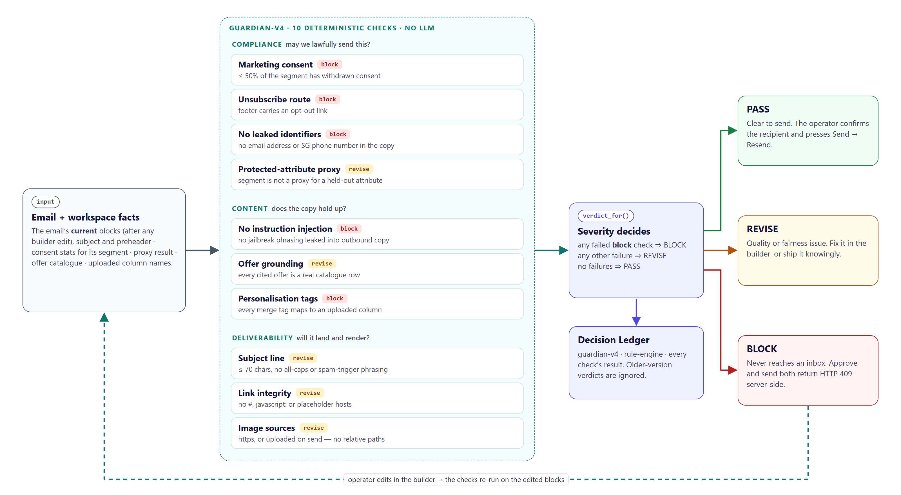
Figure 8. Guardian: ten checks, severity-driven verdict and the re-check loop.
Table 10. Guardian check set (guardian-v4)
Check | Group | Severity | Fails when
Marketing consent | Compliance | block | More than 50% of the segment’s contacts have withdrawn consent
Unsubscribe route | Compliance | block | No footer block, or the footer carries no unsubscribe / opt-out / preferences link
No leaked identifiers | Compliance | block | An email address or Singapore phone number appears in the visible copy
Protected-attribute proxy | Compliance | revise | The segment was flagged by the proxy test (max deviation > 0.35)
No instruction injection | Content | block | Jailbreak phrasing such as “ignore previous instructions” appears in the copy
Offer grounding | Content | revise | No offer is cited, or a cited id is not in the catalogue
Personalisation tags | Content | block | A {{tag}} or %%tag%% names no uploaded column, so it would render literally
Subject line | Deliverability | revise | Empty, longer than 70 characters, all caps, excessive punctuation or spam-trigger phrasing
Link integrity | Deliverability | revise | A link is #, empty, javascript:, a placeholder host or not http(s)/mailto/tel
Image sources | Deliverability | revise | An image uses a relative path or plain http

Verdict logic. Any failed block-severity check gives BLOCK; any other failure gives REVISE; no failures gives PASS. BLOCK means the message must never reach an inbox: sending without consent or an opt-out route is unlawful, leaking another customer’s identifiers is a data incident, and an unresolved merge tag renders literally to a real person. REVISE is a quality or fairness problem the operator may fix or knowingly ship over.
Why no LLM. Keeping a language model out of the veto path makes the Guardian fast, free to run on every edit, testable in CI without network access, and explainable check by check. Language-model judgement is used only in the offline evaluator.

4.6 Evaluator (sidecar)
The evaluator (app/eval/, rubric eval-v1) scores all four decision agents against artifacts that are already saved, never against a fresh and friendlier run. Each agent’s rubric sums to 100 and mixes deterministic code metrics with LLM-as-judge criteria scored on a 1–5 Likert scale by a judge whose system prompt instructs it to score conservatively and never invent facts. Runs are stored in eval_run with the judge model and a delta against the previous run. If the judge cannot run, the affected criteria are reported as unavailable rather than estimated. Results are in Section 8.

4.7 Shared prompt-engineering patterns and fallbacks
Table 11. Shared patterns
Pattern | Where | Purpose
Strict JSON schema with per-field word caps | All generating agents | Typed output at the boundary; injected instructions have nowhere to land; compact UI cards
Schema strictification + json_object retry | openrouter_client.py | Works across providers that do not support strict mode
Context first, constraints last | All prompts | Company context and segment facts, then explicit prohibitions (urgency, protected attributes, contact details)
Model names, code decides | Segmentation, Composer | The model describes numbers it was given and writes copy; structure and grounding are enforced in code
Fail visible, not silent | All agents | Failures produce a marked artifact or an actionable error and are logged, never a plausible-looking fake
Version tags on every call | Ledger | Prompt and model version recorded for every artifact

5. Explainable and Responsible AI Practices

5.1 Alignment across the development and deployment lifecycle
Table 12. Responsible-AI alignment by lifecycle stage
Lifecycle stage | Principles | What is implemented | Evidence
Data collection and ingestion | Privacy, fairness, consent | Synthetic data only; consent column detected and stored as consent_state; protected columns flagged by whole-token name matching (so average_basket is not mistaken for “age”) | csv_ingest.py; contract test test_protected_columns_are_recognised
Feature engineering | Fairness | Protected, consent and identifier columns excluded from the feature matrix; categorical weighting prevents one column dominating | _feature_schema()
Modelling (clustering) | Fairness, explainability | Z-scored feature contributions per segment; proxy test against every held-out attribute | Segments tab; proxy_check_result
Generation | Safety, non-manipulation, grounding | Schema caps; prohibitions in prompts; uncited offers dropped; layout owned by code | Agent prompts and schemas; contract tests
Adjudication | Accountability, compliance | Deterministic Guardian with BLOCK severity for legal and safety failures | guardian.py; LLMSecOps corpus in CI
Human review and dispatch | Human oversight | Only a person can send, to a confirmed address; BLOCK refused server-side; edits re-run the checks | Approval Queue; /api/emails/{id}/send
Monitoring and evaluation | Transparency, accountability | Append-only ledger with versions; activity log; eval-v1 sidecar including a “no dark patterns” criterion | Logs tab; eval_run

5.2 Fairness and bias mitigation
Exclusion. Protected attributes — age, sex, gender, race, ethnicity, religion, nationality, disability, pregnancy, marital status, date of birth and age bands — never enter the feature matrix.
Exclusion is not enough, so we test for proxies. Behavioural features can still encode a protected attribute. After clustering, the agent compares each segment’s distribution of every held-out attribute with the population’s. Continuous attributes are first bucketed into population quartiles, because a raw age column has a distinct value for almost every contact and would never flag. The largest absolute deviation is recorded; above 0.35 the segment is flagged. A flagged segment is shown on the Segments tab and carried into the Guardian as a REVISE on every email from that segment, so a person must consciously decide.
Table 13. Proxy-test results on the demo workspace (protected columns present: age, age_bracket, gender)
Segment | Contacts | Confidence | Worst attribute | Max deviation | Flagged
Lapsed Complaint Customers | 141 | 0.913 | age | 0.192 | No
Loyal Full-Price Buyers | 134 | 0.934 | age | 0.372 | Yes → REVISE
App-First Drop Explorers | 134 | 0.930 | age | 0.277 | No
Seasonal Gift Buyers | 121 | 0.929 | age | 0.220 | No
Conscious Cat Keepers | 114 | 0.927 | age_bracket | 0.147 | No
Discount-Driven Cat Shoppers | 100 | 0.946 | age_bracket | 0.067 | No

The finding is plausible: a segment defined by high spend and loyalty skews older. MOSAIC does not silently suppress the segment — that would be a judgement the system is not entitled to make — but it makes the correlation visible and requires a person to own the decision.
Bias in language. Names and descriptions come from the segment’s own feature contributions, not from free association; prompts forbid references to protected attributes; and the evaluator scores segment-name faithfulness against the contributions.
No individual price discrimination. Offer value comes only from catalogue rows with defined eligibility. The composer can choose which real offer to cite but cannot invent a price, and nothing varies offer value by inferred willingness to pay.

5.3 Explainability
Table 14. Explainability artifacts
Artifact | Explanation provided | Where the operator sees it
Segment | Size, HDBSCAN confidence, top-four z-scored feature contributions (signed bars), one-sentence rationale, proxy result | Segments tab
Creative direction | Rationale linking the direction to the segment | Creative Review tab
Email | Cited catalogue offers; Guardian verdict broken down by category and check with a plain-language detail line | Email Review, Approval Queue
System behaviour | Ledger rows with stage, agent, prompt version, model version and artifact lineage; operator actions separated from agent actions | Logs tab (“What I did” / “What the agents did”)
Agent quality | Per-criterion rubric breakdown, code vs LLM-judge, with delta from the previous run | Approval Queue → Model scores

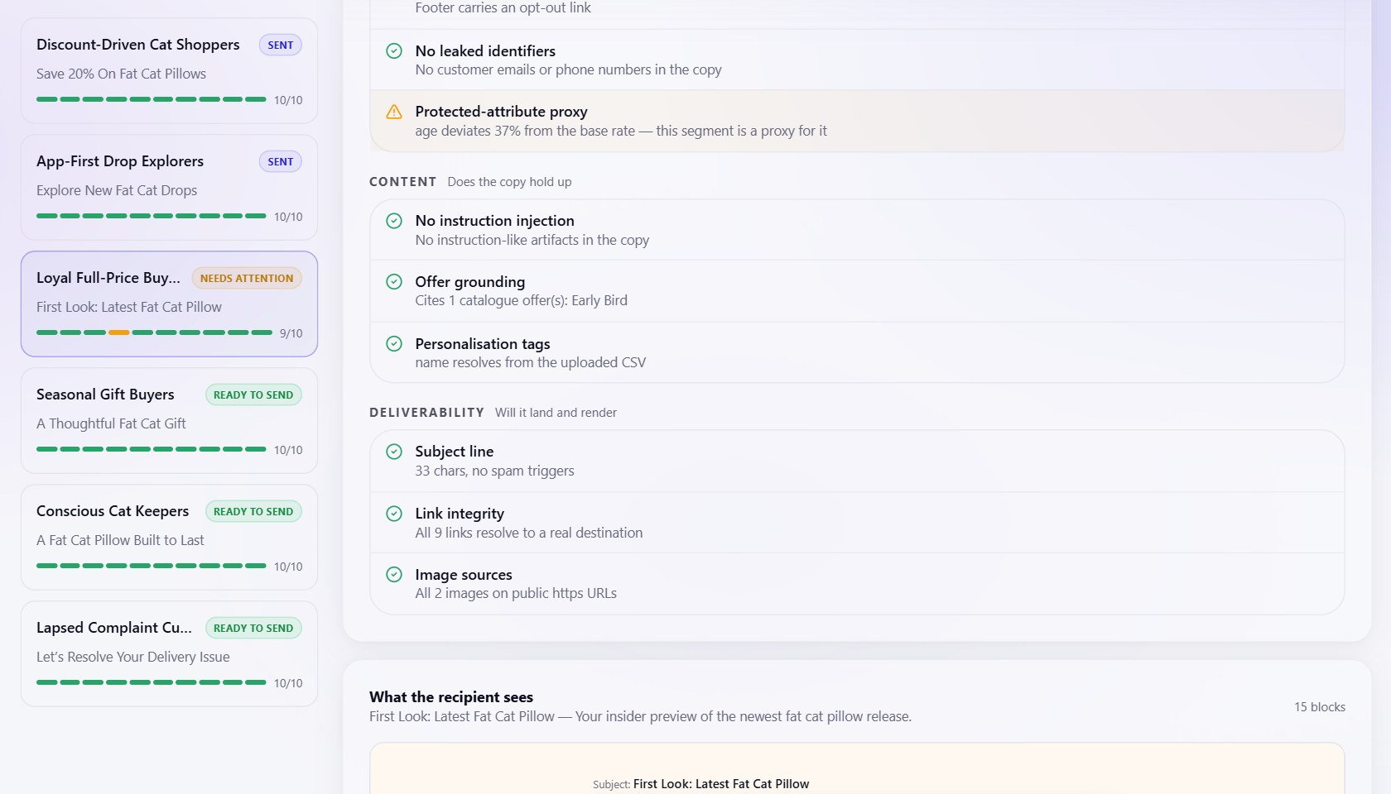
Figure 9. Approval Queue: per-check Guardian breakdown for the REVISE email, with the proxy finding explained in plain language.

5.4 Accountability and human oversight
- Human-in-the-loop at every stage: each artifact is reviewed before the next tab unlocks, and every artifact can be edited or regenerated.
- Only a person can send. There is no configuration flag that lets an agent dispatch, and nothing in the LangGraph graph sends mail.
- The gate is enforced server-side: approve and send both return HTTP 409 for an email whose latest verdict is BLOCK, independently of the disabled button in the UI.
- Editing an email revokes any earlier approval and re-runs the Guardian, so an approval always refers to the artifact that actually ships.
- Limitation: approvals are recorded against a generic “Operator” identity because the demonstrator has no authentication (Progress Report 1 discussed this trade-off). Named approvers are the first step of the auth work in Section 9.

5.5 Manipulation guardrail and ethical exclusions
The proposal planned a separate manipulation-index scorer. In the build, the guardrail is layered instead: generation prompts forbid urgency, scarcity and loss framing; the subject-line check flags spam-trigger phrasing and shouting; and the evaluator’s Creative rubric scores “no dark patterns” (the demo direction set scored 20 out of 20). Four capabilities are excluded on ethical grounds:
- no targeting or creative variation on inferred health status, financial distress, bereavement or any protected attribute;
- no individual price discrimination — offer value varies only by catalogue eligibility rules;
- no targeting of emotional vulnerability, including send timing;
- no generated imagery of identifiable real people, and no fabricated endorsements or testimonials.

5.6 Governance framework alignment
We mapped MOSAIC to the four areas of Singapore’s Model AI Governance Framework (IMDA/PDPC, second edition) and to the consent obligations of the PDPA.
Table 15. Governance mapping
Framework area | How MOSAIC addresses it
Internal governance structures and measures | Named ownership of each agent (OQQ / ABP), with the Guardian owned by the member who did not build the generators; a mandatory human gate; versioned check sets and rubrics; CI as a policy gate.
Level of human involvement in AI-augmented decision-making | Risk-tiered human-in-the-loop: the system drafts and checks, a person decides; BLOCK cannot be overridden; REVISE requires a conscious choice.
Operations management | Data provenance (synthetic, profiled columns); protected-attribute handling and proxy testing; prompt and model versions on every ledger row; evaluation runs with deltas; deterministic tests in CI.
Stakeholder interaction and communication | A working unsubscribe route is a BLOCK-level requirement; every email carries an explanation trail; the console explains each check in plain language.
PDPA — consent and withdrawal | Consent column detected at upload; withdrawal is honoured whenever the Guardian runs, including on every edit, so a withdrawal mid-campaign is picked up before the next send.

5.7 Data minimisation
The composer receives no customer records at all — only the segment description, the direction and the offer list — and merge tags are filled locally at send time. The segmentation naming call receives aggregate z-scores and at most five sample notes. Free-text notes are sent to the embeddings endpoint; with real customer data this would require a data-processing agreement with the provider or PII scrubbing before embedding (risk R4 in Section 6).

6. AI Security Risk Register

6.1 Threat model
MOSAIC ingests text an attacker can influence — free-text profile fields in an uploaded CSV — and then emits content to third parties under a brand’s name. The trust boundaries are: the uploaded CSV (untrusted), model output (untrusted until checked), the operator (trusted, but able to paste untrusted content into company fields), and three external services. Assets at risk are the brand’s reputation, recipients’ personal data and consent rights, the operator’s API budget, and the integrity of the audit trail.
Likelihood (L) and impact (I) are each rated Low (L), Medium (M) or High (H). Risks are mapped to the OWASP Top 10 for LLM Applications (2025) where one applies; the residual-risk column states what remains after the implemented controls and what we would do next.
Table 16. AI security risk register
ID | Risk | OWASP | L / I | Controls implemented | Evidence | Residual risk and planned action
R1 | Indirect prompt injection via customer free text | LLM01 | M / H | Free text reaches the chat model only as ≤5 sample notes in a data position; strict, length-capped JSON schema leaves no free-form channel; Guardian BLOCKs instruction-like phrasing in output | test_prompt_injection_in_copy_blocks | Medium. No input sanitiser or delimiting yet; add structural delimiting and an ingest-time injection scan.
R2 | Injection through operator-entered fields (company description, intent, offer terms) | LLM01 | L / M | Same schema caps and output scan; the operator is a trusted user in the demo | Guardian corpus | Low.
R3 | Cross-recipient PII leakage in copy | LLM02 | L / H | Composer receives no customer records; prompt forbids contact details; Guardian email/phone scan is BLOCK | test_pii_leak_blocks; CI negative test | Low.
R4 | Personal data sent to the model provider | LLM02 | M / M | Data minimisation (Section 5.7); synthetic data only | Prompt construction in code | Medium for real data: scrub PII before embedding or use a provider under a DPA.
R5 | Hallucinated offers, prices or claims | LLM09 | M / M | Uncited ids dropped; grounding check; coupon only when cited; judge scores grounding | test_ungrounded_offer_fails_grounding | Low–Medium. Grounding is REVISE, not BLOCK; consider raising severity.
R6 | Improper output handling (model text rendered as HTML) | LLM05 | L / M | Model output placed into typed block fields and stringified; builder sanitises HTML with DOMPurify and validates URL schemes; link check rejects javascript: | email-sanitize.ts; link check | Low.
R7 | Excessive agency | LLM06 | L / H | No agent can send; sending is a human action to a confirmed address; BLOCK refused server-side | Send endpoint; graph has no dispatch node | Low. Send currently accepts an email with no current-version verdict; require one.
R8 | Unbounded consumption / cost exhaustion | LLM10 | M / M | MAX_SEGMENTS = 6; no generation loops; 3k chat calls per run; cost meter per stage | Cost meter; Section 3.7 | Medium. No hard budget ceiling or rate limit; add both.
R9 | Unresolved merge tag or wrong personalisation | — | M / M | Both tag dialects resolved against uploaded columns; unresolved tag is BLOCK; tags filled from a real segment contact at send | test_unresolved_merge_tag_blocks | Low.
R10 | Sending to contacts who withdrew consent | — | L / H | Consent check is BLOCK above 50% withdrawn; re-checked on every Guardian run | Consent check | Low in the demo (single confirmed recipient). Bulk sending must filter withdrawn contacts per recipient.
R11 | Segments acting as proxies for protected attributes | — | M / M | Protected columns held out; proxy test; REVISE in Guardian | Table 13 | Medium. A person can ship a flagged segment knowingly; record the reason.
R12 | Secret leakage and dependency supply chain | LLM03 | M / H | Secrets only server-side; CI rejects tracked .env files and live key assignments | CI job 1; test_no_dotenv_or_live_keys_in_repo | Medium. Dependencies use >= ranges; pin with hashes and add pip-audit / npm audit to CI.
R13 | Unauthenticated API and no rate limiting | — | M / H | CORS allow-list; secrets not exposed to the browser | config.py | High. Add authentication with named approvers and per-route rate limits before any non-demo exposure.
R14 | System prompt leakage | LLM07 | L / L | Prompts contain no secrets or credentials | Prompt source | Low.

6.2 AI security testing
The LLMSecOps corpus in backend/tests/fixtures/llmsecops/ holds six fixture emails run through the real run_checks() and verdict_for() path with external dependencies stubbed: a clean email (must PASS), a PII leak, instruction-injection phrasing, a missing unsubscribe route and an unresolved merge tag (each must BLOCK), and an ungrounded offer (must fail grounding). A deliberate negative test on branch ci/demo-fail-pii planted a phone number and email address in the clean fixture; the CI job failed with assert 'BLOCK' == 'PASS', which shows the gate refuses to treat a PII leak as clean.
What we have not done is adversarial red-teaming of the live models — for example, crafting CSV notes designed to steer segment names. That is the next security test to add, together with the input sanitiser in R1.

7. MLSecOps / LLMSecOps Pipeline

7.1 Pipeline overview
Every push and pull request runs .github/workflows/ci.yml. No CI job calls OpenRouter or Supabase, so the gate is deterministic, free and safe to run on every change (Figure 10).
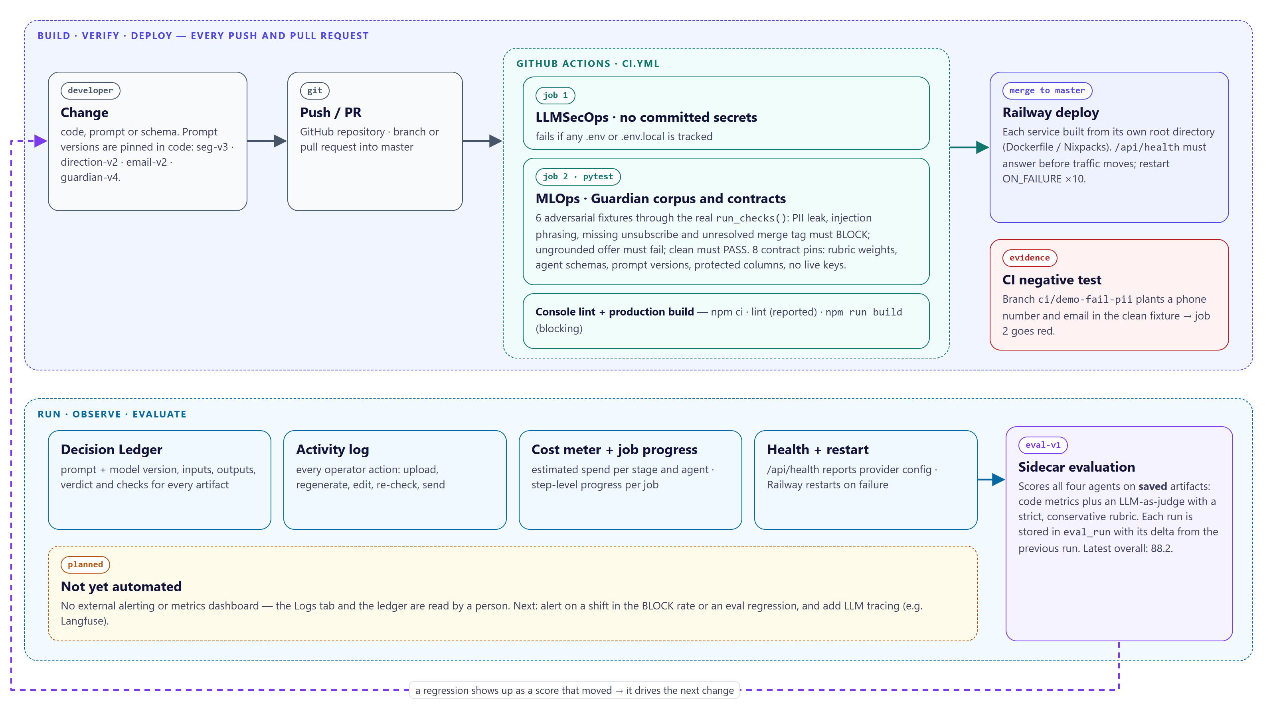
Figure 10. MLSecOps / LLMSecOps pipeline: build, verify, deploy, then run, observe and evaluate.

7.2 Automated testing, including AI security tests
Table 17. CI jobs
CI job | What it locks | Fails when
Job 1 — LLMSecOps · no committed secrets | Secret hygiene | Any .env or .env.local file is tracked
Job 2 — MLOps · Guardian corpus and contracts | Guardian behaviour on six adversarial fixtures; eval-v1 weights sum to 100 per agent; agent schemas still require their artifact fields; prompt versions seg-v3, direction-v2, email-v2, guardian-v4 pinned; protected column names recognised; no live API key assignments in tracked code | Any of the 14 pytest assertions fails
Job 3 — Console lint and production build | The exact build command Railway runs | npm run build fails (lint is reported but not blocking, because of pre-existing builder warnings)

7.3 Versioning and tracking
Table 18. Versioning
Artefact | How it is versioned | Where it is recorded
Code | Git; pull requests gated by CI | GitHub
Prompts | Version string per agent in code (seg-v3, direction-v2, email-v2); asserted by a contract test so a silent change fails CI | Every ledger row
Models | Model id per role in configuration | Every ledger row; creative and email artifacts also store model_version
Guardian check set | GUARDIAN_VERSION = guardian-v4; the console ignores verdicts from older versions | Ledger (prompt_version of Guardian rows)
Evaluation rubric | RUBRIC_VERSION = eval-v1; weights pinned by test | eval_run.rubric_version, plus the judge model
Database schema | Numbered migrations 0001–0008 | supabase/migrations/

7.4 Deployment strategy
Merges to master are built by Railway, one service per root directory. The orchestrator image must pass its /api/health check before it receives traffic, and crashed containers restart automatically. Configuration is environment-based, with secrets held only in Railway variables. Rollback is by redeploying a previous Railway deployment. Section 3.3 gives the details.

7.5 Monitoring and alerting
Table 19. Monitoring signals
Signal | Source | Status
Service health and provider configuration | GET /api/health; Railway healthcheck | Implemented
Per-stage model spend | In-process cost meter, shown on the Logs tab | Implemented (estimates; resets on restart)
Guardian verdict distribution and per-check pass rates | Ledger; eval-v1 Guardian metrics | Implemented, read by a person
Agent quality regressions | eval_run with delta against the previous run | Implemented, run on demand
Alerts on BLOCK-rate shift, eval regression, provider error rate, stage latency | — | Planned
LLM tracing (prompts, latencies, token usage) | — | Planned (e.g. Langfuse)

A shift in the BLOCK rate is the earliest signal that something upstream has drifted — a new model version, a prompt change or a different kind of customer list — so it is the first alert we would automate.

7.6 Logging and auditability
- Decision Ledger (ledger_entry): append-only, one row per agent transition, with prompt and model versions, input and output artifact ids, verdict and check results. If the database is unavailable, entries fall back to an in-process list and a log line rather than being lost silently.
- Activity log (activity_log): every operator action — upload, regenerate, edit, re-check, send, evaluation run — with actor, target and detail.
- Dispatch records (email_send): every send attempt, successful or refused by the provider, with recipient, subject, status and provider id or error.
- Application logs: Python logging of job failures with stack traces, visible in Railway’s log stream.
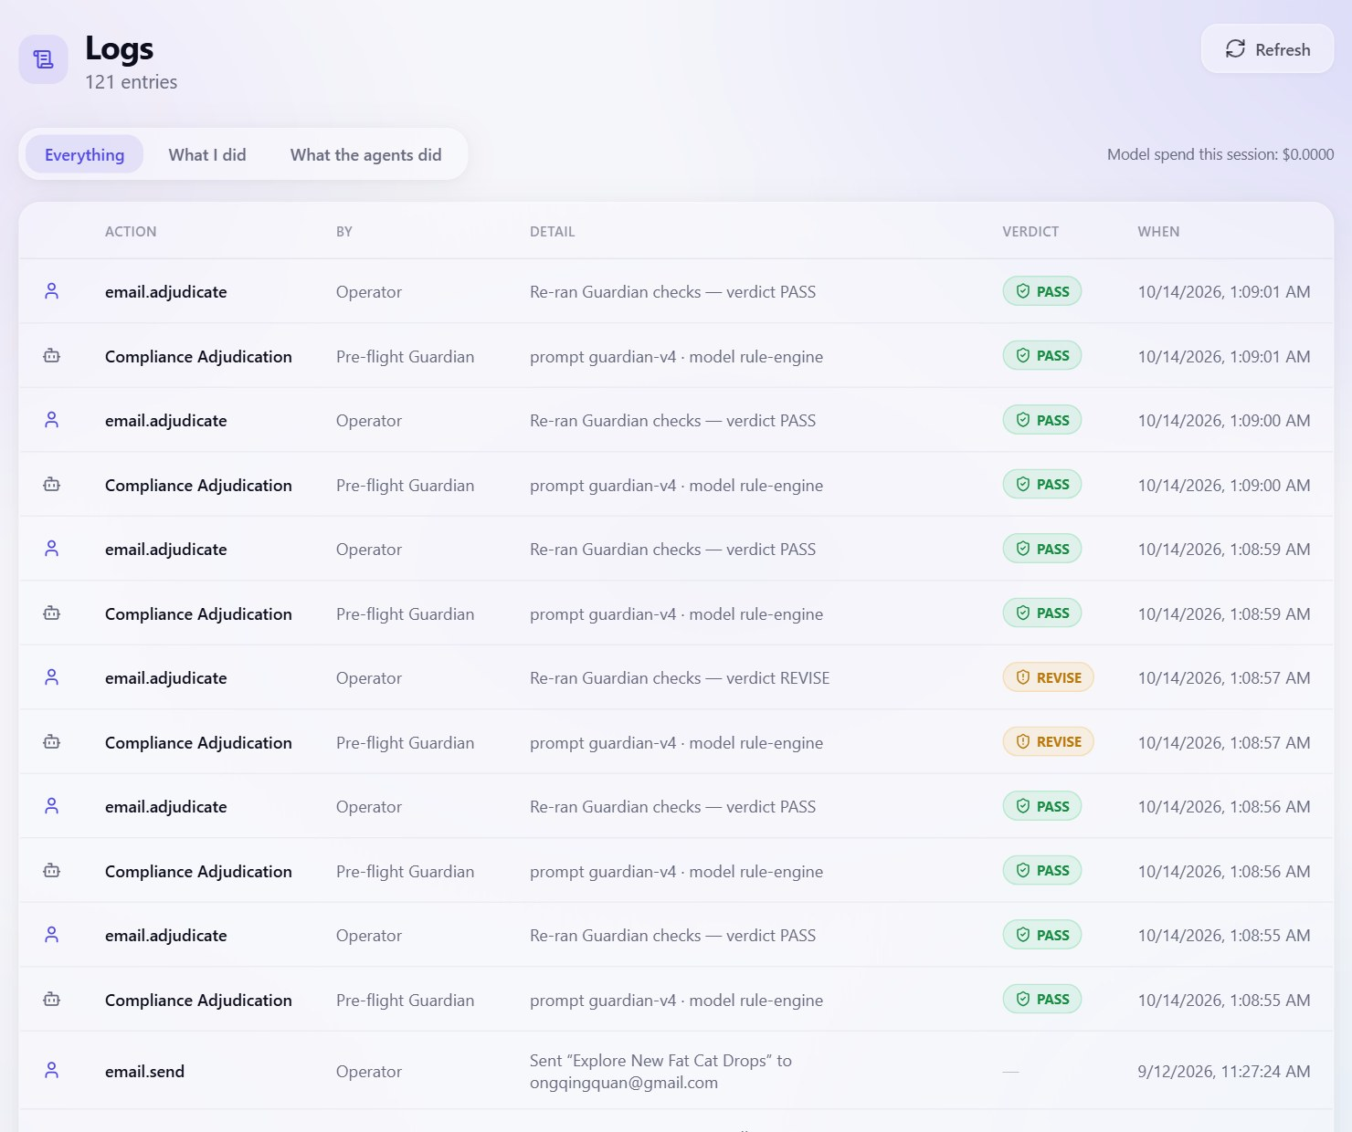
Figure 11. Logs tab: agent ledger rows (prompt and model version, verdict) interleaved with operator actions.

8. Testing and Evaluation Summary

8.1 Types of tests performed
Table 20. Tests and evaluations performed
Type | Scope | How it runs | Result
Contract tests (MLOps) | Rubric weights, agent output schemas, prompt-version pins, protected-column detection, secret scan | pytest, local and CI | 8 / 8 pass
AI security tests (LLMSecOps) | Guardian on six adversarial fixtures | pytest, local and CI | 6 / 6 pass
CI negative test | Planted PII in the clean fixture | Branch ci/demo-fail-pii | Build failed, as intended
End-to-end integration run | 1,000-contact CSV → 6 segments → 6 directions → 6 emails → Guardian → dispatch | Console against live Supabase, OpenRouter and Resend (12 Sep 2026) | Completed; 3 live sends delivered
Guardian re-adjudication | All six emails re-checked with guardian-v4 | API (14 Oct 2026) | 5 PASS, 1 REVISE, 0 BLOCK
Agent quality evaluation | All four decision agents on saved artifacts | eval-v1 sidecar, judge openai/gpt-5.6-luna | 88.2 overall

8.2 Results
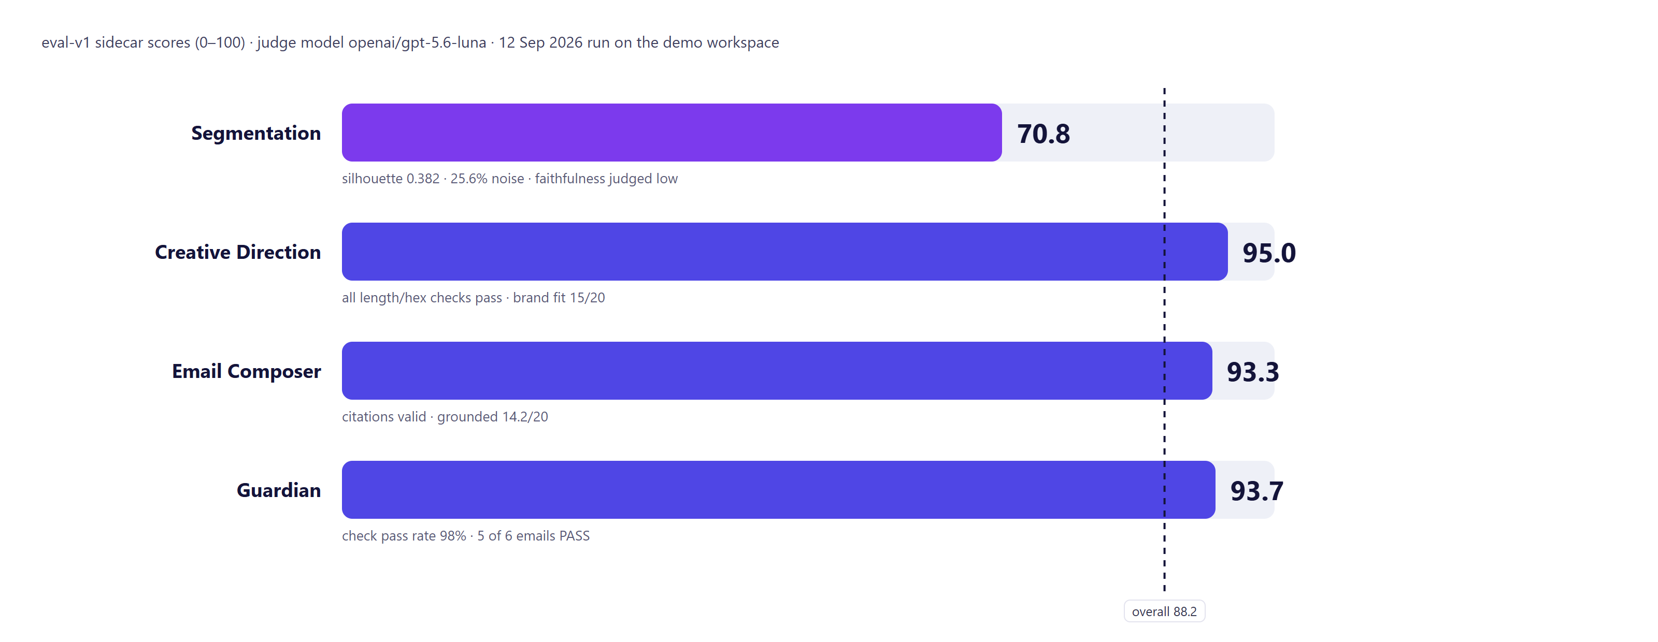
Figure 12. eval-v1 scores by agent (12 September 2026 run on the demo workspace).
Table 21. eval-v1 breakdown
Agent | Score | Criterion breakdown (earned / max)
Segmentation | 70.8 | Silhouette 26.6/38.5 (0.382) · Coverage 13.0/17.5 (25.6% noise) · HDBSCAN confidence 13.0/14 (0.93) · Faithfulness 6.9/15 (judge) · Specificity 11.2/15 (judge)
Creative Direction | 95.0 | Four length checks 8/8 each · Accent hex 8/8 · Segment fit 20/20 · Brand fit 15/20 · No dark patterns 20/20
Email Composer | 93.3 | Has citation 10/10 · Citations in catalogue 10/10 · Subject length 10/10 · Preheader length 10/10 · Follows direction 20/20 · Segment fit 19.2/20 · Grounded 14.2/20
Guardian | 93.7 | Check pass rate 68.7/70 (all checks 100% except the proxy check at 83.3%) · Email PASS rate 25/30 (5 of 6)
Overall | 88.2 | Mean of the four agent scores

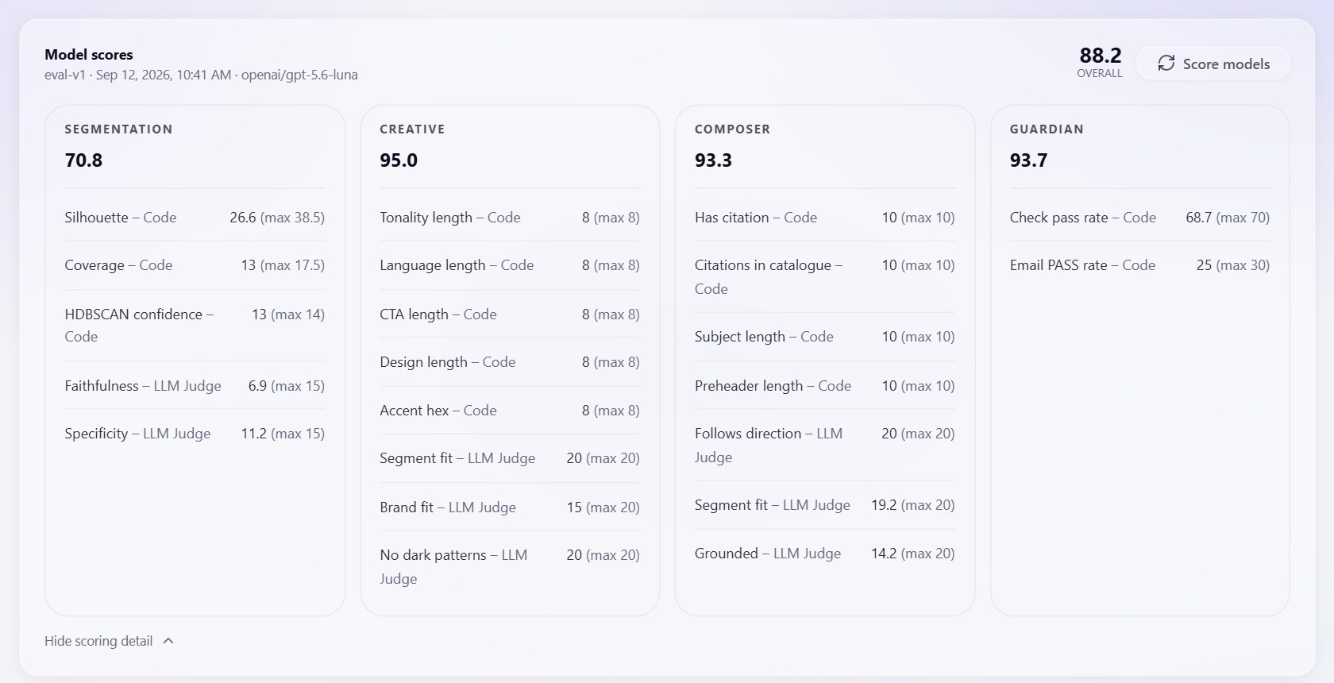
Figure 13. The same scores as shown in the console’s Model scores panel.

8.3 Key findings
- Segmentation is the weakest agent and the most honest score. A silhouette of 0.382 and 25.6% noise reflect overlapping synthetic archetypes — Progress Report 1 records that we deliberately added noise and overlap so clustering had something real to fail at. The lowest single criterion is segment-name faithfulness (6.9 / 15): the judge found that some names claim more than the contributions show. This is our clearest improvement target.
- Generation is well constrained. Every deterministic check on the creative and composer output passed, which is what the schemas and code-owned layout were designed to achieve. The judge’s lowest generation score is grounding (14.2 / 20), consistent with keeping grounding failures visible rather than trusting the model.
- The Guardian behaves as designed. It caught the one fairness issue present (age proxy) and nothing spurious.
- Limitations of the evaluation. The LLM judge has not yet been calibrated against a human-labelled sample, as the proposal intended; results come from a single evaluation run on one workspace; the generating agents have no offline unit tests because they require a live model; and there is no load test (Section 3.7).

9. Reflection

9.1 What went well
- Typed artifacts and a blackboard made every stage reviewable, re-runnable and auditable, and turned the ledger into a by-product rather than extra work.
- Putting structure in code — schemas, layout assembly, grounding — controlled the models far more reliably than prompt wording alone.
- Keeping the language model out of the veto made the Guardian cheap enough to run on every edit and testable in CI without network access.
- A real dispatch path forced the Guardian’s checks to be ones that would genuinely stop a send, rather than demonstration checks.

9.2 What changed from the proposal, and why
Table 22. Changes from the proposal
Proposal | Build | Reason
Creative Director generates and critiques images in a loop | Written creative direction; image generation is an operator-triggered tool only | Per-segment images were costly, slow to review and hard to evaluate; a written direction is cheaper, reviewable and testable
Parallel creative ∥ copy fan-out | Strictly sequential graph | The direction became the composer’s input, and each tab reviews the previous output
Per-recipient resolution as an agent stage | Merge-tag layer verified by the Guardian, filled at send | No per-recipient LLM call is needed; deterministic and cheaper
MJML compilation and accessibility linter | Builder-native EmailBlock[] with a single renderer | One renderer means the operator approves exactly what ships
Sandboxed dispatch stub | Real dispatch through Resend to a confirmed address | Makes the Guardian’s checks consequential
Budget ceilings that halt a run | Cost meter for observability; segment cap and no loops | Simpler for a demonstrator; a hard ceiling is planned (R8)
Separate manipulation-index scorer | Prompt prohibitions + subject-line check + judge criterion | Comparable coverage with less machinery
Bounded REVISE loop back to the generator | Human-driven loop: edit or regenerate, then automatic re-check | Prioritised human review; the automated loop is the first next step

9.3 Challenges
- HDBSCAN needed C++ build tools on one Windows machine; containerising the backend on a slim image with prebuilt wheels removed the problem for deployment.
- Embedding support through OpenRouter was less standardised than chat; the embedding call is isolated in one function so the provider can be swapped without touching callers.
- Clean synthetic data clustered too neatly, which would have flattered segmentation; we added noise and overlap and accepted a lower, honest silhouette.
- Strict JSON-schema mode supports only a subset of JSON Schema; the client now rewrites schemas into that subset and keeps richer constraints in field descriptions and in code.
- On Windows, a shared HTTP/2 connection pool surfaced as socket error 10035 under overlapping requests; the client moved to HTTP/1.1 per thread.

9.4 Limitations and future work
- Add a bounded Guardian → Composer revise loop (maximum three cycles) so REVISE failures such as subject-line or grounding issues are fixed automatically before a person sees them.
- Add retry with exponential backoff and a fallback model to the OpenRouter client.
- Add authentication with named approvers, per-route rate limits and a hard per-run budget ceiling; require a current-version verdict before send.
- Replace the in-memory job registry with a shared store to allow multiple replicas, then load-test the pipeline at increasing list sizes.
- Add an ingest-time injection scan and structural delimiting of free text; pin dependencies with hashes and add dependency auditing to CI.
- Automate alerts on BLOCK-rate shifts and eval regressions, add LLM tracing, and calibrate the judge against a human-labelled sample.

9.5 Team contributions
Table 23. Team contributions
Member | Responsibilities
Ong Qing Quan (OQQ) | Engineering lead. Orchestrator and LangGraph graph, job runner and Decision Ledger; Segmentation & Insight agent; Email Composer & Assembly agent; Campaign Console including the email builder; OpenRouter client and cost meter; CI, versioning and Railway deployment.
Agustinus Benyamin Prasetyo (ABP) | Domain and assurance lead. Creative Direction agent; Compliance & Brand Guardian agent; synthetic data, brand and offer content; Responsible AI instrumentation including the proxy test and governance mapping; AI security test corpus.

Appendix A. API Surface
Group | Endpoints
State | GET /api/state · GET /api/health · POST /api/reset · GET /api/jobs/{id}
Intake | GET / PUT /api/company · GET /api/audience · POST /api/audience/upload · POST /api/audience/load-sample
Pipeline | POST /api/segments/generate · GET /api/segments · POST /api/creative/generate · PATCH /api/creative/{id} · POST /api/emails/generate · PATCH /api/emails/{id} · POST /api/emails/{id}/adjudicate
Gate and dispatch | POST /api/approvals · DELETE /api/approvals/{id} · POST /api/emails/{id}/send · POST /api/email-assets/upload
Evaluation and operations | POST /api/eval · GET /api/logs · GET / PUT /api/settings
Imagery (operator only) | GET /api/images/config · POST /api/images/draft-prompt · POST /api/images/generate

Appendix B. Repository Structure
Path | Contents
backend/app/orchestrator/ | graph.py (LangGraph), state.py (typed blackboard), agents/ (one file per agent)
backend/app/eval/ | eval-v1 rubric, LLM judge, per-agent scorers, runner
backend/app/routers/ | workspace, image_gen, test_send, misc
backend/app/ | ledger.py, openrouter_client.py, csv_ingest.py, brand.py, mailer.py, persistence.py, progress.py, cost_meter.py, config.py
backend/tests/ | LLMSecOps fixtures and Guardian tests; MLOps contract tests
frontend/src/ | pages (one per tab), email builder components, lib/pipeline.ts
supabase/migrations/ | 0001–0008, applied in order
.github/workflows/ci.yml | The three CI jobs
docs/ | Deployment guide, CI negative-test evidence, diagrams, this report and the presentation
video/ | Remotion source for the 58-second intro video

Appendix C. Console Screenshots
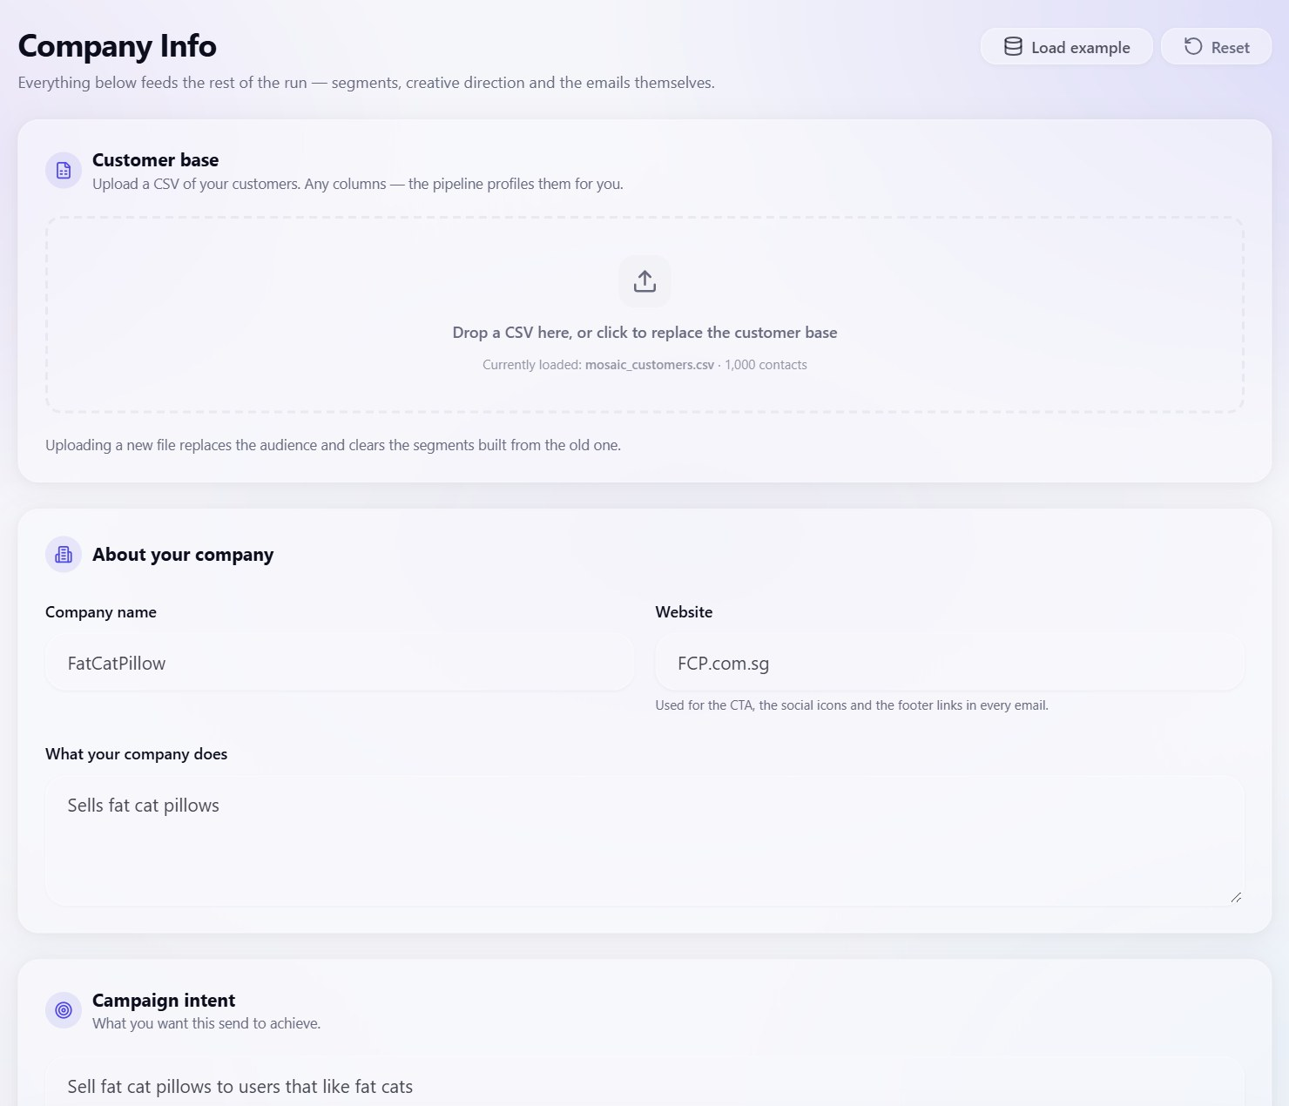
Figure 14. Company Info: customer CSV upload, company profile and campaign intent.
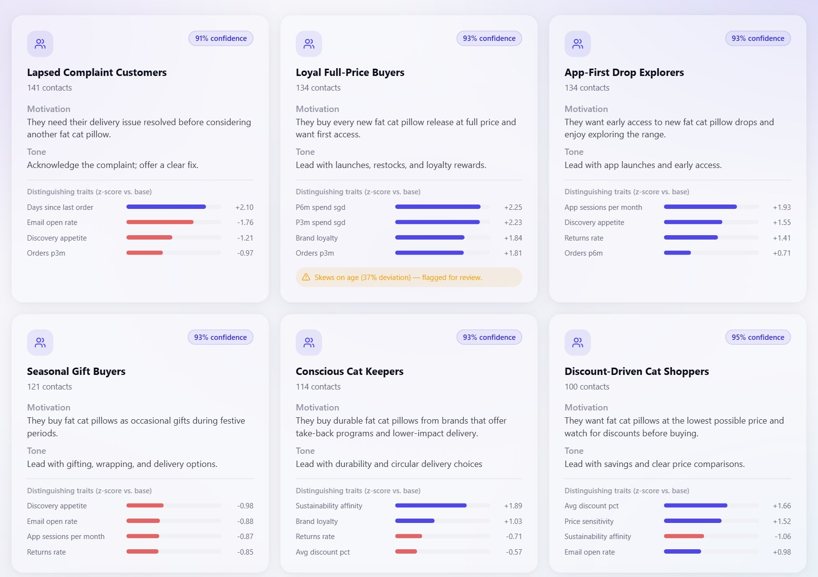
Figure 15. Segments: six discovered segments with z-scored traits; the age-proxy flag appears on “Loyal Full-Price Buyers”.
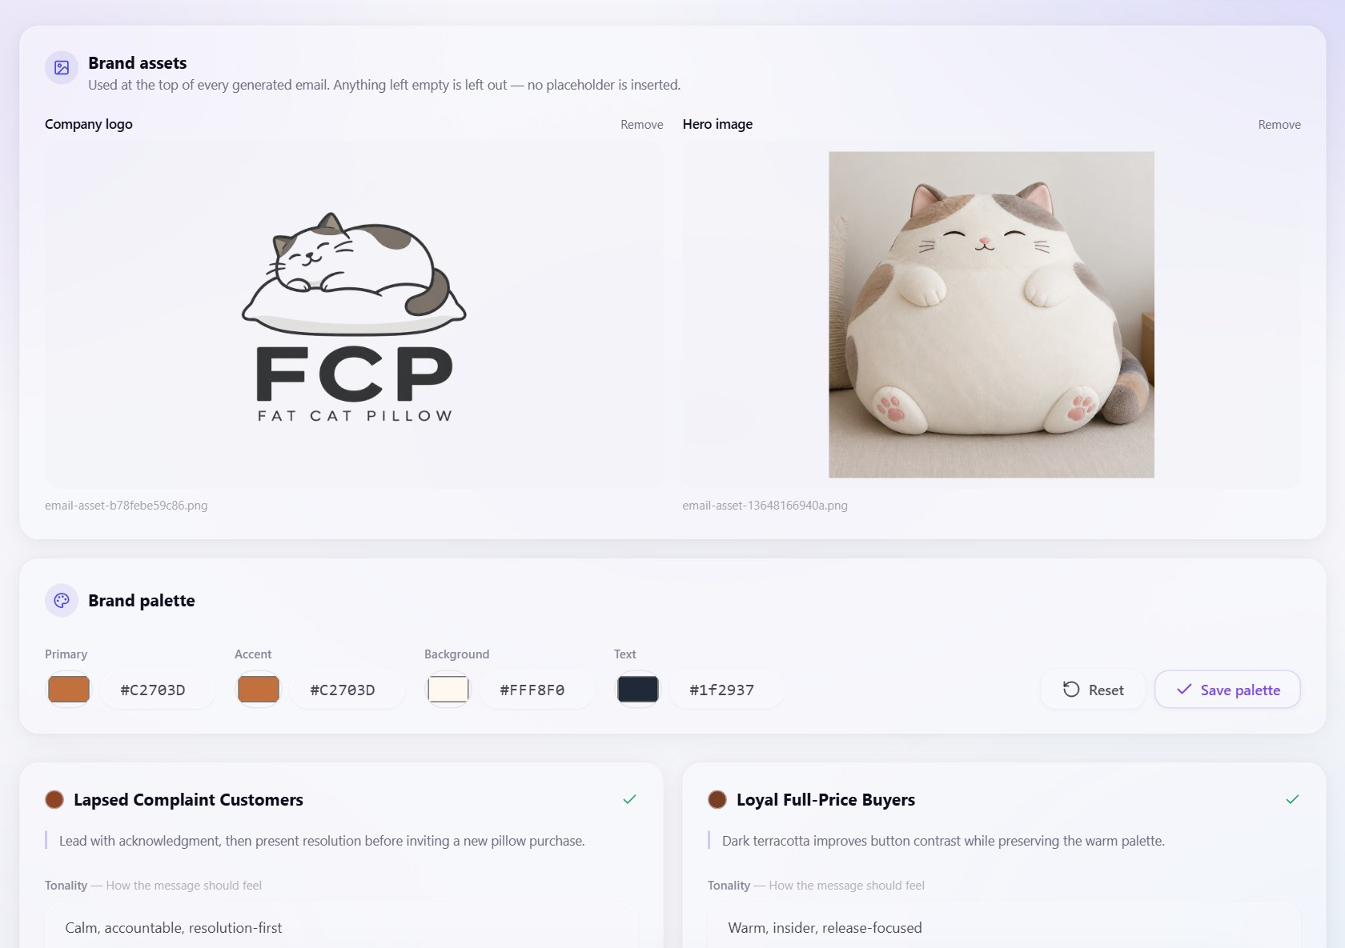
Figure 16. Creative Review: brand assets, palette and per-segment direction.
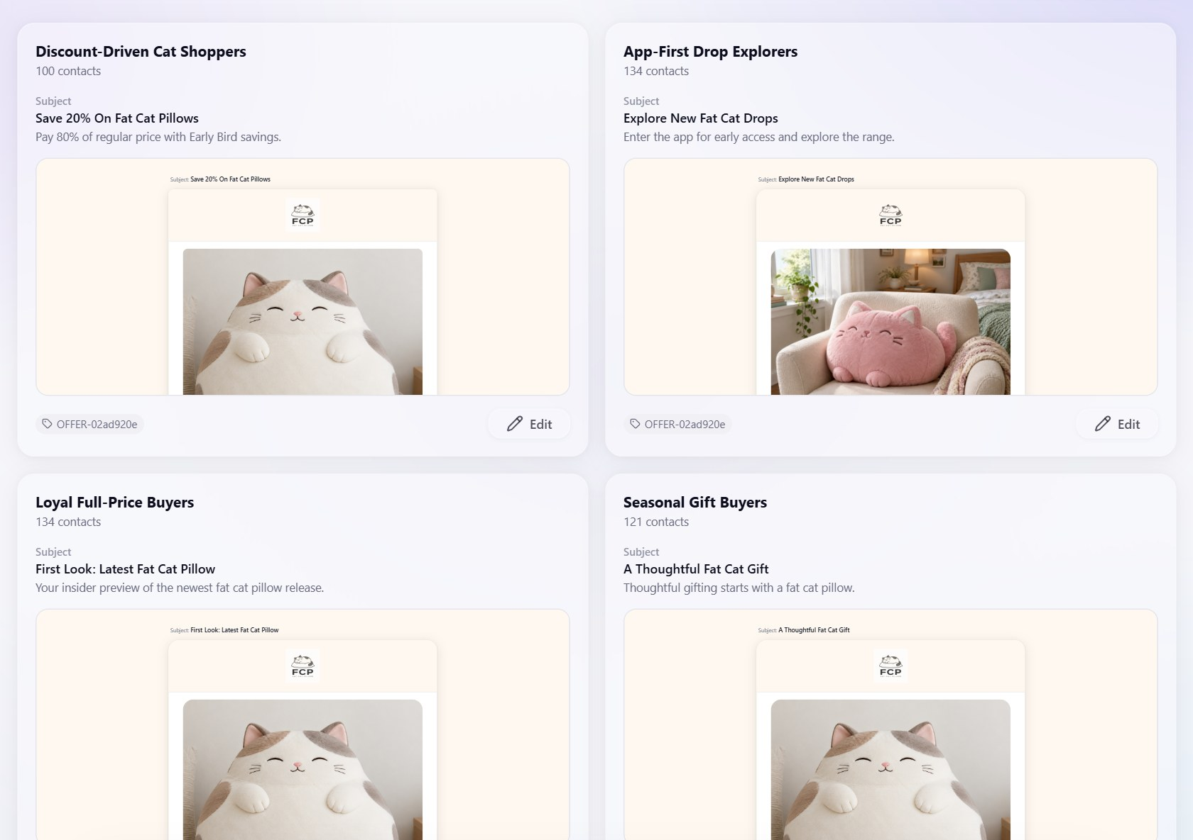
Figure 17. Email Review: one composed email per segment, each opening in the drag-and-drop builder.

