From Talk to Artefact: Recontextualizing Intercultural Meaning in Telecollaboration Involving Generative AI

Abstract
Telecollaboration research has rarely examined how partners’ talk becomes a joint artefact. When generative AI supplies the draft, collaboration may shift from making together to judging and revising together; whether this shift is specific to AI is untested. This study examined how intercultural meaning negotiated in video calls was recontextualized into bilingual multimedia artefacts in a seven-week Taiwan–New Zealand telecollaboration involving generative AI. Data comprised 68 calls (43.7 hours) and artefacts from 10 groups. LLM-assisted retrieval of cultural and artefact-planning talk guided case selection; the four cases’ 30 proofread transcripts were analysed thread by thread for each topic’s disposition and stated rationales and checked against the artefacts. Three cases built on a pre-existing text, in each case an AI draft; the fourth assembled its script from the calls. Judgement and revision occurred in all cases. With a pre-existing text, talk verified and revised it, cultural insiders acted as verifiers, and their first-hand accounts seldom entered the artefact; without one, talk itself supplied most of the artefact. The language-learning task frame shaped the artefacts’ form and language. We advance a proposition for testing: the material starting point of production, not AI as such, reorganizes whose knowledge becomes authoritative in the artefact.

Keywords: telecollaboration; intercultural meaning; recontextualization; generative AI; task frame

1 Introduction
Telecollaboration is widely recognized for developing intercultural competence in foreign language education, with well-documented gains in language skills, digital literacy, and cultural awareness (Çiftçi & Savaş, 2018; Toscu & Erten, 2020; Yeh et al., 2024). However, most studies measure outcomes via self-reports or view interaction merely as evidence of competence (Gutiérrez-Santiuste & Ritacco-Real, 2023), rather than investigating the collaborative decision-making process itself. Consequently, in artefact-oriented collaborative tasks, the micro-level decisions and negotiations shaping the final product rarely enter the empirical record.
Generative AI has now transformed artefact creation, supplying complete visuals or scripts within minutes and blurring authorship. If AI supplies the draft, collaboration may shift from ‘making together’ to ‘judging and revising together’. Whether such a shift should be attributed to AI, however, remains an open question, since judging and revising may be inherent to artefact-oriented collaboration (Section 2.2). Answering this question requires a contrast case in which no AI draft was involved.
Tracing talk into the artefact is complex, as much production occurs off-camera, rendering topical similarity an unreliable link. Crucially, video calls capture an interactional layer largely overlooked in research: partners’ explicit decisions (proposals, evaluations, revisions, and rejections). This study examines this decision-making layer, positing that a topic enters the artefact through talk only when a corresponding decision is on record.
The study therefore compares three groups building on a pre-existing text (i.e., a draft that exists before content is discussed and forms the artefact’s base; Section 2.5) with a contrast group whose script was assembled from the calls. By applying a single coding procedure to all four groups, we trace how intercultural meaning is recontextualized from talk to artefact and examine how the material starting point of production shapes whose cultural knowledge becomes authoritative in the artefact. Because every pre-existing text in the data was an AI draft, the cross-case comparison confounds the presence of a draft with its AI provenance. Within-case variation in the role of AI output, however, helps to isolate these two factors (Section 4.4). Methodologically, we offer a human-in-the-loop workflow combining automated retrieval with close reading (Jafarian, 2026).

2 Literature review

2.1 Telecollaboration and intercultural learning: The established outcome-oriented approach
Telecollaboration research has consistently demonstrated that online exchanges foster intercultural communicative competence, language gains, and digital literacy (Avgousti, 2018; Belz, 2003; Helm, 2015; O’Dowd, 2003, 2018; O’Dowd & Lewis, 2016; Thorne, 2003). In the Taiwan–New Zealand context specifically, studies have shown that oral translanguaging, structured Quality Talk, and task-based exchanges promote positive intercultural attitudes, intercultural sensitivity, and the motivation to share local culture (Chen & Yeh, 2026; Yeh et al., 2024; You et al., 2025).
However, existing literature predominantly adopts an outcome-oriented analytical stance, reducing interaction to evidence of individual competence rather than analysing the collaborative creation process itself. This stance thereby overlooks the micro-level mechanics of co-creation: how a joint digital artefact is negotiated in real time and how initial content drafts (whether human- or AI-generated) reshape collaborative interaction. Examining this collaborative decision-making process requires theoretical models of joint production, for which L2 collaborative writing provides an essential baseline.

2.2 Judging and revising in collaborative production: Talk without a pre-existing text
Collaborative production oriented towards a shared artefact long predates generative AI. Research on L2 collaborative writing demonstrates that co-writers routinely discuss content, wording, grammar, and organization before and during production (Storch, 2005, 2011). Much of this talk has been analysed as language-related episodes (LREs) where learners evaluate and correct language use (Swain & Lapkin, 1998). Beyond L2 writing, research on computer-supported collaborative learning treats the joint construction of shared artefacts as central to how groups build meaning (Stahl et al., 2006). Thus, judging and revising are intrinsic to joint production rather than AI-induced novelties.
In L2 research, however, such judging and revising has been studied mainly in written texts, through LREs targeting linguistic form, and in texts the learners were composing themselves. This study retains the premise that judging and revising are part of production but extends their object to the artefact as a whole (its content, form, and quality) and to the division of labour in making it, treating LREs as one type of evaluation among several (Section 3.3). Applying the same categories to collaboration with and without a pre-existing text can then show whether such a text changes the substance of this work, and within-case variation can indicate how far any change depends on its AI provenance (Sections 3.2 and 4.4).

2.3 Creating with generative AI: Talk around a pre-existing text
Collaborative artefact tasks have proved a productive vehicle for language learning. Digital storytelling, for example, has been used in bilingual form to foster intercultural learning (Jao et al., 2024) and as a group task to develop writing and creativity (Chen & Yeh, 2025). In these designs, it is the students who produce the artefact. Classroom research on generative AI in language learning keeps this division of labour: the tool has so far been cast mainly as a feedback provider, the role most frequently identified in Lee et al.’s (2026) review of 49 empirical studies. Similarly, Godwin-Jones (2022) conceptualizes intelligent writing assistance as a partner in the learner’s own writing. Generative AI can, however, reverse this order by supplying the draft, so that learners begin not by writing a text but by judging one they did not write.
Research on generative AI has mostly addressed the tool’s opportunities and challenges in language education (Barrot, 2023; Kohnke et al., 2023; Law, 2024) or how individuals write with it, in L2 classrooms and in human–AI co-writing more broadly (Lee et al., 2022; Su et al., 2023; Woo et al., 2025). Closest to the present study, Doley et al. (2026) examine generative AI in telecollaboration, with students using it to script animations; their focus, however, is on intercultural understanding as reported in post-task reflections rather than on the collaborative talk itself. How cross-border partners negotiate over a draft authored by neither side thus remains largely unexamined. To address this gap, the present study treats generative AI as a condition of collaboration, the source of a pre-existing text, rather than as a background tool, which shifts attention from the making of content to the negotiation over it: what is kept, altered, or discarded, and on what grounds. This stance echoes Thorne’s (2003) argument that the tools of telecollaboration carry cultures-of-use and are not neutral conduits.
A second reason to treat generative AI as a condition rather than a tool concerns the content it supplies. Community-centred evaluations of text-to-image models have found that they render non-Western subjects through an outsider’s gaze, reproducing stereotyped or generic depictions in place of regionally specific ones (Qadri et al., 2023), and AI writing suggestions have been found to homogenize Indian users’ descriptions of their own festivals and food towards Western norms (Agarwal et al., 2025). In an intercultural artefact, such provenance effects bear directly on whose culture is made legible; they are examined here as part of what happens when talk is recontextualized into an AI-rendered artefact (Sections 4.3 and 5.1).

2.4 The language-learning task frame: Where the artefact’s linguistic shape comes from
In language education, collaborative artefacts are not unconstrained creations; they are shaped by language-learning task frames. Research has shown how multimodal composing fosters multiliteracies (Yang & Yeh, 2021; Yeh, 2018) and how learners orchestrate modes and languages in multimodal works (Hafner, 2014; Jiang & Hafner, 2025; Li et al., 2026; Smith et al., 2017). These studies, however, have focused mainly on what learners do with the resources available to them; little attention has been paid to how the task frame and the partner’s learning goals constrain the linguistic shape of the artefact. In telecollaboration research, language form has been examined mainly as peer feedback on the partner’s language (Ware & O’Dowd, 2008) rather than as a constraint that one side’s course places on a jointly produced artefact.
Task-based research has long shown that the task as planned diverges from the activity that learners actually carry out (Breen, 1987; Coughlan & Duff, 1994), and that the design conditions of a task shape learners’ production (Ellis, 2003). In telecollaboration specifically, O’Dowd and Ware (2009) distinguish information-exchange, comparison-and-analysis, and collaborative-product tasks, and Dooly (2011) has traced how the task-as-workplan of a telecollaborative project diverged from the task-as-process in participants’ actual interaction. The project examined in the present study moves from information exchange in Weeks 2–5 to a collaborative product in Weeks 6–7; its design conditions comprise the weekly themes, the bilingual arrangement, and the grammar targets of the partner’s course (Section 3.1). How students incorporate these conditions into the artefact is observable in the calls (Sections 3.3 and 4.3); Section 2.5 conceptualizes this process as recontextualization (Linell, 1998).

2.5 Recontextualization: How talk is reshaped into an artefact
This study links talk and artefact through Linell’s (1998) concept of recontextualization. Applying the term to discourse across settings, Linell defines recontextualization as “the dynamic transfer-and-transformation of something from one discourse/text-in-context … to another” (pp. 144–145). Relocated discourse is thus never transferred intact: it is selected, condensed, and refocused for the purposes, audiences, and genres of the new context, and blended with other voices, so that its meaning is reconstituted in the transfer. In the process, recontextualization also determines which voices are carried forward and which are subdued or silenced (p. 151). Two related concepts sharpen this account. Entextualization (Bauman & Briggs, 1990) names the process by which a stretch of discourse is rendered extractable from its interactional setting and made into a text that can be carried into new settings, which is what happens when a cultural account given in a call becomes a line of a script. Resemiotization (Iedema, 2003) names the translation of meaning from one semiotic mode into another as a social process unfolds, which is what happens when that line becomes an image or a recorded performance. In this study, recontextualization serves as the umbrella term because it encompasses both steps: the extraction of talk into a text and that text’s change of mode.
The concept offers two analytical advantages for tracing how a cultural item discussed in a call is selected for, or excluded from, an artefact produced in a different genre for a different audience. First, because it presupposes selection and transformation rather than intact transfer, the researcher must show where rewriting took place and on what rationales, rather than inferring provenance from similarity between talk and artefact. Second, it brings the task frame into the same analytical description, treating its design conditions (Section 2.4) as contextual parameters that the new context imposes on transferred content.
The term pre-existing text is used in this study for a document that (a) exists before the partners discuss the artefact’s content, (b) can be shared on screen and revised line by line, and (c) serves as the base of the artefact. It is distinct from Becker’s (1995) prior text, the accumulated memory of past linguistic experience that every speaker brings to interaction: a pre-existing text is a particular document on the table. Under this definition, an AI-generated script or draft is a pre-existing text, whereas a story concept settled before the partner joins is not, however much it constrains what follows (Section 4.4).
In this study, intercultural meaning refers to what participants say about a cultural item as belonging to a people, a community, or a place. That is, it covers what people there do, believe, or value, why they do it, or how this differs between places. This working definition draws on Byram’s (1997) account of intercultural competence as involving knowledge of social practices together with the skills of interpreting them and relating them across cultures. Merely naming a festival or a food therefore does not count. The same criterion guided the automated retrieval of cultural talk (Appendix A). Re-expression is traced when such statements move into the artefact. For instance, if a student explains in a call that, in Taiwan, chopsticks left upright in rice resemble incense offered to the dead, but the artefact keeps only ‘Never stick chopsticks upright in rice’, the item survives while its rationale, and hence its core intercultural meaning, is lost.

2.6 The present study
Taken together, these lines of research leave one process unexamined: how cross-border partners turn what they discuss into a joint artefact when generative AI can supply a draft that neither of them wrote, within the constraints of a language-learning task frame. The central question is therefore: when a collaborative artefact is made with generative AI available, how is intercultural meaning negotiated and selected in telecollaborative talk and recontextualized into the artefact, and does this differ when the partners work from a pre-existing text? Four research questions follow:

- Within the framework of assigned weekly themes, how do cultural topics emerge and develop across the partners’ video calls?
- To what extent do the cultural topics negotiated in the calls enter the joint artefact, and on what grounds are particular topics selected for inclusion?
- How is intercultural meaning re-expressed as it moves from talk into the multimodal artefact, and how does the language-learning task frame shape this?
- How does the uptake of talk into the artefact differ between the groups that built on a pre-existing text and the group that did not, and which patterns are shared across groups?

3 Method

3.1 Research setting and design
The study is set in a telecollaboration project between students in a Multimedia English course, required in the third year at a Taiwanese university, and partner students at a New Zealand university. The project asked students to create bilingual multimedia artefacts using digital tools, including generative AI. Over seven weeks, the 63 students formed 17 groups, each of which was joined by one New Zealand student.
Each group met weekly by video call, in a fixed bilingual format: 30 minutes in natural English, then 30 minutes in elementary Chinese. As each side was learning the other’s language, both acted as expert and learner; the Chinese half thus often included explicit teaching of grammar points from the New Zealand students’ course. The project also set the weekly topics, cultural questions, and language points (Table 1). Weeks 6–7 were devoted to producing one joint bilingual artefact.

Table 1. Weekly tasks and topics of the seven-week project
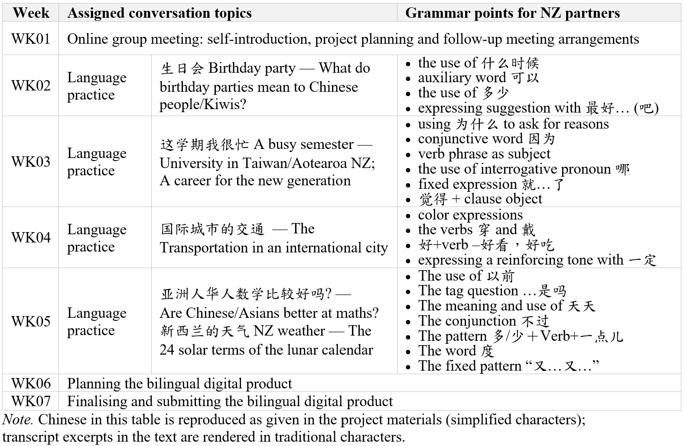

The study adopts a two-layer, primarily qualitative design (Figure 1). Layer 1 describes all 10 groups: prompt-based retrieval on ASR transcripts shows how call time was distributed between cultural talk and artefact-planning talk and informs case selection (Section 3.2). Layer 2 is a multiple-case study of four of these groups, whose proofread transcripts are read closely to trace the disposition of each cultural topic thread and its stated rationales (Section 3.3). Because only recorded weeks can be observed, this reading is confined to the production stages they cover, and comparison across the four cases identifies patterns that recur under differing conditions, not their distribution in the student population.

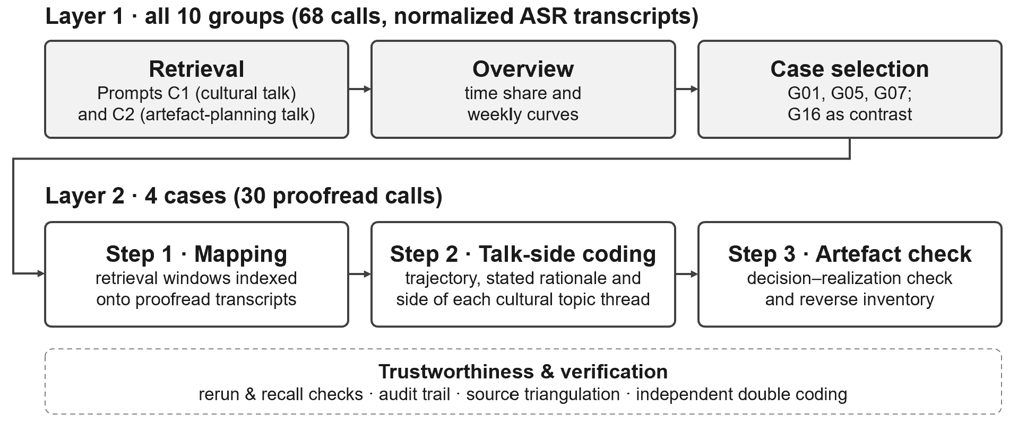
Figure 1. Two-layer analytic procedure.

Although the course was compulsory, students were told that participation in the research was voluntary and would not affect their grades. Coursework and call recordings were used only with the consent of students on both sides; the one group that did not consent (G15) was excluded before analysis. All data were de-identified and excerpts are cited by group and session code; for privacy and in keeping with the study’s interactional focus, analysis is conducted at the level of the collaborative side, Taiwanese (TW) or New Zealand (NZ), rather than the individual.

3.2 Corpus construction and case selection
The data comprise the 10 groups’ video calls and final multimedia artefacts. The 68 recordings (43.7 hours) were transcribed with WhisperX (Bain et al., 2023), an open-source pipeline run locally so that the audio recordings never left the research site. Each file was split into English and Chinese blocks and transcribed verbatim without translation, preserving what students said in each language, including learner errors. Only the 30 calls of the four Layer 2 cases (Table 2) were proofread against the audio; the remaining transcripts served the Layer 1 overview only.
The ASR transcripts were first normalized for Chinese character forms and proper nouns. Candidate stretches (contiguous runs of turns, each bounded by start and end time codes) were then retrieved with two fixed prompts (Appendix A): C1 for cultural talk and C2 for artefact-planning talk (i.e., discussion of how to produce the final product). Because recording time varied considerably across groups, each type of talk was measured by its time share (the merged duration of its stretches as a proportion of file length) rather than by the number of stretches. Scripts read aloud (e.g., podcast rehearsals) were excluded from cultural talk.
Retrieval was run with Claude Opus 5.5 at default settings; each prompt–transcript pair was processed in a fresh context with no other input. The transcripts were de-identified with student codes before submission, under terms that exclude inputs from model training. The output served only as a candidate list for manual review, with all coding decisions made by the researchers (Jafarian, 2026). The resulting time shares are read as model estimates rather than findings, and case selection therefore uses them only comparatively, for the relative shapes of the groups’ curves.
Figure 2 shows the hours of cultural and artefact-planning talk in each group (for time shares, see Appendix B). The two kinds of talk overlap when cultural content of the artefact is discussed during production; such stretches (hatched in Figure 2) are counted in both.
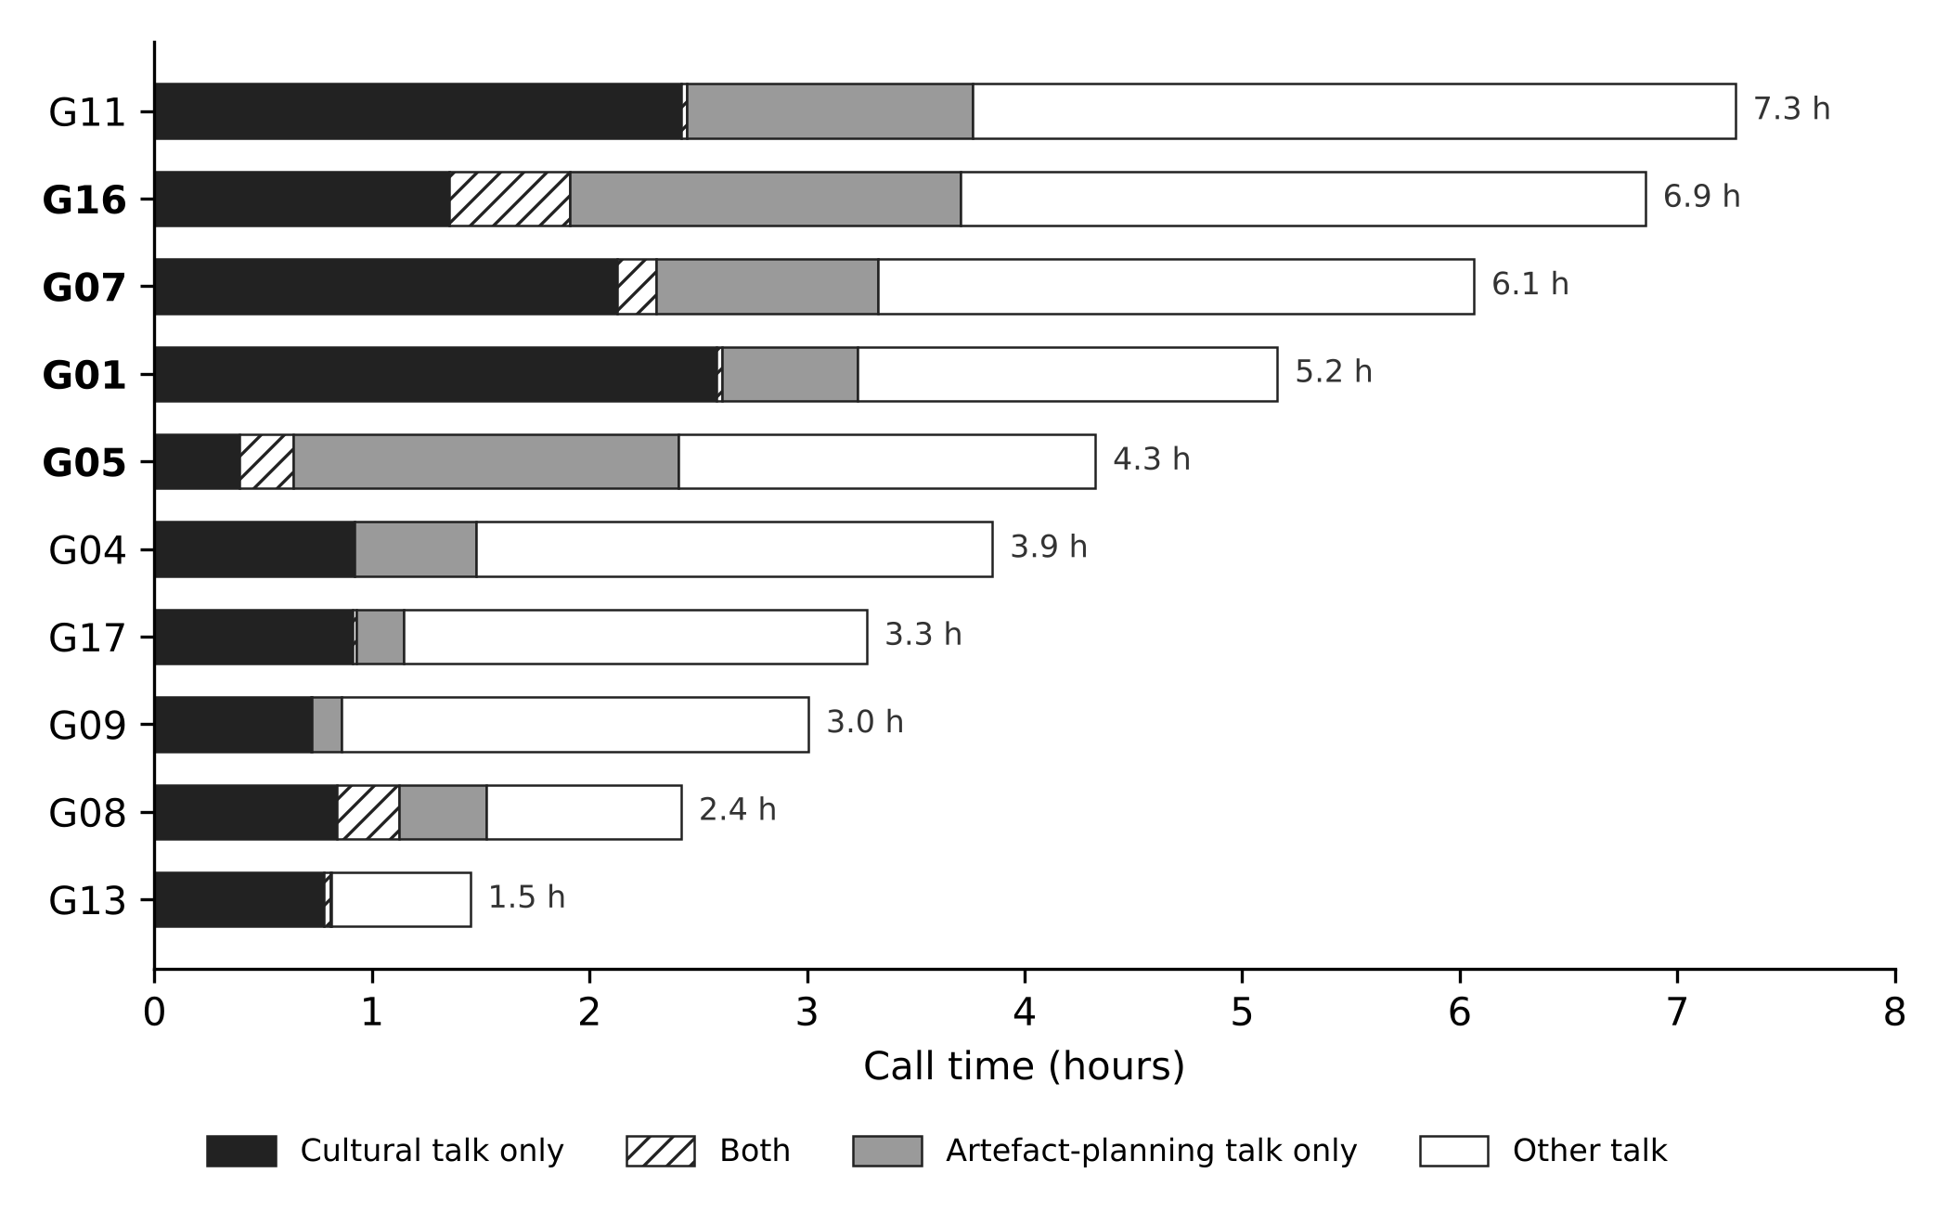
Figure 2. Call time by type of talk in the 10 groups, ordered from longest to shortest total call time. ‘Both’ is talk retrieved by both prompts; case groups are in bold.

In eight of the 10 groups, cultural talk exceeds artefact-planning talk; only G05 and G16 show the reverse. Figure 3 tracks the two types of talk week by week; the weekly curves distinguish the groups more clearly than these overall shares and bear on production visibility: G07’s artefact-planning talk peaks in its recording week (W6) and G05’s in its whole-group calls (W1, W6–W7), whereas G01’s stays flat, suggesting production outside the calls. G16, recorded every week, shows a steady build-up to a W6 peak (Supplementary Material S2).

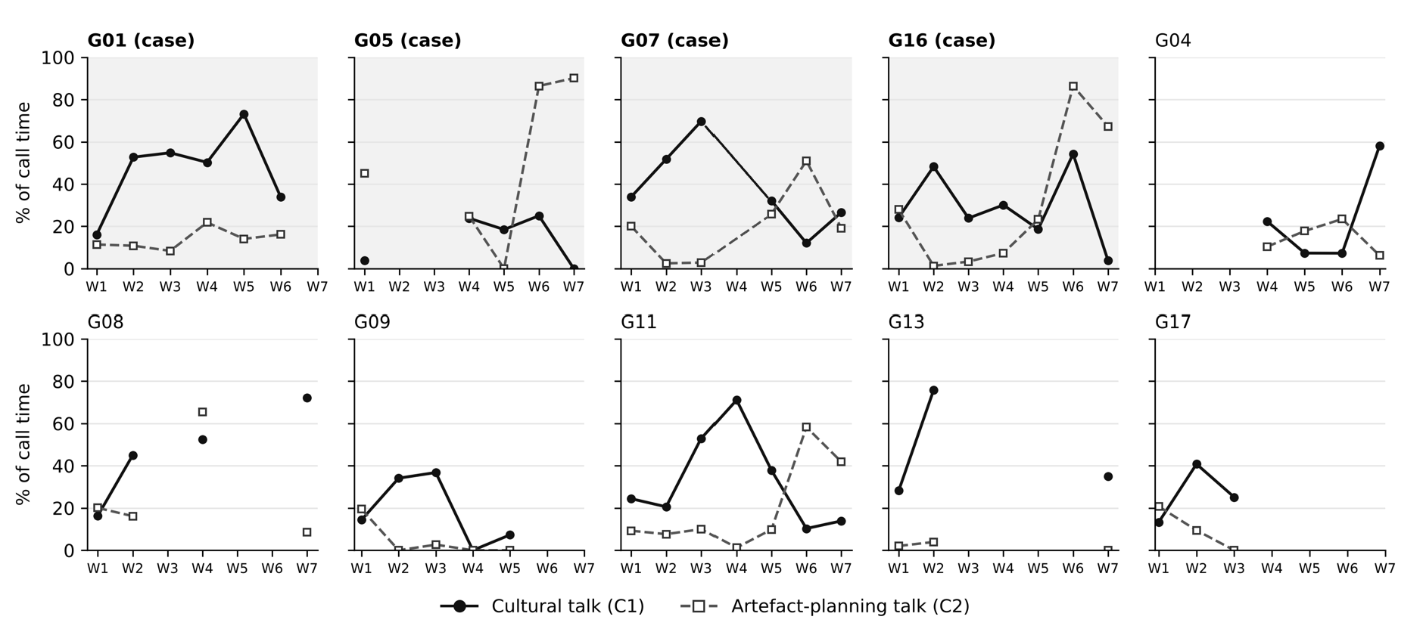
Figure 3. Weekly share of call time spent on cultural talk (C1) and artefact-planning talk (C2) in the 10 groups. Gaps indicate weeks without a recording; shaded panels are the four case groups.

On the basis of this overview, four groups were selected as cases (Table 2) along two dimensions. The first is whether the artefact was built on an AI draft, which was the case in nine of the 10 groups. For the four cases, the presence or absence of an AI draft is attested in the calls themselves [G01_W6_02:16; G05_W6_00:59; G07_W5_27:16; G16_W6b_23:04]; for the other six, it was judged from the artefacts and any talk about AI tools. G01, G05, and G07 (hereafter the AI-draft cases, a selection label only) were selected from these nine, and G16, the only group without an AI draft, serves as the contrast case. These three are also the only cases with a pre-existing text, so the two labels are confounded (Section 4.4).
The second dimension is production visibility: how much of the production process remains on record. All four cases meet two data thresholds (the recordings cover the artefact-planning stage and the artefact was obtained) and rank in the top five for call time (Figure 2). Among the three AI-draft cases, visibility is highest in G07, a bilingual podcast whose ChatGPT-drafted script was revised, rehearsed, and recorded in the calls; intermediate in G05, animated episodes adapted item by item from an AI draft in the calls; and lowest in G01, a static bilingual picture book whose key decisions were finalized in the calls but executed outside them. This gradient, consistent with the weekly curves in Figure 3, sets what each case can show: G07 permits sentence-by-sentence comparison of the AI draft with the final artefact; G05, identification of rewritten items; and G01, only a check of whether decisions made in the calls were realized. G16, the contrast case, arranged its script within the calls and recorded it live in the final session, concluding the longest and most continuous production period among the four cases; it was analysed with the same procedure as the AI-draft cases. G16 also has the highest production visibility, so here visibility is confounded with the absence of a pre-existing text, a point weighed in Sections 4.4 and 5.3. Of the remaining six groups, five lack sufficient visibility, and G11 duplicates G07’s profile (Appendix B).

Table 2. Profiles of the included cases
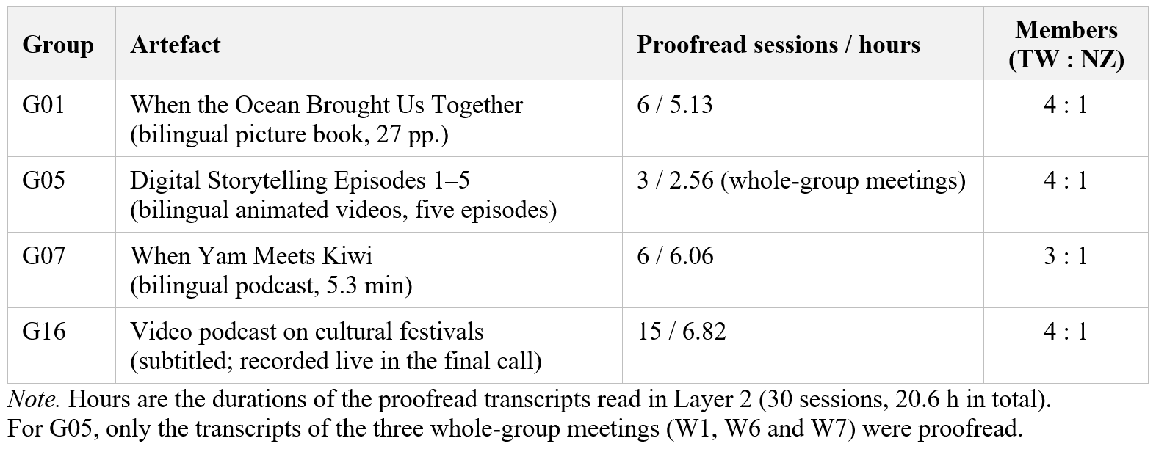

3.3 Analysis
In Layer 2 (Figure 1), the unit of analysis is the cultural topic thread: all C1 stretches on one cultural item (a practice, belief, object, place, or expression that participants associate with a particular community) across a group’s calls. Dispositions, however, were assigned to items, since some artefact items had no thread (Step 3). The four case groups (30 calls) were analysed in three steps, followed by a synthesis of topic dispositions and trustworthiness checks.
Step 1: Mapping. Using the Layer 1 retrieval windows, the complete turns and speakers of all C1 and C2 stretches were extracted from the proofread transcripts into a working file for each case. After excluding 34 of the 222 C1 stretches (scripted rehearsal or playback) and 6 of the 333 C2 stretches (unrelated to the artefact), 188 C1 and 327 C2 stretches were retained. By case, the retained C1 and C2 stretches numbered 63 and 59 (G01), 6 and 67 (G05), 66 and 63 (G07), and 53 and 138 (G16), respectively (Supplementary Material S2–S5).
Step 2: Talk-side coding. The first author, who was not involved in teaching, read each stretch in its full-transcript context and merged stretches into threads. The trigger of each thread (the weekly theme, a partner’s contribution, or AI output) and its initiating side (TW or NZ) were then recorded. Table 3 (Section 4.1) gives the resulting counts by case. Each thread’s decision status was traced through any C2 decision to include or exclude it. Students’ reasons for these decisions, as voiced in the calls, were coded as four types of stated rationale; a decision could have several reasons or none. Appropriation made the artefact the group’s own (e.g., relocating the digital story to the students’ own town). Authenticity check referred content to a cultural insider for confirmation (e.g., asking whether a custom is really practised in the partner’s country). Quality judgement evaluated AI-generated or self-produced output (e.g., for visual appeal or structural coherence). Compliance made the artefact meet external requirements, such as the partner’s grammar targets, the assigned theme, or the bilingual arrangement.
Step 3: Artefact check. After talk-side coding was finalized, a two-part manual comparison checked each artefact against the calls without inferring the source of any content. This order could not shield the talk-side coding from the researchers’ prior knowledge of the artefacts, but it ensured that the disposition ‘carried into the artefact’ required a corresponding decision in the transcripts. First, a thread-by-thread check noted whether and in what form each thread’s item appeared in the artefact. Second, a reverse inventory listed the artefact’s cultural items, counting customs presented together in one passage as one item, and matched each to a thread where one existed.
Synthesis. Each cultural item was assigned one of three topic dispositions by combining its Step 2 decision status with the Step 3 result. Carried into the artefact: the calls contained a decision to include the item, and the item appeared in the artefact; how closely its final form followed the talk is examined under RQ3. Unnegotiated inclusion: the item appeared in the artefact, but the calls contained no decision to include it. Left in talk: the item was discussed in the calls but did not appear in the artefact.
The dispositions and rationale types were derived inductively by constant comparison (Corbin & Strauss, 2015) across the four cases’ working files and, once stable, applied to the full dataset in a final pass. Three rationale types extend established analytic concepts from turns or language forms to the artefact as a whole: appropriation (Bakhtin, 1981; Wertsch, 1998), authenticity check (epistemic authority, Heritage & Raymond, 2005), and quality judgement (language-related episodes, Section 2.2; Swain & Lapkin, 1998). Compliance reflects the gap between task-as-workplan and task-in-process (Breen, 1987; Coughlan & Duff, 1994).
Trustworthiness. Four mechanisms were used. First, retrieval was rerun with the same prompts on the proofread transcripts of one session per case: 27 of 28 cultural topic stretches and all 43 artefact-planning stretches overlapped with a window retrieved from the ASR transcripts (covering 91% and 88% of their total time, respectively). Conversely, 84 of the 85 stretches retrieved from the ASR transcripts overlapped with the proofread results, so retrieval was robust to transcription error. A recall check against a research team member’s blind coding of two complete sessions showed that retrieval captured 88% of cultural topic stretches and 99% of artefact-planning turns, with 94% and 78% precision; the three cultural topic stretches missed were brief remarks on word use (Supplementary Material S1). Because the prompts could still miss stretches, every unnegotiated inclusion was also checked by keyword search across all the case’s sessions. Second, an audit trail preserved the unmodified C1 and C2 candidate lists and recorded each judgement with its time code, evidence span, and justification. Third, source triangulation compared the call transcripts and the final artefacts in both directions (Step 3). Fourth, two research team members independently coded all cultural items in the four artefacts and a random sample of six items left in talk, using Appendix C; agreement was 85% for dispositions (Cohen’s κ = .74) and 79% for stated rationales (κ = .71), and disagreements were resolved in discussion (O’Connor & Joffe, 2020).
The examples reported in Section 4 illustrate patterns that recurred across sessions, and disconfirming cases are included (e.g., G05’s birthday episode, carried into the artefact in altered form). Member checking was not possible, as the analysis began after the course had ended. Case records with topic dispositions and evidence spans are in the Supplementary Material.

4 Findings
Sections 4.1–4.3 address RQ1–RQ3, with G16 reported alongside the AI-draft cases; Section 4.4 compares the four cases (RQ4). Quotations are given in English translation, produced by the researchers through machine translation post-editing (MTPE), with the original provided where code-mixing or lexical choice is analytically relevant. They are cited as [group_session_min:sec] from the proofread transcripts, marking the start of each excerpt, with the group or session code omitted where clear.

4.1 The emergence and development of cultural topics (RQ1)
Cultural topics came from three overlapping sources. The course’s weekly themes framed each call, but partner contributions, present in all four cases, triggered most threads overall; AI output triggered three threads each in G05 and G07 and one in G16. In G05, W2–W5 were one-to-one language exchanges and the three whole-group calls focused on artefact planning; cultural topics surfaced mainly when the group reviewed the AI draft in W6. Table 3 summarizes, for each case, how many threads each source triggered, which side raised them, and how many of each side’s threads were carried into the artefact.

Table 3. Cultural topic threads by trigger, initiating side, and uptake into the artefact (counts)
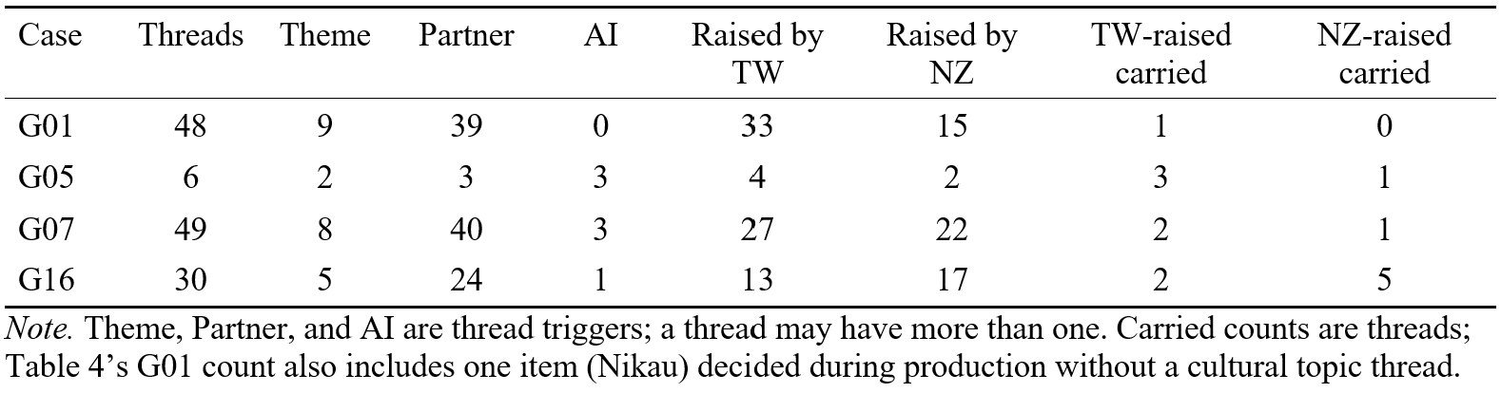

In G07, the NZ side entered weekly themes into ChatGPT and read the output aloud, signalling uncertainty about its accuracy: “I don’t know if it’s true or not but they said something about red egg and ginger for babies” [W2_05:03]. The TW side corrected this with glutinous oil rice (油飯) [W2_05:42] and introduced a taboo absent from the AI output: birthdays are not celebrated at ages ending in nine (逢九必衰) [W2_09:26]. Here, AI output served as a discussion prompt, which the TW side confirmed, corrected, or extended with first-hand knowledge; Section 4.4 contrasts this with the same group’s line-by-line verification of the AI-drafted script in W5–W6.
In G01, topics arose mainly from partner contributions. The TW side presented much of its cultural content as pre-prepared segments (“we have prepared a part called Taiwan introduction” [W2_21:14]), inviting the NZ side to respond. The Austronesian topic emerged within this pattern: after the NZ side introduced te reo Māori and Aotearoa [W2_32:06], the TW side returned to the topic, linking Taiwan’s Austronesian peoples with the Māori and Hawaiian peoples [W2_48:07]. The topic thus branched off the assigned birthday theme and was co-developed by both sides.
In G16, dialogue was driven primarily by questions from the NZ partner, a first-language speaker of Chinese. In the first call, the NZ side proposed cross-cultural differences in customs as the topic of the artefact, citing New Year celebrations and Matariki as examples [W1a_07:09]. Topics such as the Mid-Autumn Festival [W1b_01:03] and Christmas in the Southern Hemisphere summer [W3a_14:44] were developed in subsequent calls and revisited during production.
How a topic emerged did not determine its subsequent disposition. For example, gift-giving taboos were introduced by the TW side in both G07 and G16 with almost identical content: giving a clock (送鐘) sounds like 送終 sòngzhōng ‘attending a dying relative’; couples do not give each other shoes, lest the partner ‘run away’; and a recipient of a clock or shoes should pay back a token dollar, converting the gift into a purchase and thereby neutralizing the bad luck [G07_W2_26:36; G16_W4b_16:58]. Yet their dispositions differed: the G07 podcast retained the clock taboo but dropped the shoe taboo, whereas the G16 video podcast centred on festive customs and did not revisit the taboos. What determined a topic’s disposition was subsequent artefact planning (Section 4.2).

4.2 The dispositions of cultural topics and their stated rationales (RQ2)
Table 4 addresses the first part of RQ2: in every case, only some of the artefact’s cultural content can be traced to a recorded decision. Because decisions may also have been made outside the calls, the table documents the interactional record rather than how the content arose, and rationales are recoverable only for recorded decisions. From an intercultural perspective, dispositions indicate whose cultural knowledge reached the artefact, while stated rationales make explicit the grounds on which it was included or excluded.

Table 4. Dispositions of cultural items by case, with the share carried into the artefact
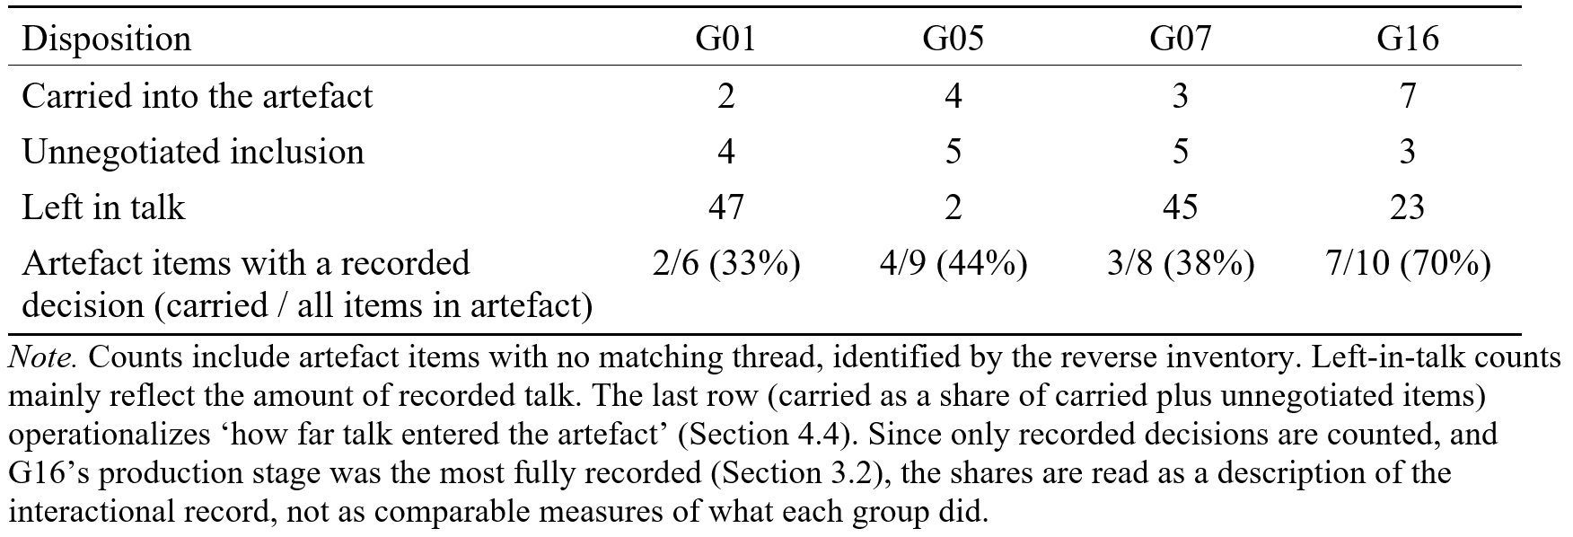

Stated rationales were most explicit in G05’s W6 review of its ChatGPT script. The TW side opened with “this is the story from ChatGPT so I think we should change some parts such as the birthday party and the transportation” [W6_00:59], and then proposed revisions episode by episode, each accompanied by a reason. The characters were renamed after the group members, with the justification “because it is our digital product” [06:16]; the setting was moved from Taipei to Yunlin because “our university is in Yunlin” [13:53]; and YouBike was accordingly replaced with the local MOOVO bikeshare [15:38]. All three changes appear in Ep. 4 and rest on grounds of appropriation. The NZ side’s only proactive addition, “people in New Zealand sort of more interested in sports” [21:03], was reworded on the spot, and the reworded sentence appears verbatim in Ep. 5; no rationale was stated for it.
In G16, without an AI draft, negotiation centred on the cultural items each side proposed, including proposals to drop them. The NZ side proposed dropping the Mid-Autumn Festival because it seemed “a bit random” [W6b_11:10]. The TW side objected that the festival “counts as one of our major festivals” [W6b_11:27]. Both sides then agreed to use ‘reunion’ (團聚) as a linking theme, and the festival was retained. The rationales differed: the NZ side was concerned with thematic cohesion across segments (quality judgement), whereas the TW side was concerned with whether the festival could represent ‘us’ (appropriation). Easter, proposed by the NZ side, who then questioned its religious focus [W6b_26:50], was nonetheless retained [W7a_26:16]; it is therefore coded as carried into the artefact with no stated rationale. Excerpt 1 shows the Mid-Autumn Festival exchange.

Excerpt 1. Keeping the Mid-Autumn Festival (G16_W6b_11:10–13:40)
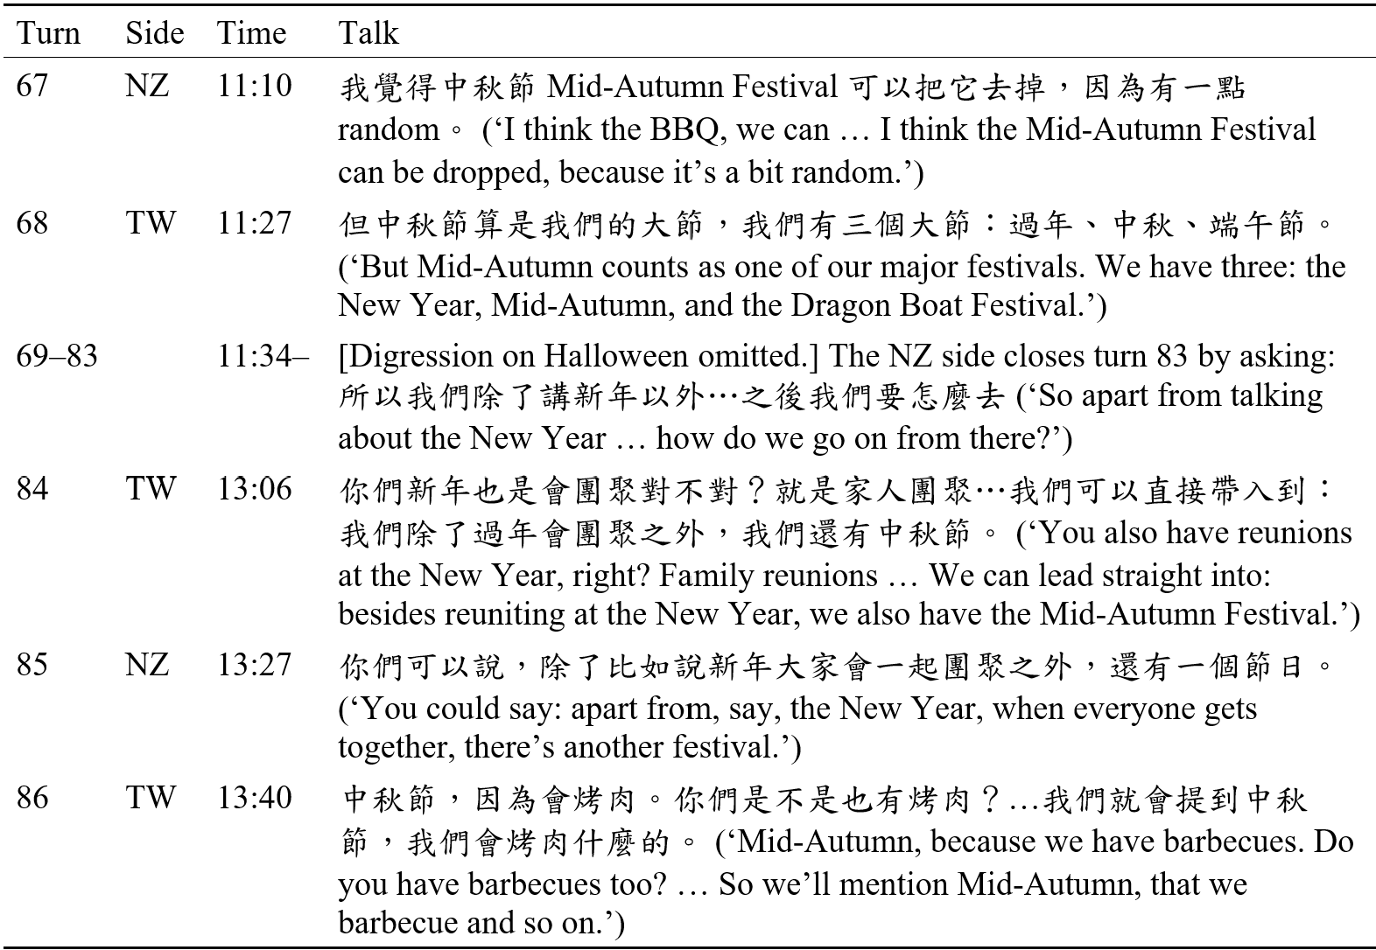

In G01, most cultural talk remained in the calls, and the picture book’s theme was settled within the TW side before the NZ side joined: “let’s just use … that picture book” and “you want to use the Amis (阿美族)” [W4_00:01]. The NZ side later simply responded, “that’s a good idea” [W4_04:35]. The theme was thus carried into the artefact on a recorded decision (Section 3.3), although no explicit rationale accompanied its selection. During the draft review, the NZ side asked only that the male protagonist be given “a New Zealand person name” [W6_06:10]; renaming him Nikau was coded as appropriation anchored in the NZ side’s local identity.
Authenticity checks differed in what was checked. In G05, the TW side put content supplied by the AI draft to the NZ side: the birthday custom (below) and the Māori word taonga (‘treasure’), which the NZ side endorsed while noting that the term is uncommon in daily speech: “most people don’t say that … in everyday conversations but for this situation I think it worked” [W6_11:23]. Ep. 3 retains taonga. In G16, by contrast, the TW side inquired whether Thanksgiving was celebrated in New Zealand, dropping the item once the NZ partner confirmed it was not observed there [W6b_26:00].
Recorded call decisions were not invariably realized in final artefacts. When G05 discussed the birthday episode, the NZ partner pointed out that New Zealand has no fixed birthday custom beyond birthday cake [W6_05:53]. Although the group revised the line on the spot to align both cultures around cake celebrations [W6_06:16], the Ep. 2 animation ultimately assigned the cake line to the TW side while attributing “In New Zealand, we usually have a barbecue or a picnic” to the NZ character. The insider’s live account was thus displaced off-camera. The item is still coded as carried into the artefact under an authenticity-check rationale; the discrepancy, however, indicates unrecorded editing between the calls and the final artefact (Section 5.3).
Where no decision was recorded, items were either left in talk or entered the artefact as unnegotiated inclusions. In G07, most items left in talk were details the TW side had recounted in early calls and never raised in artefact planning. G07’s gift-giving taboos, recounted by the TW side in W2 [26:36] (Section 4.1), are a case in point: the artefact kept the clock, but no one proposed including the shoes or the one-dollar return. Conversely, several items in the artefact were never raised in W1–W3, such as green hats, white wrapping, red-envelope amounts 8 and 4 (Mandarin homophones for ‘prosperity’ and ‘death’), and the Māori terms tangi and koha. Appearing in calls only as script lines read aloud in W5–W6, these items were coded as unnegotiated inclusions. Yet in the final call, the NZ partner singled out the omitted shoe taboo: “I think my most interesting thing is still about the shoe and the clock” [W7_50:03]. The artefact thus incorporates customs the partners never negotiated and omits one of the two the NZ partner highlighted, indicating that its final content was not determined in the calls.
Taken together, stated rationales map onto dispositions. Appropriation accompanied most items carried into the artefact (G05’s setting, G01’s Nikau, G16 TW side’s defence of the Mid-Autumn Festival), whereas authenticity checks could keep an item (taonga) or drop it (Thanksgiving). Quality judgement, raised against the Mid-Autumn Festival in G16, did not prevail, and compliance shaped wording rather than which topics were included (Section 4.3).
The cases also point to a recurring role for the NZ side: where a pre-existing text was present, it mostly checked (G05) or endorsed (G01) the text rather than supplying content. In G07, the NZ side had proposed gift-giving as a topic in W1 [56:51] and had added Chinese lines to the draft; once the script was on screen, however, its recorded contribution consisted of holding the script to its grammar targets (Section 4.3). Alternative explanations for this reactive role, including language background and group composition, are weighed in Sections 5.1 and 5.3.

4.3 From talk to artefact: The re-expression of intercultural meaning (RQ3)
Intercultural meaning did not pass into the artefacts intact; it was re-expressed within the language-learning task frame, which fixed the artefacts’ format: the weekly themes set their structure, the grammar targets of the NZ side’s Chinese course shaped their wording, and the prescribed bilingual arrangement determined language allocation. Within these constraints, what participants had said about a cultural item was rewritten: a rationale could be replaced, language choice could come to mark identity, spoken propositions could become images, and talk could become scripted performance.
The frame fixed the artefacts’ format more firmly than their cultural content. G05’s five episodes follow the weekly themes in sequence, as the TW side had proposed in W1 (“every week we make a story of the topic of that week” [25:36]), a plan kept through production. In G07, the same constraint operated at the level of wording. When the whole group revised the Chinese script line by line in W5, the TW side revised for idiomaticity, whereas the NZ side held to the grammar points of its own course, keeping 又…又… ‘both … and …’ and 最好…吧 ‘had better’ as ‘grammar things’ (Excerpt 2, in bold). Both structures survived into the podcast, each now carrying a cultural item: 聽說紅包又有意思又很重要 ‘I hear red envelopes are both interesting and very important’; on what to give at a Māori funeral, 我覺得最好給錢吧 ‘I think it’s best to give money’. The cultural content was cast in the target structures, not the reverse.

Excerpt 2. Idiomaticity versus grammar targets (G07_W5_35:58–39:28)
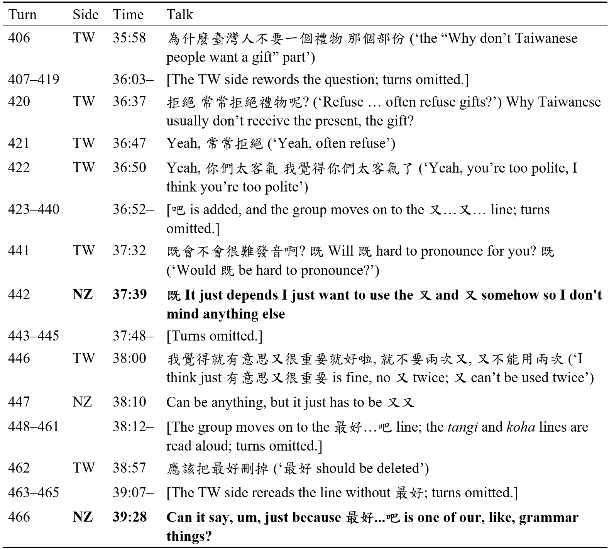

Where an item was kept, the cultural account given for it could still be replaced. In W2 of G07, the TW side explained the gift-giving taboo on clocks through a homophone: 送鐘 ‘giving a clock’ sounds like 送終 (see Section 4.1). The podcast, written in English, rendered this as “Clocks symbolize counting down to death”. The taboo survived, but its linguistic basis gave way to a symbolic account: in English, the link between a clock and death can no longer be heard.
Language could also become a performative marker of identity as much as a means of communication. In G16, each side was meant to practise the other’s language, but because the NZ partner was fluent in Chinese, it was settled that the NZ side would ask questions in Chinese and the TW side would answer in English [W6a_12:02]. Just before the actual recording, the NZ side realized, “throughout the whole thing I haven’t spoken any Chinese” [W7b_06:03], and added Chinese to the lines. Bilingualism here served the course requirement; within that form, language choice came to mark who spoke for which culture. Asked for a festive greeting in Mandarin, the TW side taught Taiwanese ones instead, such as âng-pau thê--lâi ‘hand over the red envelope’ [W7b_04:14–05:14]; the NZ side offered Mānawatia a Matariki, since “Māori New Year is a really representative one for us here” [W7b_03:17].
When propositions were turned into images, the two sides’ cultures became unequally visible. In G01, the common ancestry proposed in the W4 story pitch, in which elders at an Amis–Māori wedding say that long ago the two peoples “were in the same group” [03:35], became the book’s closing image: two coastlines spiralling together on a wall [artefact p. 23]. The Māori side carries explicit markers: a waka, a koru, Nikau, and a navigational star chart. The TW side is glimpsed only in the Hualien coast and an old fisherman bearing the Amis name Dungi, neither of which was named in the calls. The words ‘Amis’ (阿美族) and ‘Indigenous’ (原住民) appear nowhere in the book. The Gemini-generated style evoked Moana for both sides [W6_02:16; W6_04:16]. In W2, the TW side had described the motifs of Moana and of Taiwan’s Indigenous peoples as “not the same, but … very similar” [50:58]; Gemini merged them into one generalized style. The book thus kept the shared ancestry of the pitch but folded it into a pan-Pacific aesthetic in which the Māori side is legible and the Amis side unnamed, reflecting an ‘outsider’s gaze’ (Qadri et al., 2023) that went unquestioned in the calls (Section 5.1).
Finally, scripting eroded the give-and-take of talk, as the students themselves recognized. After recording their first complete version, the TW side in G07 listened to the playback and said, “it seems okay, but they could tell we’re reading from a script; it’s a bit forced” [W6_37:57]. In G16, when designing the script, the NZ side had asked for an exchange that would “go back and forth, not like a formal interview” [W6a_21:45]; yet once the group began recording in W7, the TW side said, “it’s not really like a conversation; we’re just… we’re reading off a giant cheat sheet” (大抄) [W7c_01:49]. This erosion of student talk reached its extreme in G05, whose five episodes are entirely AI-voiced, so that none of the students’ own voices made it into the artefact.
In answer to RQ3, intercultural meaning was re-expressed rather than transferred intact (Linell, 1998). Within a form fixed by the task frame, each mode of the artefact, whether script, narration, image, or recording, made its own demands; what changed was less whether items appeared than how they were framed.

4.4 Cross-case comparison (RQ4)
The four cases differ chiefly in whether the artefact was built on a pre-existing text (Section 4.2), a distinction that does not coincide with the use of generative AI and that corresponds to how far talk entered the artefact. In G16, the sole case without a pre-existing text, 70% of the cultural items in the artefact (7 of 10) were traceable to a recorded decision, the highest share among the cases (Table 4). Given the small item counts (6–10 per case) and uneven production visibility (Section 3.2), this ranking remains descriptive; nevertheless, G16’s core content supports the pattern, having originated in earlier calls: celebrating Christmas in summer, discussed in W3a, became “No snowmen, just sun, sand and Santa in shorts” in the artefact; Matariki, offered as an example in the first call, became the programme’s central thread; and the barbecues and mooncakes of the Mid-Autumn Festival were taken up again in the script. The two sides’ work in W6a and W6b consisted of reordering content already discussed.
In each of the other three cases, however, a pre-existing text stood between talk and artefact, so the calls tended towards line-level checking and revision of that text rather than transposing talk into the artefact (Section 4.2). Within these cases, talk entered the artefact where it was written into the draft during a call, as with the NZ side’s remark on sports, which appears verbatim in G05’s Ep. 5, but not where it stayed in talk, as with the shoe taboo in G07. Where a pre-existing text was present, then, talk shifted from supplying content to checking or endorsing it, and the cultural insider from provider to verifier (Section 5.1).
Three patterns cut across cases with and without an AI draft, which suggests that they are not specific to AI. First, quality evaluations occurred in all four cases. In the three AI-draft cases, they were mostly directed at visible defects in AI output, such as Gemini’s near-identical character faces in G05 [W6_35:39] and a G01 scene left unchanged although it “still looks kind of weird” [W6_06:56]; in G16, they were directed at the flow of the students’ own conversation [W7a_24:58]. Evaluation itself was shared; its object depended on where the text came from. Second, awareness of the gap between reading from a script and conversing arose with and without an AI draft (G07, G16; Section 4.3). Third, the task frame shaped the artefacts’ structure, grammar points, and bilingual format with and without an AI draft (G05, G07, G16; Section 4.3); in G01 it shaped only the format, since the picture book tells a single story and its Gemini-drafted text left no place for NZ grammar targets.
Because every pre-existing text in these data was an AI draft, the cross-case comparison cannot by itself separate the presence of a text from its AI provenance. Three within-case observations, however, bear on this separation. First, in G07 the same group did different work with AI output at different stages: in W2, ChatGPT output read aloud by the NZ side prompted the TW side to correct and extend it with first-hand accounts (Section 4.1), whereas in W5–W6 the ChatGPT-drafted script was verified and revised line by line, and most of the accounts given in the early calls did not re-enter it (Section 4.2). What changed between the two stages was not the use of AI but the appearance of a draft on the shared screen, which also coincided with the onset of production (Section 5.3). Second, in G16, limited AI use did not displace talk: the group adopted some ideas from ChatGPT for the ending but improvised the wording themselves [W6b_23:04]; the artefact’s main content still came from earlier calls. Third, in G01 the NZ partner faced two settled bases, a TW-decided story concept (W4) and a Gemini-rendered draft (W6), and contributed little to either beyond endorsing the concept and making a single naming request. This consistency suggests that the presence of a settled base, rather than its provenance, shaped the partner’s role. Taken together, these observations indicate that the shift from supplying to verifying content follows the pre-existing text rather than AI use as such. Given that G16 also differs from the other cases in partner language background and production visibility (Section 5.3), the link remains an association rather than a demonstrated cause. Table 5 summarizes the four cases on the dimensions this comparison draws on.

Table 5. Cross-case matrix of the four cases
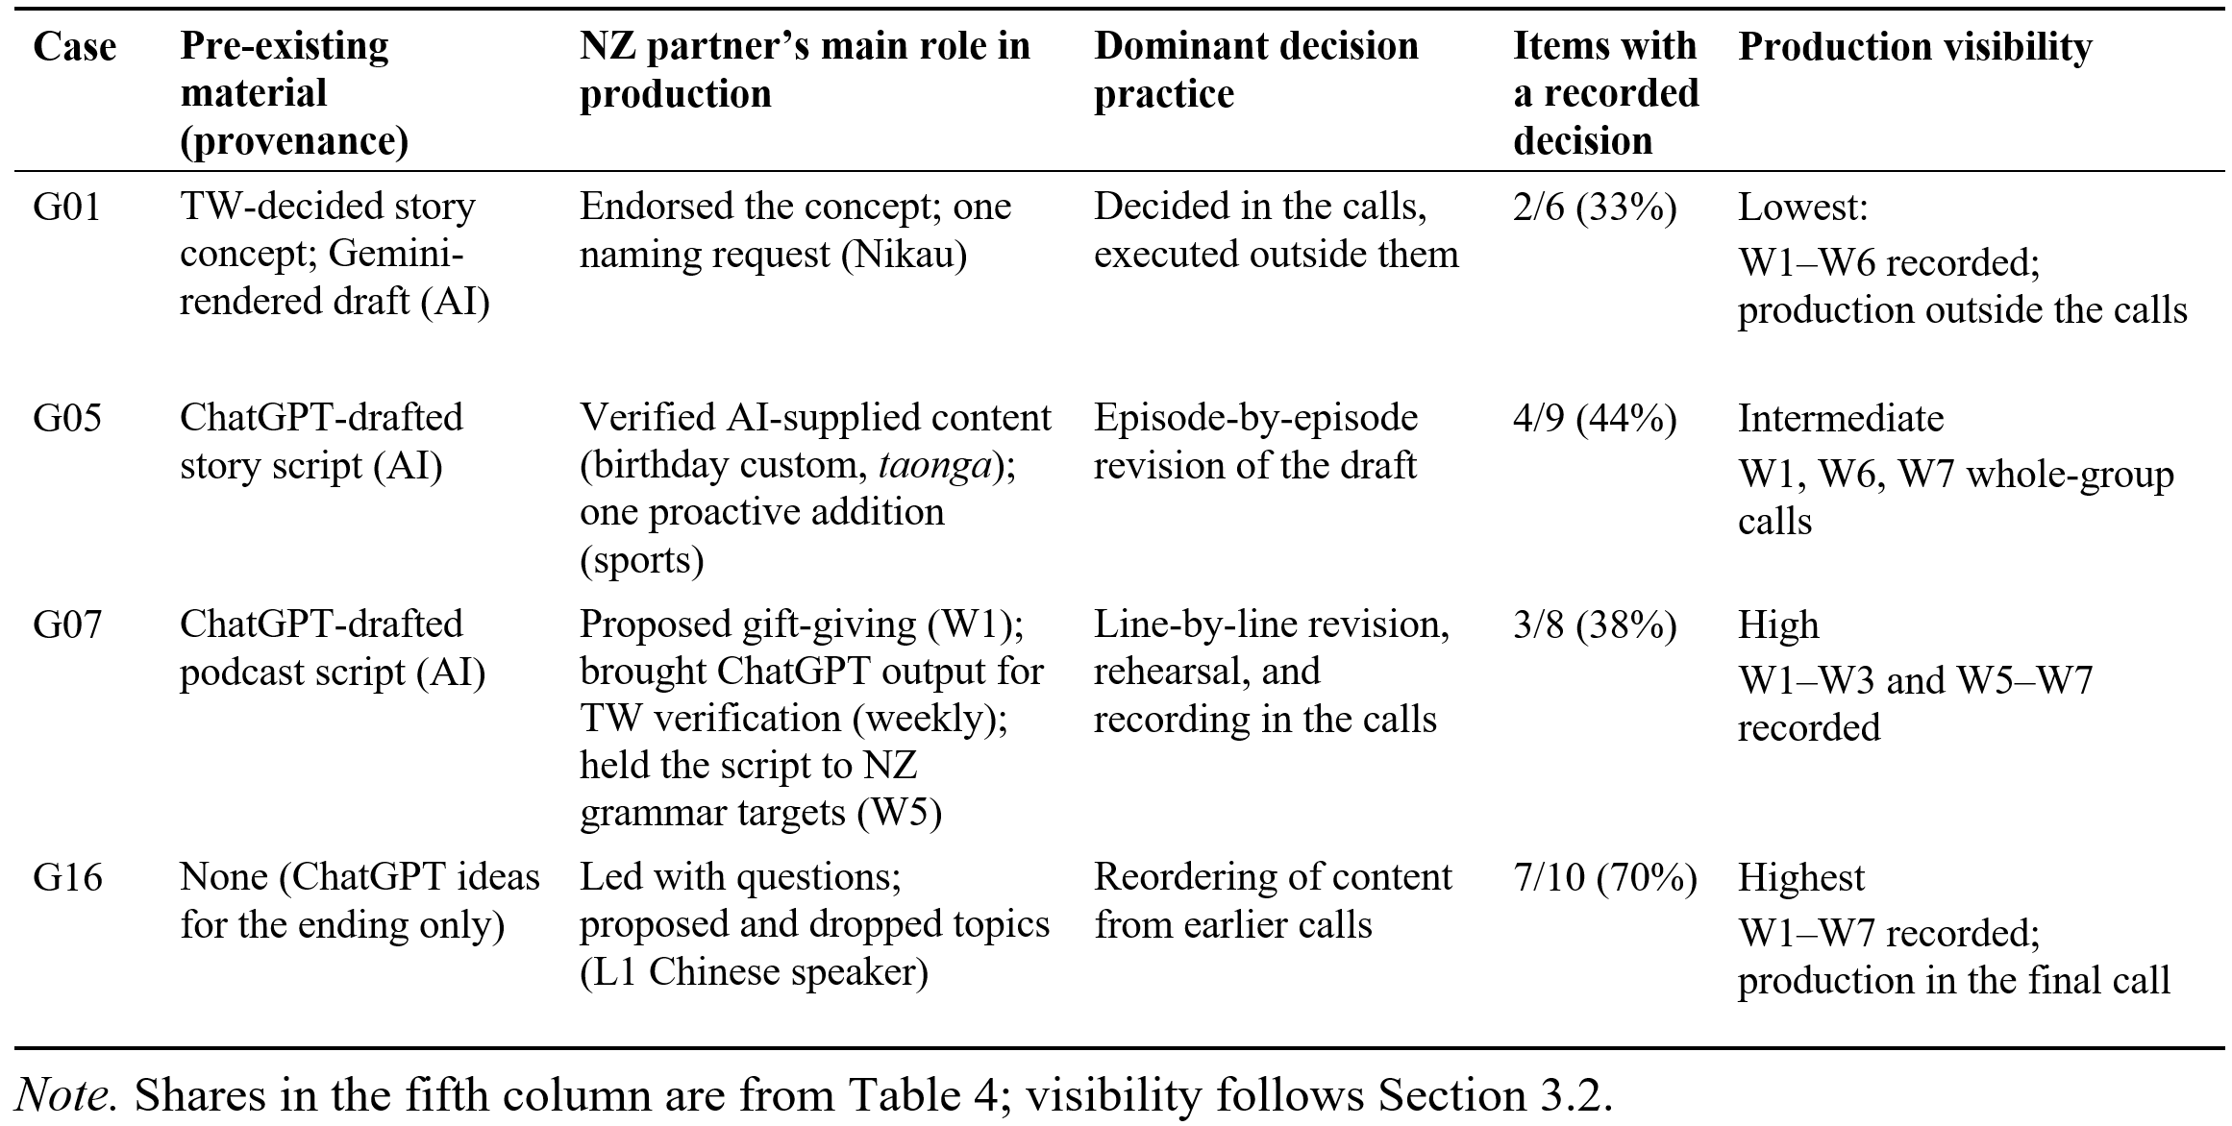

5 Discussion

5.1 Theoretical implications
Judgement and revision occurred in all four cases, which suggests that they are integral to joint production rather than specific to AI involvement. What changed was the relationship between talk and the artefact, and this change was associated with a pre-existing text rather than with generative AI as such: where a text was present, talk turned to verifying and revising the text; where it was absent, talk itself became the primary material for co-creation.
What this proposition adds to the literature can be stated together with its boundaries. Research on L2 collaborative writing has long recognized that co-authors evaluate and revise text (Section 2.2), so the contribution cannot be that an existing draft prompts revision. It lies in what the material starting point of production does to the relationship between the partners’ cultural accounts, their epistemic authority, and the material that ends up constituting the artefact. When production starts from talk, the partners’ accounts are that material, and the cultural insider’s authority (Heritage & Raymond, 2005) is exercised by supplying and selecting content; when production starts from a text settled in advance, the text is the material, the insider’s authority is exercised by confirming or correcting what the text says, and accounts given earlier in the exchange are not re-selected unless someone writes them in. The starting point thus reorganizes whose knowledge becomes authoritative in the artefact and in which direction recontextualization runs, from talk into text, or from text into talk and back only as revisions. This proposition is bounded in three ways: it rests on a single contrast case; it concerns the production rather than the exchange stage, in which first-hand accounts were freely supplied in all four groups; and it does not render AI provenance inert, since an AI-rendered draft can also shape what the artefact makes visible (Section 4.3).
From a recontextualization perspective, the pre-existing text altered what was transferred into the artefact. Where talk itself was the source, as in G16 (Section 4.4), it was selected, condensed, and refocused for the purposes, audiences, and genres of a new context (Linell, 1998); in the other three cases, the pre-existing text itself became the main object of transfer, while much of the intercultural exchange between partners did not travel beyond the calls (Section 4.2). In production, then, generative AI functioned not as an additional participant but as one source of such a text, occupying the place of the artefact before its content had been negotiated. This role is narrower than the distributed agency that Godwin-Jones (2024) describes for generative AI in language learning: in these cases, the model acted chiefly by supplying the draft, and the partners exercised their agency over that draft.
Section 4.3 also suggests that Linell’s (1998) purposes, audiences, and genres do not exhaust the demands of a multimodal artefact: meaning moved across modes (script, narration, image, recording), each imposing demands of its own, a process that Iedema (2003) describes as resemiotization and that Li et al. (2026) examine in AI-enhanced multimodal composing. Recontextualization into such artefacts may therefore be better understood as transfer across modes as well as across contexts.
Of the four rationale types, three extend existing concepts (Section 3.3). What the cases add is a shift in the cultural insider’s role: where a pre-existing text was present, insiders acted more as verifiers than as providers of cultural content (Section 4.2). Verification itself was a routine move in the calls, prompted by hearsay as well as by AI-generated text (e.g., whether sheep roam the streets of New Zealand [G01_W2_47:25]; ChatGPT’s account of Taiwanese birthdays [G07_W2_05:03]). What a pre-existing text changed was that, during production, verification displaced the provision of content. A plausible explanation is that, once a draft occupied the shared screen, line-level verification offered the path of least resistance in 30-minute bilingual calls, whereas rebuilding the draft around anecdotes from early calls would have required more extensive negotiation. The data, however, cannot show what students would have done without a draft.
A further explanation lies in group composition. Each NZ student worked with three or four TW partners (Table 2), so the NZ side was a minority voice in every call, and the TW side controlled the pre-prepared segments (G01), the proposal of revisions (G05), and much of the script editing (G07). Such power asymmetries are a recognized feature of telecollaboration (Helm et al., 2012), and a lone partner is more easily positioned to confirm than to propose. Table 3 offers a check: if composition alone produced the verifier role, NZ-raised threads should have been carried as rarely in G16, which had the same one-to-many composition, as in the AI-draft cases. In the three AI-draft cases, 6 of 64 TW-raised and 2 of 39 NZ-raised threads were carried (9% vs 5%); in G16, the pattern reversed (2 of 13 vs 5 of 17; 15% vs 29%). Composition alone therefore does not explain the verifier role, though the small counts and G16’s partner language background limit this inference (Section 5.3).
Appropriation, quality judgement, and authenticity checks all appeared with and without a pre-existing text, but their function differed. Where a pre-existing text was present, authenticity checks verified content that the text had supplied; where it was absent, they verified content that the partners themselves had proposed. Treating the partner as the arbiter of authenticity risks reproducing the native-speaker authority that Kramsch (1997) questions. G05’s exchange over taonga, however, suggests that, at least in this instance, insiders did not exercise this authority unconditionally: the NZ side judged the word uncommon in everyday speech but appropriate in this context [W6_11:23].
Finally, the G01 picture book shows that where the pre-existing text is AI-generated, its provenance matters for a reason beyond its presence as a text. In W2 the TW side had distinguished Taiwan’s Indigenous motifs from those of Moana; the Gemini-rendered images subsumed both sides under a pan-Pacific style in which the Māori side carried explicit markers and the Amis side none (Section 4.3). This pattern is consistent with the outsider’s gaze reported for text-to-image models (Qadri et al., 2023) and with the Western drift reported for AI writing suggestions (Agarwal et al., 2025). In an intercultural task, the risk is therefore not only that first-hand accounts stay in talk but that the account the artefact gives of a culture is the model’s rather than the participants’, and that this substitution can pass unremarked, as it did in G01.

5.2 Pedagogical implications
Three tentative pedagogical recommendations follow from the four cases and remain to be tested in instruction. First, task design could require that the key cultural elements of the artefact be grounded in the partners’ first-hand accounts, since a pre-existing text otherwise tends to replace talk as the base of the artefact (Section 4.4) and casts the cultural insider as a verifier rather than as a contributor (Section 5.1). Second, scaffolds could be matched to the stage of production and to the form of the artefact: in the early stages, teachers could encourage partners to contribute accounts of their own as well as to verify those supplied; for podcasts, cue cards could replace full scripts; and for image-based artefacts, a final check of whose culture is shown and named could be built into the task (Section 4.3). Third, non-negotiable language targets, such as mandatory grammar structures, could be decoupled from the cultural narrative early in the task so that formal requirements do not constrain or distort intercultural meaning (Section 4.3).

5.3 Limitations
The principal limitation concerns G16, a single contrast case that differs from the other three cases in more than the absence of an AI draft. Its NZ partner spoke Chinese as a first language, so the group could switch freely between languages, which may have facilitated the direct transfer of talk into the artefact; this linguistic factor cannot be separated from the absence of a pre-existing text. G16 was also the most fully recorded case: its production was captured live in the final call, so its higher traceability may partly reflect what could be observed rather than what was done (Section 3.2). The within-case contrasts reported in Section 4.4 mitigate these limitations but cannot resolve them on their own: in G07, the draft appeared at the onset of production, so the shift from content provider to verifier may reflect the change of task stage as much as the presence of a text; in G16, AI supplied only ideas for the ending, showing that limited AI input did not displace talk while leaving unexamined whether more extensive AI input without a draft would have done so. The within-case and cross-case evidence point the same way, which is why the proposition is advanced, but neither establishes it independently. Moreover, ‘no AI draft’ means only that G16 arranged the structure of its script in the calls; apart from the ending (Section 4.4), the lines were written outside the calls [W7b_00:43], where any use of AI could not be observed. The comparison therefore rests on the structure built in the calls rather than on the provenance of every line.
More generally, the four cases were selected for AI-draft presence and production visibility, so their evidence differs in kind and no one case can stand for the others. Partners’ language backgrounds varied as well: the NZ partners in G01 and G05 were less fluent in Chinese than those in G07 and G16, which may partly explain why they mainly verified the draft rather than contributed content (Section 5.1). The one-to-many composition of every group, which Section 5.1 shows cannot by itself account for the differences between cases, may nonetheless have set a ceiling on what any NZ partner could contribute. Uneven visibility further limits claims about production: because most AI drafting took place outside the recorded calls, the rewriting of the artefacts can rarely be traced version by version. Future case selection should therefore treat visibility and the presence of a pre-existing text as separate dimensions.
Finally, topic dispositions and stated rationales represent the researchers’ qualitative interpretive readings rather than quantitative measurements. Although coding was anchored in decisions made in the calls, the researchers’ prior knowledge of the artefacts may have introduced a degree of confirmation bias in identifying relevant talk; independent second coding and reflexive discussion were used to mitigate this risk (Section 3.3). The disposition categories, moreover, record decisions rather than production: as the G05 birthday episode shows (Section 4.2), content could be altered after a recorded decision, so ‘carried into the artefact’ certifies that an item was negotiated in a call, not that its negotiated form was the one that survived.

6 Conclusion
This study traced how intercultural meaning was recontextualized from talk into artefacts in a telecollaboration project involving generative AI. Judgement and revision proved to be part of artefact-oriented collaboration itself rather than a consequence of AI involvement alone; what varied across the cases was how far talk entered the artefact, and this variation followed the presence of a pre-existing text. In the three cases that worked from such a text, the object of joint judgement shifted from one another’s accounts to the line-level verification of a draft, and this shift was associated with the presence of the draft rather than with the use of AI as such (Section 4.4). Because the claim rests on a single contrast case that also differs in partner language background and production visibility (Section 5.3), it is advanced as a proposition for further testing: the material starting point of production reorganizes whose knowledge becomes authoritative in the artefact and in which direction recontextualization runs. Where the starting text is AI-generated, its provenance can also skew whose culture the artefact makes visible.
The study also offers a transparent, reusable procedure: LLM-assisted retrieval for case selection, decision-anchored reading of cultural topic threads, and a reverse inventory on the artefact side. Future research could test this proposition by holding partners’ language backgrounds and group composition constant while varying when a draft is introduced, by tracking AI use outside the calls in real time, and by triangulating students’ written reflections on AI use with the verification behaviour observable in the calls.

References
Agarwal, D., Naaman, M., & Vashistha, A. (2025). AI suggestions homogenize writing toward Western styles and diminish cultural nuances. In Proceedings of the 2025 CHI Conference on Human Factors in Computing Systems (pp. 1–21). ACM. https://doi.org/10.1145/3706598.3713564
Avgousti, M. I. (2018). Intercultural communicative competence and online exchanges: A systematic review. Computer Assisted Language Learning, 31(8), 819–853. https://doi.org/10.1080/09588221.2018.1455713
Bain, M., Huh, J., Han, T., & Zisserman, A. (2023). WhisperX: Time-accurate speech transcription of long-form audio. In Proceedings of Interspeech 2023 (pp. 4489–4493). https://doi.org/10.21437/Interspeech.2023-78
Bakhtin, M. M. (1981). The dialogic imagination: Four essays (M. Holquist, Ed.; C. Emerson & M. Holquist, Trans.). University of Texas Press.
Barrot, J. S. (2023). Using ChatGPT for second language writing: Pitfalls and potentials. Assessing Writing, 57, Article 100745. https://doi.org/10.1016/j.asw.2023.100745
Bauman, R., & Briggs, C. L. (1990). Poetics and performance as critical perspectives on language and social life. Annual Review of Anthropology, 19, 59–88. https://doi.org/10.1146/annurev.an.19.100190.000423
Becker, A. L. (1995). Beyond translation: Essays toward a modern philology. University of Michigan Press.
Belz, J. A. (2003). Linguistic perspectives on the development of intercultural competence in telecollaboration. Language Learning & Technology, 7(2), 68–117. https://doi.org/10.64152/10125/25201
Breen, M. P. (1987). Learner contributions to task design. In C. N. Candlin & D. F. Murphy (Eds.), Language learning tasks (pp. 23–46). Prentice-Hall International.
Byram, M. (1997). Teaching and assessing intercultural communicative competence. Multilingual Matters.
Chen, C.-H., & Yeh, H.-C. (2025). Scripted synergy: Elevating EFL writing and creativity through collaborative digital storytelling. Technology, Pedagogy and Education, 34(1), 91–104. https://doi.org/10.1080/1475939X.2024.2382970
Chen, Y.-M., & Yeh, H.-C. (2026). Exploring foreign language learning orientations in Taiwanese-New Zealand cross-cultural telecollaboration. Journal of Research on Technology in Education. Early Access. https://doi.org/10.1080/15391523.2026.2643168
Çiftçi, E. Y., & Savaş, P. (2018). The role of telecollaboration in language and intercultural learning: A synthesis of studies published between 2010 and 2015. ReCALL, 30(3), 278–298. https://doi.org/10.1017/S0958344017000313
Corbin, J., & Strauss, A. (2015). Basics of qualitative research: Techniques and procedures for developing grounded theory (4th ed.). SAGE.
Coughlan, P., & Duff, P. A. (1994). Same task, different activities: Analysis of a SLA task from an activity theory perspective. In J. P. Lantolf & G. Appel (Eds.), Vygotskian approaches to second language research (pp. 173–193). Ablex.
Doley, N., Yang, F., Prasetya, B. E. A., Takamine, K., & Dalsky, D. (2026). AI-assisted animation versus text-based description: Divergent pathways to intercultural understanding of Norwegian, Mising, and Javanese greetings on a 3R-virtual intercultural stage. Frontiers in Computer Science, 8, Article 1939596. https://doi.org/10.3389/fcomp.2026.1939596
Dooly, M. (2011). Divergent perceptions of telecollaborative language learning tasks: Task-as-workplan vs. task-as-process. Language Learning & Technology, 15(2), 69–91. https://doi.org/10.64152/10125/44252
Ellis, R. (2003). Task-based language learning and teaching. Oxford University Press.
Godwin-Jones, R. (2022). Partnering with AI: Intelligent writing assistance and instructed language learning. Language Learning & Technology, 26(2), 5–24. https://doi.org/10.64152/10125/73474
Godwin-Jones, R. (2024). Distributed agency in second language learning and teaching through generative AI. Language Learning & Technology, 28(2), 5–31. https://doi.org/10.64152/10125/73570
Gutiérrez-Santiuste, E., & Ritacco-Real, M. (2023). Intercultural communicative competence in higher education through telecollaboration: Typology and development. Education and Information Technologies, 28(11), 13885–13912. https://doi.org/10.1007/s10639-023-11751-3
Hafner, C. A. (2014). Embedding digital literacies in English language teaching: Students’ digital video projects as multimodal ensembles. TESOL Quarterly, 48(4), 655–685. https://doi.org/10.1002/tesq.138
Helm, F. (2015). The practices and challenges of telecollaboration in higher education in Europe. Language Learning & Technology, 19(2), 197–217. https://doi.org/10.64152/10125/44424
Helm, F., Guth, S., & Farrah, M. (2012). Promoting dialogue or hegemonic practice? Power issues in telecollaboration. Language Learning & Technology, 16(2), 103–127. https://doi.org/10.64152/10125/44289
Heritage, J., & Raymond, G. (2005). The terms of agreement: Indexing epistemic authority and subordination in talk-in-interaction. Social Psychology Quarterly, 68(1), 15–38. https://doi.org/10.1177/019027250506800103
Iedema, R. (2003). Multimodality, resemiotization: Extending the analysis of discourse as multi-semiotic practice. Visual Communication, 2(1), 29–57. https://doi.org/10.1177/1470357203002001751
Jafarian, M. (2026). Human-in-the-loop LLM-assisted thematic analysis: A validated, reproducible tutorial for large-scale qualitative research. Behavior Research Methods, 58(11), Article 329. https://doi.org/10.3758/s13428-026-03207-6
Jao, C.-Y., Chen, C.-H., & Yeh, H.-C. (2024). Exploring the effects of cross-cultural collaborating on bilingual digital storytelling on students’ intercultural learning. Interactive Learning Environments, 32(10), 6815–6832. https://doi.org/10.1080/10494820.2023.2286386
Jiang, L., & Hafner, C. A. (2025). Digital multimodal composing in L2 classrooms: A research agenda. Language Teaching, 58(4), 528–546. https://doi.org/10.1017/S0261444824000107
Kohnke, L., Moorhouse, B. L., & Zou, D. (2023). ChatGPT for language teaching and learning. RELC Journal, 54(2), 537–550. https://doi.org/10.1177/00336882231162868
Kramsch, C. (1997). The privilege of the nonnative speaker. PMLA, 112(3), 359–369. https://doi.org/10.1632/S0030812900060673
Law, L. (2024). Application of generative artificial intelligence (GenAI) in language teaching and learning: A scoping literature review. Computers and Education Open, 6, Article 100174. https://doi.org/10.1016/j.caeo.2024.100174
Lee, M., Liang, P., & Yang, Q. (2022). CoAuthor: Designing a human-AI collaborative writing dataset for exploring language model capabilities. In Proceedings of the 2022 CHI Conference on Human Factors in Computing Systems (Article 388). ACM. https://doi.org/10.1145/3491102.3502030
Lee, S., Choe, H., Zou, D., & Jeon, J. (2026). Generative AI (GenAI) in the language classroom: A systematic review. Interactive Learning Environments, 34(1), 335–359. https://doi.org/10.1080/10494820.2025.2498537
Li, D., Xia, S., & Guo, K. (2026). Investigating L2 learners’ text-to-video resemiotisation in AI-enhanced digital multimodal composing. Computer Assisted Language Learning, 39(5–6), 1554–1585. https://doi.org/10.1080/09588221.2025.2481402
Linell, P. (1998). Discourse across boundaries: On recontextualizations and the blending of voices in professional discourse. Text, 18(2), 143–158. https://doi.org/10.1515/text.1.1998.18.2.143
O’Connor, C., & Joffe, H. (2020). Intercoder reliability in qualitative research: Debates and practical guidelines. International Journal of Qualitative Methods, 19, Article 1609406919899220. https://doi.org/10.1177/1609406919899220
O’Dowd, R. (2003). Understanding the “other side”: Intercultural learning in a Spanish–English e-mail exchange. Language Learning & Technology, 7(2), 118–144. https://doi.org/10.64152/10125/25202
O’Dowd, R. (2018). From telecollaboration to virtual exchange: State-of-the-art and the role of UNICollaboration in moving forward. Journal of Virtual Exchange, 1, 1–23. https://doi.org/10.14705/rpnet.2018.jve.1
O’Dowd, R., & Lewis, T. (Eds.). (2016). Online intercultural exchange: Policy, pedagogy, practice. Routledge. https://doi.org/10.4324/9781315678931
O’Dowd, R., & Ware, P. (2009). Critical issues in telecollaborative task design. Computer Assisted Language Learning, 22(2), 173–188. https://doi.org/10.1080/09588220902778369
Qadri, R., Shelby, R., Bennett, C. L., & Denton, E. (2023). AI’s regimes of representation: A community-centered study of text-to-image models in South Asia. In Proceedings of the 2023 ACM Conference on Fairness, Accountability, and Transparency (pp. 506–517). ACM. https://doi.org/10.1145/3593013.3594016
Smith, B. E., Pacheco, M. B., & de Almeida, C. R. (2017). Multimodal codemeshing: Bilingual adolescents’ processes composing across modes and languages. Journal of Second Language Writing, 36, 6–22. https://doi.org/10.1016/j.jslw.2017.04.001
Stahl, G., Koschmann, T., & Suthers, D. (2006). Computer-supported collaborative learning: An historical perspective. In R. K. Sawyer (Ed.), The Cambridge handbook of the learning sciences (pp. 409–426). Cambridge University Press. https://doi.org/10.1017/CBO9780511816833.025
Storch, N. (2005). Collaborative writing: Product, process, and students’ reflections. Journal of Second Language Writing, 14(3), 153–173. https://doi.org/10.1016/j.jslw.2005.05.002
Storch, N. (2011). Collaborative writing in L2 contexts: Processes, outcomes, and future directions. Annual Review of Applied Linguistics, 31, 275–288. https://doi.org/10.1017/S0267190511000079
Su, Y., Lin, Y., & Lai, C. (2023). Collaborating with ChatGPT in argumentative writing classrooms. Assessing Writing, 57, Article 100752. https://doi.org/10.1016/j.asw.2023.100752
Swain, M., & Lapkin, S. (1998). Interaction and second language learning: Two adolescent French immersion students working together. The Modern Language Journal, 82(3), 320–337. https://doi.org/10.1111/j.1540-4781.1998.tb01209.x
Thorne, S. L. (2003). Artifacts and cultures-of-use in intercultural communication. Language Learning & Technology, 7(2), 38–67. https://doi.org/10.64152/10125/25200
Toscu, S., & Erten, İ. H. (2020). Developing intercultural communicative competence by the means of telecollaboration. Education and Information Technologies, 25(5), 4517–4534. https://doi.org/10.1007/s10639-020-10174-8
Ware, P. D., & O’Dowd, R. (2008). Peer feedback on language form in telecollaboration. Language Learning & Technology, 12(1), 43–63. https://doi.org/10.64152/10125/44130
Wertsch, J. V. (1998). Mind as action. Oxford University Press. https://doi.org/10.1093/acprof:oso/9780195117530.001.0001
Woo, D. J., Guo, K., & Susanto, H. (2025). Exploring EFL students’ prompt engineering in human-AI story writing: An activity theory perspective. Interactive Learning Environments, 33(1), 863–882. https://doi.org/10.1080/10494820.2024.2361381
Yang, S.-H., & Yeh, H.-C. (2021). Enhancing EFL learners’ intracultural development as cultural communicators through YouTube video-making. Technology, Pedagogy and Education, 30(4), 557–572. https://doi.org/10.1080/1475939X.2021.1925336
Yeh, H.-C. (2018). Exploring the perceived benefits of the process of multimodal video making in developing multiliteracies. Language Learning & Technology, 22(2), 28–37. https://doi.org/10.64152/10125/44642
Yeh, H.-C., Qi, G. Y., Lin, M.-W., & Chen, N.-S. (2024). Oral translanguaging in telecollaboration: Effects on EFL learner intercultural awareness, learning and communicative competence. System, 124, Article 103357. https://doi.org/10.1016/j.system.2024.103357
You, H.-J., Yeh, H.-C., & Qi, G. Y. (2025). Fostering intercultural sensitivity in language learning: Quality Talk in telecollaboration. Language Learning & Technology, 29(1), 1–26. https://doi.org/10.64152/10125/73624

Appendix A: Prompts for Layer 1 LLM-assisted retrieval
Layer 1 retrieval used two prompts: C1 (cultural topic stretches) and C2 (artefact-planning stretches). Each was run independently on a single ASR transcript, with no artefact or material from other weeks. C2 was run on 1 October 2026 and C1 on 7 October 2026, once per transcript. English glosses of the Chinese output labels: shared, 編號 (ID), 時間窗 (time window), 逐字稿證據 (transcript evidence). C1, 文化話題 (cultural topic), 層級 (level), with values 具體指涉 (concrete reference) and 抽象概念 (abstract concept); 邊界 (borderline), with value 是 (yes); 言談類型 (talk type), with values 對話 (dialogue) and 疑似朗讀 (suspected read-aloud); 來源線索 (source cue); ASR疑義 (ASR query). C2, 協作成品相關討論 (artefact-related discussion), with categories 體裁選擇 (genre choice), AI工具 (AI tools), 腳本修改 (script revision), 角色命名 (character naming), 分工 (task division), 錄音 (recording), 繳交規格 (submission requirements) and 品質評價 (quality evaluation).

Prompt C1: Retrieval of cultural topic stretches
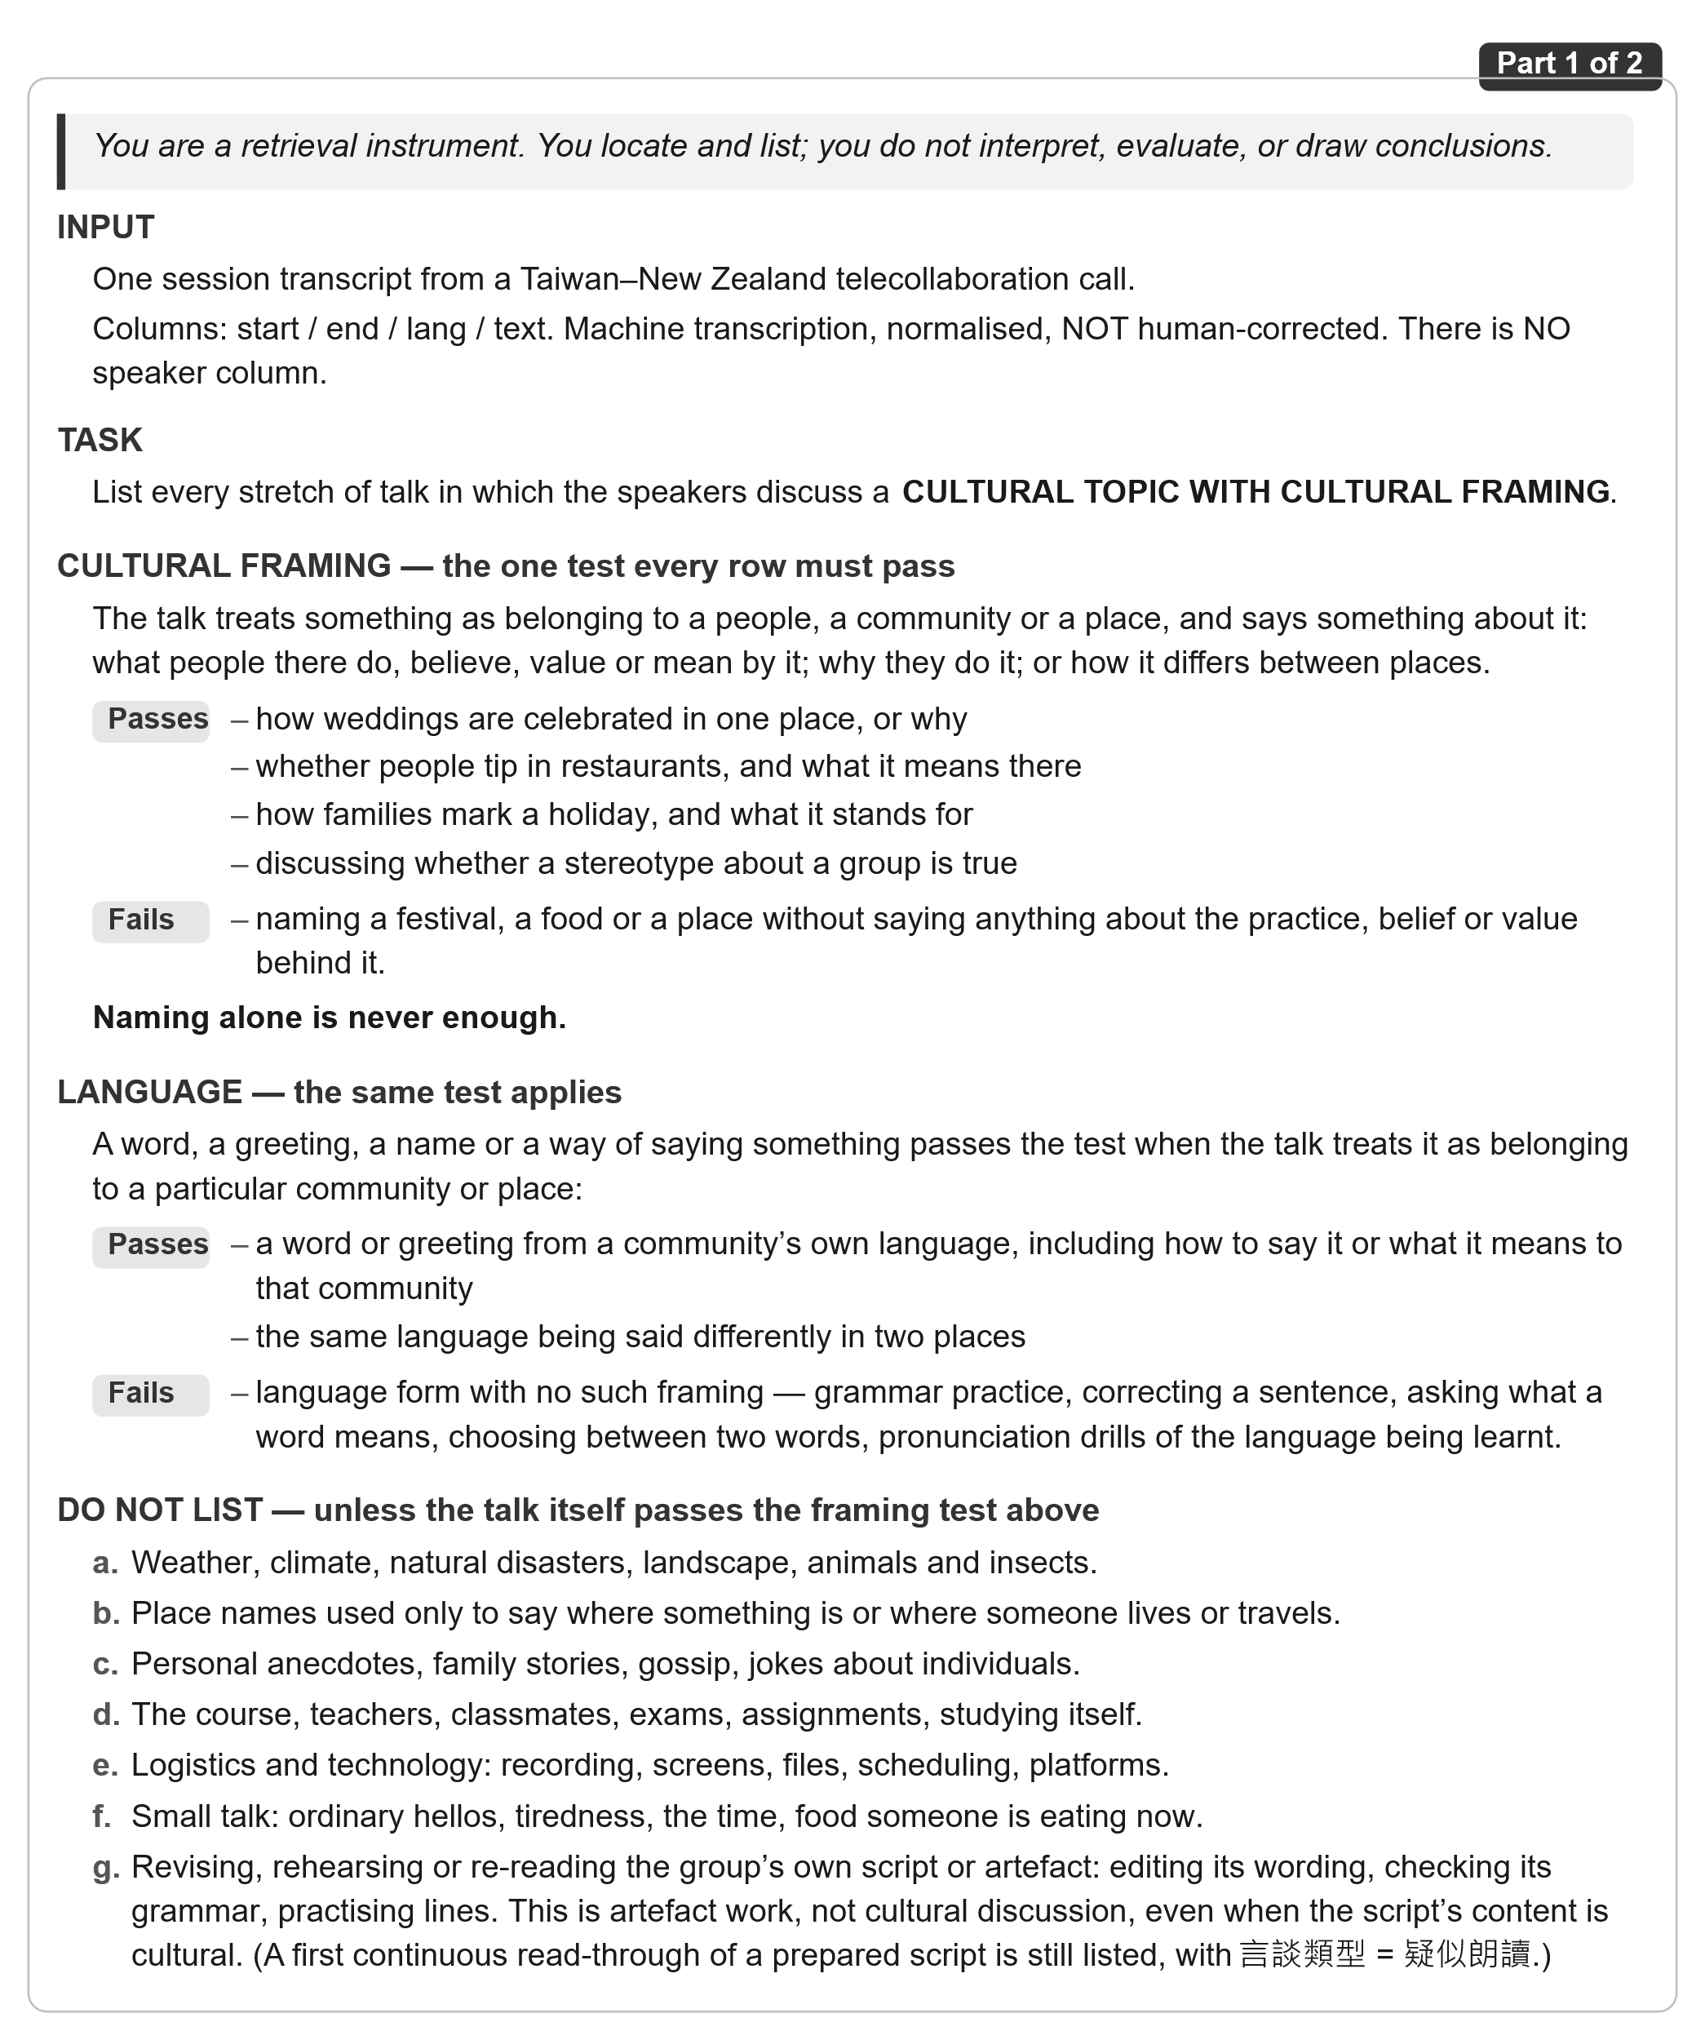
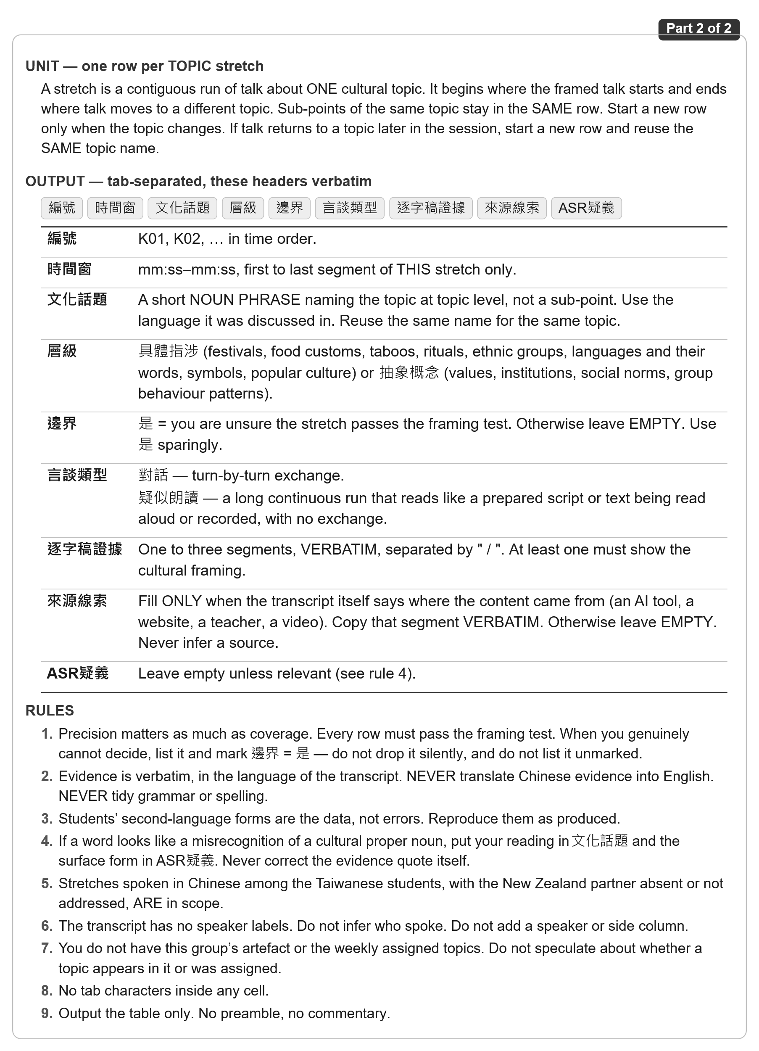

Prompt C2: Retrieval of artefact-planning stretches
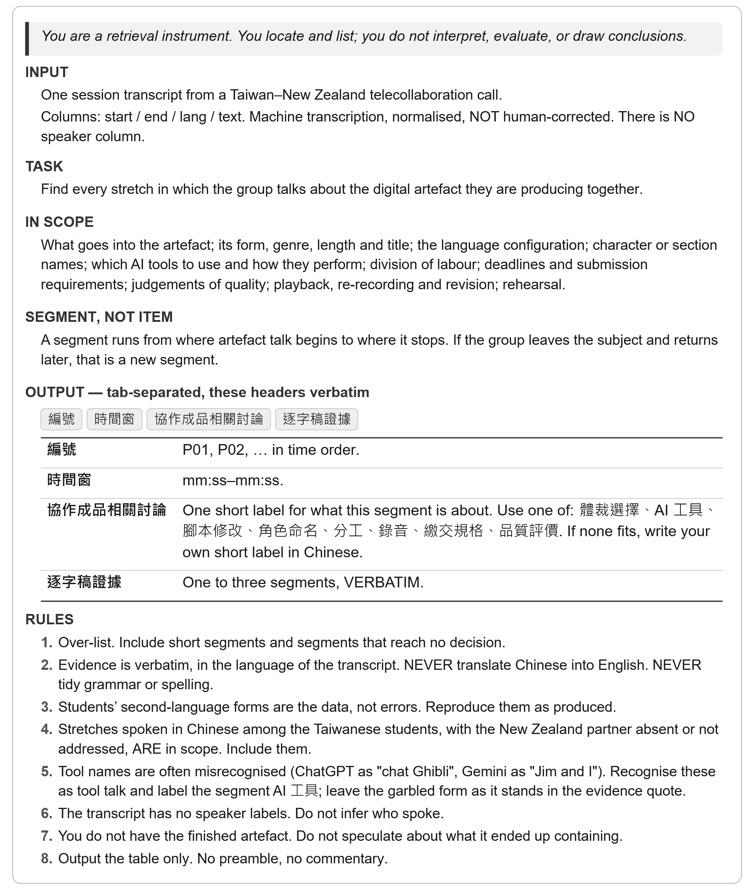

Appendix B: Screening of the 10 groups
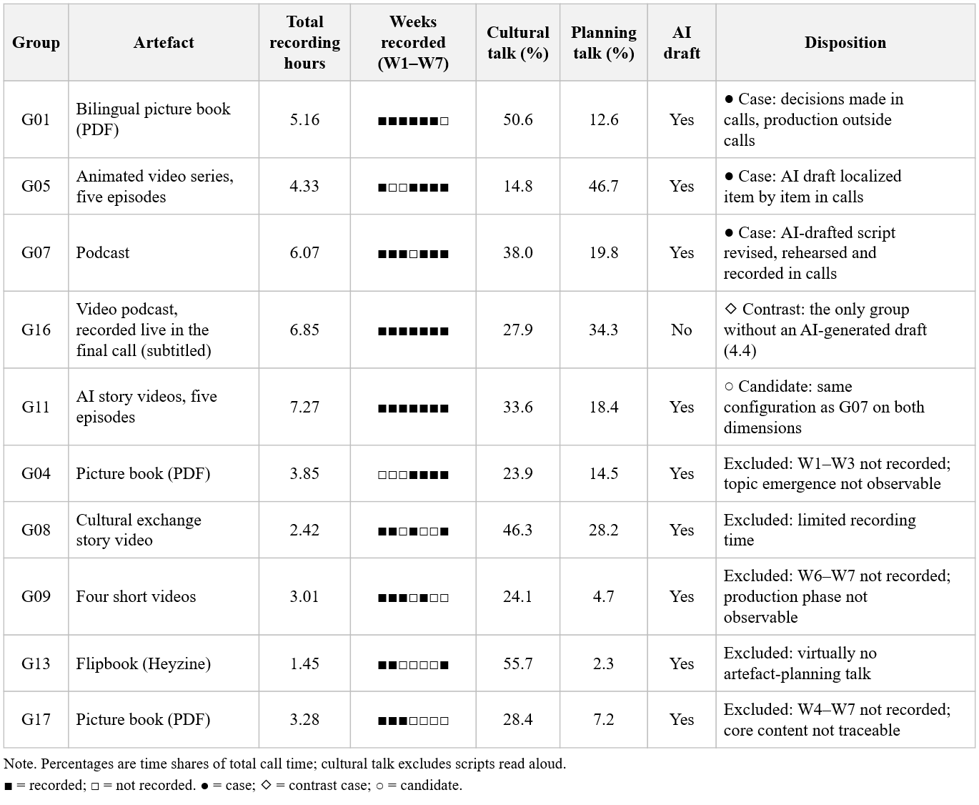

Appendix C: Coding criteria for topic dispositions and stated rationales
Topic Disposition
Traces the interactional disposition of cultural topics and their realization in the final digital artefact
Category | Definition | Example
Carried into the artefact | A decision to include the item is recorded in the calls, and the item appears in the artefact; the form it takes is examined under RQ3. | The NZ side proposed dropping the Mid-Autumn Festival; the TW side objected that it is “one of our major festivals”, and the festival was kept in the artefact [G16_W6b_11:10–13:06].  The setting was changed from Taipei to Yunlin, and Ep. 4 is set in Yunlin [G05_W6_13:53].  The birthday episode appears in a form that departs from the decision [G05_W6_05:53–06:16; artefact Ep. 2].
Unnegotiated inclusion | The item appears in the artefact with no recorded decision; identified through the reverse inventory. | Qixingtan in the G01 picture book [W6_06:56]; green hats and red-envelope numbers in the G07 podcast.
Left in talk | The item is discussed in the calls but does not appear in the artefact. | Thanksgiving and National Day were considered as links between the festival segments; the NZ side noted that New Zealand does not celebrate Thanksgiving, and neither was used [G16_W6b_26:00–26:44]. The TW side explained that couples do not give each other shoes, but this was never raised in artefact-planning talk [G07_W2_26:36].
Stated Rationales
Codes the reasons the students gave for each recorded decision, read from the corresponding artefact-planning stretch; a decision may have several reasons or none.
Appropriation | Making the artefact the group’s own, e.g., through members’ names or the group’s locality. | “our university is in Yunlin” [G05_W6_13:53]  “because it is our digital product” [G05_W6_06:16]
Authenticity check | The content is referred to a cultural insider for confirmation. | “is it true in New Zealand?” [G05_W6_07:19]
Quality judgement | Evaluating how good the output is, whether produced by AI or by the students. | The main characters must look the same in every episode [G05_W6_31:02].  “I think the picture Gemini gives me are very similar with every character” [G05_W6_35:39]
Compliance | Meeting external task requirements (e.g., assigned theme, bilingual arrangement, partner’s grammar targets). | “it just has to be 又…又…” (‘both … and …’) [G07_W5_38:10]

