From Talk to Artefact: Recontextualizing Intercultural Meaning in Telecollaboration Involving Generative AI

Supplementary Material [Online only]
S1 reports the retrieval consistency check and a recall check against human coding, and S2–S5 the case observation records. All recorded calls of the four cases were proofread; stretch counts exclude rehearsal or playback C1 stretches and unrelated C2 stretches (Section 3.3).

S1 Retrieval consistency and recall check
For one session per case, retrieval was rerun with the same prompts on the proofread transcripts and compared with the ASR results (windows from the same session and prompt were treated as overlapping if no more than 5 seconds apart; overlap was checked in each direction separately, and one window could overlap several). Of the 28 cultural topic stretches retrieved on the proofread transcripts, 27 had an overlapping window on the ASR transcripts, as did all 43 artefact-planning stretches. In time, the ASR windows covered 91% and 88% of these stretches respectively; the shortfall mostly reflects shifting boundaries rather than whole stretches being missed. Conversely, 84 of the 85 stretches retrieved on the ASR transcripts overlapped with the results on the proofread transcripts.

Recall check. To estimate what the prompts missed, a research team member who had not seen the retrieval output coded every turn of two complete sessions for C1 and C2: G07_W2 (an early discussion session, 682 turns) and G16_W6a (a production session, 126 turns). Recall is the share of human-coded talk that the prompts also retrieved; precision is the share of retrieved windows that contained human-coded talk. For C1, recall was 88% (23 of 26 stretches) and precision 94% (15 of 16 windows); the three missed stretches, all in G07_W2, were two- or three-turn remarks on word use (e.g., 簡訊 versus 短信 [58:51]), and none reached the artefact. For C2, recall was counted in turns rather than stretches, because the planning talk in G16_W6a formed a single continuous stretch (108 of 126 turns), for which a stretch count (1 of 1) would be uninformative; by this measure, recall was 99% (107 of 108 turns). Precision across the two sessions was 78% (14 of 18 windows): G07_W2 contained no human-coded C2 talk, but four windows were retrieved there, all concerning ChatGPT output on the weekly theme. These four were retained in the analysis (see S4); as they contained no decision to include or exclude any item, they did not affect disposition coding.

S2 Case G01: bilingual picture book
1) Recorded calls
G01 held six calls (W1–W6), with no week missing.

Calls | Duration (min) | Cultural topic stretches (C1) | Artefact-planning stretches (C2)
W1 | 28.1 | 4 | 5
W2 | 66.7 | 22 | 15
W3 | 73.9 | 16 | 4
W4 | 19.6 | 7 | 5
W5 | 64.6 | 8 | 16
W6 | 54.8 | 6 | 14
Total | 307.7 | 63 | 59

2) The artefact
- Form: a bilingual picture book, When the Ocean Brought Us Together (海洋讓我們再次相遇), a 27-page PDF.
- Languages: Chinese and English; the English version was checked by the NZ side [W4_05:03].
- AI use: the TW side generated the draft and the illustrations with Gemini, describing how ‘it really churned it out in five minutes’ (它真的5分鐘就生出來了) [W6_02:16]; the visual style resembles that of Moana.
- Made in or outside the calls: the topic was settled within the TW side before the NZ side joined the call [W4_00:01]; the draft was generated outside the calls, then presented in W6 and reviewed by the NZ side during the call.

3) Main topic thread: Austronesian peoples
Stage | Source | Content
Emergence | G01_W2_32:06–48:07 | The NZ side introduced te reo Māori and the meaning of Aotearoa; about fifteen minutes later the TW side returned to it: “By the way, you mentioned about native people, right?”
Development | G01_W2_48:18–51:48 | The TW side explained that Taiwan is one of the homelands of the Austronesian peoples, with sixteen officially recognized groups, and linked Māori and Hawaiian through the pronunciation of numbers; the NZ side extended this: “everyone’s kind of related in some way”; the TW side noted that the motifs in Moana and those of Taiwanese Indigenous peoples are “not the same, but very similar”.
Proposed for the artefact | G01_W4_00:01–05:06 | Before the NZ side joined, the TW side settled on a picture book with the Amis as its theme; it then proposed to the NZ side a story of an Amis woman and a Māori man, at whose wedding the elders say the two peoples were once one; the NZ side responded “that’s a good idea”.
Verification or revision | G01_W6_04:16–06:10 | The TW side showed the draft generated by Gemini, saying “the style looks like Moana story”; the NZ side’s only change requested in the call was that the male protagonist should have a New Zealand name.
In the artefact | Artefact pp. 2–10, 23 | Nikau, a young Māori man, travels to Hualien and meets Dungi, an old fisherman; the koru spiral runs through the book; at the end, the two coastlines join into a single spiral on a wall. Neither ‘Amis’ nor ‘Indigenous’ appears anywhere in the book.

Figure S1. G01, W4 call: TW side’s AI-formatted story proposal (screenshot)
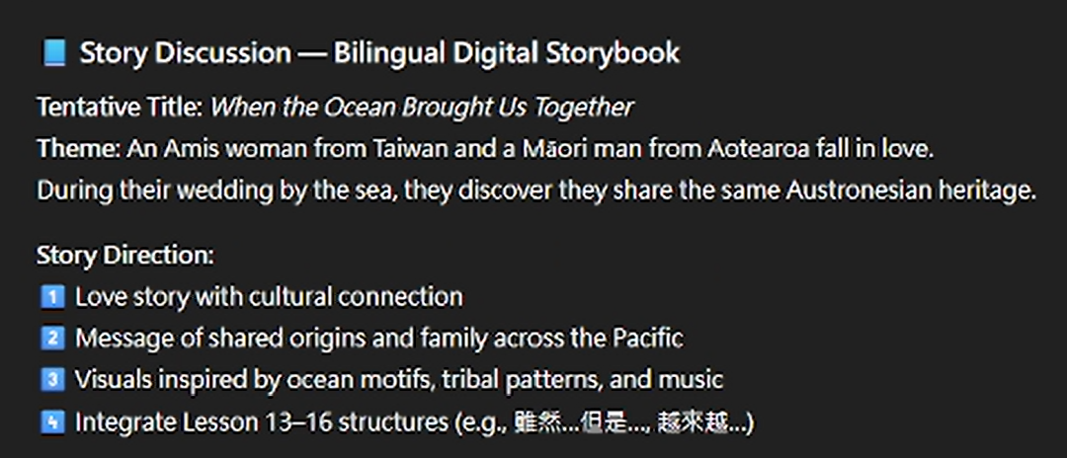
Figure S2. G01, W5 call (screenshot)
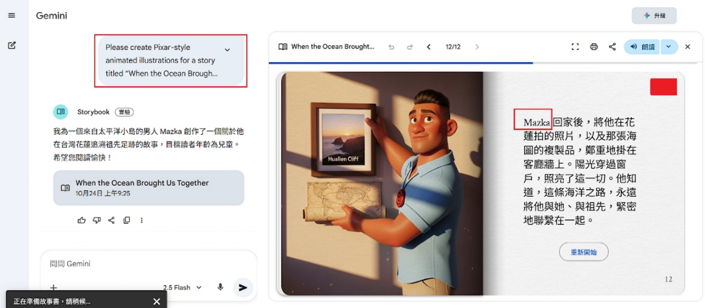
Figure S3. G01, W6 call: revised Gemini draft with the protagonist renamed Nikau (screenshot)
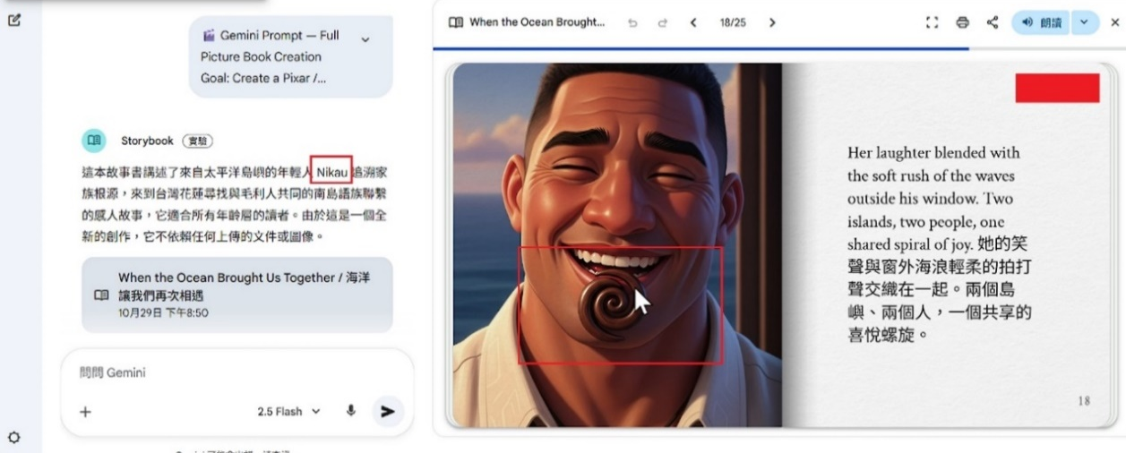
Figure S4. G01 artefact, pp. 13–18
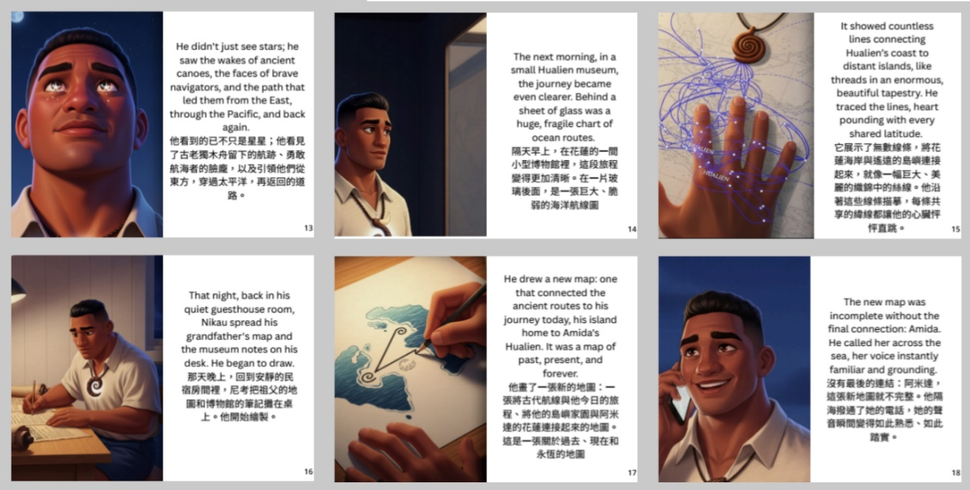

4) Dispositions
- Carried into the artefact: the Austronesian theme [W4_00:01–05:06]. No rationale was stated.
- Carried into the artefact: the male protagonist was renamed with the Māori name Nikau [W6_06:10]; rationale: appropriation.
- Left in talk (47 items, 32 of them raised by the TW side), e.g. the TW side’s accounts of barbecues at the Mid-Autumn Festival [W2_23:24], green 乖乖 snacks placed on machines to keep them running smoothly [W2_27:24] and the Chinese white dolphin [W3_53:58]; from the NZ side, the similarity between Taiwanese and Māori numbers that they had looked up [W6_13:40].
- Unnegotiated inclusion (4 items): (1) Qixingtan, which first appeared in the generated draft and was explained only in W6; no decision to include or modify it was made in the calls [W6_06:56; artefact p. 4]; (2) Hualien; (3) hibiscus flowers; (4) the fisherman Dungi, the last three never discussed in the calls.

Quality evaluations also occurred without leading to a decision: the TW side remarked that a Gemini-generated scene “still looks kind of weird, he just lying on this rock mountain”, but no revision was proposed and the scene remains in the artefact [W6_06:56; artefact p. 4]; the NZ side reported having edited some of the English sentences outside the calls “just so they make a little bit more sense in english” [W6_05:28–05:52]. Because the draft was generated and revised outside the calls, the artefact can be traced to talk mainly at the level of theme.

S3 Case G05: bilingual animated episodes
1) Recorded calls
G05 held three whole-group calls (W1, W6 and W7); W2 to W5 were one-to-one language exchange sessions, so the middle stage of production is not visible.

Calls |  | Duration (min) | Cultural topic stretches (C1) | Artefact-planning stretches (C2)
W1 | 57.9 |  | 2 | 12
W6 | 58.5 |  | 4 | 29
W7 | 36.9 |  | 0 | 26
Total | 153.3 |  | 6 | 67

2) The artefact
- Form: five bilingual animated episodes (Ep. 1–5), about 4 minutes in total.
- Languages: dialogue in Chinese and English; the entire video is AI-voiced and contains no student speech.
- AI use: the story was generated by ChatGPT [W6_00:59]; the character images were first generated with Gemini but rejected by group members because the faces looked alike, and other tools were sought [W6_35:39–39:29]; the voice-over was also AI-produced.
- Made in or outside the calls: the form was chosen by an in-group vote in W1 [W1_08:10]; in W6 the story was verified and revised episode by episode during the call, and in W7 the artefact was played during the call [W7_10:24]; generation and editing took place outside the calls.

3) Main topic thread: birthdays and the localization of settings
Stage | Source | Content
Emergence | G05_W1_25:36 | The TW side proposed “every week we make a story of the topic of that week”; birthdays were one of the course’s weekly themes, but the call for that week is not in the proofread corpus.
Development | Not in the record | Each episode of the story was generated by ChatGPT.
Proposed for the artefact | G05_W6_00:59 | The TW side explained: “this is the story from ChatGPT so I think we should change some parts such as the birthday party and the transportation”.
Verification or revision | G05_W6_05:53–15:38 | The NZ side explained that New Zealand has no fixed birthday custom, and the TW side immediately changed the NZ character’s lines so that, as in Taiwan, the birthday is celebrated with a cake; the characters were renamed after the group members themselves [06:16], the setting was moved from Taipei to Yunlin [13:53], and YouBike was replaced with MOOVO [15:38].
In the artefact | Artefact Ep. 2, Ep. 4 | In Ep. 2 the NZ character says “In New Zealand, we usually have a barbecue or a picnic”, which differs from the conclusion reached in the call; in Ep. 4, Yunlin and MOOVO are realized item by item.

Figure S5. G05 artefact: stills from Ep. 1–5, one per weekly theme

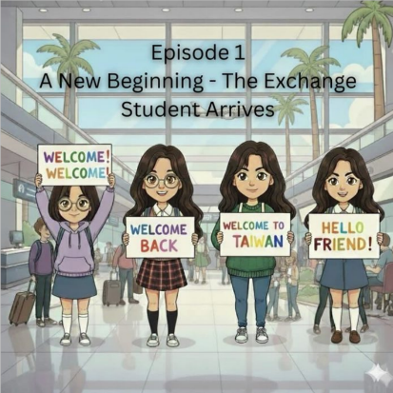 | 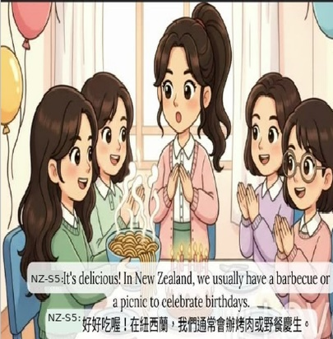 | 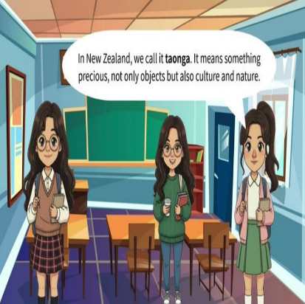
Ep. 1: arrival | Ep. 2: birthday party | Ep. 3: taonga

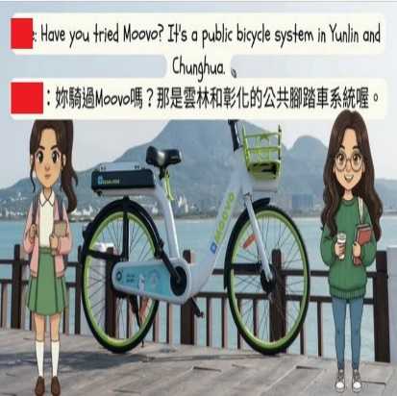 | 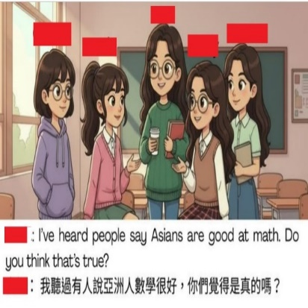
Ep. 4: MOOVO in Yunlin | Ep. 5: ‘Asians are good at maths’

4) Dispositions
- Carried into the artefact: character names, setting and means of transport [W6_06:16–15:38; artefact Ep. 4]; rationale: appropriation. The NZ side’s addition, “people in New Zealand sort of more interested in sports” [W6_21:03], appears verbatim in Ep. 5.
- Carried into the artefact: the AI-produced Māori word taonga, which the NZ side endorsed with reservations [W6_11:23; artefact Ep. 3]; rationale: authenticity check.
- Carried into the artefact: the birthday cake [W6_06:16], in a form that departs from the decision; the artefact substitutes a barbecue and a picnic; rationale: authenticity check.
- Left in talk (2 items): traditional and simplified characters; school hours in the two countries.
- Unnegotiated inclusion (5 items): (1) the Taiwanese counterparts in Ep. 3 (friendliness, night markets, bubble tea, Indigenous songs); (2) Māori carving and songs, also in Ep. 3; (3) the street foods of Ep. 1; (4) the longevity noodles of Ep. 2; (5) the stereotype that Asians are good at maths in Ep. 5.

S4 Case G07: bilingual podcast
1) Recorded calls
G07’s record comprises six calls (W1–W3 and W5–W7); W4 was not recorded.

Calls | Duration (min) | Cultural topic stretches (C1) | Artefact-planning stretches (C2)
W1 | 61.5 | 17 | 14
W2 | 64.4 | 10 | 4
W3 | 59.9 | 13 | 3
W5 | 60.7 | 9 | 10
W6 | 56.8 | 5 | 18
W7 | 60.4 | 12 | 14
Total | 363.7 | 66 | 63

2) The artefact
- Form: a bilingual podcast, When Yam Meets Kiwi: Unpacking Culture Differences, of about 5.3 minutes, with a subtitled video version. The title uses the sweet potato (yam) to stand for Taiwan and the kiwifruit to stand for New Zealand.
- Languages: the roles of host and interviewee alternate, mainly in English with Chinese interspersed; the NZ side’s section comes first, followed by the TW side’s.
- AI use: the TW side generated the first draft of the script with ChatGPT, and the NZ side then added their own Chinese lines; the script shared on screen during the W5 call is this first draft [W5_27:16]. The subtitles were produced by AI recognition and then corrected [W7_03:41].
- Made in or outside the calls: the first draft was generated outside the calls, whereas language revision [W5] and rehearsal and recording [W6] took place in the calls.

3) Main topic thread: gift-giving taboos
Stage | Source | Content
Emergence | G07_W1_56:51–58:11 | The NZ side proposed gift-giving as a topic, drawing on their Chinese course, on the grounds that “something like that would be easy to talk about”; the TW side responded with expressions such as ‘just coming is enough’ (人來就好).
Development | G07_W2_25:12–28:06 | Reciprocity rules in gift-giving were compared; the TW side explained that giving a clock (送鐘) sounds like 送終 sòngzhōng ‘attending a dying relative’, that couples do not give each other shoes (“It means you will run”), and that the recipient must give one dollar back.
Proposed for the artefact | Not in the record | The TW side generated the first script draft with ChatGPT and the NZ side added Chinese lines; when the script was shared on screen in W5, a Taiwanese student asked a peer ‘Is this what GPT gave us?’ (這個是GPT給我們的嗎?) [W5_27:16].
Verification or revision | G07_W5_30:24–39:51; G07_W6_20:48–23:54 | The whole group read through the script line by line and revised the Chinese: the TW side adjusted naturalness (‘Why do Taiwanese people often refuse gifts? Aren’t you being too polite?’ (為什麼臺灣人常常拒絕禮物？你們太客氣了吧？)), while the NZ side treated the course grammar points 又…又… ‘both … and …’ and 最好…吧 ‘had better …’ as a bottom line; rehearsal and recording followed in W6.
In the artefact | G07_P1; G07_W7_01:30–03:36 | The clock was kept but recast as the English symbolic statement “Clocks symbolize counting down to death”.

Figure S6. G07 podcast
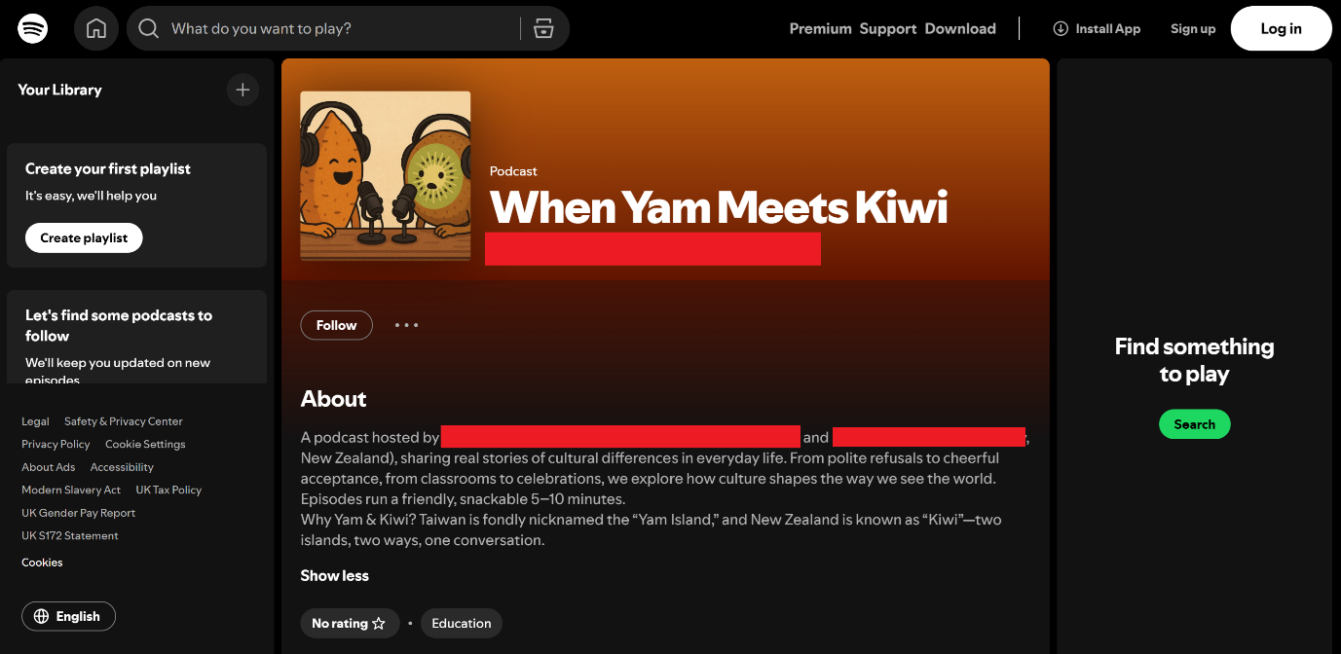

4) Dispositions
- Carried into the artefact: the clock taboo [G07_W2_26:59; G07_P1]; the homophone on which it rests is lost in English.
- Carried into the artefact: gift etiquette as the podcast’s theme, proposed by the NZ side [W1_56:51–58:11]; the yam and kiwifruit as national symbols on the cover [W7_06:39–07:23].
- Left in talk (45 items), e.g. couples not giving shoes, and the one-dollar return gift [W2_26:36–27:23]; in the final call, the NZ side said that what had stayed with them most was still “the shoe and the clock” [W7_50:03].
- Unnegotiated inclusion (5 items): (1) the Māori funeral terms tangi, whānau pani and koha; (2) presenting a gift with both hands, red wrapping and the avoidance of white; (3) sharp objects and green hats as gifts to avoid; (4) the numbers 8 and 4 in 紅包 (red envelopes); (5) kia ora and Aotearoa in the opening.

S5 Case G16: bilingual video podcast
1) Recorded calls
G16 held fifteen calls (W1a–W7c; two per week, with an additional recording session, W7c, in W7), with no week missing. The NZ member of this group migrated to New Zealand in their youth and speaks Chinese as a first language; language switching in the calls was largely led by this partner (Section 4.3).

Calls | Duration (min) | Cultural topic stretches (C1) | Artefact-planning stretches (C2)
W1 (a–b) | 46.8 | 7 | 10
W2 (a–b) | 53.9 | 13 | 4
W3 (a–b) | 54.1 | 4 | 2
W4 (a–b) | 58.5 | 6 | 5
W5 (a–b) | 52.3 | 6 | 14
W6 (a–b) | 61.4 | 15 | 28
W7 (a–c) | 82.3 | 2 | 75
Total | 409.3 | 53 | 138

2) The artefact
- Form: a bilingual video podcast, recorded in the final call [W7c], then edited and subtitled.
- Languages: the original arrangement had the TW side speaking mostly English and the NZ side mostly Chinese; because the NZ partner was fluent in Chinese, the group settled on the NZ side asking questions in Chinese and the TW side answering in English [W6a_12:02–13:37]. In addition, the two sides taught each other New Year greetings, the TW side in Taiwanese (Hokkien) and the NZ side in Māori [W7b_03:17–05:56].
- AI use: only one use was visible in the calls, namely drafting the closing with ChatGPT, which was read back and partly adopted [W6b_23:04–25:02]; there was no AI draft.
- Made in or outside the calls: the script structure was laid out in the W6a and W6b calls; each side wrote its lines outside the calls [W7b_00:43]; recording took place in a call.

3) Main topic thread: New Year and festivals
Stage | Source | Content
Emergence | G16_W1a_07:09 | The NZ side proposed New Year and Matariki (Māori New Year) as the topic of the artefact.
Development | G16_W1b_01:03; G16_W3a_14:44; G16_W4b_16:08–25:25 | Pomelos, mooncakes and barbecues at the Mid-Autumn Festival; Christmas in the New Zealand summer, with shopping malls still decorated with snowflakes and snowmen; gift-giving taboos and handwritten cards.
Proposed for the artefact | G16_W6a_12:02–29:00 | The bilingual allocation and speaking order were set, on the principle of ‘back and forth, not like a formal interview’ [21:45]; the NZ side asked the TW side not to say too much yet, ‘because I haven’t had a chance to introduce my two New Years’ [29:00].
Verification or revision | G16_W6b_11:10–26:50; G16_W7a_26:16 | The NZ side proposed dropping the Mid-Autumn Festival; the TW side countered with ‘our major festival’ and linked it to New Year through ‘reunion’ (團聚). Easter was raised and then questioned by the NZ side, and the decision to keep it was announced in W7a [W7a_26:16]. Before recording, the NZ partner noticed they had not spoken any Chinese and added some on the spot [W7b_06:03].
In the artefact | G16_W7b–W7c | Matariki is the programme’s central thread; Christmas in summer becomes “No snowmen, just sun, sand and Santa in shorts”; the Mid-Autumn barbecue and mooncakes are drawn on again.

Figure S7. G16 artefact: title card of the video podcast. Other frames are omitted to protect participant anonymity.
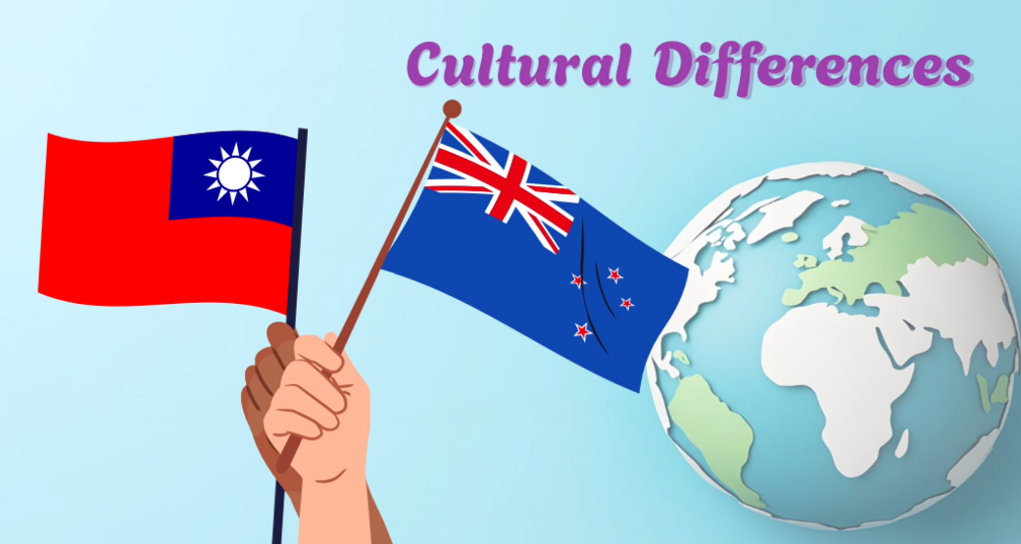

4) Dispositions
- Carried into the artefact: New Year and Matariki [W1a_07:09] and Christmas in summer [W3a_14:44]; Easter, kept after the NZ side had questioned it [W6b_26:50; W7a_26:16]; the Mid-Autumn Festival, retained after a proposal to drop it [W6b_11:10–13:06] (rationales: quality judgement, NZ side; appropriation, TW side); the ending on gratitude and reunion, written by the students from ideas supplied by ChatGPT, [W6b_23:04–25:02], the exchange of New Year greetings [W7b_03:17–05:56] and the opening kia ora [W7a_03:53].
- Left in talk (23 items), e.g. gift-giving taboos [W4b_16:58–17:33]; the TW side’s account was almost identical to that in G07, yet it did not enter the artefact; Thanksgiving and National Day, dropped after the NZ side said they are not celebrated in New Zealand [W6b_26:00]; rationale: authenticity check.
- Unnegotiated inclusion (3 items): (1) a pōhutukawa Christmas tree and jandals; (2) hot cross buns; (3) the wishing star Hiwa-i-te-rangi, none discussed in the calls.

