Branding
Here is a proposed brand identity for Kintsu, designed to embody the principles of "premium resilience" and the Kintsugi metaphor.

1. The Primary Logo: The Resilient Vessel
The core of the brand is a simple, powerful icon that immediately communicates the concept of being "broken but made whole."
- The Icon: A stylized ceramic vessel, visibly fractured but held together by a glowing vein of gold that forms a subtle 'K'.
- The Meaning: This represents the user's life and assets, which have been shattered by disaster. Kintsu is the golden binding agent that not only repairs the damage but makes the resulting record stronger and more valuable.
- The Typography: A clean, modern humanist sans-serif font that is professional, legible, and approachable.
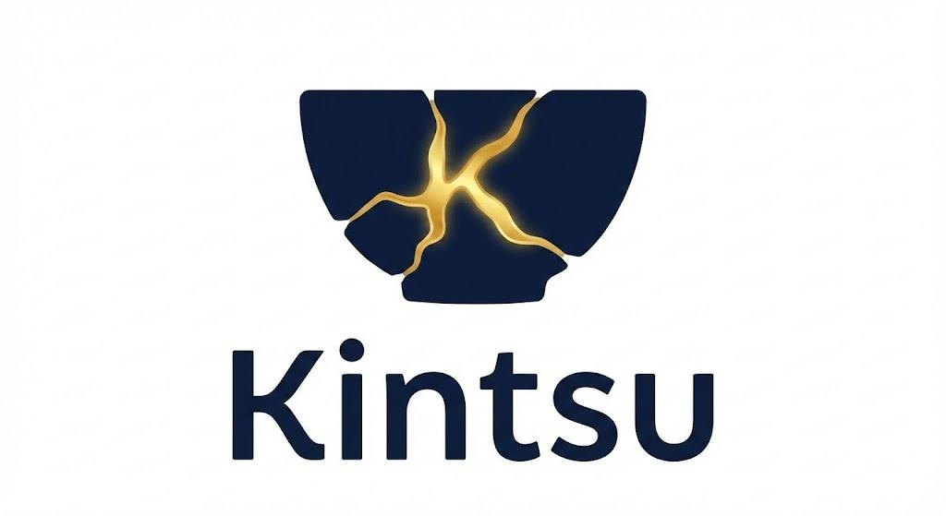

2. User Interface: The "Golden Mend" in Action
The Kintsugi metaphor is woven directly into the user experience. Progress isn't just a bar filling up; it's a visual representation of repair.

A. The Empty State
When a user starts an inventory for a new room, the screen shows a faint, broken outline of that room's icon. The progress bar at the bottom is a crack that is slowly being filled with liquid gold as tasks are completed. This provides a calming sense of progress and restoration.
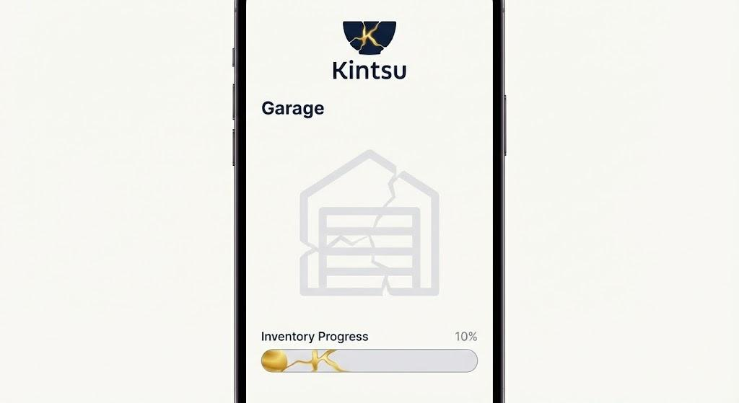

B. The Data Processing State
When the app's AI is working—for example, ingesting a raw data dump from the user's Google Drive—the screen displays a dynamic animation. Fragmented data shards float together and lock into place, sealed by a golden glow. This visualizes the app's core function: creating order from chaos.
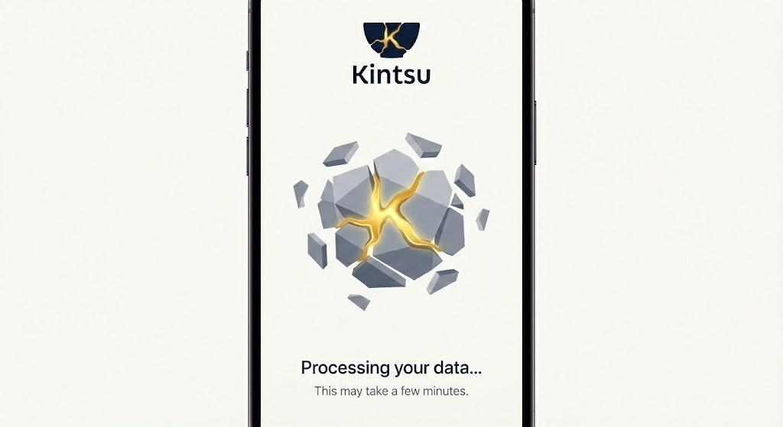

3. Brand Overview
This final image summarizes the complete Kintsu brand identity, showcasing how the logo, color palette, typography, and UI elements work together to create a cohesive, premium, and resilient aesthetic.
- Color Palette: Kintsugi Gold for value, Deep Trust Blue for security, Ash Grey for neutrality, and Off-White for a clean interface.
- Typography: A modern, legible sans-serif font for all text.
- Overall Feel: The identity is professional, empathetic, and hopeful, designed to build trust with a user in crisis.
