**EduWeek**

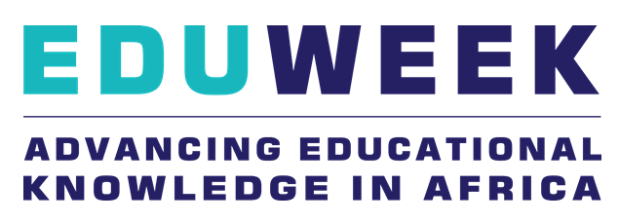

**EduWeek is the largest and most recognised African education event bringing together educational professionals across Educational Technology (E-Tech), Vocational & Higher Education, Basic Education, Inclusive Education and Early Childhood Development.**

**EduWeek offers the perfect platform in which to evaluate, see and buy new solutions for all education institution’s needs whilst attending free training sessions dedicated to your needs. Be at the forefront of Africa’s transformation by networking with leaders, strategic thinkers and entrepreneurs from across the globe.**