Welcome!
MBA2s, welcome to MMC’s Re-Recruiting Guide! A hub for resources, ideas-sharing and connection to past MBAs who have gotten through the other side. This guide includes examples of internship resume bullet points, links to resources, refresher on interviews, peer coaches, and more. If you have any feedback or questions, please don’t hesitate to reach out to mmc-presidents@umich.edu

How does re-recruiting work?

Timing
- Rolling basis!
- For some companies, it has already started but will continue throughout the year!

Avenues
- Ross Recruit - look for events and coffee chats!
- LinkedIn
- Fellow MBA2s who interned there (list of summer 2025 internships)
- Recruiters from last year - reach out to anyone you talked to during the recruitment season, especially places where you got offers!

Updating Resumes

CDO Resources
- Resume Writing
- Off Campus search guide

Resume bullet point examples

- Developed key growth strategies for Brand X $XM seasonal CATEGORY portfolio by leveraging internal, competitive, and consumer insights with projected increase in revenues of X% over the next X years
- Created a go-to-market strategy for BRAND X by utilizing insights gained from consumer interviews and focus groups to enable expansion into GEOGRAPHY
- Created marketing strategy plan for A PRODUCT LINE by incorporating price, place, and promotion tactics, projecting $X M additional net income
- Conducted target demographic analysis with cross-functional partners, identifying $X M household penetration opportunity and inspiring new communication messaging
- Led a company-wide Generation Z deep dive using data from X+ interviews, X+ survey respondents, IRI and Mintel research; presented findings to C-Suite
- Supported team with P&L management, day-to-day core category operations, packaging redesign, and competitive monitoring
- Analyzed & assessed competitive landscape to unlock a $XMM opportunity, resulting in consumer profiles, SWOT, and size-of-prize of X potential paths
- Delivered X-year strategy proposal to fight portfolio share loss in growing $XB subcategory, restaging current products and resulting in $XM projected impact or +xpts in share gains

MMC Resources

Education Sessions
MBA2s are invited and attendance is encouraged!!!

Curriculum Matrix
- 9/5/25: Getting Started with Recruiting
- 9/12/25: Preparing for Networking Success
- 9/19/25: The Marketing Interview
- 9/26/25: Casing 101: The 5Cs
- 10/3/25: Casing 101: The 4Ps
- 10/24/25: Casing 101: Performance/Hybrid Casing
- 10/31/25: Casing 101: Review
- 11/7/25: Casing 101: Market Sizing & Advertising Analysis
- 11/14/25: RCC 101
- 12/5/25: Interview Prep
- 12/12/25: Final Application Questions & Interview Prep

Other Resources
- Salary Database
- Interview Question Bank

Marketing Peer Coaches
YOU STILL GET 2 APPOINTMENTS PER WEEK - USE THEM!

Name & Summer Internship
Natalie Ricklefs    General Mills - Minneapolis | Jasmin Lopez  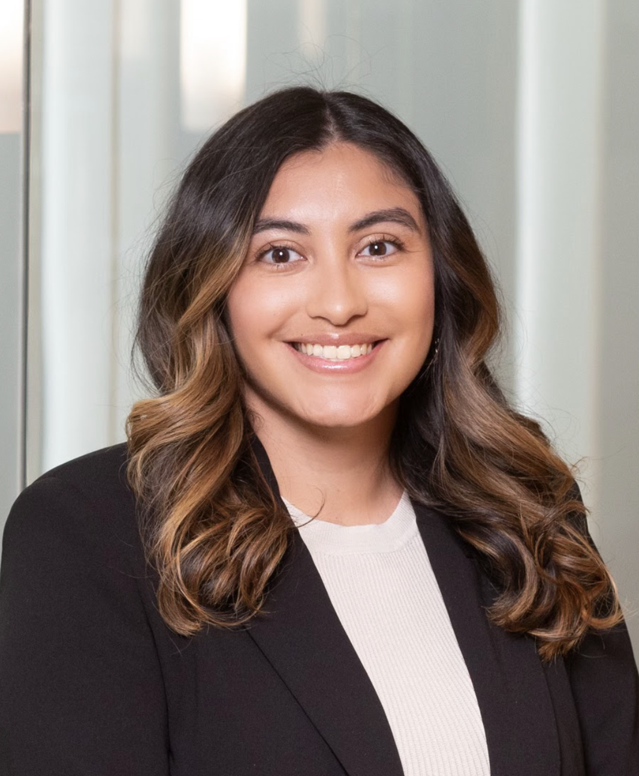  Procter & Gamble - Cincinnati
Jack May    PepsiCo - Chicago | Shivanee Shah    General Mills - Minneapolis
Rahul Narain



Nike - Beaverton

More Words of Wisdom from Alumni

Jess Drossner - Class of 2023 - Clorox Company
- If you want to go the on-campus route, start networking and looking for open applications as soon as possible.
  - As you probably know, it starts early. Be proactive and persistent with your contacts and leverage the existing relationships you created last year.
- A lot of companies (if they weren't actively hiring on-campus) were open to conversations but said they wouldn't have a sense for hiring needs until the spring.
  - While I ended up getting an offer in the fall and taking it, I had a few of those connections reach back out come spring without prompting, so there are definitely options if you're willing to be patient. Know yourself and your appetite for risk.
- Take some time to reflect on your internship experience and what you ultimately want. I had multiple people ask me 'so do you still want to do brand management after this, or are you switching gears?' which was a valid question with good intentions, but made me doubt myself and my path for a bit.
  - Ultimately, despite not getting a return offer from my internship, I didn't give up on what I wanted, which was to pursue brand mgt, and I'm so happy I didn't give up because I'm very happy in my current role. Basically, don't let a bump in the road or an imperfect internship stop you from going after what you genuinely want. And upon reflection, if what you want is something else entirely, that's also great!
- Although it can be an awkward conversation, obviously be prepared to have an answer to why you are not returning to ___ company that you interned at. I workshopped my response with some peers and with CDO.
  - I don't think there's a right way to speak about it, but I remained focused on the positive and what I learned from my internship that I would take forward with me, and what I was super excited about for x company you're interviewing with.
- Leverage your re-recruiting peers!!!! Practice casing together, commiserate together - you will get through it together!
- Remember that rejection is *redirection*, as cheesy as that might sound! That mentality really helped me and I genuinely believe it!

Other words of wisdom
- Market your own story! If you didn’t like your internship/ didn’t get a return, spin it your way. Why is the company you are re-recruiting even better? Why would you rather be there? You’re a marketer— storytelling is your forte.
  - Personally, re-recruiting worked out for me—I ended up at a company that I am very happy at and it will work out for you too. That’s not to say it wasn’t hard work. I had to miss the famous MMC Halloween Party for a final round interview, but it was worth it!
- Worry less about the resume, cover letter, etc. and more about the conversations with people. Ask good questions, be prepared to tell your stories. Stay concise, curious, and hungry.
- Keep your head up! This is your own journey, do not compare it to anyone else’s. You have plenty of time to find your next role. Keeping a positive attitude and knowing your self-worth is essential.

