Matplotlib

What is Data visualization?

* Data visualization is a quick, easy way to convey concepts in a universal manner
* Data visualization is the graphical representation of information and data.
* Visual elements like charts, graphs, and maps, data visualization tools provide an accessible way to see and understand trends, outliers, and patterns in data

#Type of data visualization in python

* Matplotlib: Low level, provides lots of freedom.
* Pandas visualization: easy to use interface, built on matplotlib
* Seaborn: High-level interface, great default styles.
* Ggplot: Based on R’S ggplot2, uses grammar of graphics.
* Ploty: can create interactive interface plots.

What is Matplotlib?

* Matplotlib is a plotting library for the python programming languages and its numerical mathematics extension Numpy.
* Matplotlib is a python library used for Data visualization
* Matplotlib is a 2D and 3D plotting python library
* It was in traduced by john hunter in the year 2002

#Matplotlib graphs

* Linear plot
* Scatter plot
* Bar plot
* Stem plot
* Hist plot
* Box plot
* Pie plot
* Fill_Between plot

#Matplotlib line plot

Syntex:

Import matplotlib as plt

X=[]

Y=[]

Plt.bar(x,y)

Plt.show()

#CODE

import matplotlib.pyplot as plt

x=["python","c","c++","java"]

y=[85,70,60,82]

plt.xlabel("languages",fontsize=15)

plt.ylabel("No",fontsize=15)

c=["y","b","m","g"]

plt.bar(x,y,width=0.4,color=c,align="center",edgecolor='r',linewidth=5)

plt.show

output:

<function matplotlib.pyplot.show(close=None, block=None)>

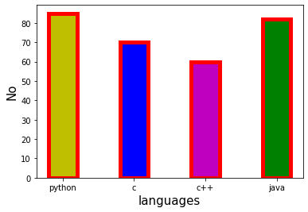

#CODE

x=["python","c","c++","java"]

y=[85,70,60,82]

z=[20,30,40,50]

plt.xlabel("languages",fontsize=15)

plt.ylabel("No",fontsize=15)

plt.bar(x,y,width=0.4,color='r')

plt.bar(x,z,width=0.4,color='b')

plt.show

output:

<function matplotlib.pyplot.show(close=None, block=None)>

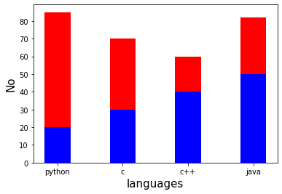

Showing two graphs side by side

#CODE

import matplotlib.pyplot as plt

import numpy as np

x=["python","c","c++","java"]

y=[85,70,60,82]

z=[20,30,40,50]

width=0.2

p=np.arange(len(x))

p1=[j+width for j in p]

plt.xlabel("langage",fontsize=15)

plt.ylabel("no",fontsize=15)

plt.title("Beast",fontsize=15)

plt.bar(p,y,width,color="r",label="popularity")

plt.bar(p1,z,width,color="y",label="popularity1")

plt.xticks(p+width/2,x,rotation=20)

plt.legend()

plt.show()

output:

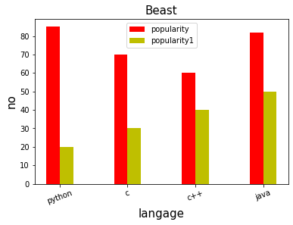

#Horizontal bar graph

#CODE

import matplotlib.pyplot as plt

import numpy as np

x=["python","c","c++","java"]

y=[85,70,60,82]

z=[20,30,40,50]

plt.xlabel("langage",fontsize=15)

plt.ylabel("no",fontsize=15)

plt.title("Beast",fontsize=15)

plt.barh(p,y,width,color="r",label="popularity")

plt.barh(p1,z,width,color="y",label="popularity1")

plt.legend()

plt.show()

output:

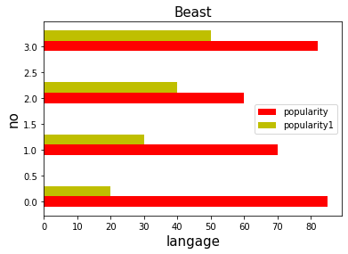

N/A