. Data visualization Library

Importing the libraries

import seaborn as sns

import matplotlib.pyplot as plt

import numpy as np

import pandas as pd

#total bill vs tip dataset

tips=sns.load_dataset('tips')

tips.

|  | **total_bill** | **tip** | **sex** | **smoker** | **day** | **time** | **size** |
| --- | --- | --- | --- | --- | --- | --- | --- |
| **0** | 16.99 | 1.01 | Female | No | Sun | Dinner | 2 |
| **1** | 10.34 | 1.66 | Male | No | Sun | Dinner | 3 |
| **2** | 21.01 | 3.50 | Male | No | Sun | Dinner | 3 |
| **3** | 23.68 | 3.31 | Male | No | Sun | Dinner | 2 |
| **4** | 24.59 | 3.61 | Female | No | Sun | Dinner | 4 |

()

#setting a theme for the plots

sns.set_theme()

#visualize the data

sns.relplot(data=tips,x='total_bill',y='tip',col='time',hue='smoker',style='smoker',size='size')

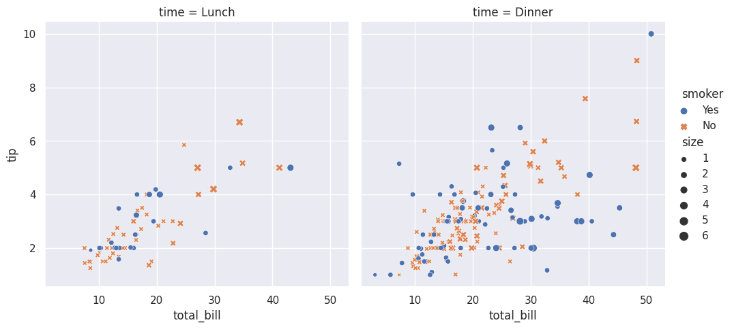

#load the iris dataset

iris=sns.load_dataset('iris')

|  | **sepal_length** | **sepal_width** | **petal_length** | **petal_width** | **species** |
| --- | --- | --- | --- | --- | --- |
| **0** | 5.1 | 3.5 | 1.4 | 0.2 | setosa |
| **1** | 4.9 | 3.0 | 1.4 | 0.2 | setosa |
| **2** | 4.7 | 3.2 | 1.3 | 0.2 | setosa |
| **3** | 4.6 | 3.1 | 1.5 | 0.2 | setosa |
| **4** | 5.0 | 3.6 | 1.4 | 0.2 | setosa |

sns.scatterplot(x='sepal_length',y='petal_length',hue='species',data=iris)

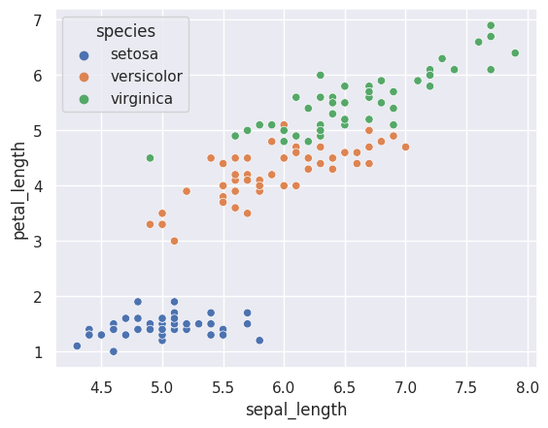

#loading the titanic dataset

titanic=sns.load_dataset('titanic')

titanic.head()

|  | **survived** | **pclass** | **sex** | **age** | **sibsp** | **parch** | **fare** | **embarked** | **class** | **who** | **adult_male** | **deck** | **embark_town** | **alive** | **alone** |
| --- | --- | --- | --- | --- | --- | --- | --- | --- | --- | --- | --- | --- | --- | --- | --- |
| **0** | 0 | 3 | male | 22.0 | 1 | 0 | 7.2500 | S | Third | man | True | NaN | Southampton | no | False |
| **1** | 1 | 1 | female | 38.0 | 1 | 0 | 71.2833 | C | First | woman | False | C | Cherbourg | yes | False |
| **2** | 1 | 3 | female | 26.0 | 0 | 0 | 7.9250 | S | Third | woman | False | NaN | Southampton | yes | True |
| **3** | 1 | 1 | female | 35.0 | 1 | 0 | 53.1000 | S | First | woman | False | C | Southampton | yes | False |
| **4** | 0 | 3 | male | 35.0 | 0 | 0 | 8.0500 | S | Third | man | True | NaN | Southampton | no | True |

sns.countplot(x='class',data=titanic)

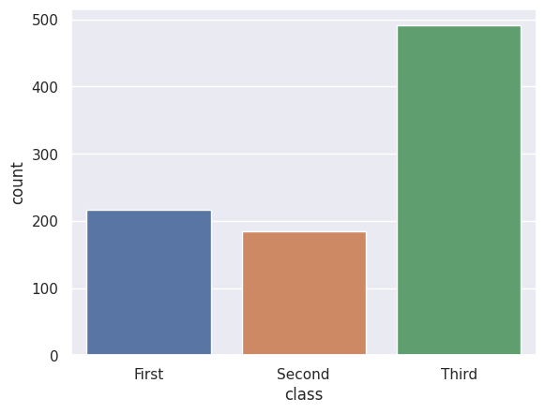

sns.countplot(x='survived',data=titanic)

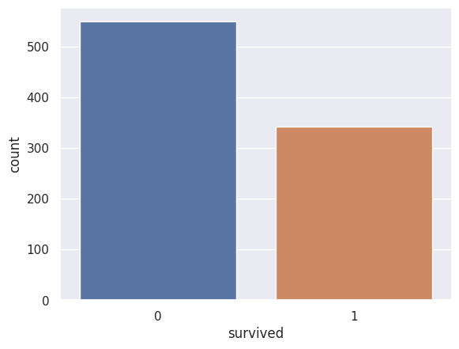

sns.barplot(x='sex',y='survived',hue='class',data=titanic)

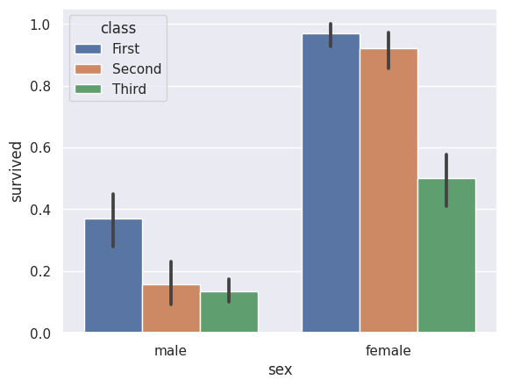

sns.distplot(titanic['fare'])

