Algorithm:
An algorithm is a well-defined computational procedure that takes some value, or set of values, as input and produces some value, or set of values, as output.
Algorithm is a finite number of computational statements that transform input into the output
For example,
- given the input sequence (31; 41; 59; 26; 41; 58), a sorting algorithm returns as output sequence (26; 31; 41; 41; 58; 59).
- Such an input sequence is called an instance of the sorting problem.
In summary, "sorting" is the broad problem, while "(31; 41; 59; 26; 41; 58)" is a single, concrete example—an instance—that an algorithm can be tested on.

An Algorithm is evaluated using these 4 points:
1. Completeness:
- An algorithm is complete if it always finds a solution when one exists.
- Example: In path-finding, a complete algorithm always finds a path if there is one.
2. Optimality:
- An algorithm is optimal if the solution it finds is the best among all possible solutions (according to some measure, like minimum cost, shortest path, maximum profit, etc.).
- Example: Dijkstra’s algorithm is both complete and optimal for shortest path (with non-negative weights).
3. Time Complexity:
- Measures how much time an algorithm takes as a function of input size n.
- Expressed in asymptotic notation like O(n), O(n²), O(log n).
- Example: Linear search → O(n), Binary search → O(log n).
4. Space Complexity:
- Measures how much extra memory (RAM/storage) the algorithm uses apart from the input itself.
- Includes:
  - Fixed part (constants, program size)
  - Variable parts (stack/heap usage, recursion, temporary storage)

**Correct Algorithm: For every valid input, it produces the expected output. It halts in finite time (does not run forever).
**Incorrect Algorithm: It gives a wrong result for some inputs. It fails to terminate (goes into infinite loop). It does not follow the problem’s specifications.
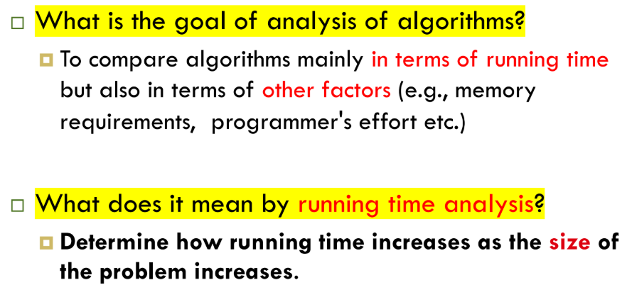
Time complexity, expressed using Big O notation, describes how the runtime of an algorithm scales with the size of its input. It doesn't measure the exact time in seconds, but rather the rate of growth of operations as the input size (n) increases. The most significant difference between various time complexities is how rapidly their runtime increases as the input size grows.
Analysis Of Algorithm:
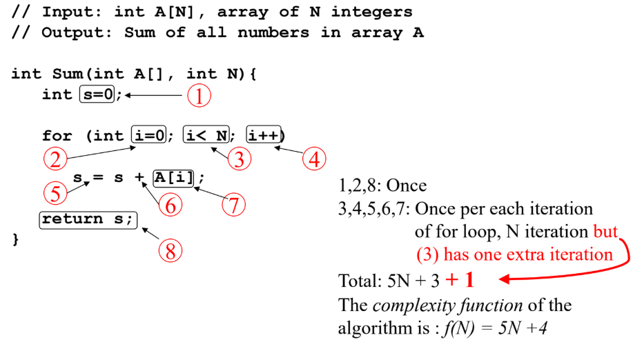

Constant Time:
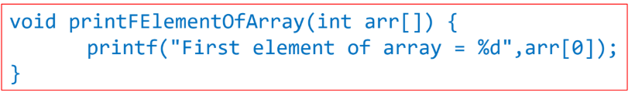
This function runs in O(1) relatives to its input
Constant Time Statements:
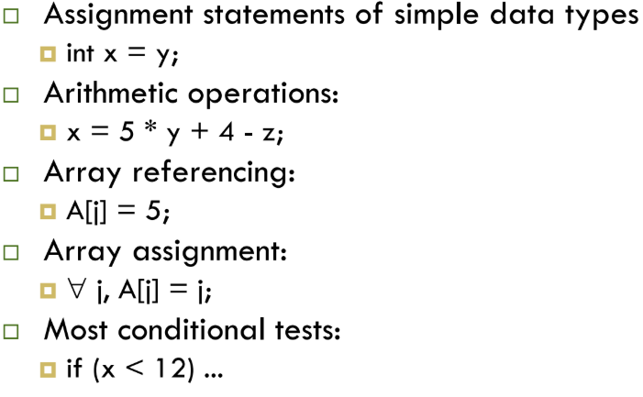
Example2:
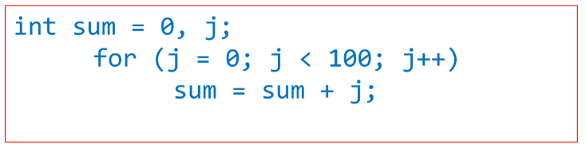
Loop executes 100 times and O(1) times per iterations Total Time is 100*O(1) = O(1*100) = O(100) = O(1).
- Variable Initialization: int sum = 0, j; is a single step.
- For Loop Initialization: j = 0; is executed once.
- For Loop Condition Checks: j < 100; is checked 101 times (100 times to execute the loop, and once to terminate it).
- For Loop Increment: j++; is executed 100 times.
- Loop Body Execution: sum = sum + j; is inside the loop and runs 100 times. Each execution consists of:
  - An addition operation (sum + j).
  - An assignment operation (sum = ...). This means the loop body accounts for 2 operations/step×100 executions=200 total steps.
Linear Time:
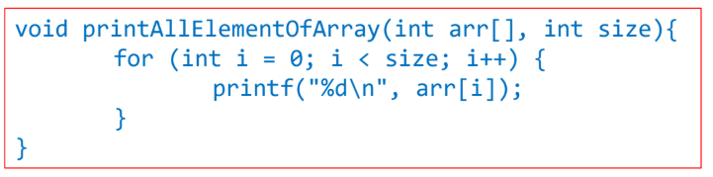
This function runs in O(n) times relative to its input (n), where n is the number of items in the array. The runtime is directly proportional to the input size. As N increases, the time taken increases linearly.

Quadratic Time:
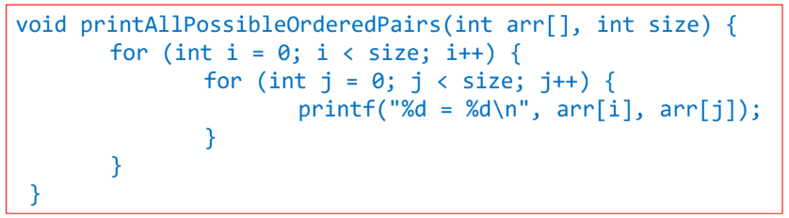
This function runs O(n²) time relative to its input, where n is the number of items in the outer array and n for the inner array. When ever there is a nested loop then the T.C will be O(n²).
The runtime is proportional to the square of the input size. This often occurs with nested loops where each element is compared with every other element.
- Example: Simple sorting algorithms like Bubble Sort, Selection Sort, or Insertion Sort.
An algorithm takes 10 seconds to sort a list of 100 elements. If the algorithm has an O(n2) time complexity, approximately how long will it take to sort a list of 200 elements?
Since the input size is doubled from 100 to 200, the runtime for an O(n2) algorithm will increase by a factor of 2²=4. Therefore, the new time will be approximately 10×4=40 seconds.
An algorithm has a time complexity of O(n2). If an input of size n=100 takes 5 seconds to run, approximately how long will it take to run an input of size n=400?
Increasing the input size by a factor of 4 (from 100 to 400) for an O(n2) algorithm means the runtime will increase by a factor of 4²=16. The new runtime will be approximately 5*16=80 seconds.

Exponential Time:
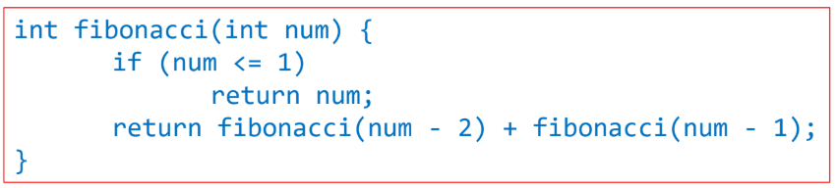
Recursive functions have O(2^{n}) Time Complexity. The runtime doubles with each addition to the input size. These algorithms are extremely inefficient and impractical for anything but very small inputs.
The growth curve of recursive functions are exponential.
Logarithmic Time:
An algorithm has logarithmic time complexity if the amount of work it does is proportional to the logarithm of the input size. The runtime grows very slowly as the input size increases. This is typical of algorithms that repeatedly halve the input data.
In simple words:
The input size reduces/increases exponentially by a constant factor (usually half/double) in each step.
Logarithmic time has the most efficient growth rate for large values of n as it grows slower than all other common complexities for large inputs, making it the most efficient.
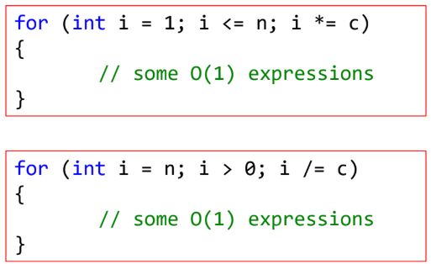
Algorithm that runs in log(n₂):
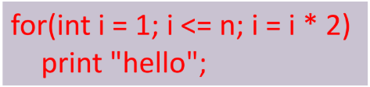
Algorithm that runs in log(n₃):
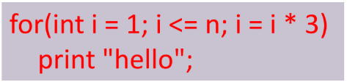
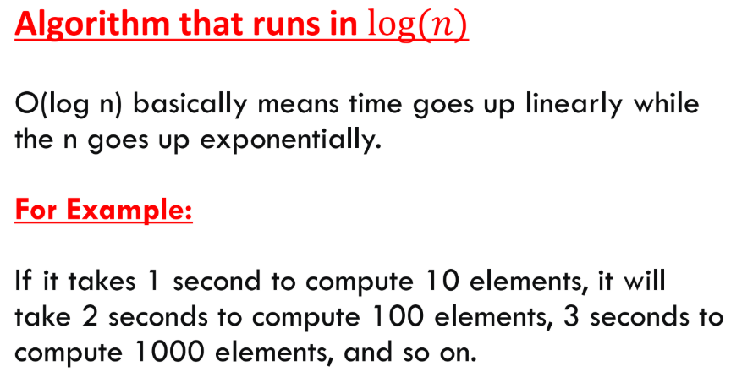
Examples of O(log n) Algorithms
- Binary search on a sorted array. With each step, the search space is cut in half.
- Balanced Binary Search Tree (BST) Operations
- Divide and Conquer Algorithms
- Heap Operations
Linearithmic Time
The runtime grows faster than linear but slower than quadratic. It's a very common and efficient complexity for many sorting algorithms.
- Example: Efficient sorting algorithms like Merge Sort and Quick Sort.
- Time vs. Input Size: If the input size doubles, the runtime is slightly more than double.
An algorithm has a time complexity of O(nlogn). If it takes 20 seconds to run on an input of size n=1,000, what would be a reasonable estimate for its runtime on an input of size n=2,000?
When the input size is doubled, an O(nlogn) algorithm's runtime will increase by a factor slightly greater than 2. The new runtime is approximately 20*(1000 log10​(1000) / 2000 log10​(2000))​=20*2*33.3​ ≈ 44 seconds.
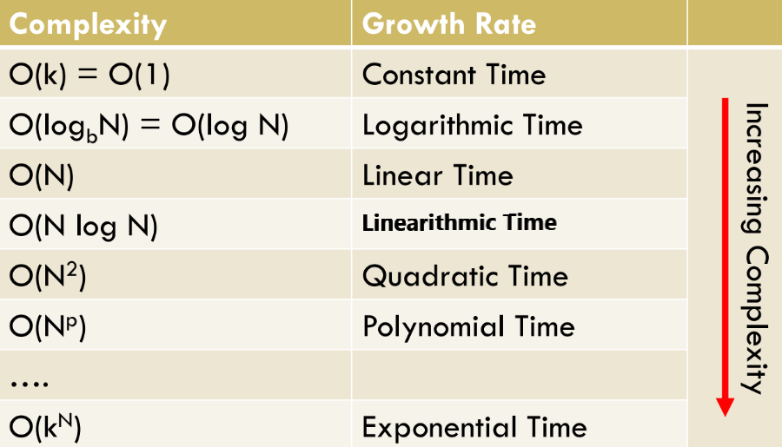
Comparative Analysis of T.C:
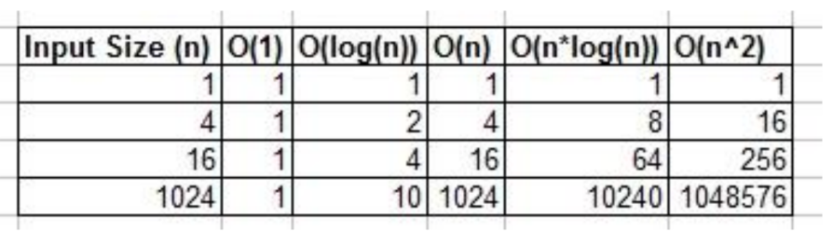
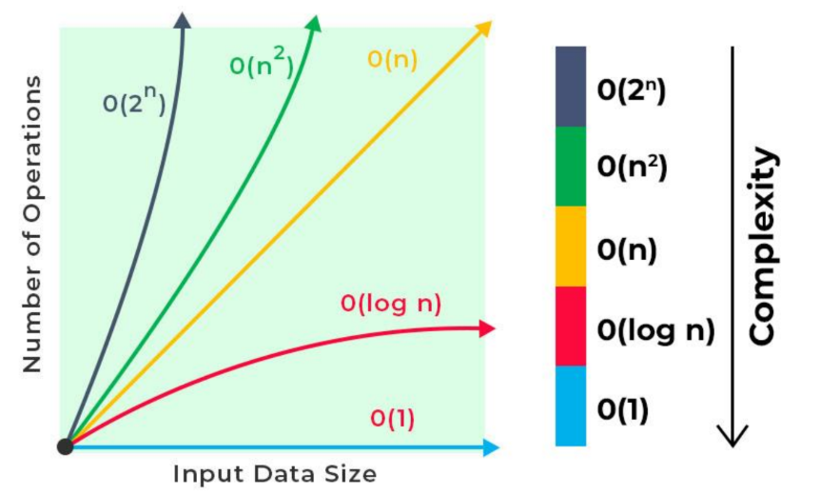
Important Step While Calculating T.C:
1. Drop the Constants:
When we analyze time complexity, we are interested in the asymptotic growth of the function as input size n.
- Small details like constants or lower-order terms don’t matter in Big-O.
- Example: If T(n) = 3n² + 5n + 20 → we drop 5n + 20 and write O(n²).
Dropping constraints (constants & lower-order terms) is important while calculating time complexity, because:
- It simplifies analysis.
- It highlights the true growth rate.
- It allows us to compare algorithms effectively.
2. Drop the Less Significant Terms:
When analyzing algorithms, we often write the runtime as a function like:
T(n)=an²+bn+c
- The most significant item is the one that grows fastest as n increases.
- The less significant items (constants and smaller-order terms) become negligible for large inputs.
So, we drop them to focus only on the dominating term.
Example:
T(n) = 3n²+7n+50T(n)
- For small n → all terms matter.
- For large n → n² dominates.
Drop less significant items → O(n²).
