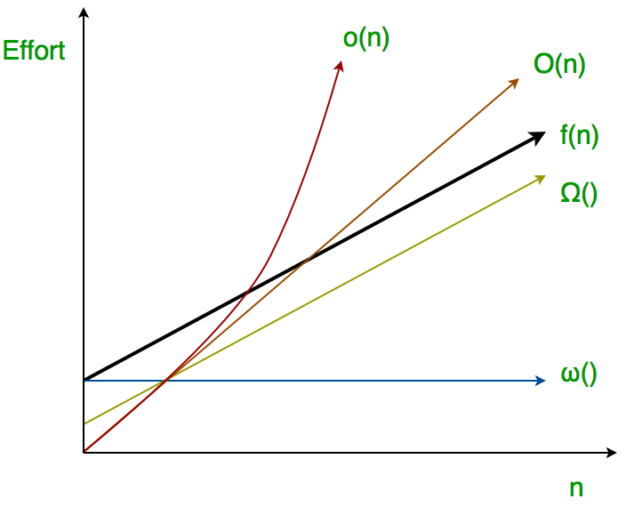
Asymptotic notations
Asymptotic notations are the notations that are used to describe the behavior of the time or space complexity. Let us represent the time complexity and the space complexity using the common function f(n).
- ➢ O (Big Oh notation)
- ➢ Ω (Omega notation)
- ➢ θ (Theta notation)
- ➢ o (Little Oh notation)
- ➢ ω (Little Omega notation)

Types of Analysis:
1. Worst-Case Analysis
- Definition: The maximum time (or space) an algorithm can take for any input of size n.
- Why important? It gives a guarantee that the algorithm will never take longer than this time.
- Notation: Big-O.
- Example:
  - Linear Search → O(n) (if the element is not found until the last position or not present).
  - QuickSort → O(n²) (if pivot is always the smallest/largest element).
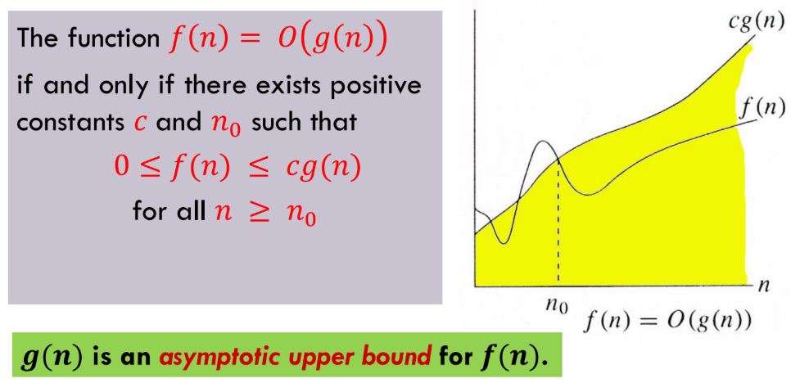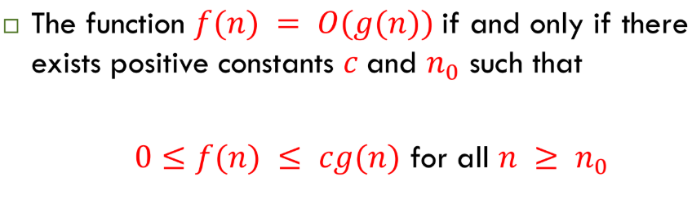
The expression f(n) = O(g(n)) refers that f(n) grows slower than c*g(n) for all values of n >= n0.
- f(n): This represents the actual runtime function of your algorithm. For example, if an algorithm's runtime is 5n+3, then f(n)=5n+3
- g(n): This represents a function that you're using to categorize f(n). It's a simpler, more generalized function like n, n², or log(n). Which establishes that g(n) is an asymptotic upper bound for f(n).
- O(g(n)): This is read as "Big O of g(n)" and indicates that g(n)is an asymptotic upper bound for f(n). In simpler terms, it means that for large enough n, f(n) will grow no faster than g(n) (up to a constant factor).
- c (a positive constant): This constant scales g(n) to ensure it's always greater than or equal to f(n). We need this constant because Big O notation ignores constant factors. For example, an algorithm with a runtime of 5n and another with a runtime of 100n are both considered O(n). The constant C accounts for the difference.
- n0​ (a positive constant): This is the threshold for the input size. The relationship f(n) ≤ cg(n) only needs to hold true for all values of n that are greater than or equal to n0​. This is because Big O notation is concerned with the long-term growth rate of the function as n approaches infinity, not its behaviour for small input sizes. The behaviour for small values of n is often dominated by factors that aren't relevant to the algorithm's asymptotic efficiency.

Example
- Let's use the example where f(n)=3n+5. We want to show that this is O(n). So, g(n)=n.
- We need to find constants c and n0​ such that 3n+5≤c*n for all n≥n0​.
- Let's try to find a suitable value for c. If we choose c=4, our inequality becomes: 3n+5≤4n
- Now, we solve for n to find the threshold n0​:
- 5≤4n−3n becomes 5≤n
- So, we can choose n0​=5. This proves that for c=4 and n0​=5, the condition 3n+5≤4n holds true for all n≥5. Therefore, 3n+5=O(n)
Question: Given the function f(n)=5n+10, prove that f(n)=O(n) by finding a valid pair of positive constants (c, n0) that satisfy the definition 5n+10≤cn for all n≥n0?
Answer: For c=6 and n0​=10, the inequality is 5n+10≤6n. Subtracting 5n from both sides gives 10≤n. This holds true for all n≥10. Therefore, these values are valid.

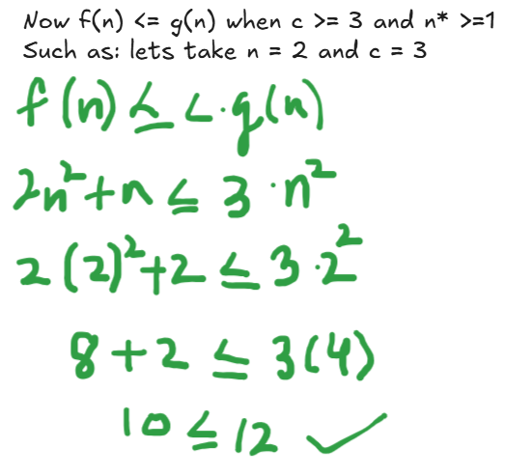
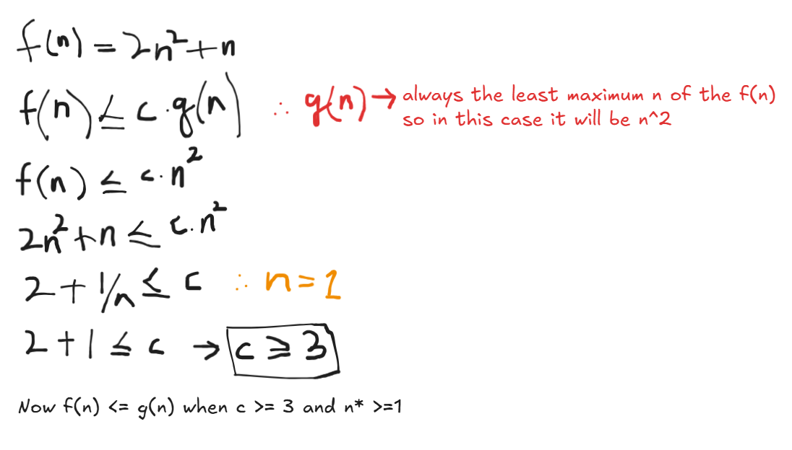
Calculating Worst Case Time Complexity

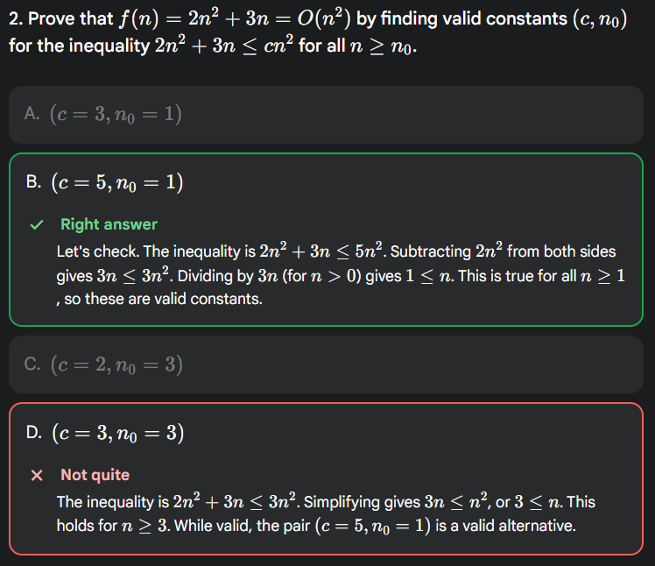
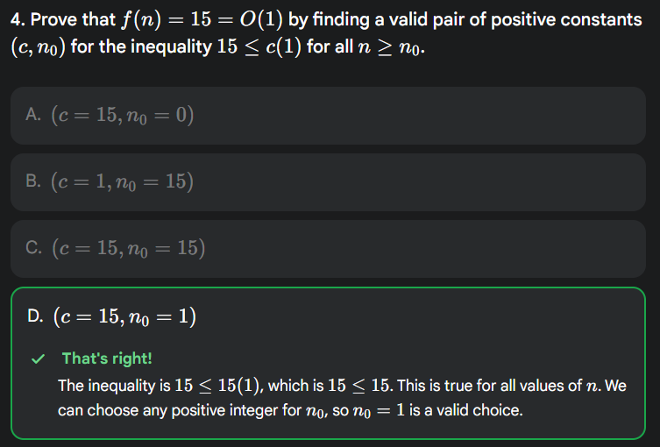
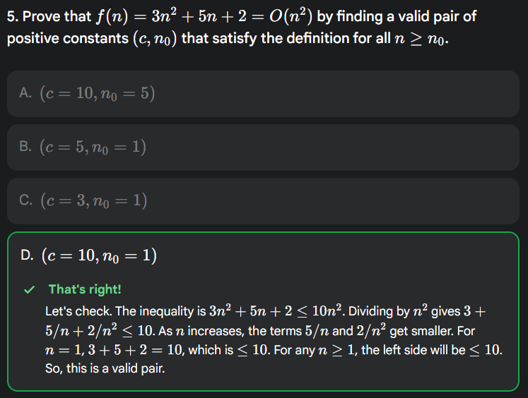
Or simply just assume n = 1, and solve for c.
2. Best-Case Analysis
- Definition: The minimum time an algorithm takes for any input of size n.
- Why important? It shows the fastest the algorithm can possibly run, but it’s often not very useful alone.
- Notation: Big-Omega (Ω).
- Example:
  - Linear Search → Ω(1) (if the element is the first one).
  - QuickSort → Ω(n log n) (if pivot always divides array equally).
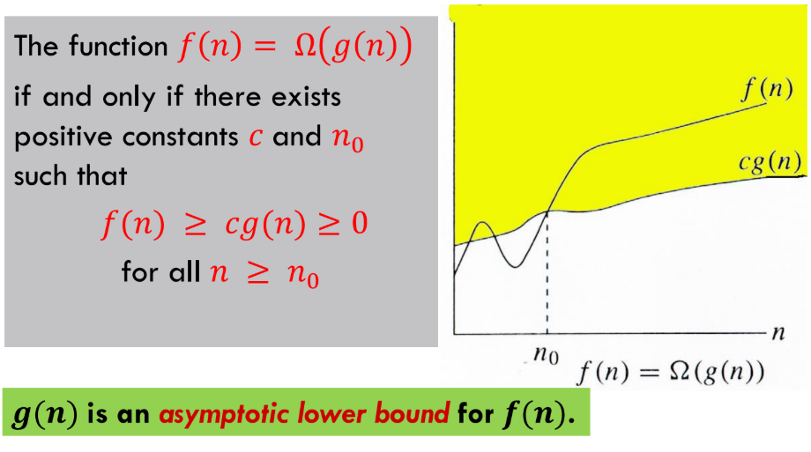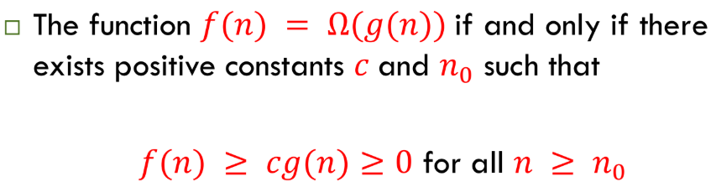
The expression f(n) = Ω(g(n)) refers that f(n) grows faster than c*g(n) for all values of n >= n0.
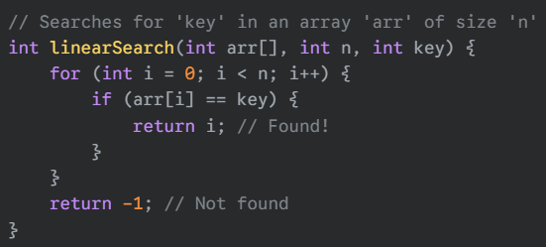
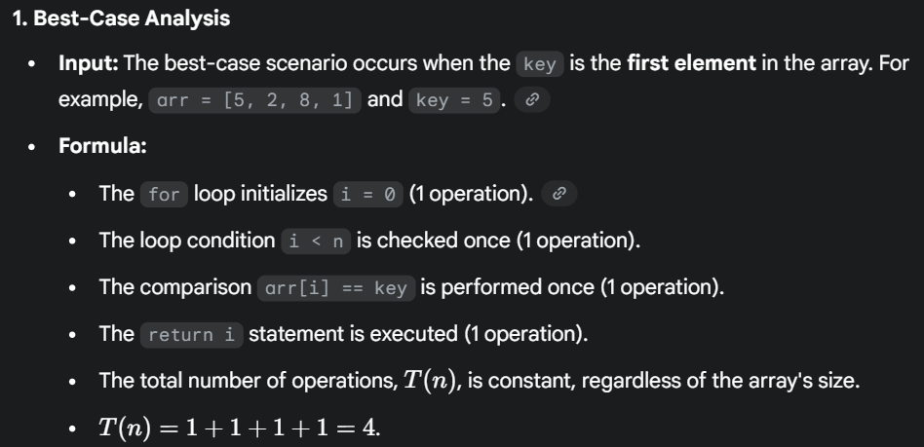
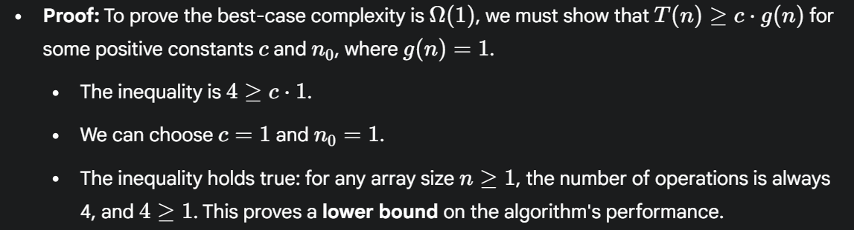
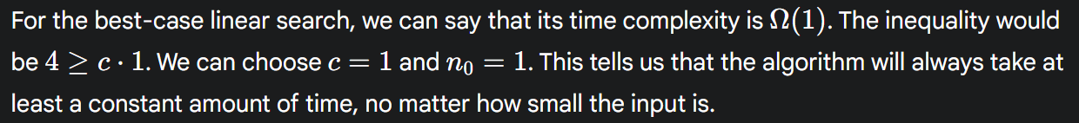
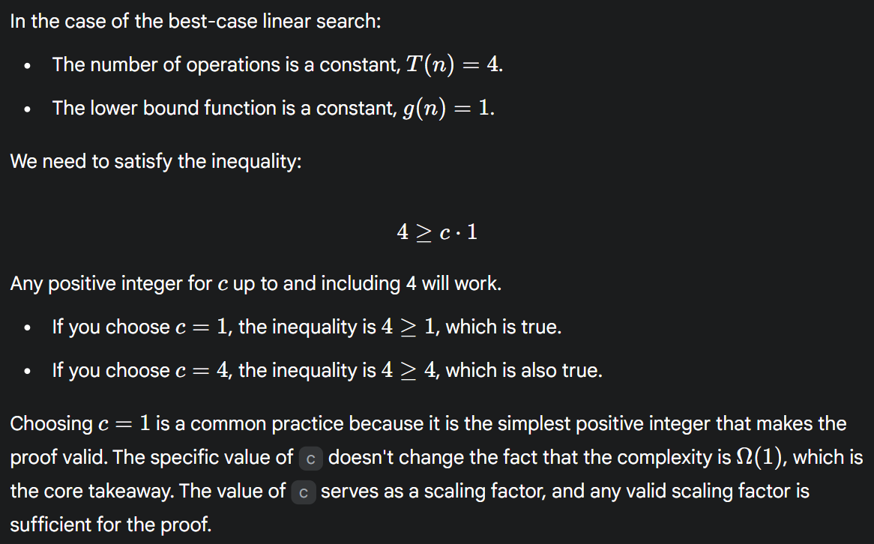
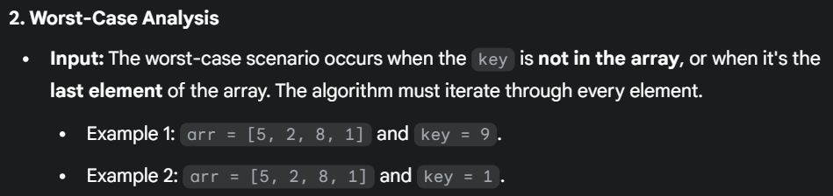
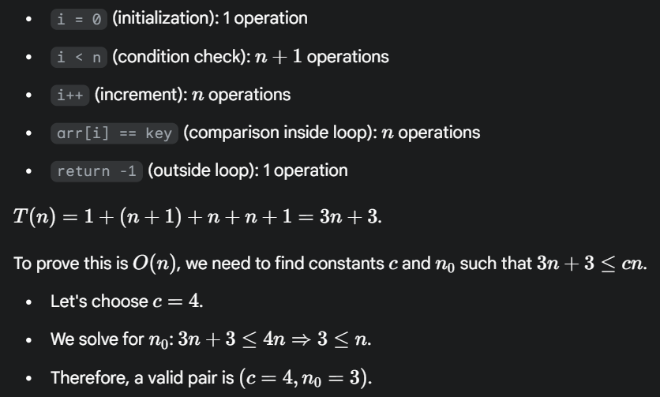
For the worst-case linear search, the constant c can be any value greater than or equal to 4.
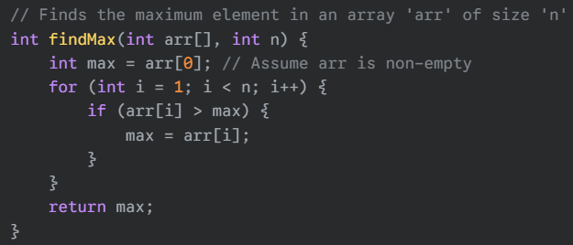
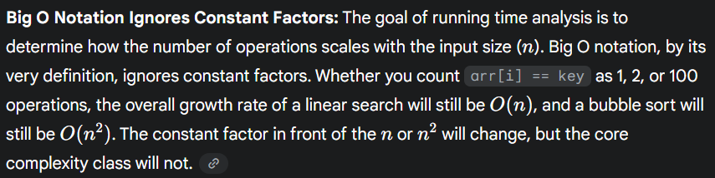
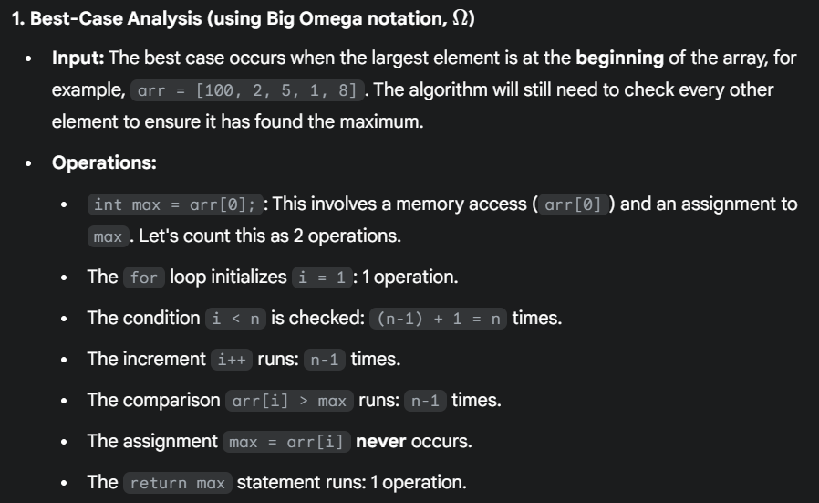
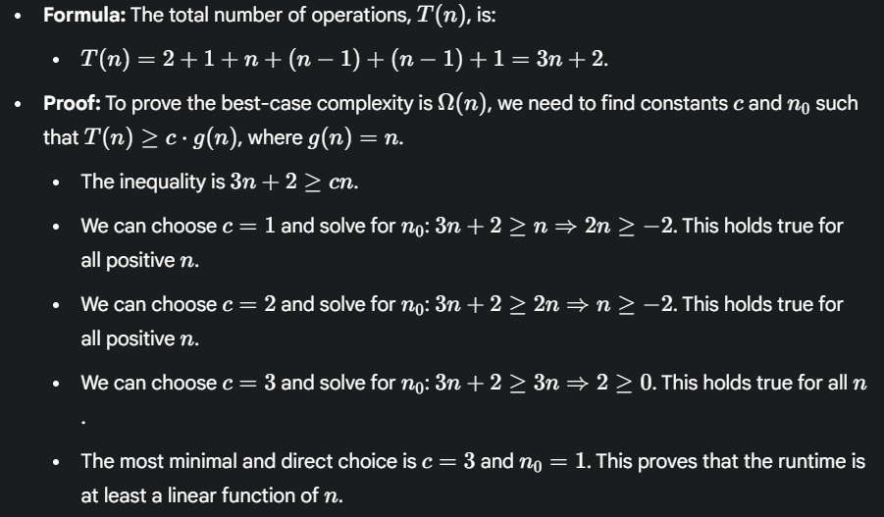
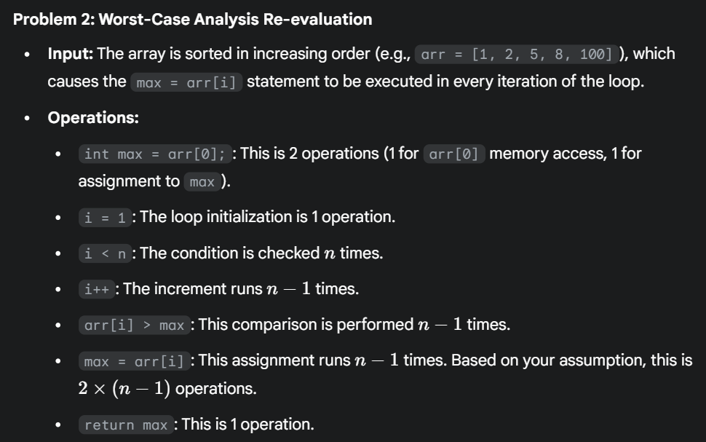
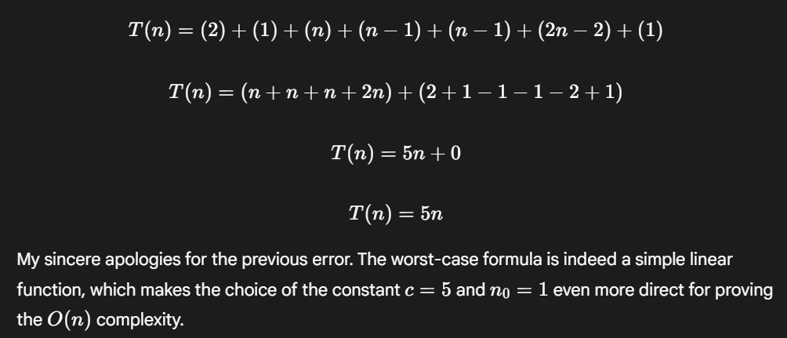
3. Average-Case Analysis
- Definition: The expected time for an algorithm over all possible inputs of size n, assuming a certain probability distribution of inputs.
- Why important? Gives a realistic measure of performance in practice.
- Notation: Big-Theta (Θ).
- Example:
  - Linear Search → Θ(n) (on average, element found halfway).
  - QuickSort → Θ(n log n) (on average, pivot divides array reasonably well).
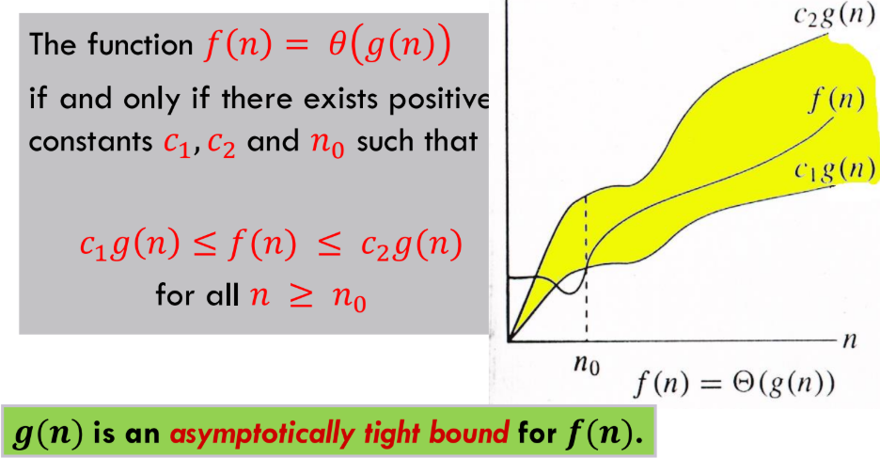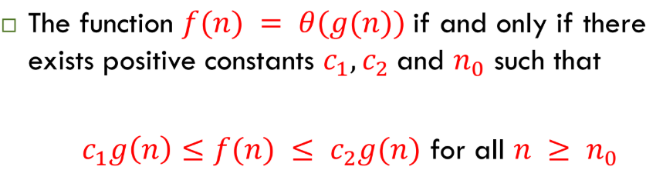
The expression f(n) = Θ(g(n)) refers that f(n) grows faster than c1*g(n) and slower than c2*g(n) for all values of n >= n0.
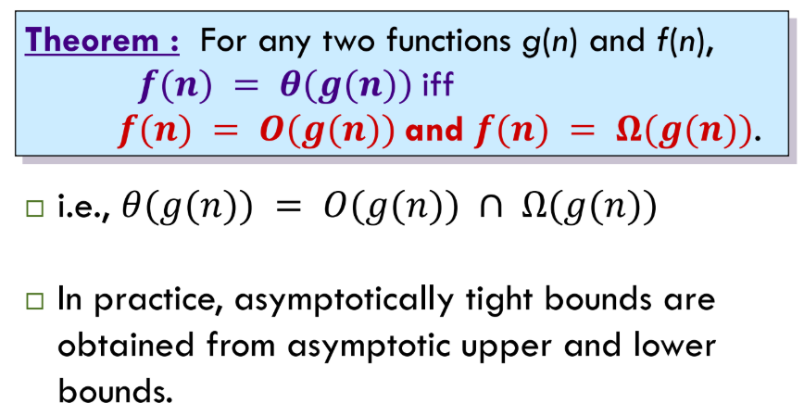
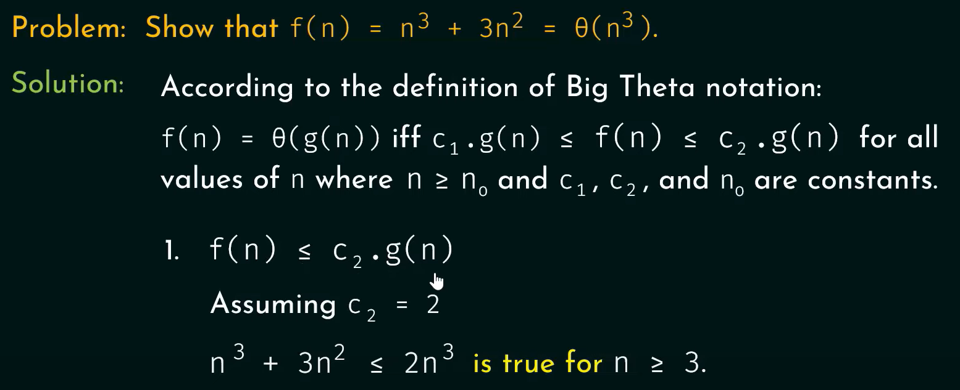
It is true because subtracting n^3 from both sides gives => 3n^2 <= n^3 then dividing both sides by n^2 which gives 3 <= n.
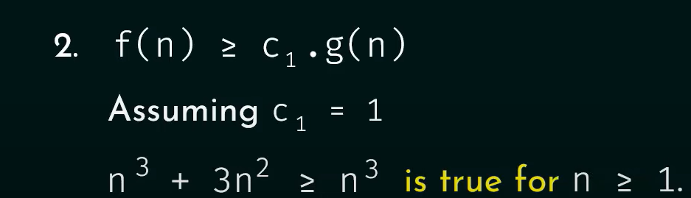
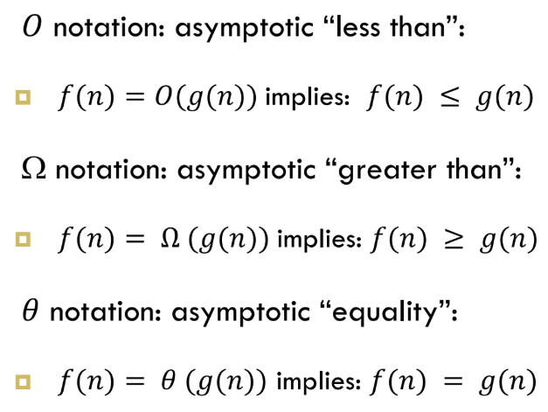
Little Oh Notation o(n)/o(n²),.. :
- Little o gives a strict upper bound.
- It means the function grows slower than the bound, not equal.
- Think of it as: “f(n) grows strictly slower than g(n), no matter what constant you multiply g(n) with.”
- f(n) < c*g(n) unlike Big Oh where f(n) <= c*g(n)
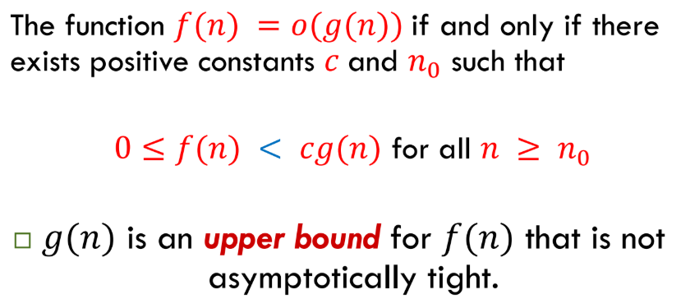
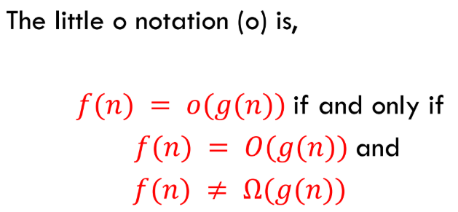
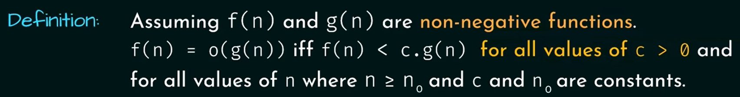
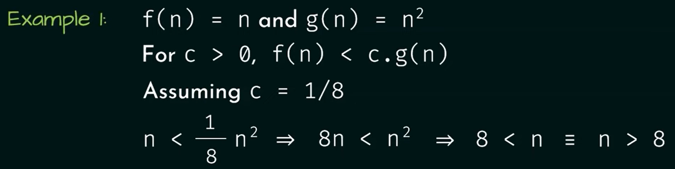
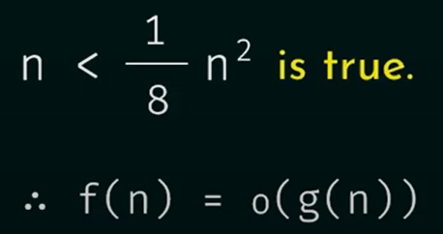
The inequality is true for c = 1/8 & n0 = 9.
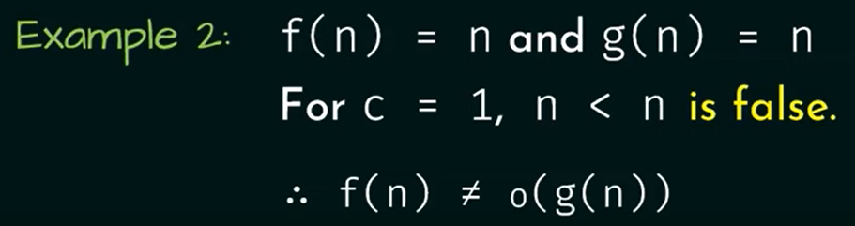
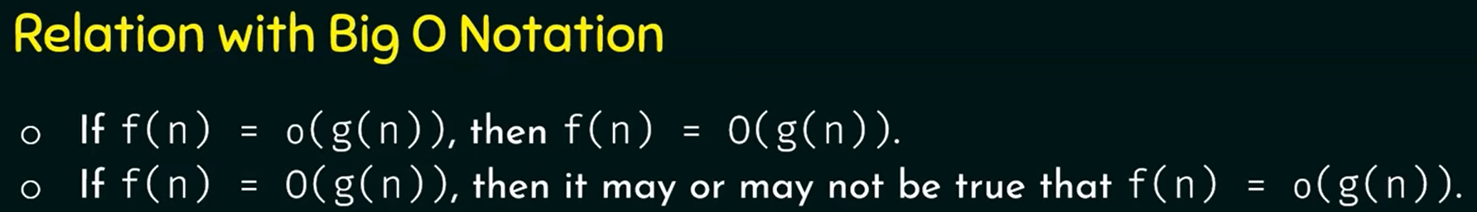
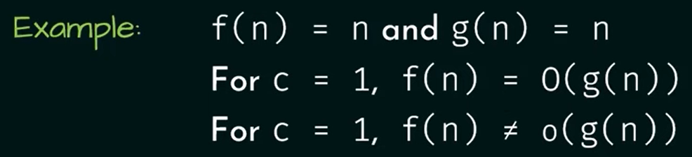
We cannot take higher value of c just to prove that this is true because the inequality of little oh must be true for all values of c.
Little Omega Notation ω(n)/ ω(n²),.. :
- Little ω gives a strict lower bound.
- It means the function grows faster than the bound, not equal.
- Think of it as: “f(n) grows strictly faster than g(n), no matter what constant you multiply g(n) with.”
- f(n) > c*g(n) unlike Big Omega where f(n) >= c*g(n)
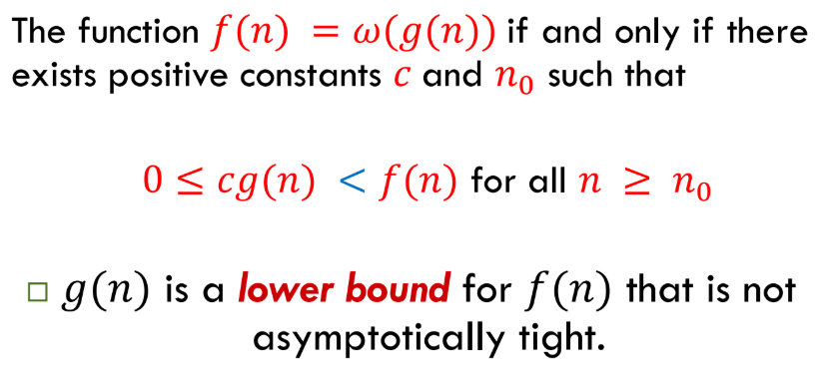
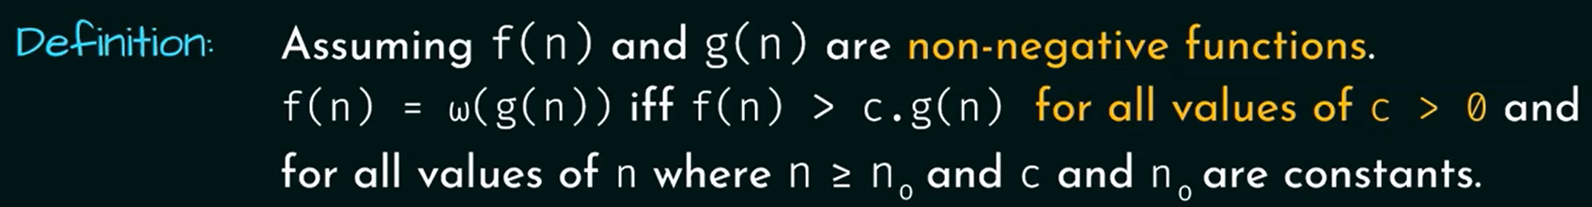
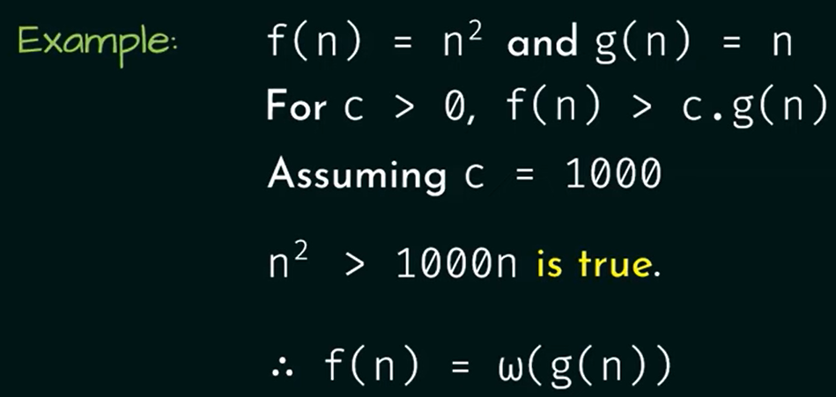
This inequality is true because n^2 > 1000n (divide both side by n) => n > 1000. So, for c = 1000 and n0 = 1001 this inequality is true.
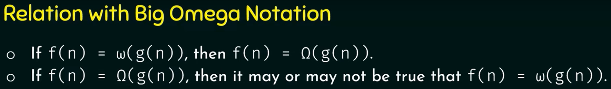
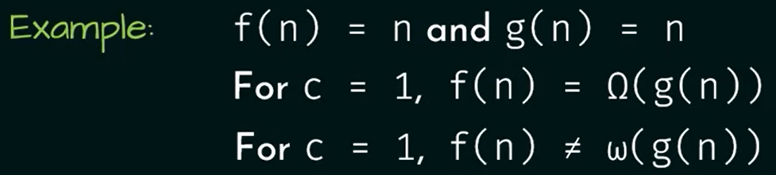
We cannot take higher value of c just to prove that this is true because the inequality of little omega must be true for all values of c > 0.
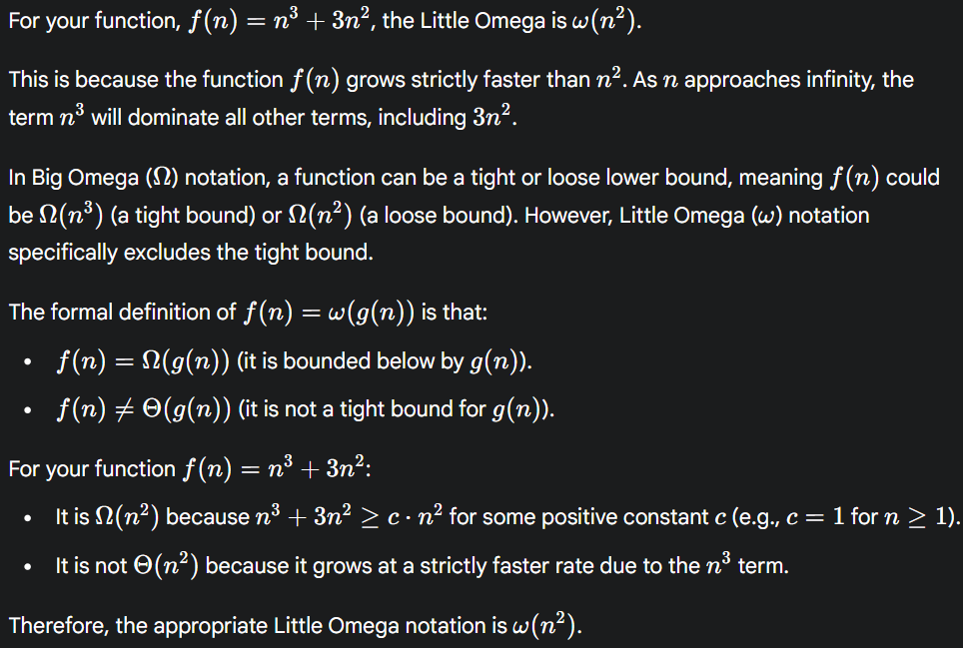
Properties:
Comparing Functions:
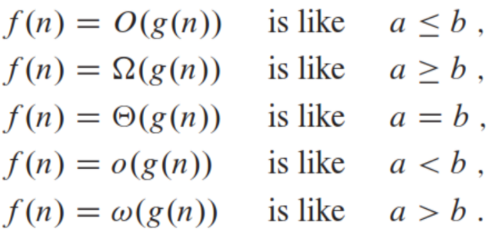
- Transitivity:
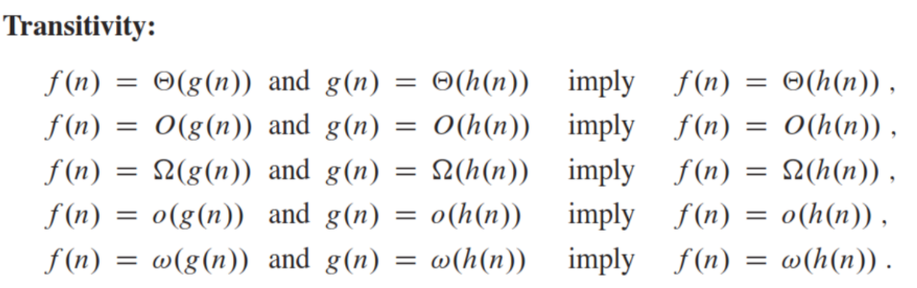
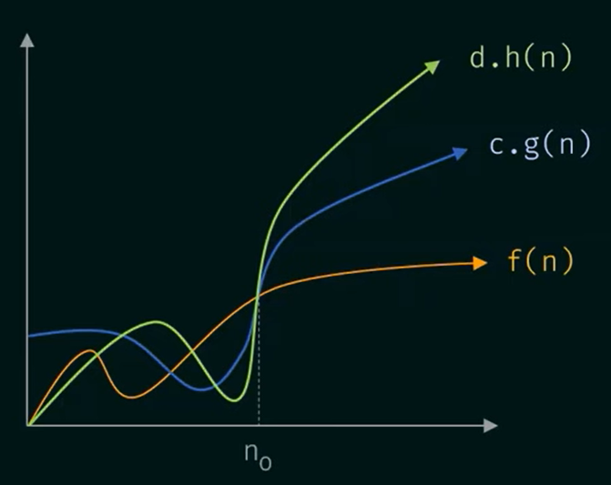
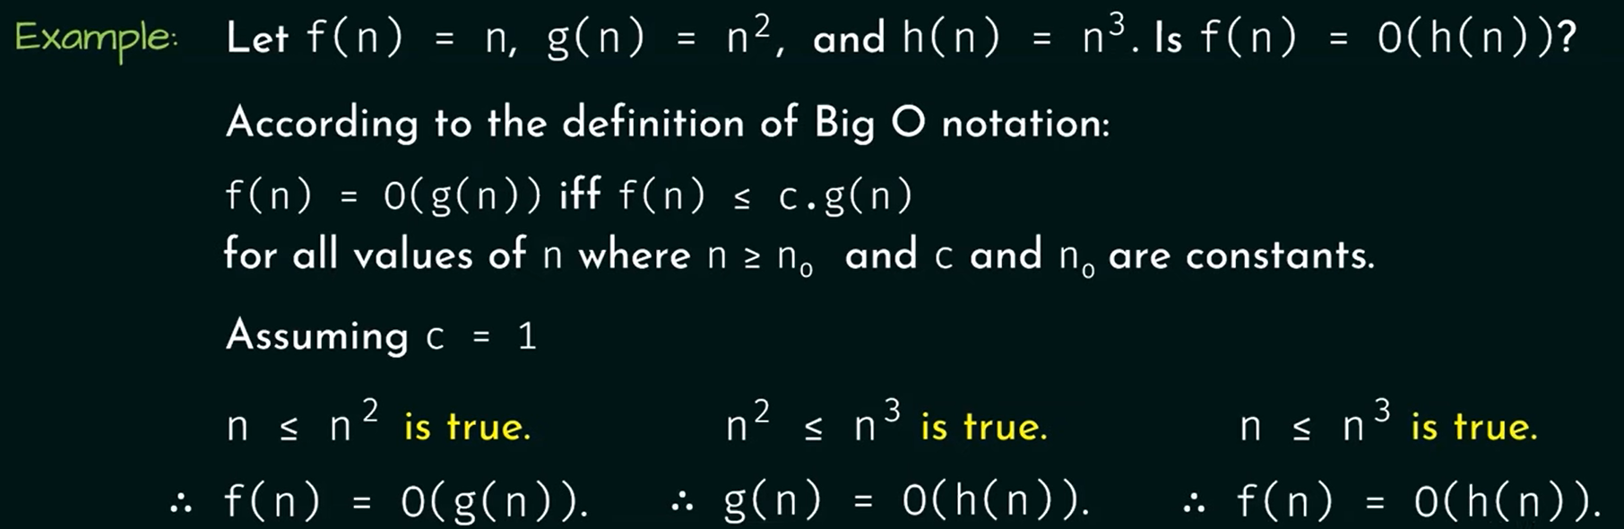
- Reflexivity:
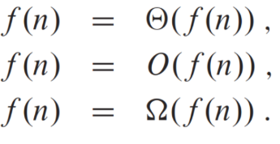
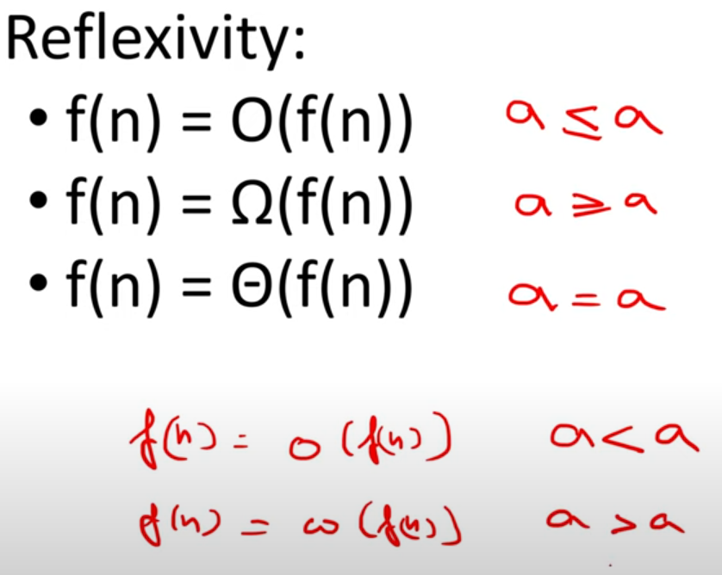
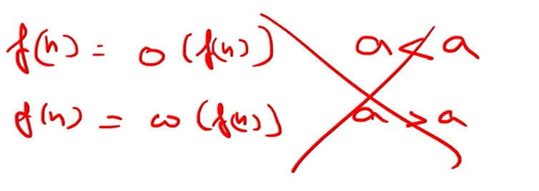
That’s why reflexivity only works for big notations.
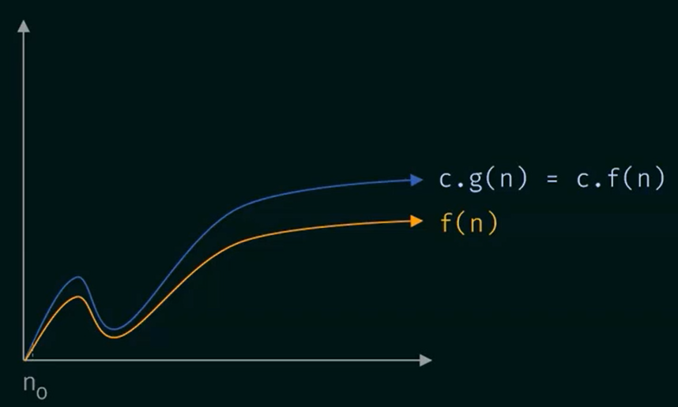
After the threshold n0, c*f(n) is greater than f(n) or (f(n) <= c*f(n)).
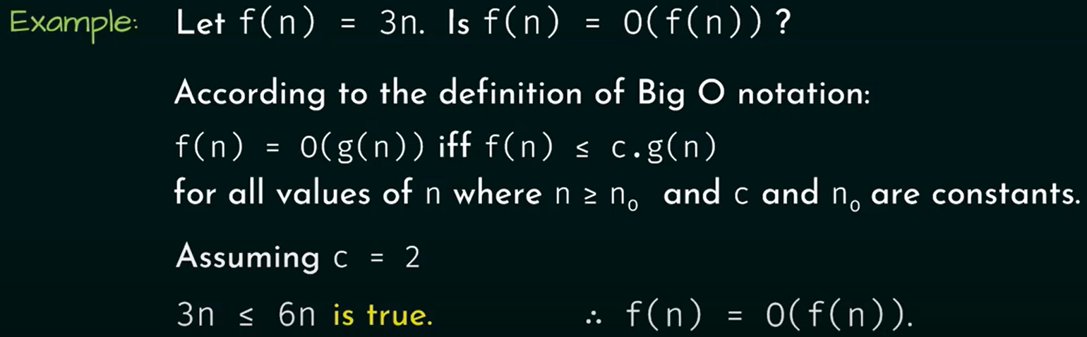
- Symmetry:
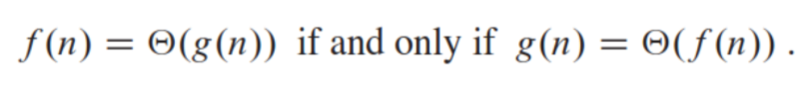
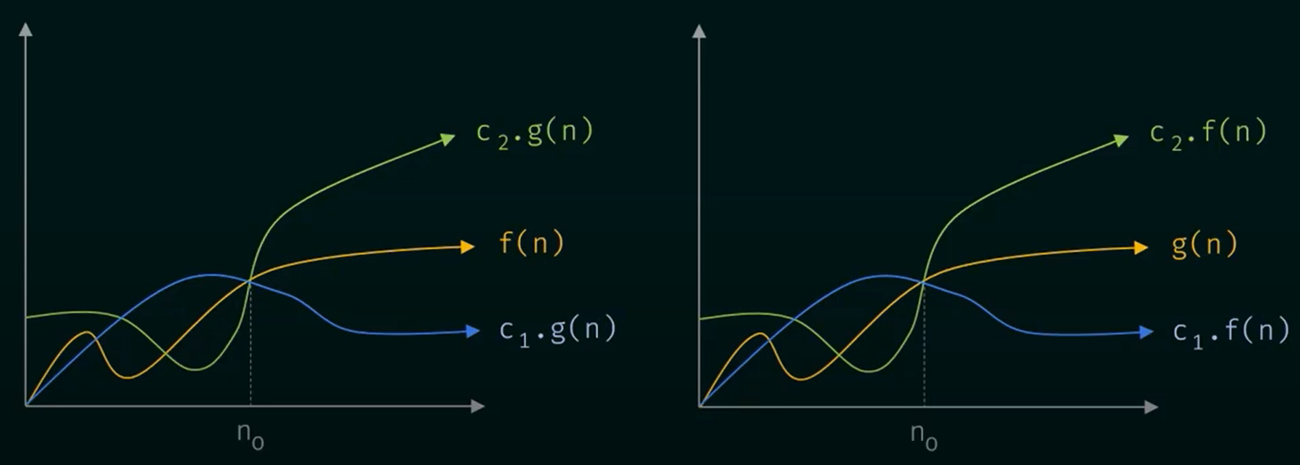
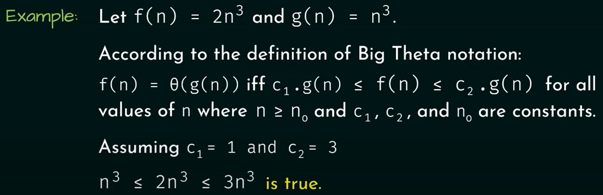
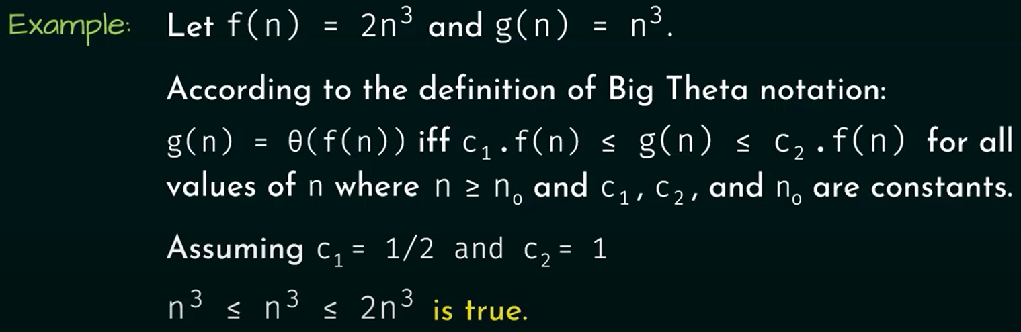
- Transpose Symmetry
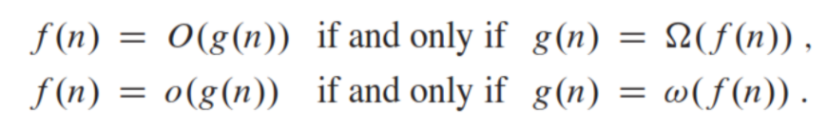
It refers that, if f(n) grows slower than c*g(n), then g(n) still grows faster than c*f(n).
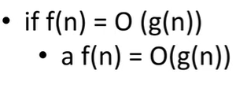
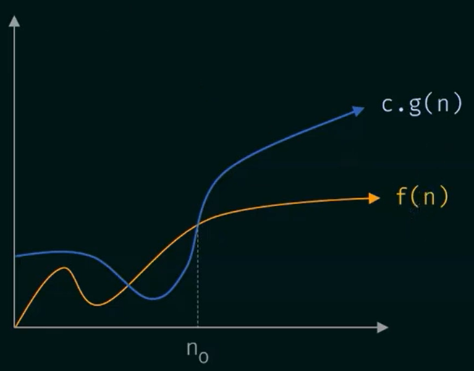
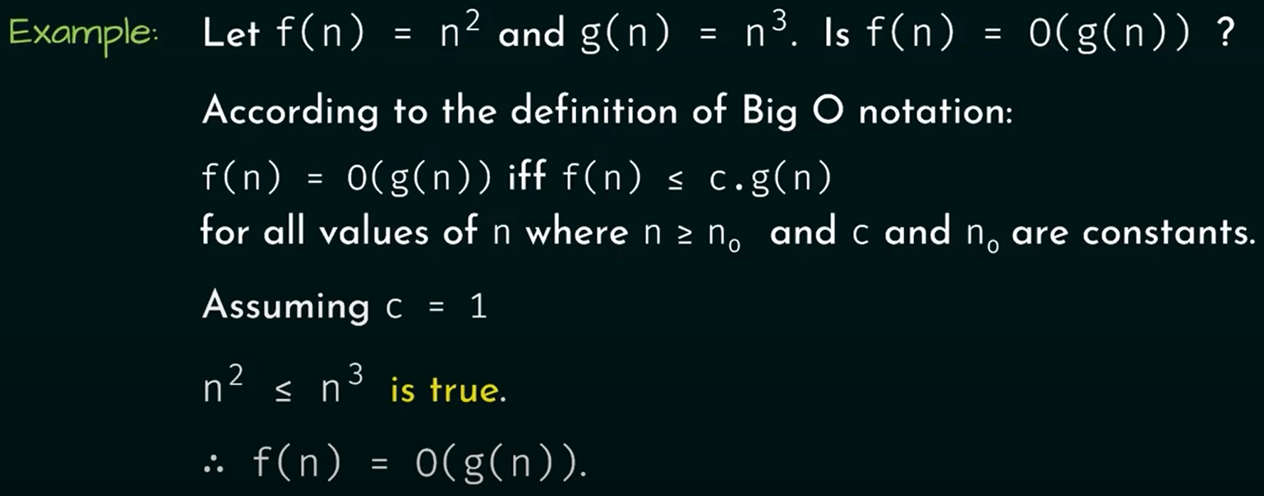
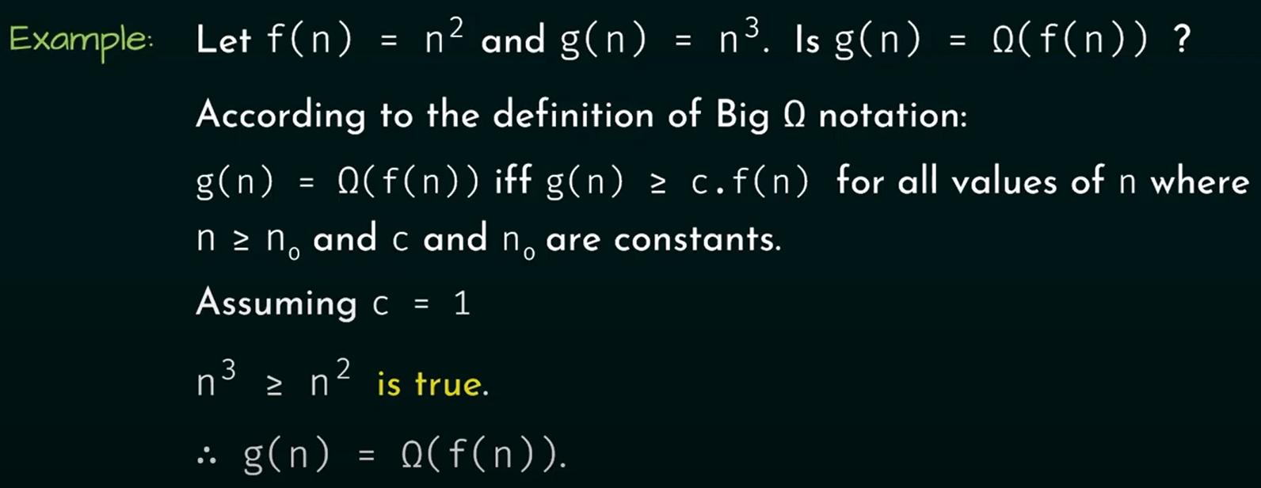
Big Oh Functions:
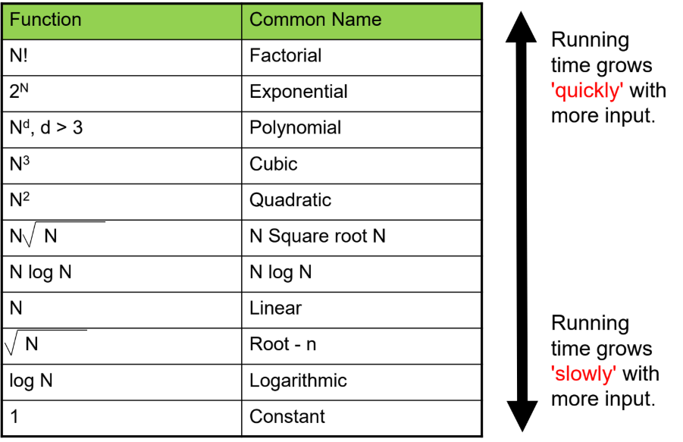

Growth of Oh Functions:
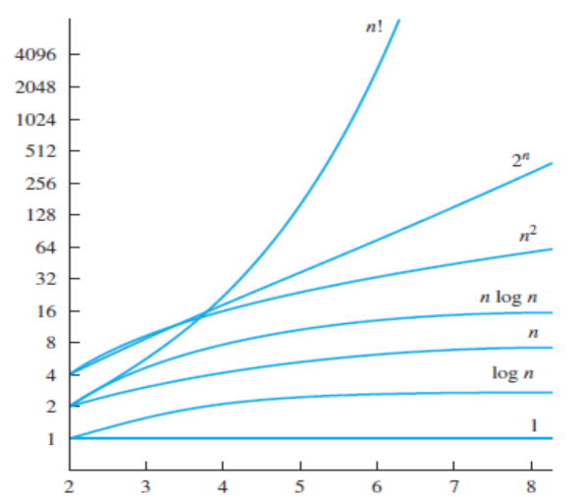

Bubble Sort T.C Analysis:
Pseudocode:
for i = 1 to n-1:
swapped = false
for j = 1 to n-i:
if A[j] > A[j+1]:
swap(A[j], A[j+1])
swapped = true
if swapped == false: break // early exit if already sorted
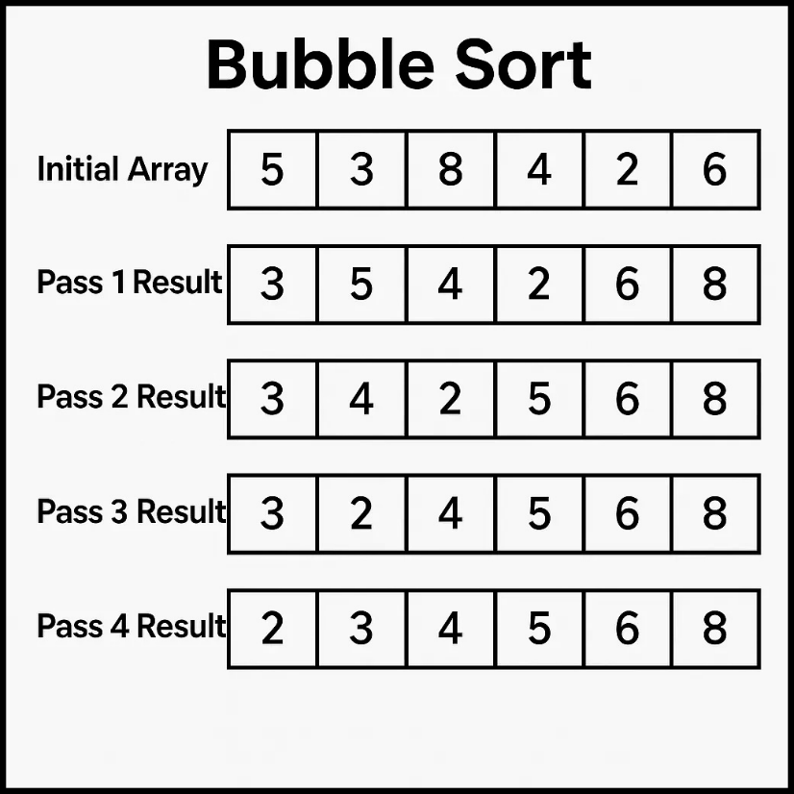
Bubble Sort works by repeatedly swapping adjacent elements if they are in the wrong order.
After each full pass:
- The largest element "bubbles up" to the end.
If we have n elements, we need up to n-1 passes.
In Bubble Sort, the main work is comparing elements.
- Pass 1: compare (n-1) pairs
- Pass 2: compare (n-2) pairs
- Pass 3: compare (n-3) pairs
...
- Last Pass: compare 1 pair
Total comparisons =
S = (n−1)+(n−2)+(n−3)+...+2+1 ---- eq(1)
Or
S = 1+2+3+……(n-2)+(n-1)+n ----- eq(2)
If we add both the equations then we will get:
- First term: (n−1)+1=n(n-1) + 1 = n(n−1)+1=n
- Second term: (n−2)+2=n(n-2) + 2 = n(n−2)+2=n
- Third term: (n−3)+3=n(n-3) + 3 = n(n−3)+3=n
- … and so on …
- Last term: 1+(n−1)=n1 + (n-1) = n1+(n−1)=n.
- In equation (2) we also have an extra nnn (since eq(1) ends at 1 but eq(2) ends at nnn).
So total after addition:
2S=n+n+n+⋯+n (with n terms)
There are n terms, each equal to n.
So:
2S=n×n=n²
S=n²/2 O(n²)

