Bubble Sort T.C Analysis:
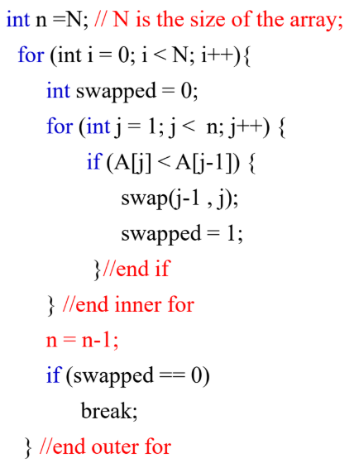
Worst Case:
Pseudocode:
for i = 1 to n-1:
swapped = false
for j = 1 to n-i:
if A[j] > A[j+1]:
swap(A[j], A[j+1])
swapped = true
if swapped == false: break // early exit if already sorted

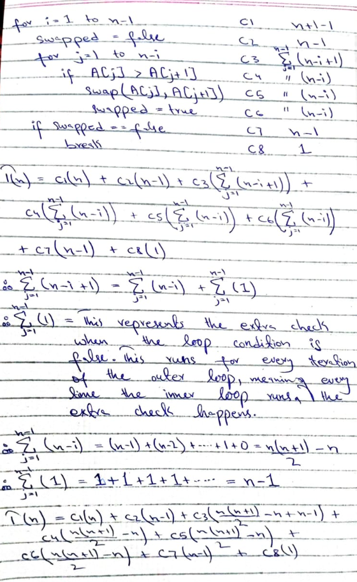
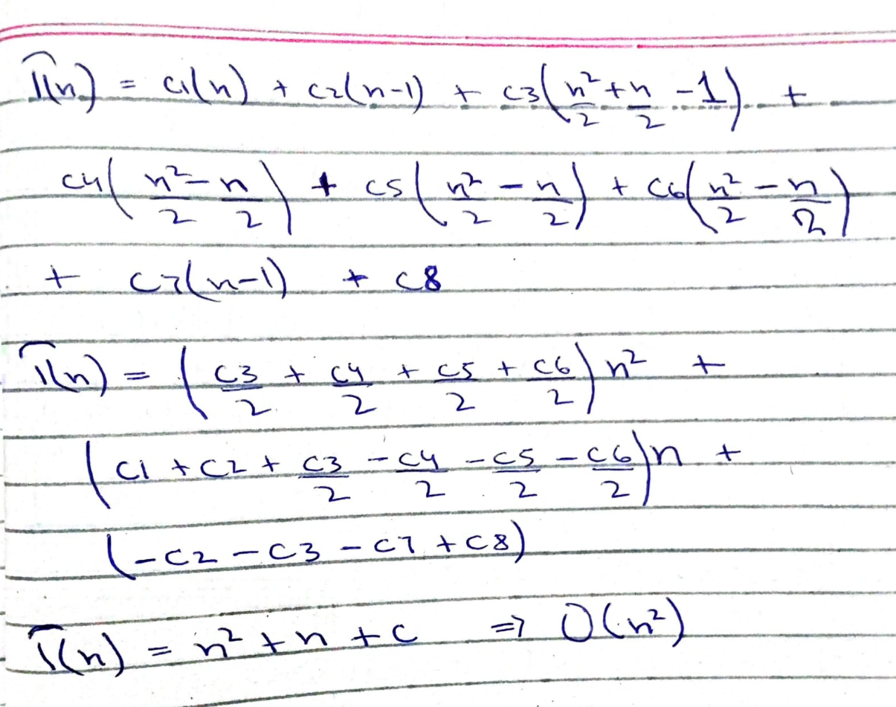
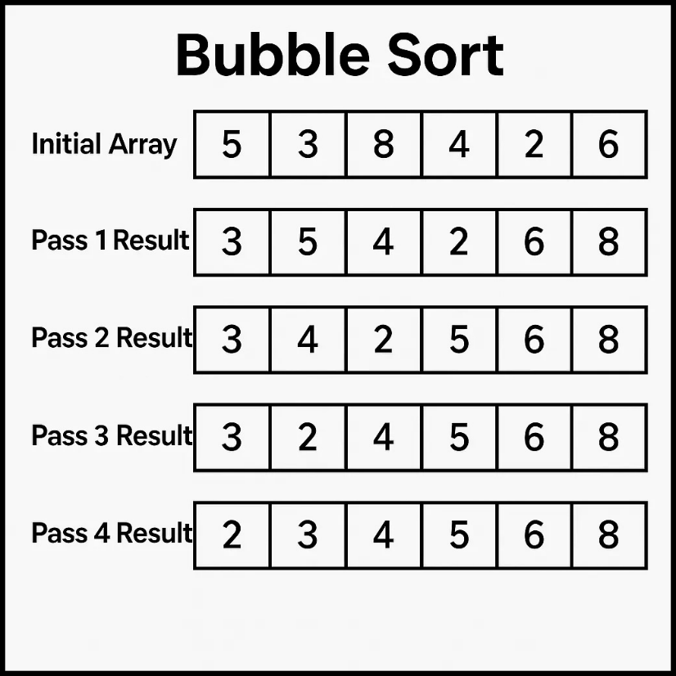
Bubble Sort works by repeatedly swapping adjacent elements if they are in the wrong order.
After each full pass:
- The largest element "bubbles up" to the end.
If we have n elements, we need up to n-1 passes.
In Bubble Sort, the main work is comparing elements.
- Pass 1: compare (n-1) pairs
- Pass 2: compare (n-2) pairs
- Pass 3: compare (n-3) pairs
...
- Last Pass: compare 1 pair
Total comparisons =
S = (n−1)+(n−2)+(n−3)+...+2+1 ---- eq(1)
Or
S = 1+2+3+4+……(n-2)+(n-1)+n ----- eq(2)
So, this is the linear series summation formula:
S = (n(n+1)) / 2 = (n²+n)/2
So, the T.C will be O(n²).
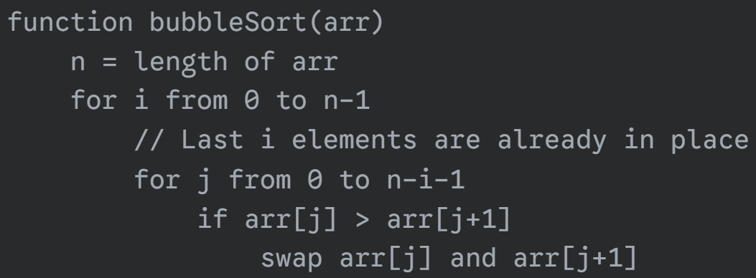
Best Case:
Pseudocode:
for i = 1 to n-1:
swapped = false
for j = 1 to n-i:
if A[j] > A[j+1]:
swap(A[j], A[j+1])
swapped = true
if swapped == false: break // early exit if already sorted
In the best-case scenario, the outer loop executes its first iteration, setting the flag to false. It then runs the inner loop from 1 to n-1 to check for any necessary swaps. Since the array is already sorted in the best case, the flag remains false. When the inner loop finishes, the outer loop's break condition, if (flag == false), is met. This causes the outer loop to terminate after only one iteration, while the inner loop runs n-1 times. Therefore, the time complexity is O(n-1),which simplifies to Ω (n).

Insertion Sort T.C Analysis:
Worst Case:
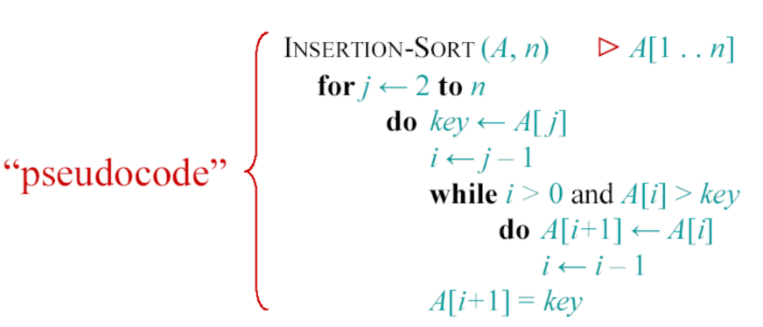
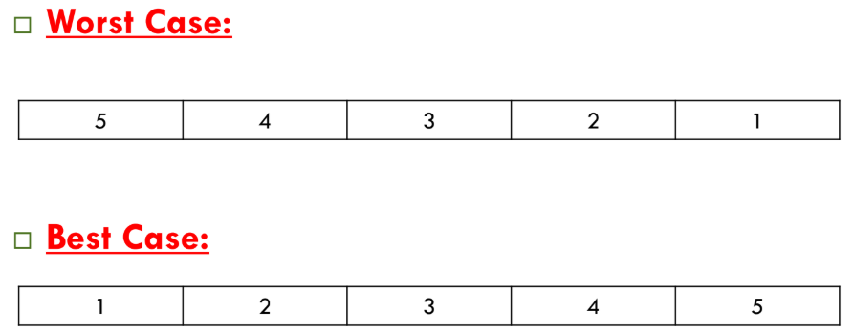
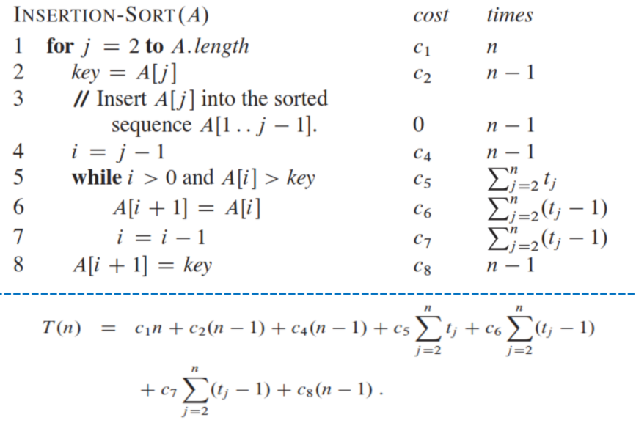
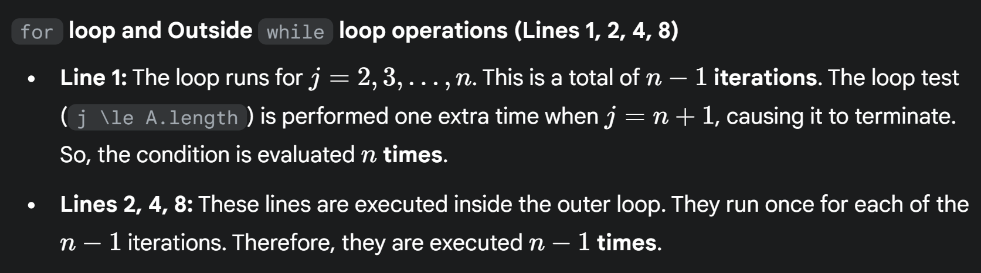
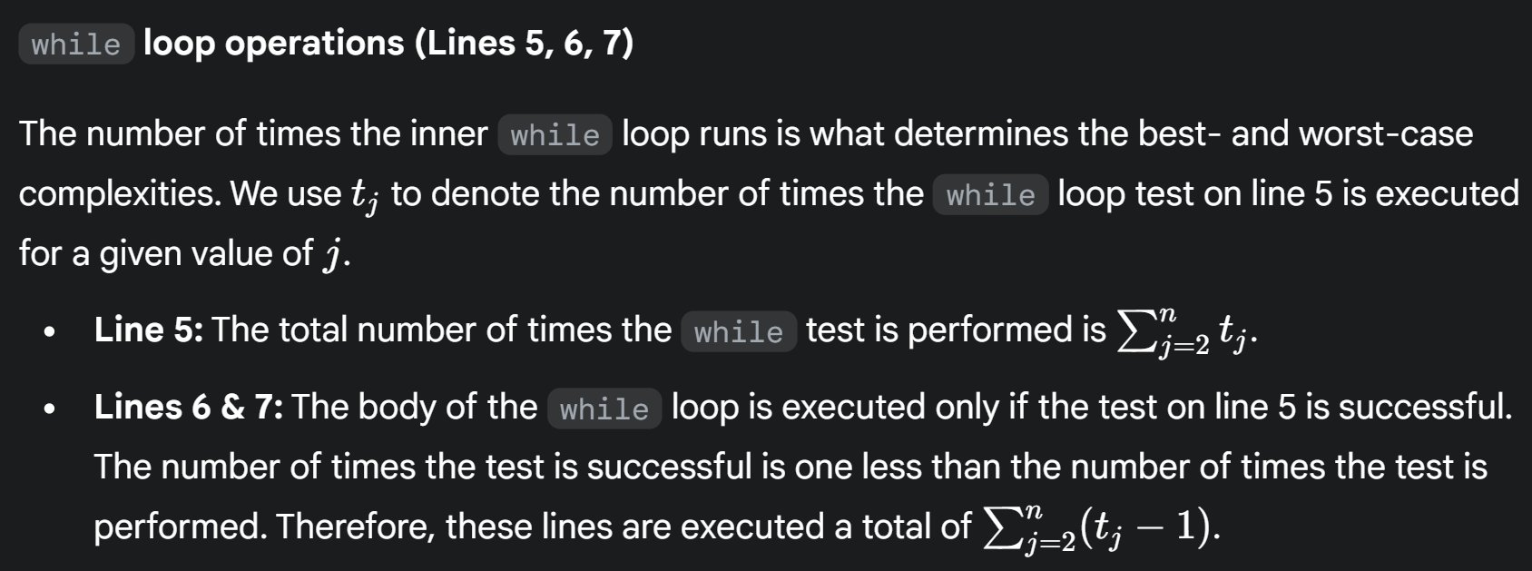
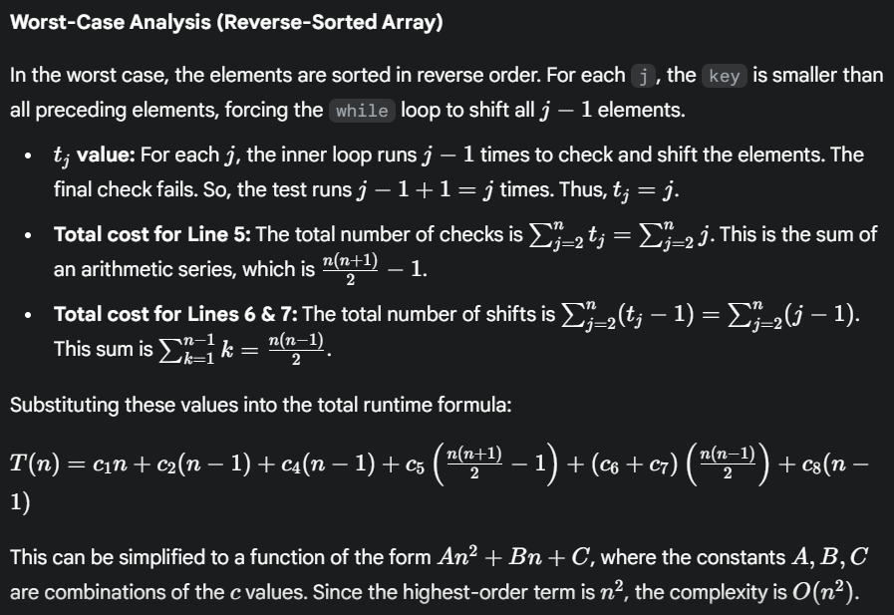
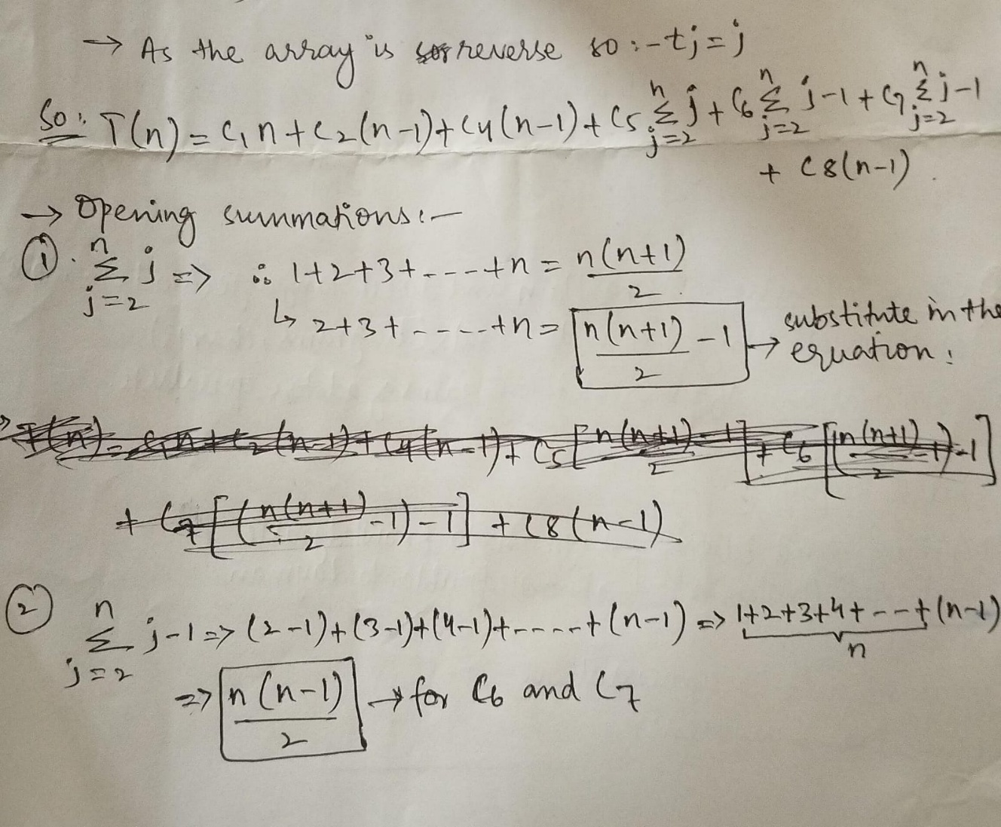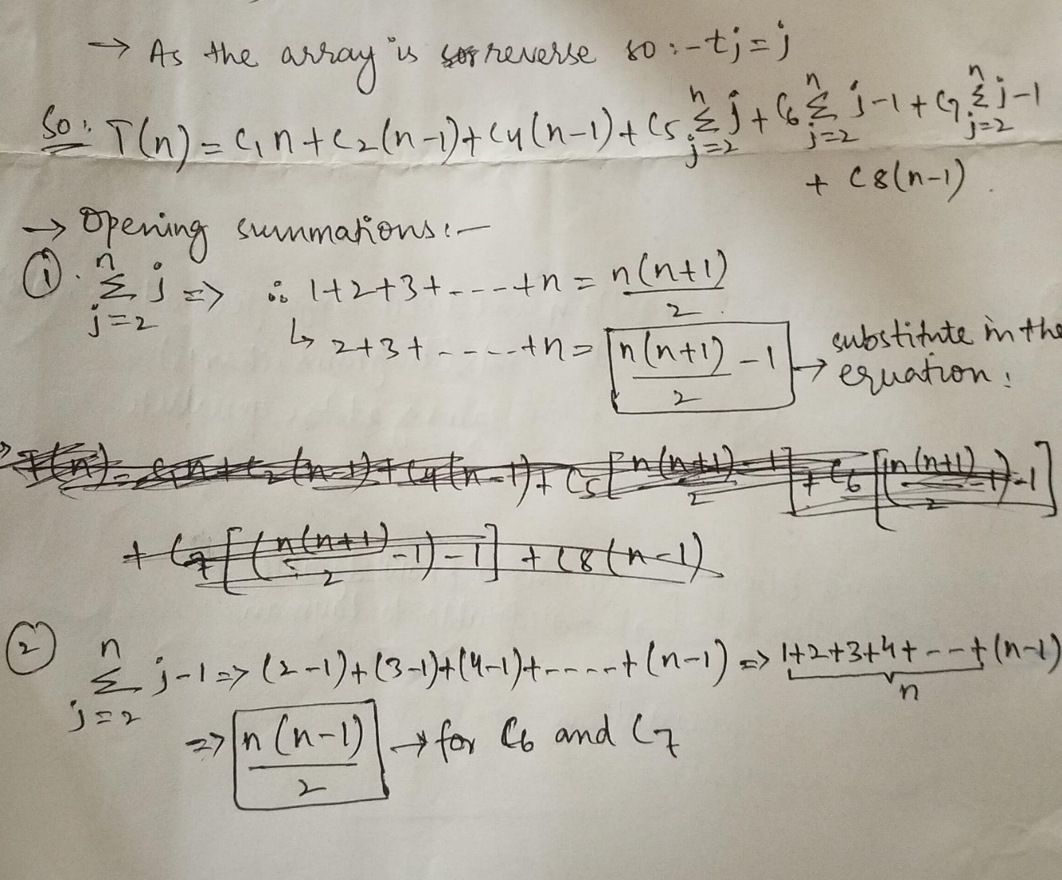
Now substituting the summations in the equation:
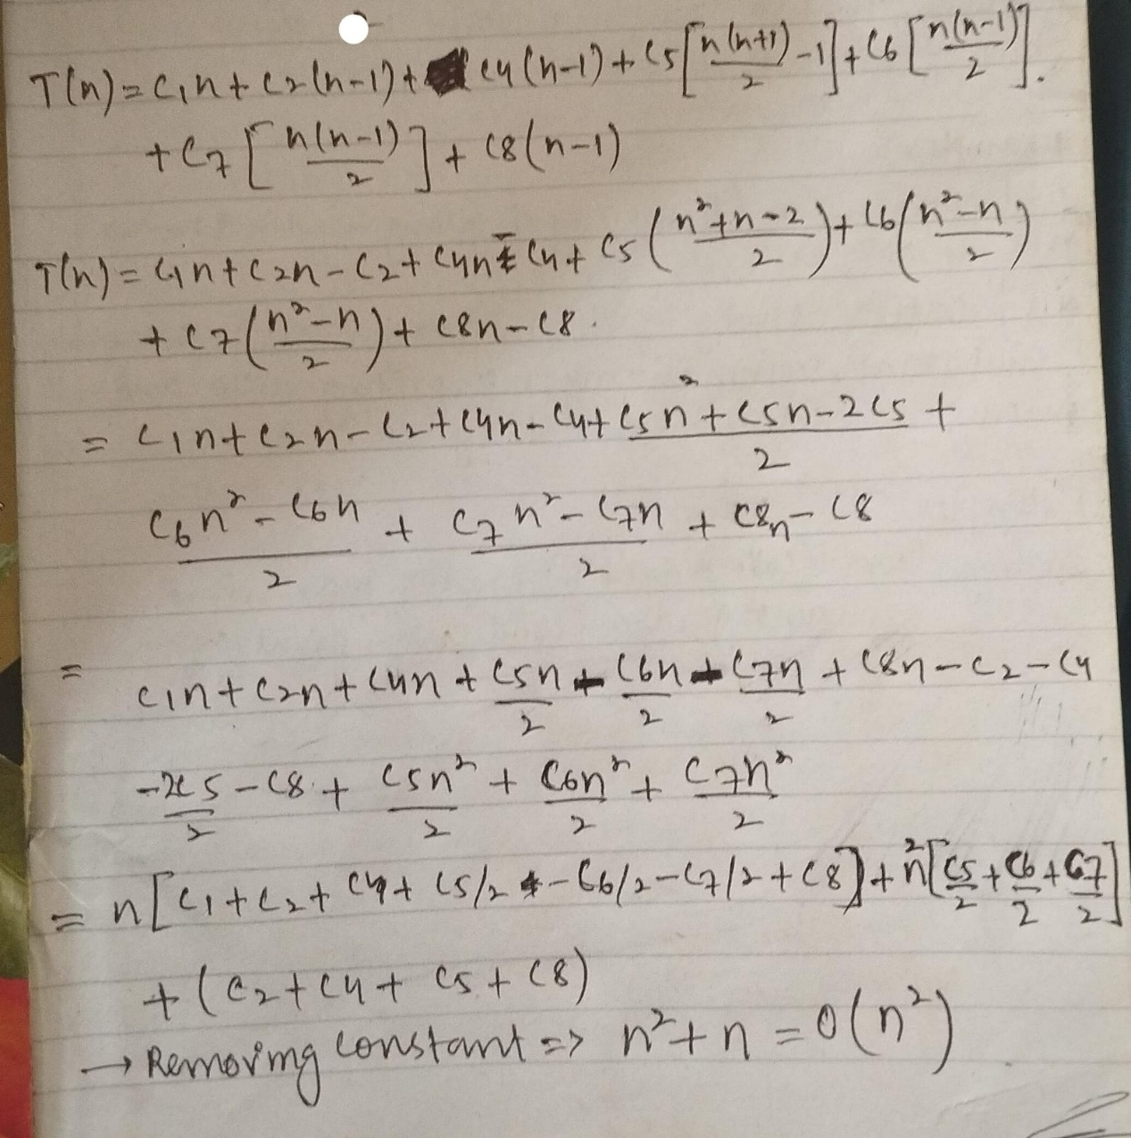

Best Case:
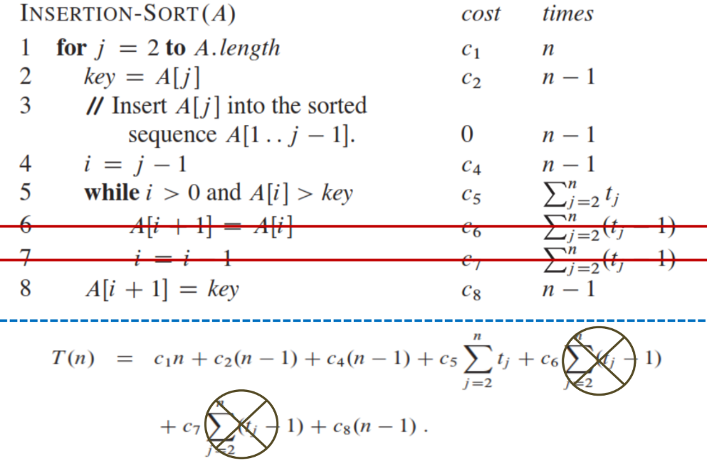
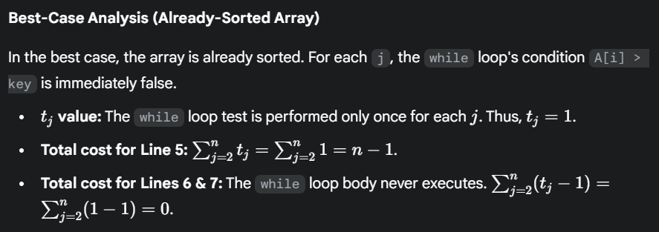
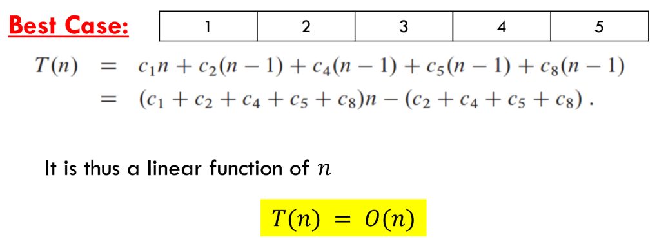
In the best case it will not run the lines written in the while loop because the while loop’s condition failed in every instance because the array is already sorted so there will be no N² in this case.

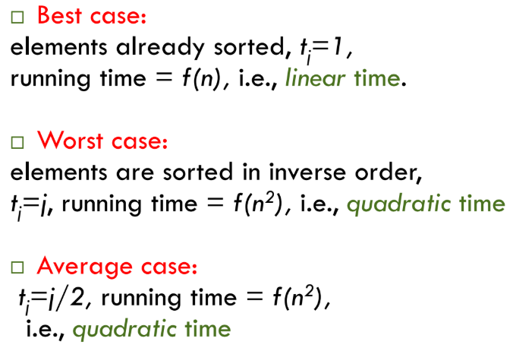
Insertion sort is stable, meaning if there are 2 similar elements adjacent to each other, their position will remain same, and they will not swap with each other.
