Selection Sort:
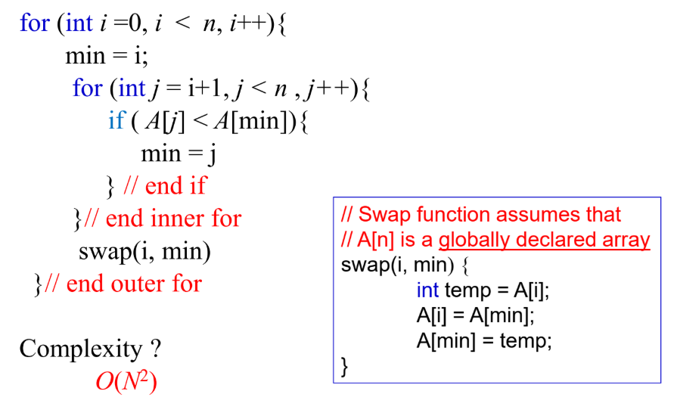
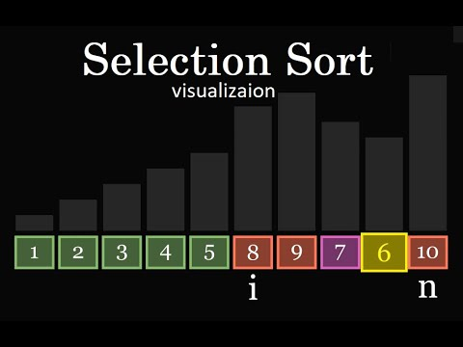
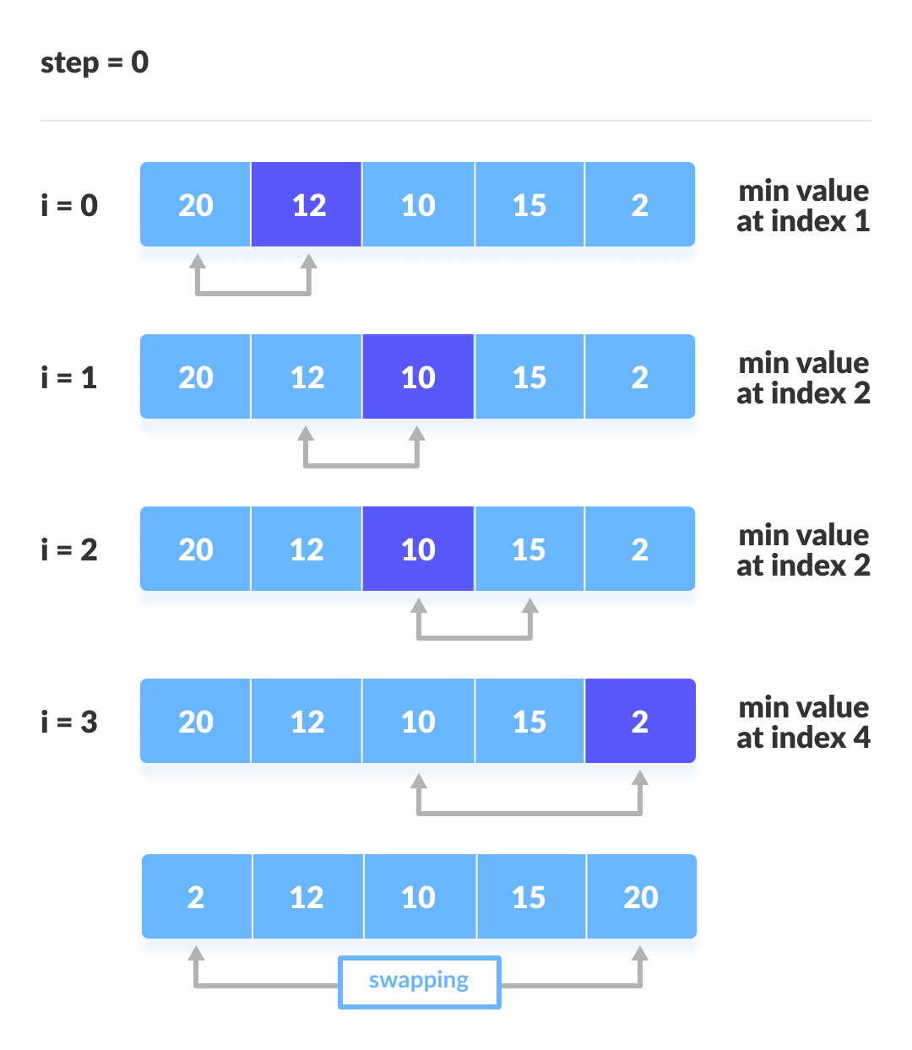
How Selection Sort Works
- Find the minimum element in the unsorted part of the array.
- Swap it with the first element of the unsorted part.
- Repeat for the rest of the array until everything is sorted.

This process will repeat n times until the outer loop is terminated.

Worst Case/Best Case:


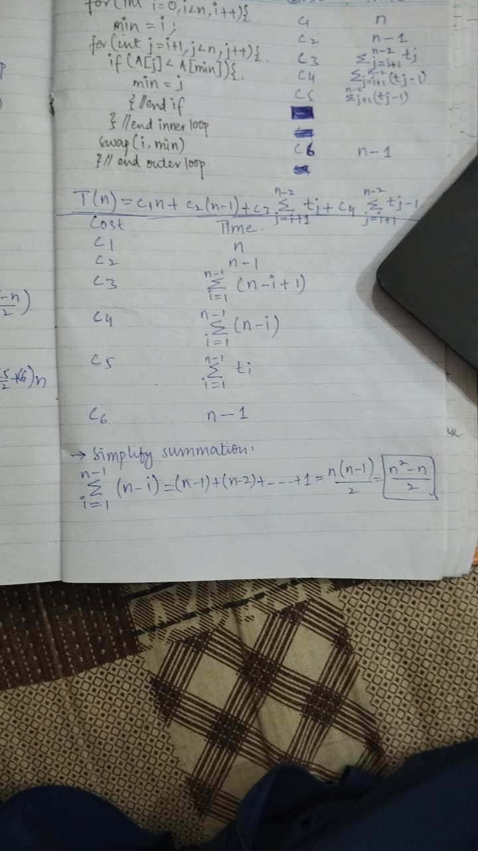


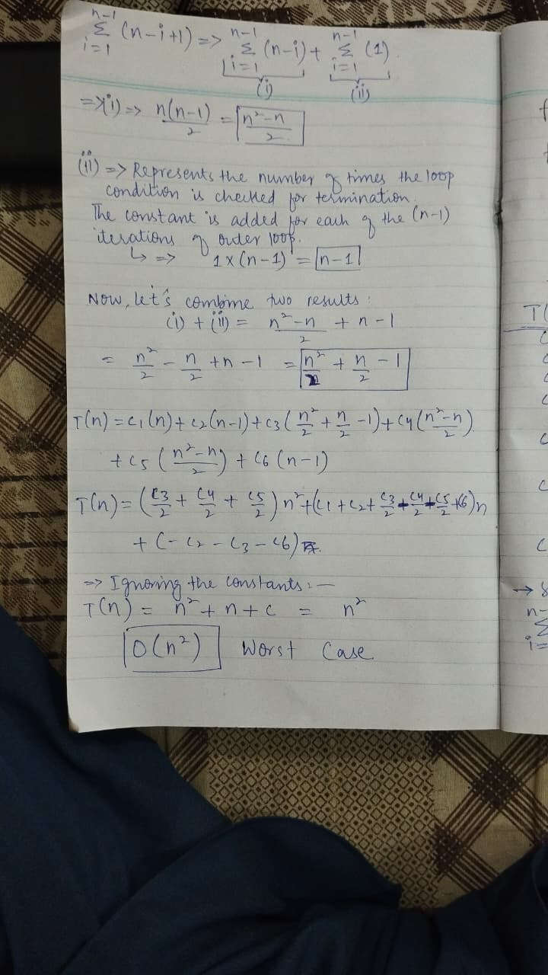

Recurrence Relations:
A recurrence relation, T(n), is a recursive function of an integer variable n.
Like all recursive functions, it has one or more recursive cases and one or more base cases.
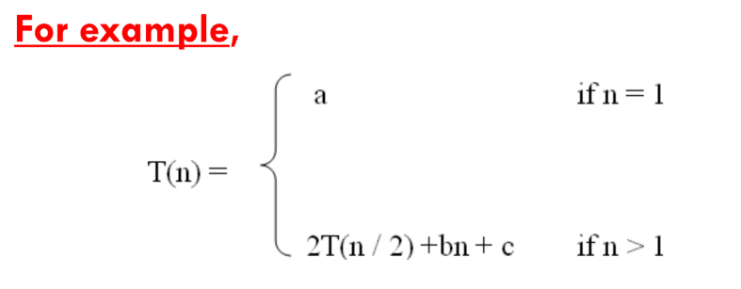
The portion of the definition that does not contain T(n) is the base case of the relation.
The portion that contains T(n) is the recurrent or recursive case.
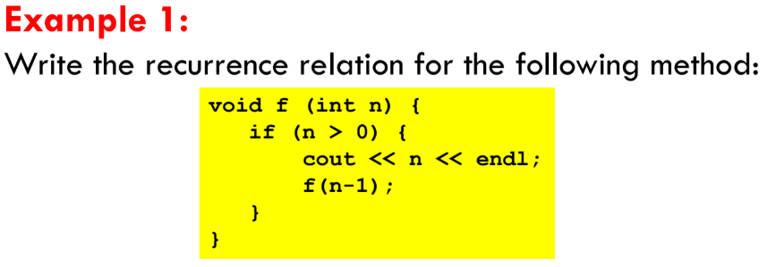
The base case is reached when n == 0. The method performs one comparison. Thus, the number of operations when n = = 0, T(0), is some constant a.
When n > 0, the method performs two basic operations and then calls itself, using ONE recursive call, with a parameter n – 1.
- Here the first operation will be considered as constant
- Second operation is the recursive call of the same function using parameter (n-1)

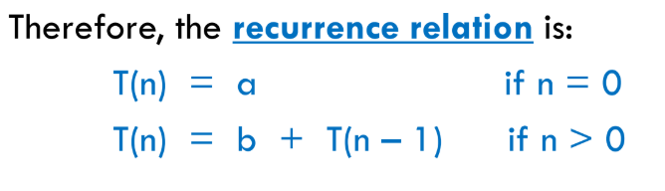
b is considered as the constant lines in the code that are calculated after the recursive condition is hit.
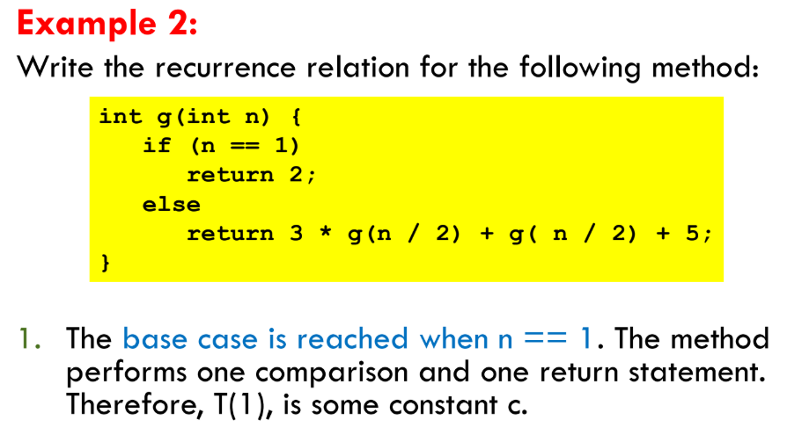
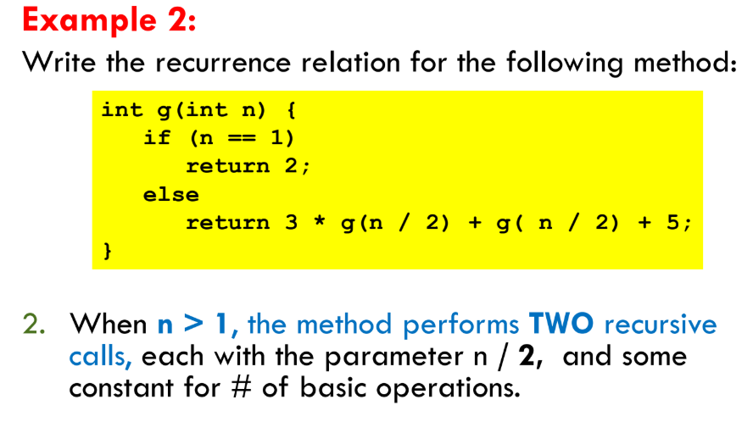
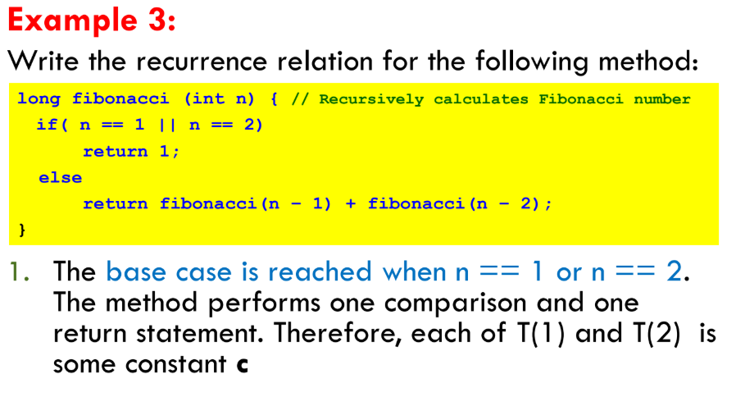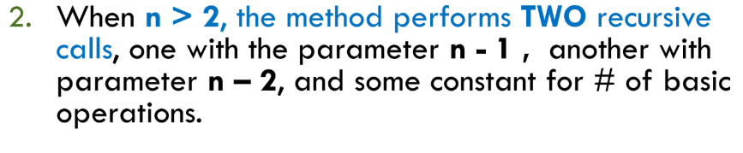
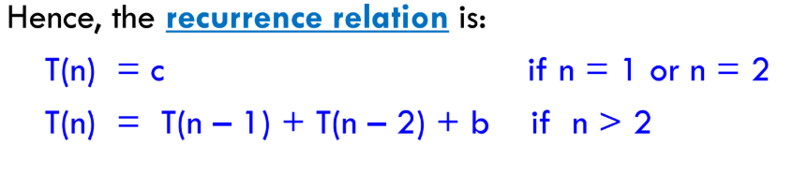
Finding Time Complexities of Recurrence Relation:
To find the time complexity of recurrence relation, we need to derive a form of T(n) that is not a recurrence relation
It means that such a form that is a closed form.
- A closed form means:
when you rewrite the recurrence without self-reference.
That means: express T(n) only in terms of n, not in terms of smaller T's

Methods for Solving Recurrence Relations
- Iteration Method:
- Keep expanding the recurrence step by step until you see a pattern.
- Stop when the input size hits the base case.
- Sum up all the work.
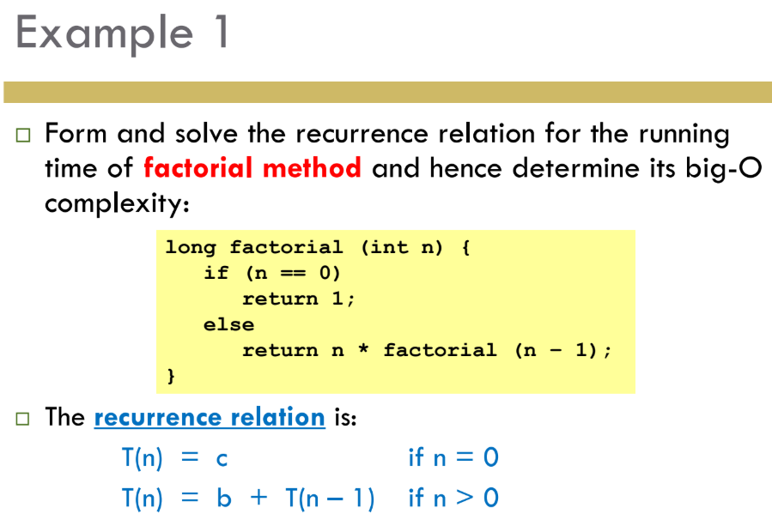
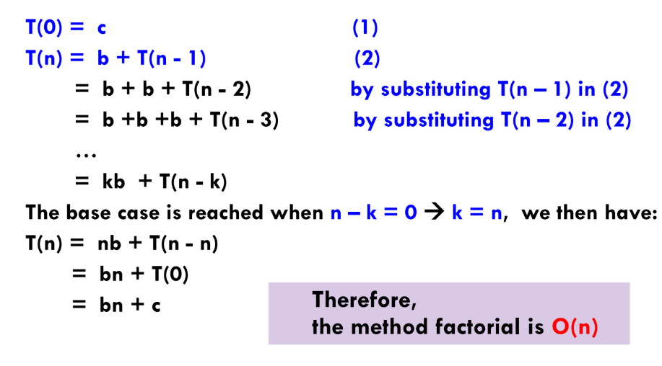

Finding the T.C in details:
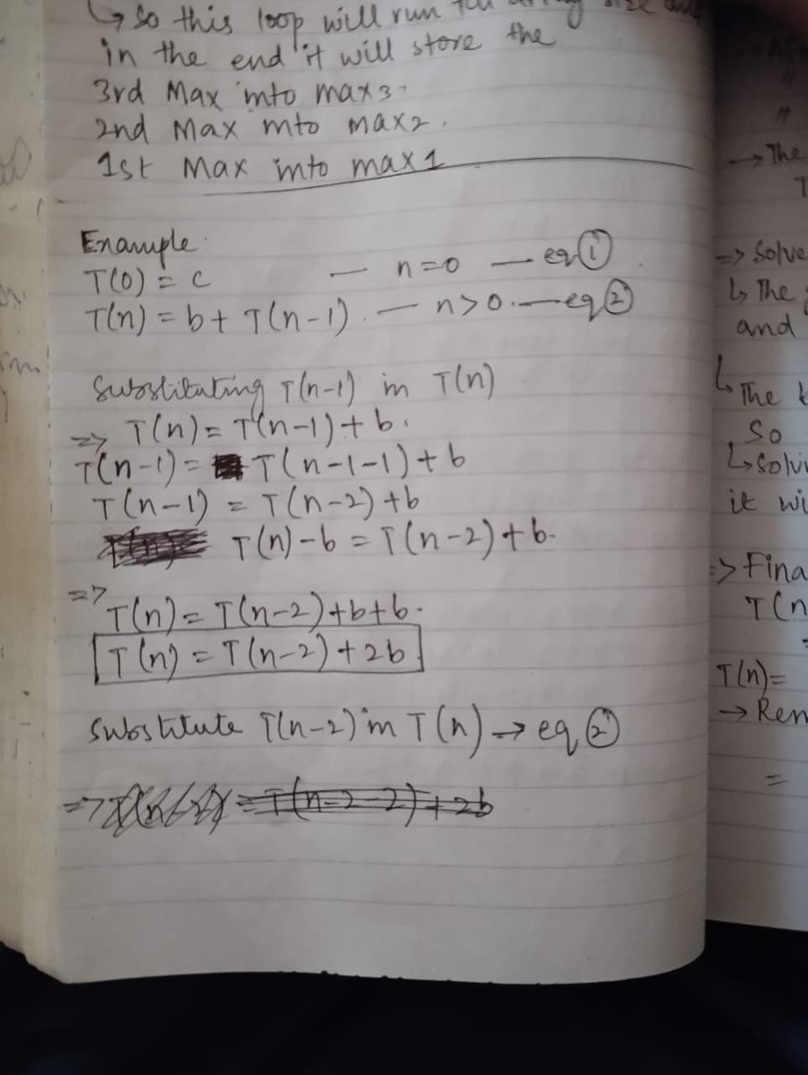
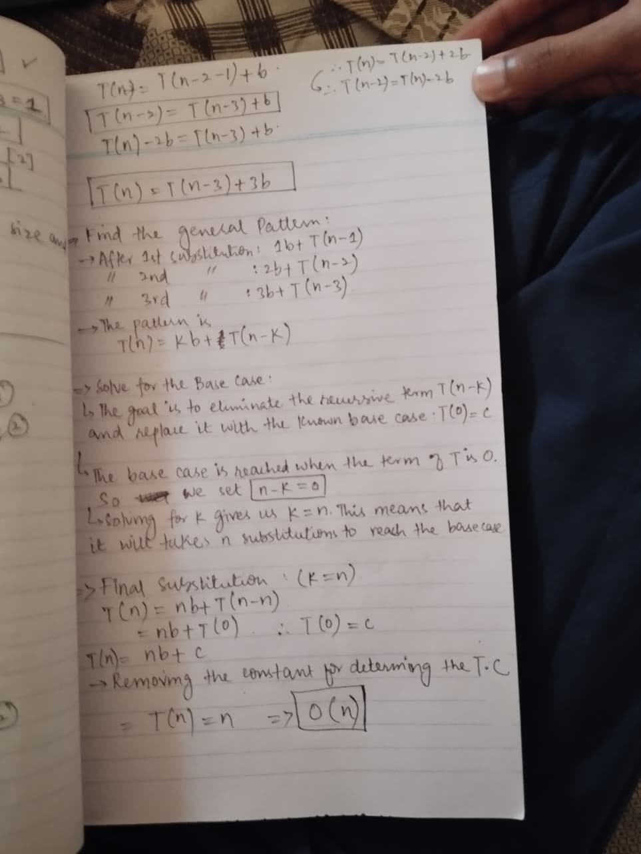
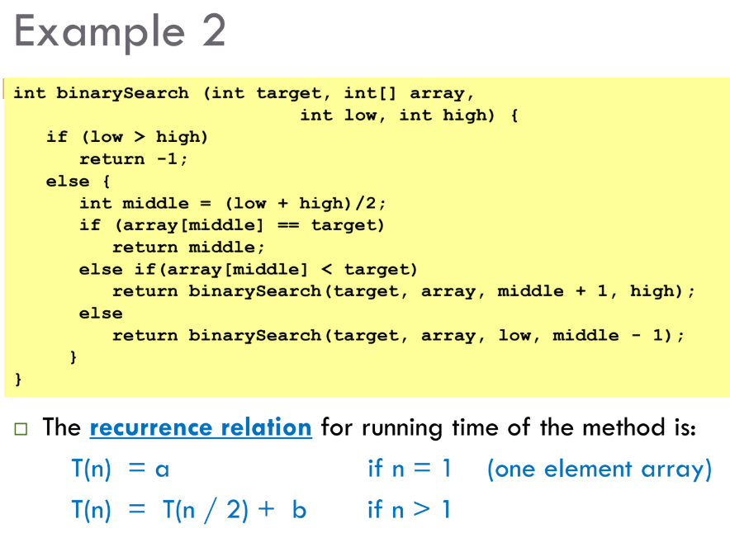
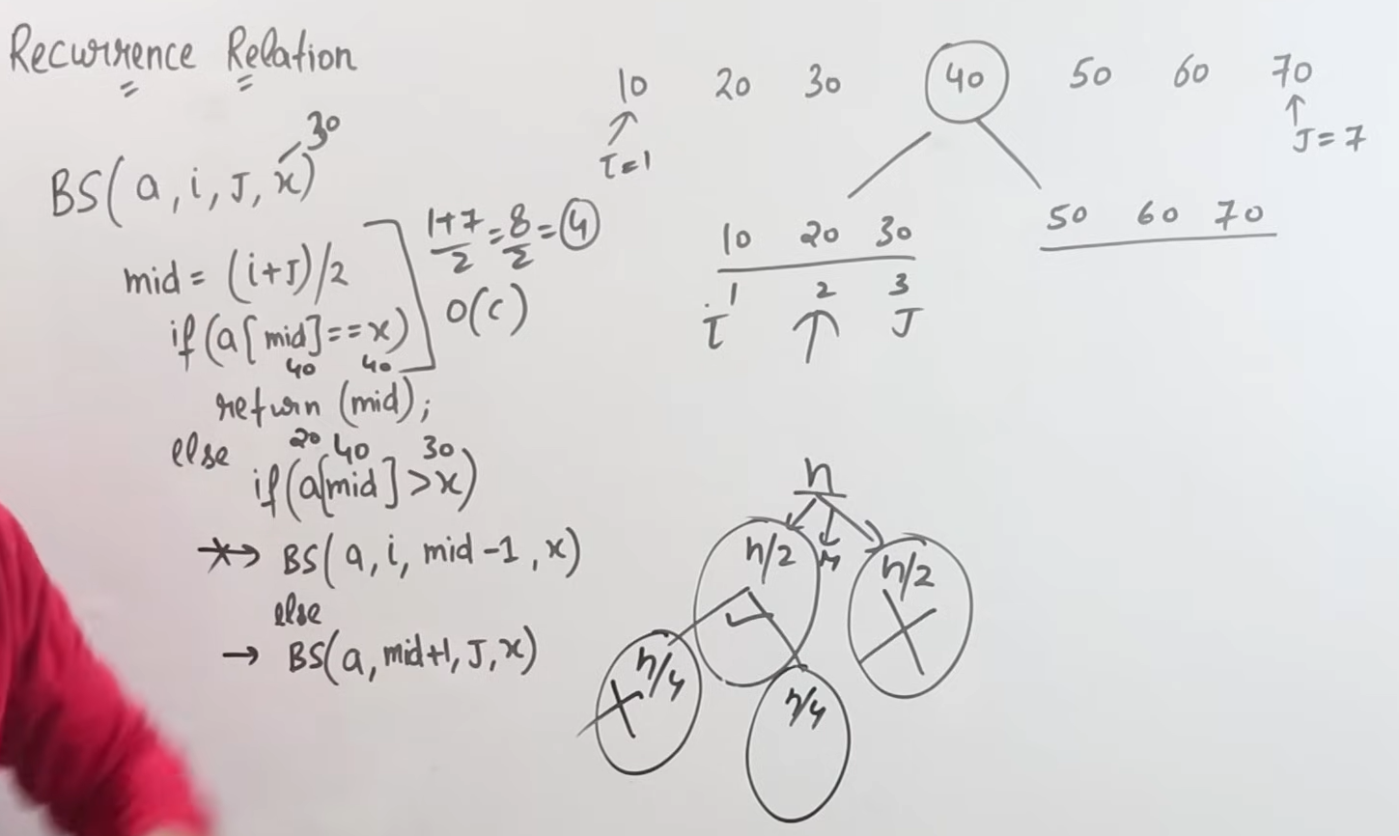
Now Let’s find out its T.C using recurrence relation:
