Recurrence Relations:
A recurrence relation, T(n), is a recursive function of an integer variable n.
Like all recursive functions, it has one or more recursive cases and one or more base cases.
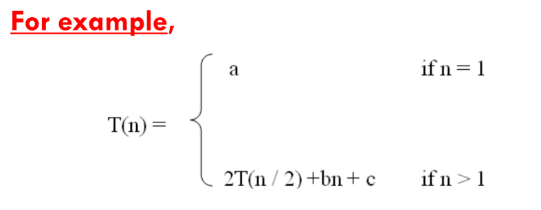
The portion of the definition that does not contain T(n) is the base case of the relation.
The portion that contains T(n) is the recurrent or recursive case.
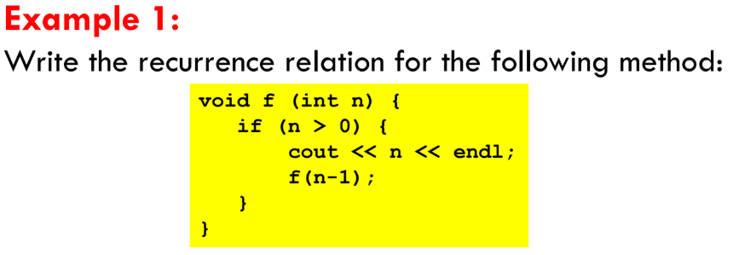
The base case is reached when n == 0. The method performs one comparison. Thus, the number of operations when n = = 0, T(0), is some constant a.
When n > 0, the method performs two basic operations and then calls itself, using ONE recursive call, with a parameter n – 1.
- Here the first operation will be considered as constant
- Second operation is the recursive call of the same function using parameter (n-1)

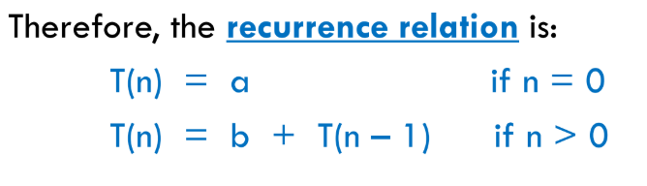
b is considered as the constant lines in the code that are calculated after the recursive condition is hit.
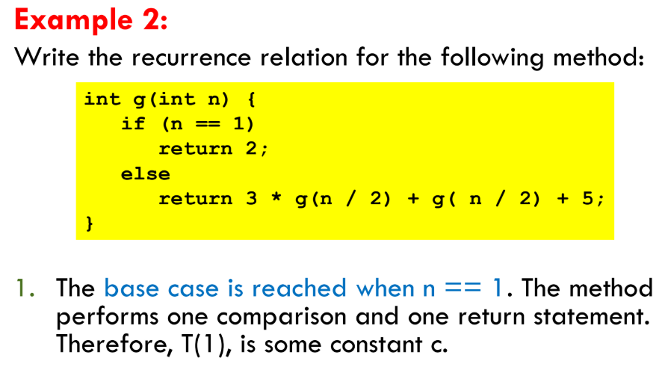
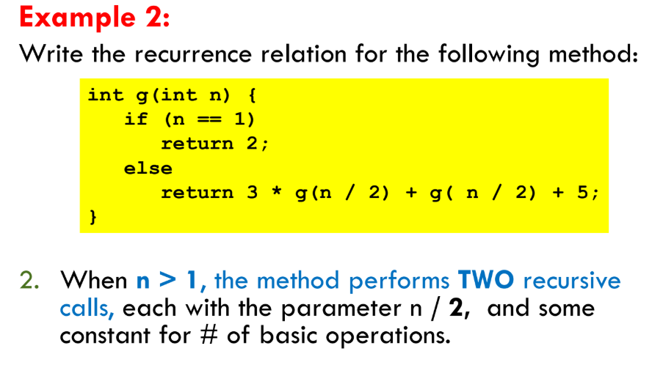
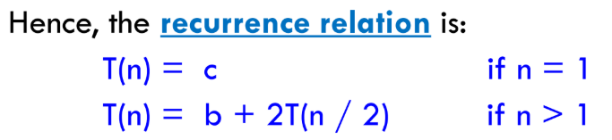
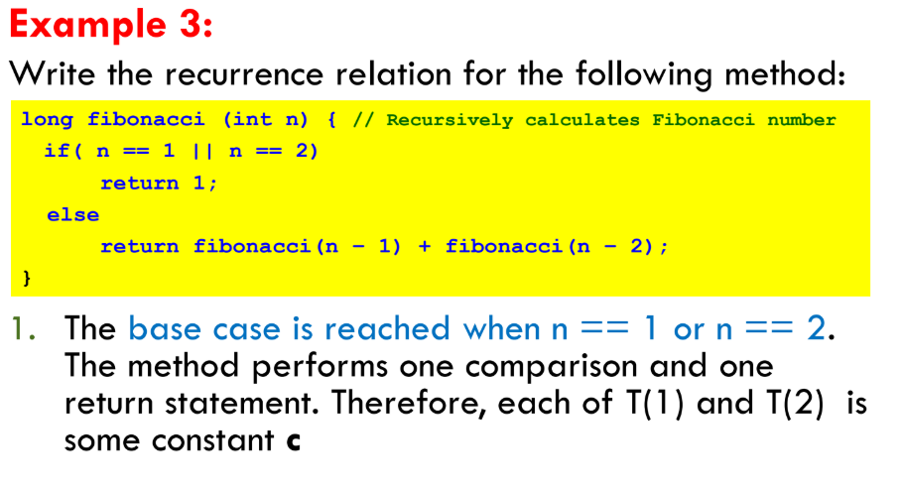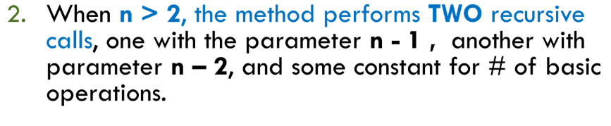
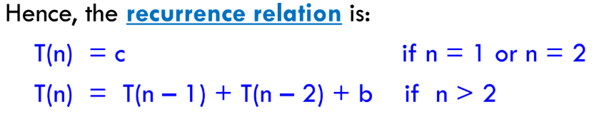
Recurrence Relation for return values:
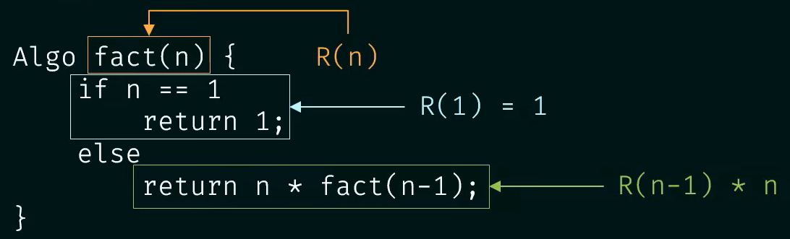
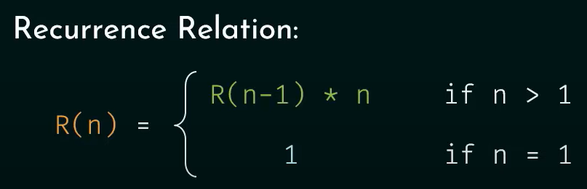
Finding Time Complexities of Recurrence Relation:
To find the time complexity of recurrence relation, we need to derive a form of T(n) that is not a recurrence relation
It means that such a form that is a closed form.
- A closed form means:
when you rewrite the recurrence without self-reference.
That means: express T(n) only in terms of n, not in terms of smaller T's

Methods for Solving Recurrence Relations
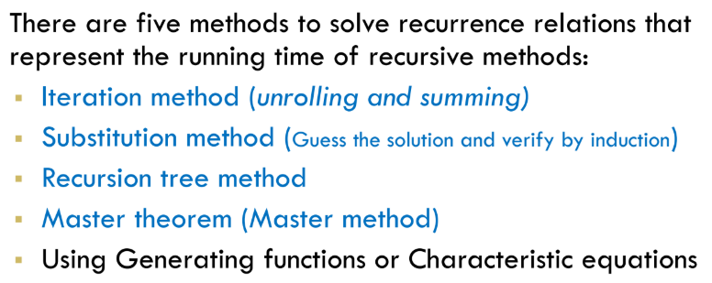
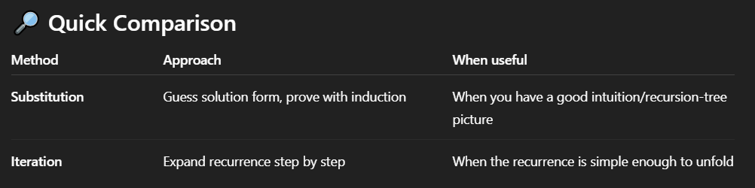
⚡ Key Idea: Substitution works when you can “see” the form of the answer (often by comparing with a recursion tree or known patterns), then prove it with induction.
⚡ Key Idea: Iteration works by repeatedly expanding until you reach the base case. Then sum up the terms that appear. The “depth” of recursion often gives you the log.
Iteration Method:
- Keep expanding the recurrence step by step until you see a pattern.
- Stop when the input size hits the base case.
- Sum up all the work.
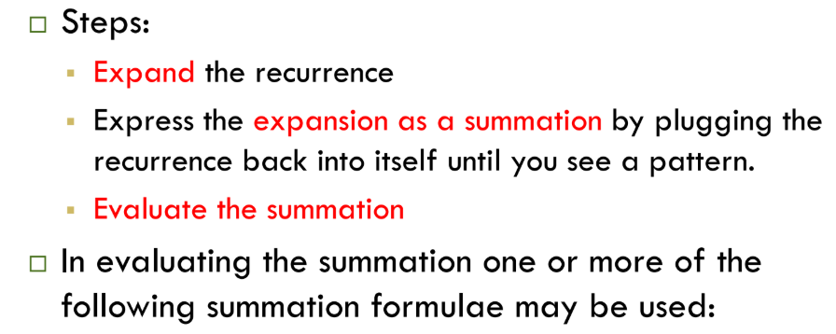
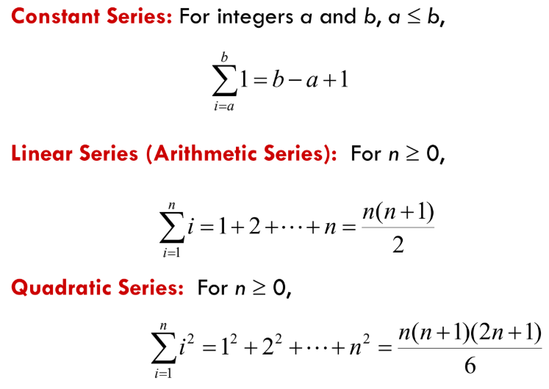
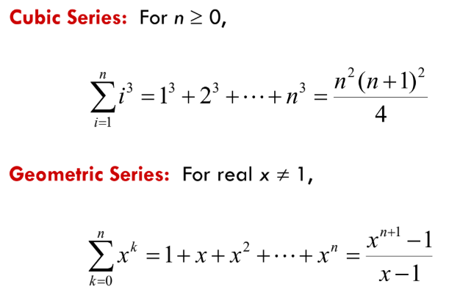
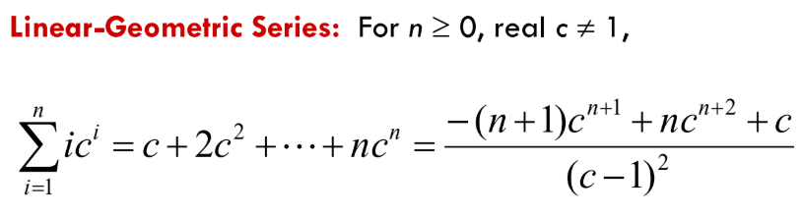
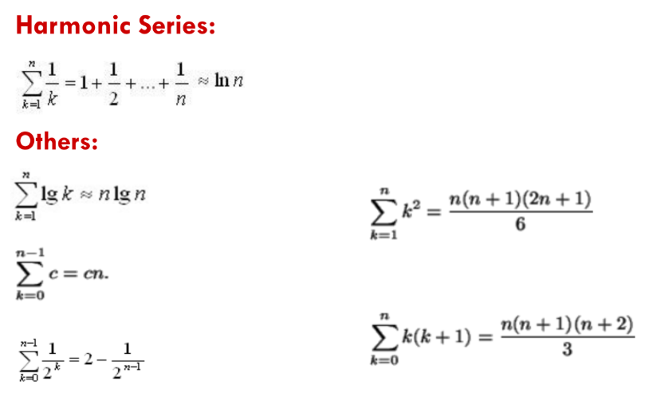
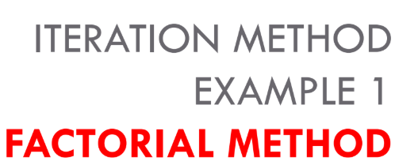
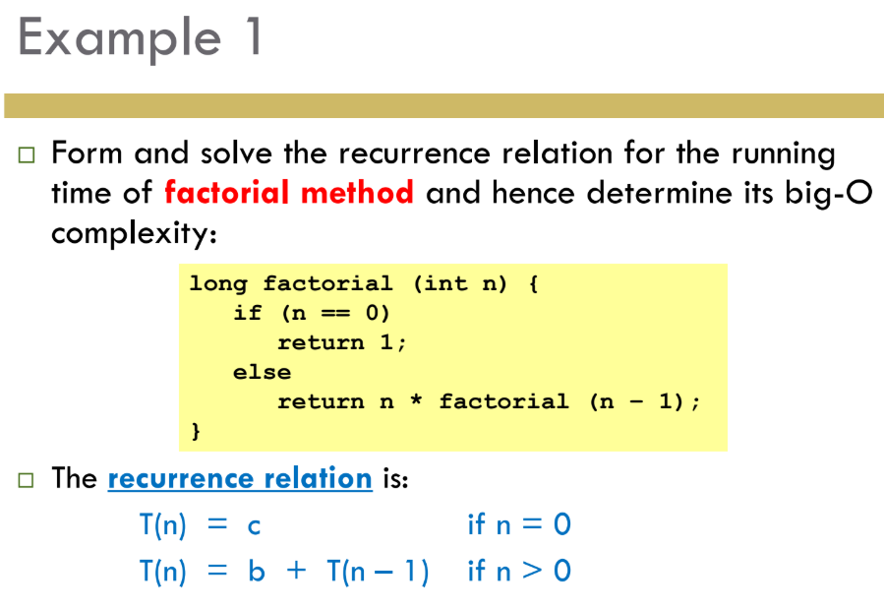
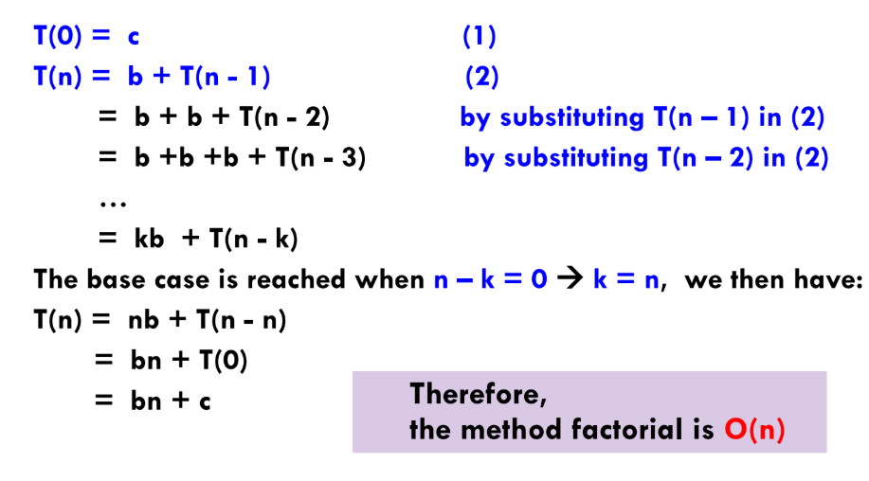
Finding the T.C in details:
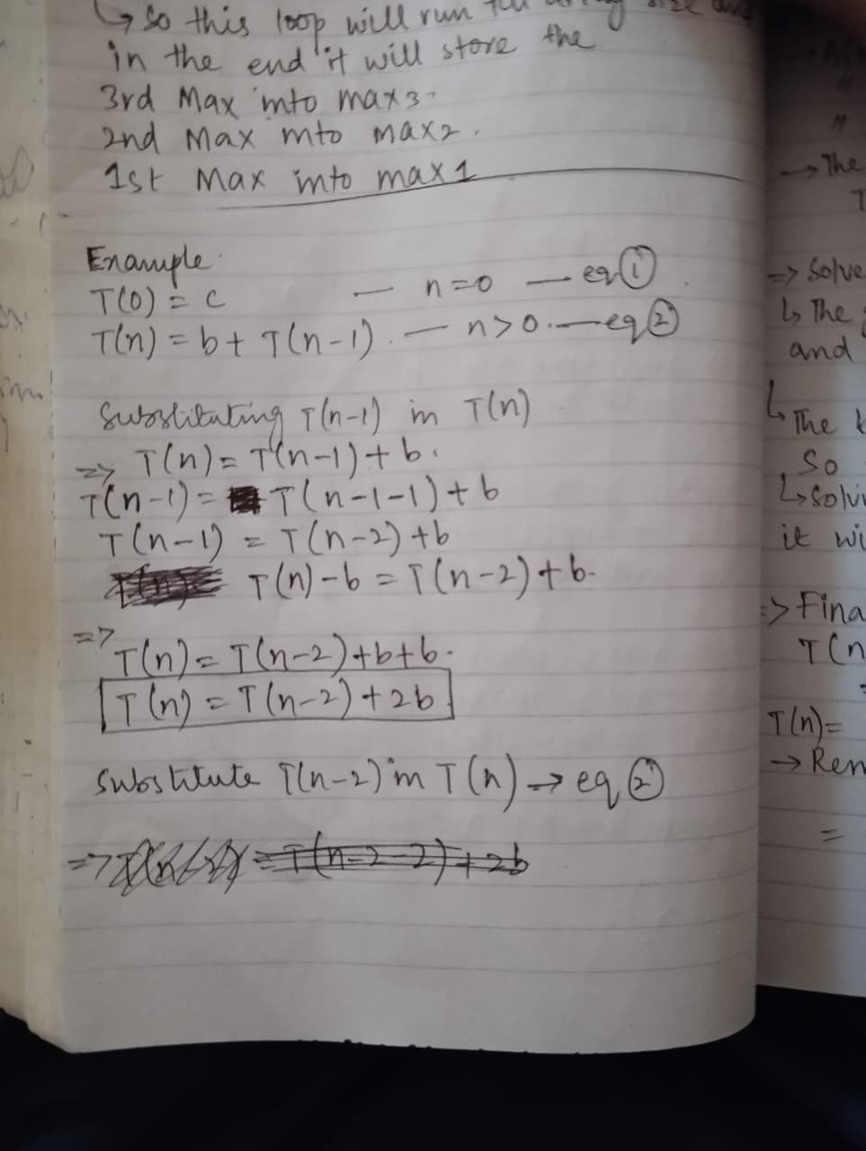
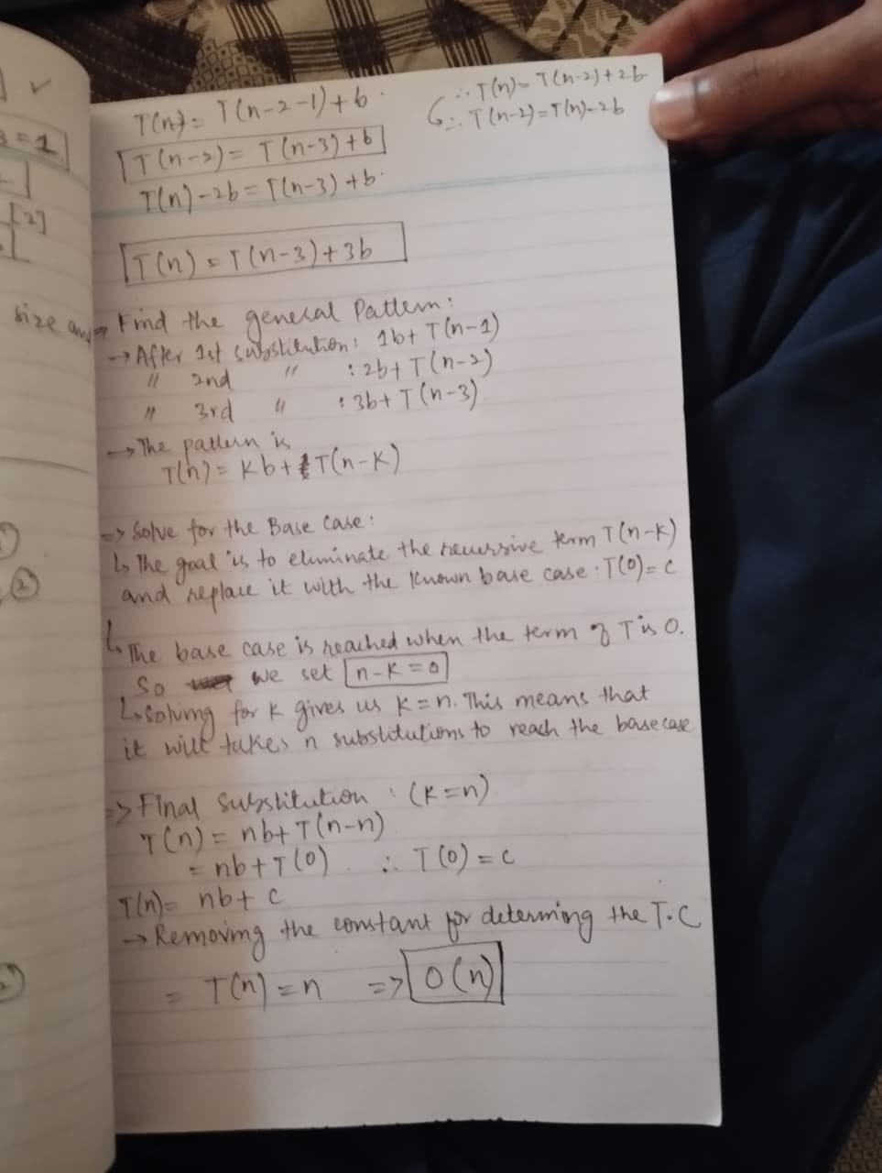
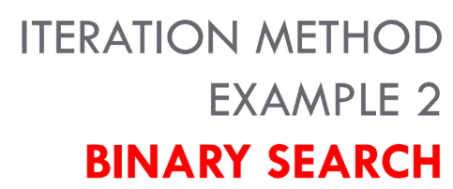
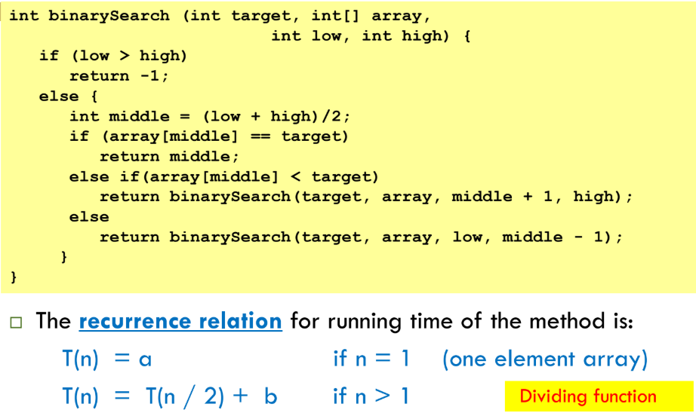
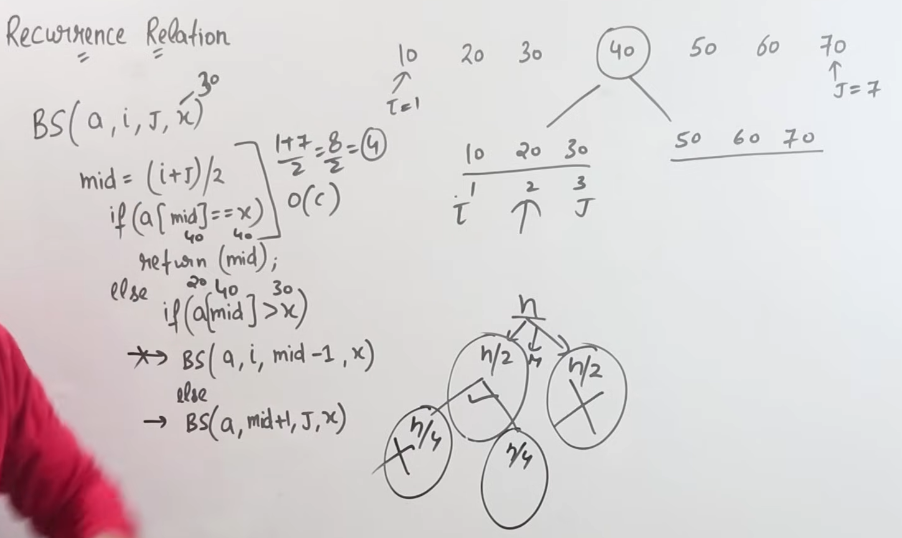
Now Let’s find out its T.C using recurrence relation:
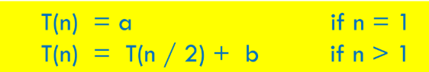
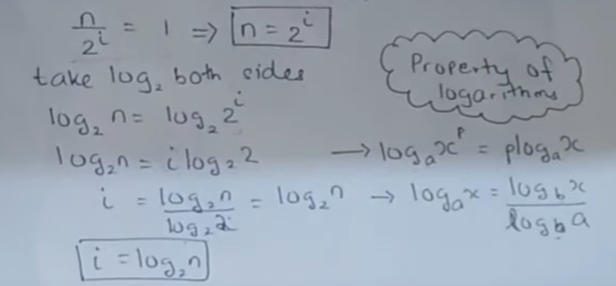
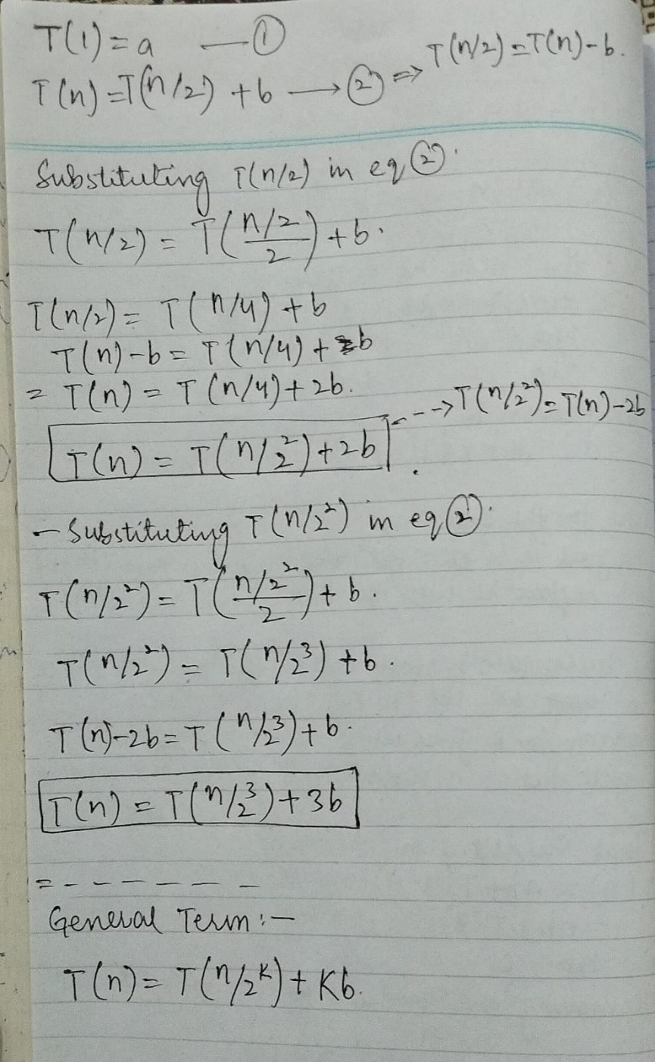
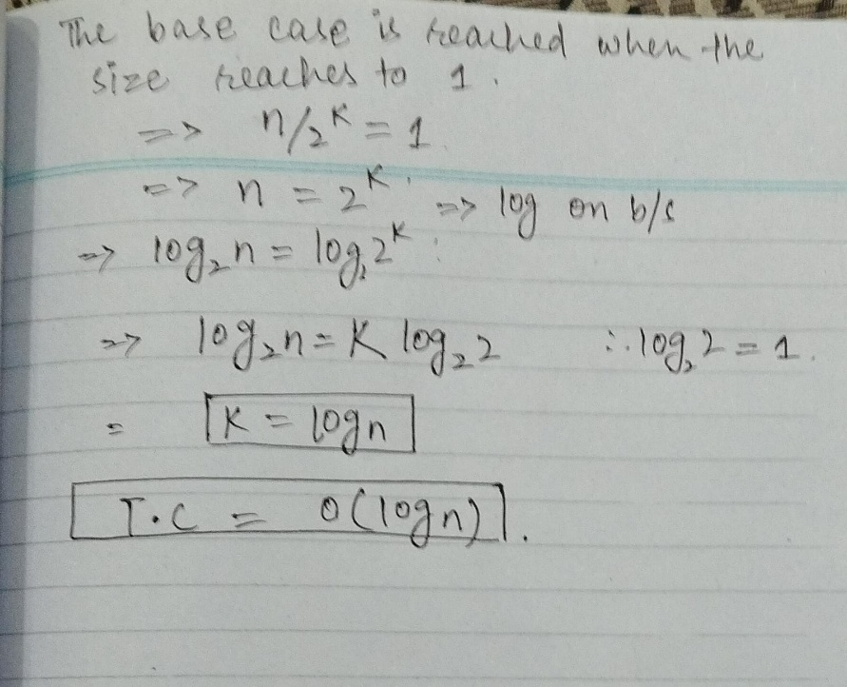
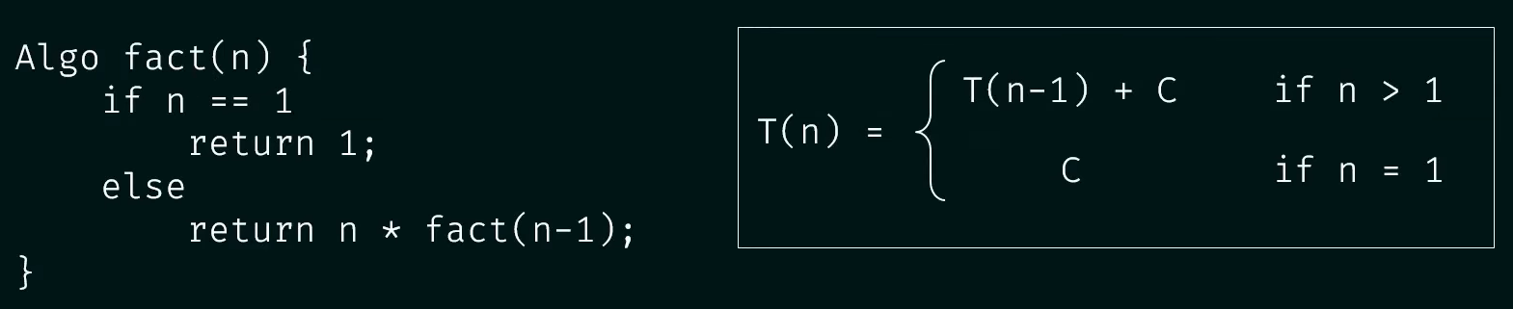
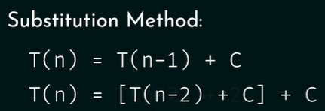
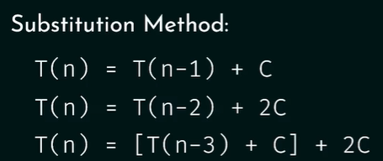

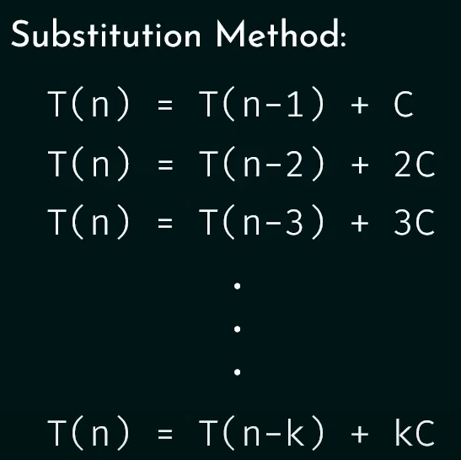
We need to satisfy the base case, for that we assume;
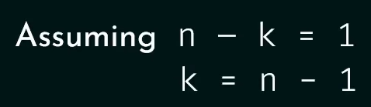
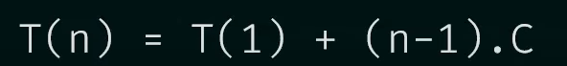
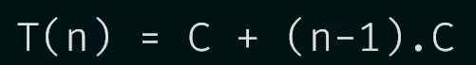

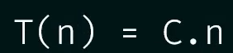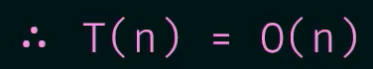

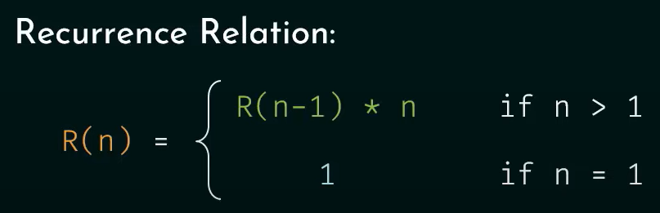
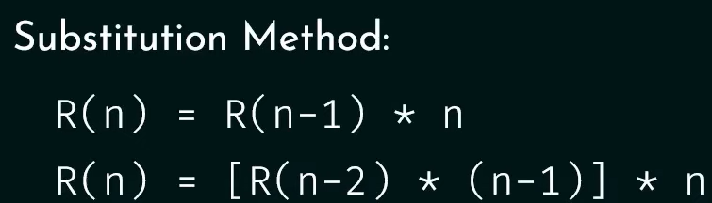
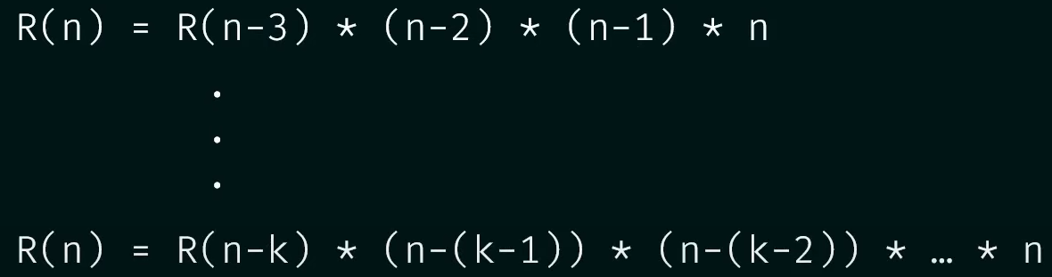
For base case:
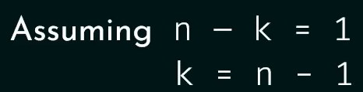
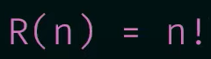

Substitution Method:
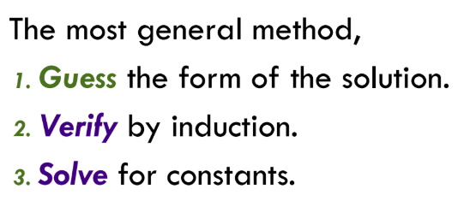
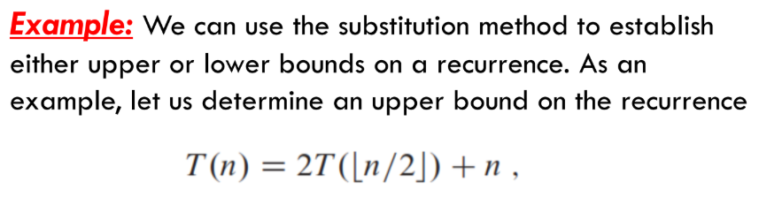
Merge Sort Recurrence Relation
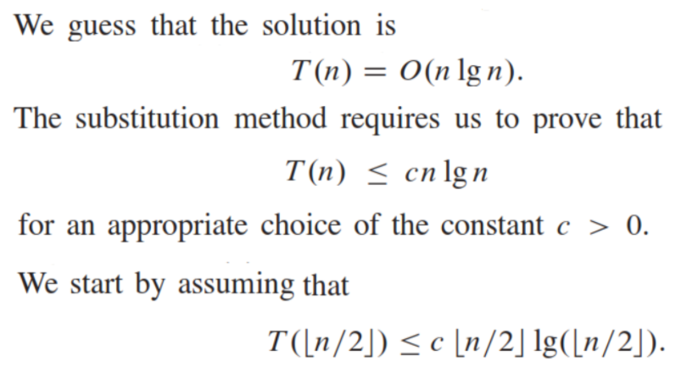
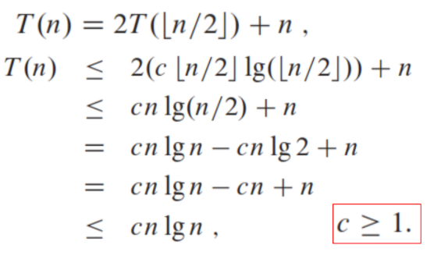
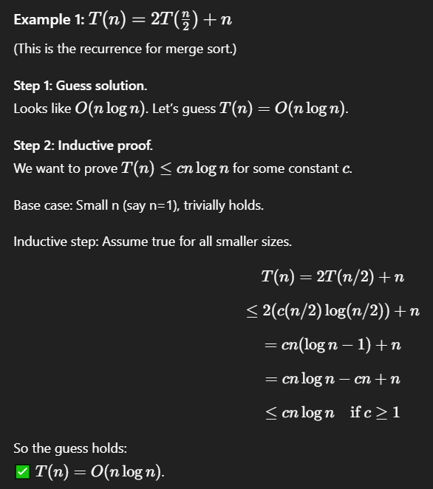
Example:
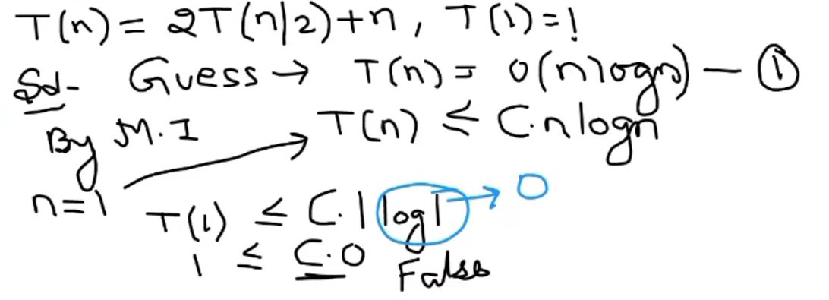
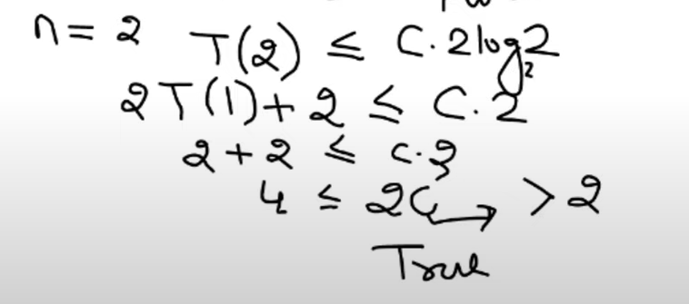
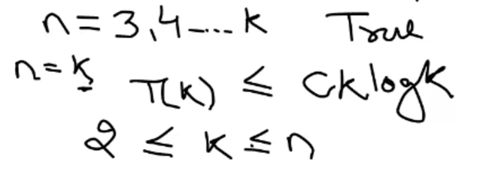
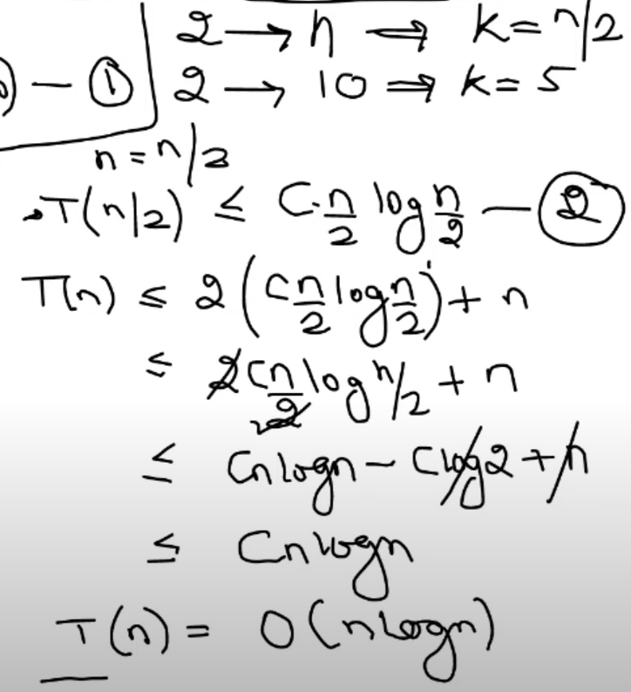

Recurrence Tree
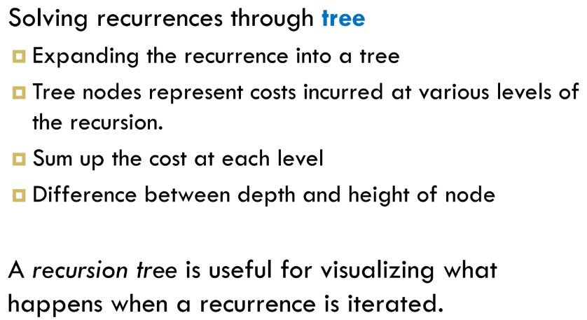
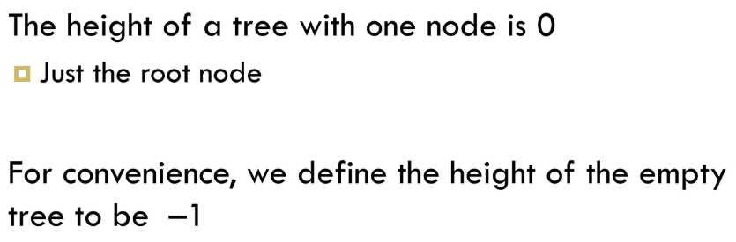
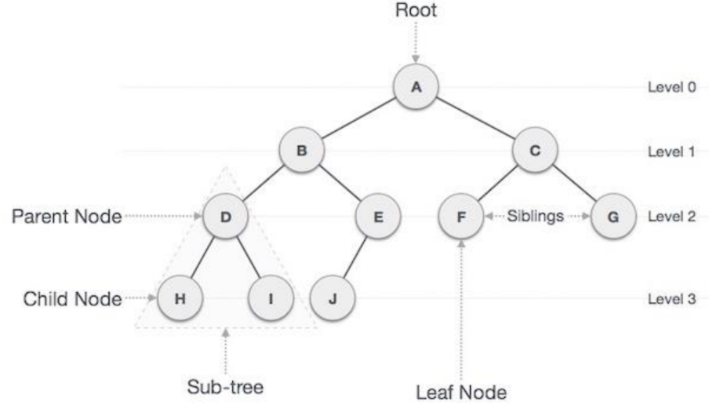
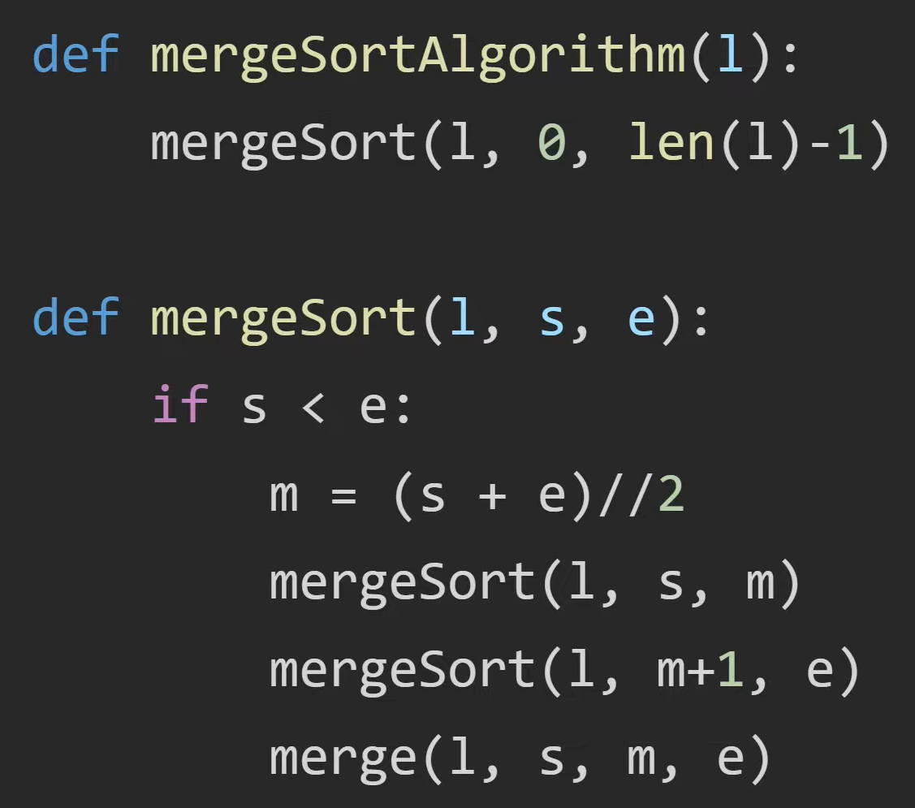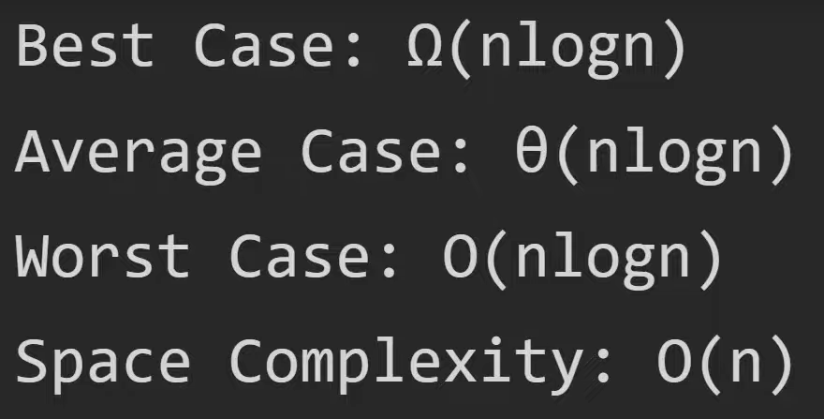
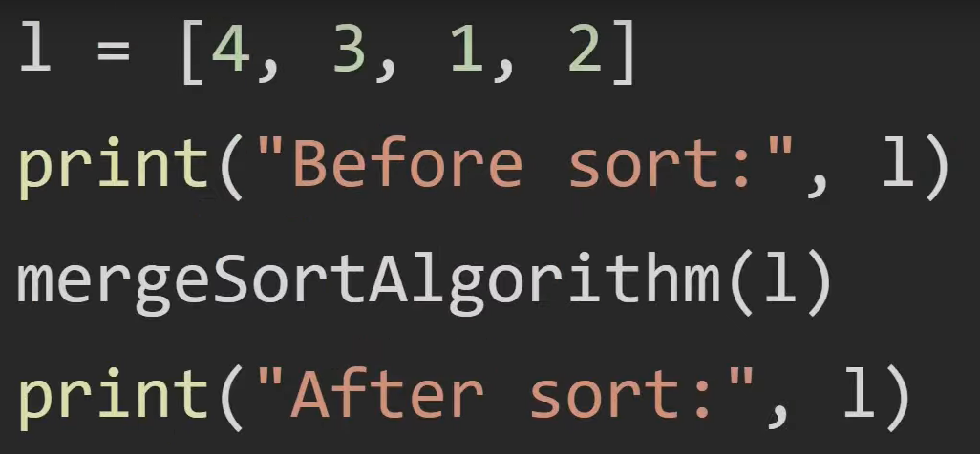
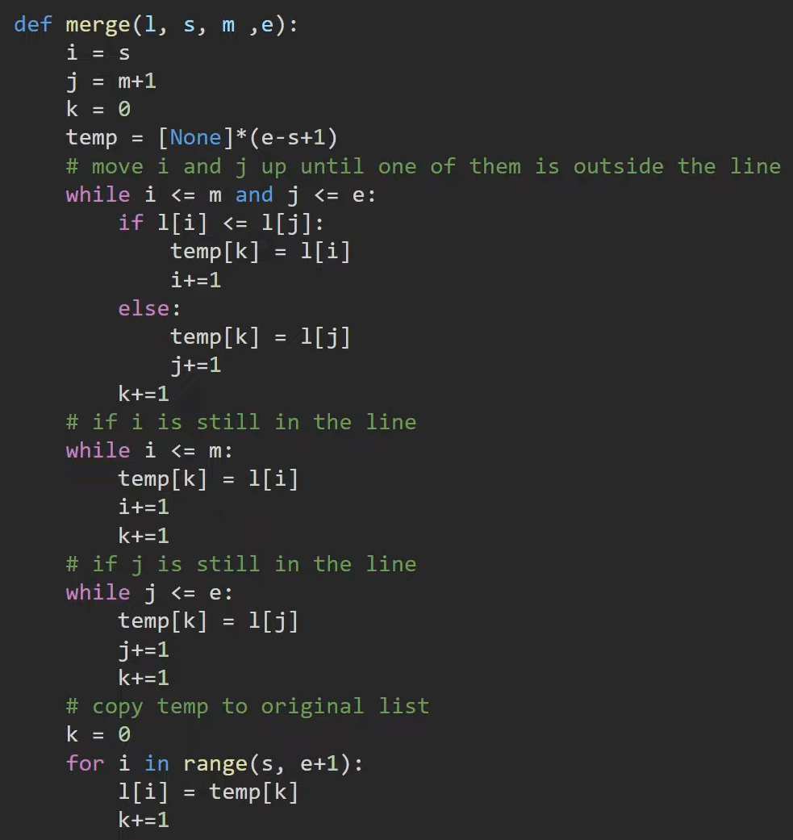
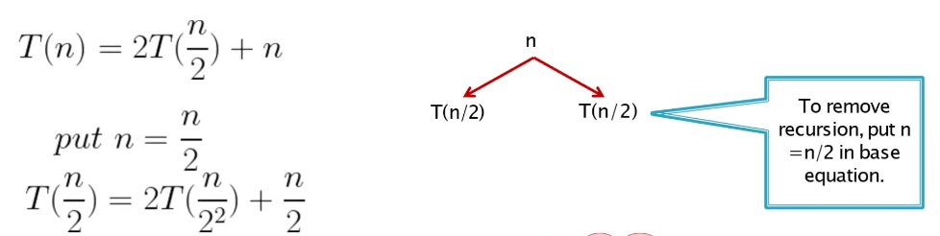
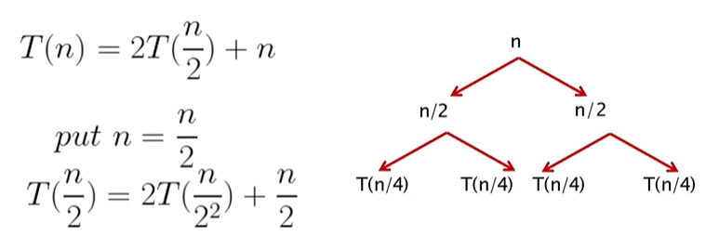

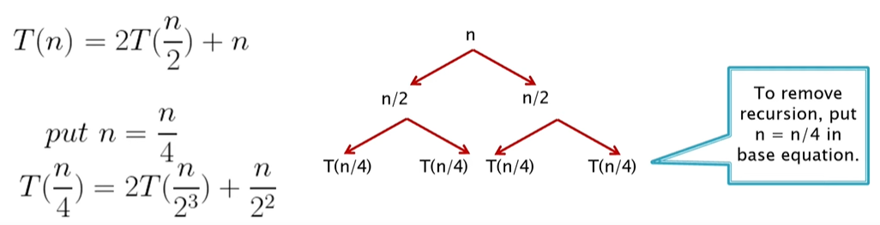
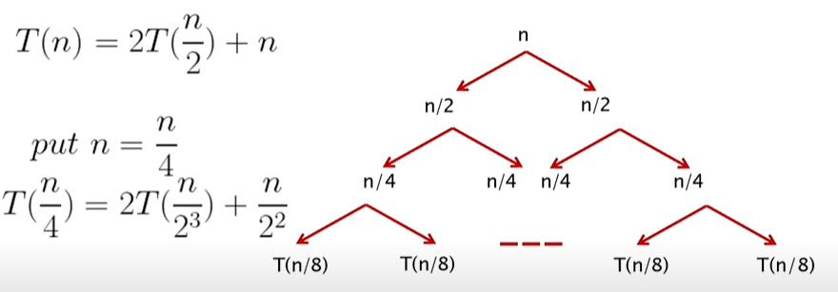
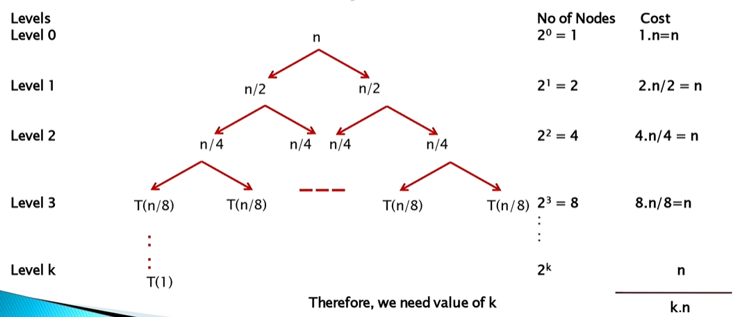
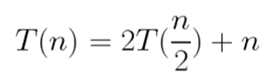
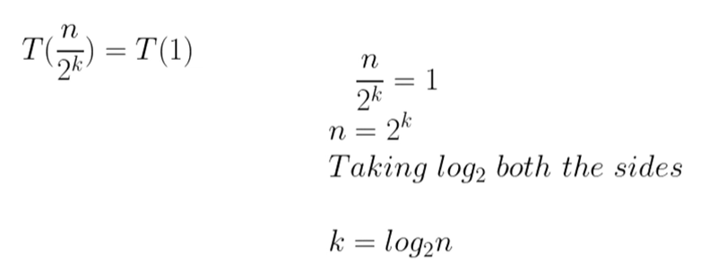
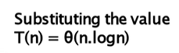

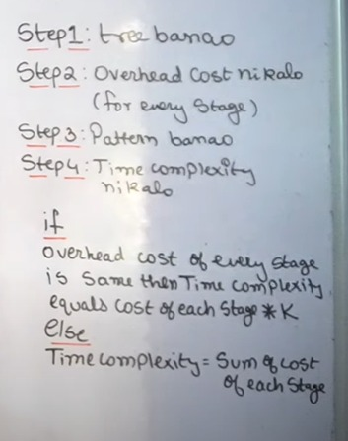
** Steps to Find T.C Using Recursion Tree:
Step 1: Draw the Tree
First, draw the recurrence tree. The root of the tree represents the initial problem, and the branches represent the recursive calls. This step visually breaks down the problem into smaller and smaller subproblems.
Step 2: Find the Overhead Cost
Next, calculate the overhead cost for every. This means you need to sum the costs of all the nodes at each level of the tree. The cost at each level is the work done at that stage, excluding the recursive calls.
Step 3: Find the Pattern
Once you have the costs for a few levels, find a pattern. Look for a pattern in the cost from one level to the next. This pattern often forms a geometric series. Also, determine the height of the tree, which is the number of levels from the root to the leaves.
Very Important Point of Step#4
Step 4: Calculate the Time Complexity
Finally, calculate the time complexity
- If the overhead cost of every stage is the same, then the total time complexity is the cost of each stage multiplied by the (K) -> where K is the number of stages or the height of the tree.
- Else, the time complexity is the sum of the costs of each stage. This involves summing the geometric series you found in Step 3.

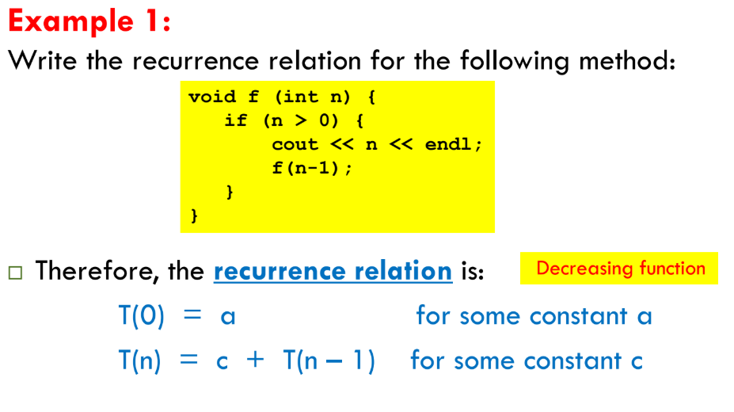
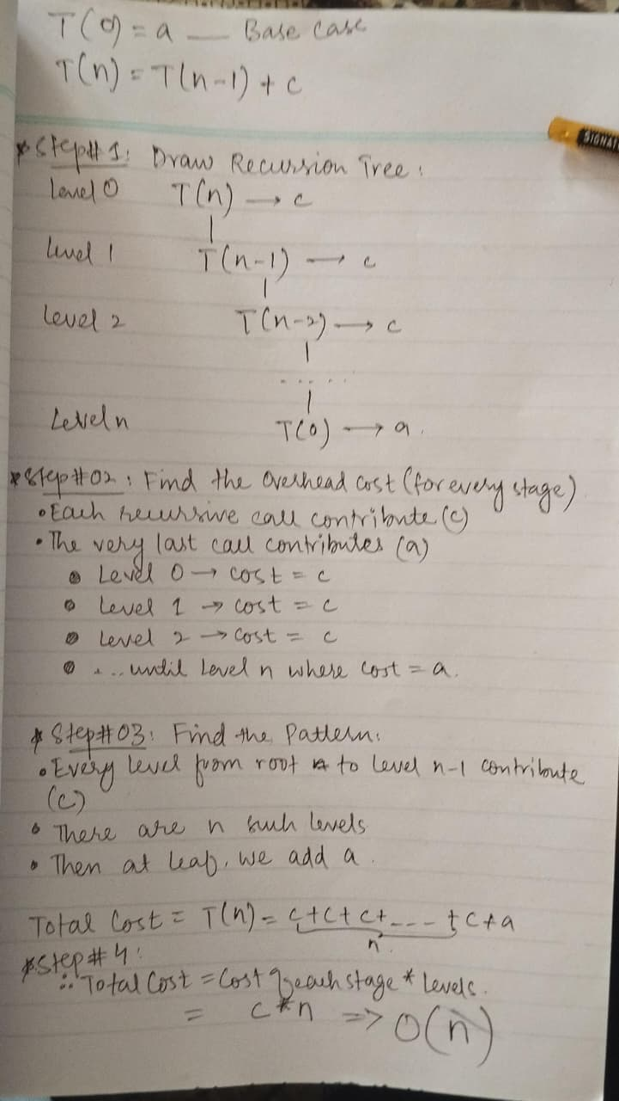
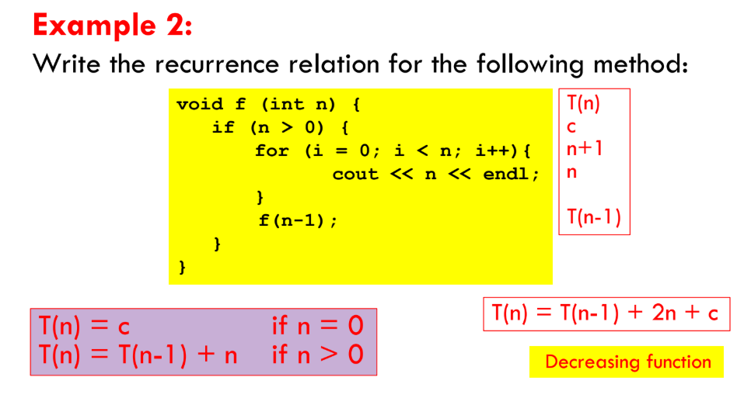
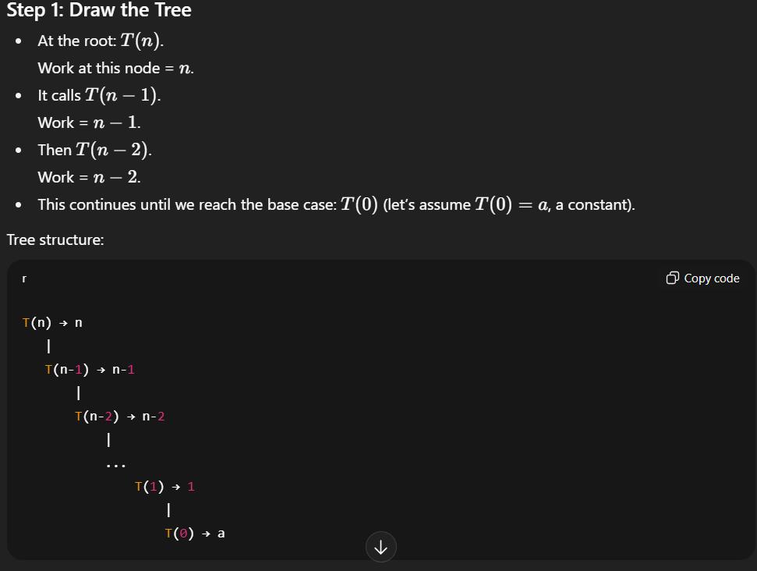
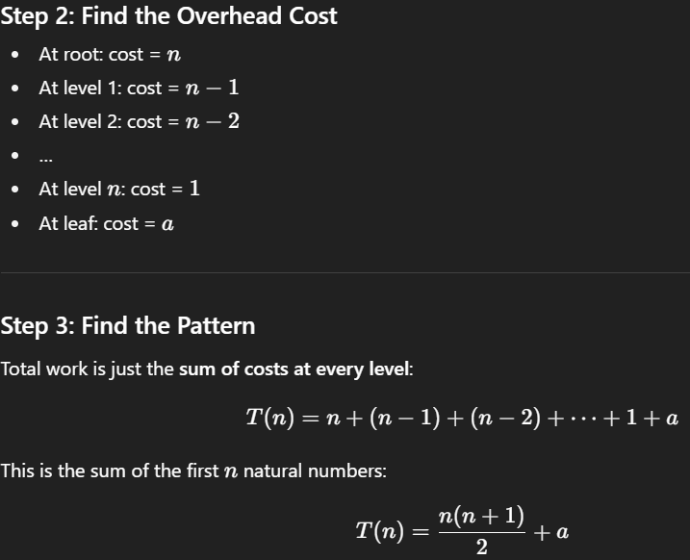
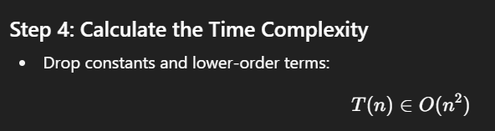

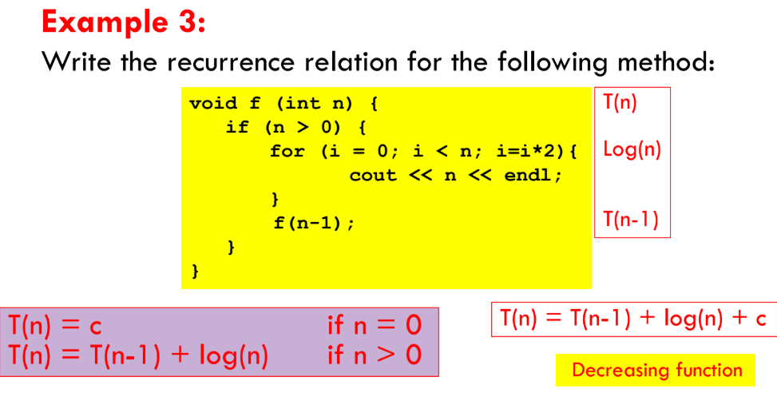
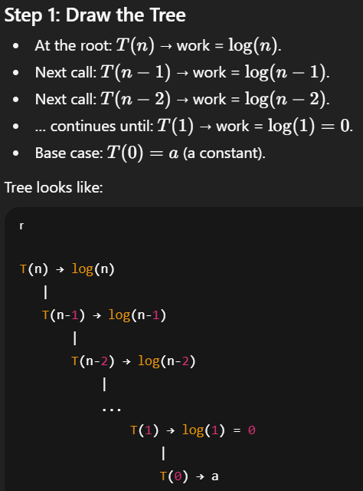
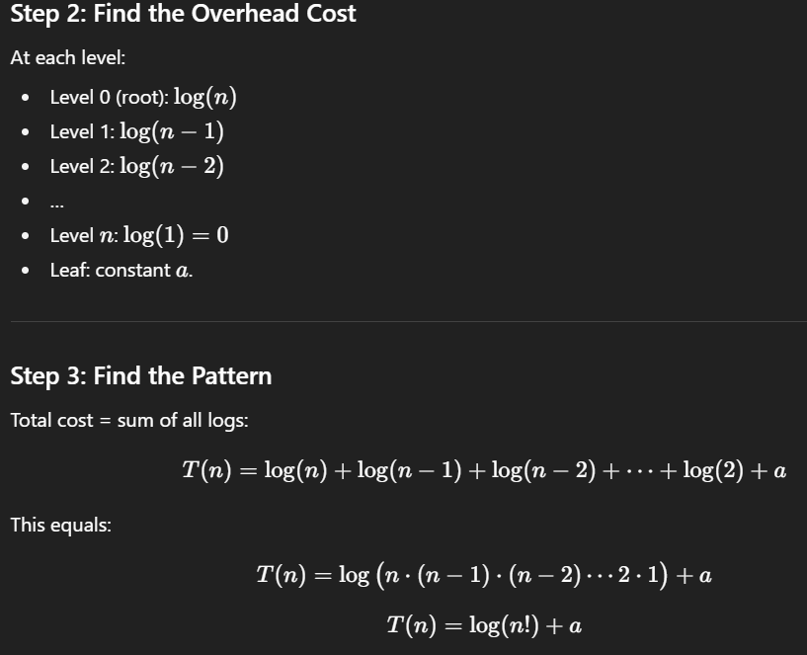
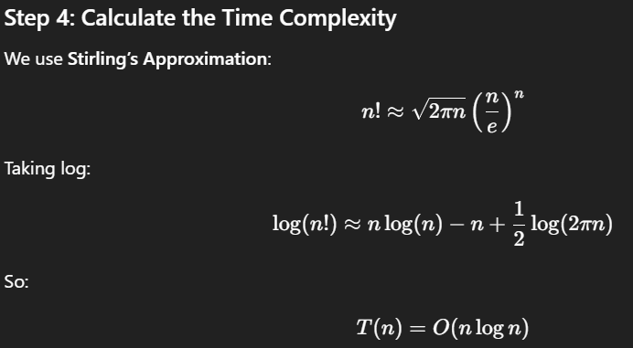
Rattafication Point:
Whenever the T.C is T(n)=log(n!), just rewrite it as O(nlogn)
